Azyume Cut AI

Durable Video Platform

STATUS  Implemented / pre-production |  | OWNER  Azhar / Azyume Cut AI |  | LAST UPDATED  July 19, 2026

Authors | Azhar (product owner); OpenAI Codex (implementation)
Reviewers | Product owner; payment merchant reviewers; operations owner
Related docs | CLAUDE.md; prisma/schema.prisma; remotion-render-service/README.md
Scope | Payments, credits, private media, durable rendering, delivery, and rollout gates.

1. Abstract
Azyume Cut AI is a secure, credit-funded video editing platform that accepts private multipart uploads, verifies media, and runs recoverable Remotion renders. The web application owns identity, quotes, payments, wallets, orders, and delivery; a separate renderer owns only a single idempotent render attempt.
The design replaces client-priced orders, password credentials, public order access, legacy payment gateways, permanent signed URLs, and ephemeral render state. PostgreSQL is the business source of truth, Cloudflare R2 stores private media, and Redis transports work without becoming authoritative.

2. Goals and Non-Goals
Goals | Non-goals
Secure every customer and admin boundary; make money and credit effects replay-safe. | No storage of raw card data or custom card-processing surface.
Verify private uploads and recover renders without charging failed work. | No prohibited marketplace scraping or automatic gig submission.
Use DOKU for one-time packs and Xendit v3 for packs plus token-ready recurring billing. | No claim that live merchant products are active before provider approval.
Ship a mobile-friendly PWA and admin console with rollback and human review. | No production 360 or ComfyUI workflow; research stays feature-flagged off.

3. Background and Problem Statement
The previous application mixed an early fixed-package sales flow with partially implemented automation. Price and order data could be supplied by the client, multiple routes did not consistently enforce ownership, render status could disappear on process restart, signed media URLs were persisted, and Wise, Payoneer, Stripe, and n8n paths competed with the intended production flow.
The rebuilt boundary is explicit: Next.js validates identity and creates durable business state; DOKU and Xendit move money; PostgreSQL records quotes, events, credits, and render attempts; R2 stores bytes; BullMQ schedules attempts; and the Remotion service renders one immutable attempt. The guiding invariant is durable state before side effects and credit consumption only after a verified output exists.

4. Proposed Architecture

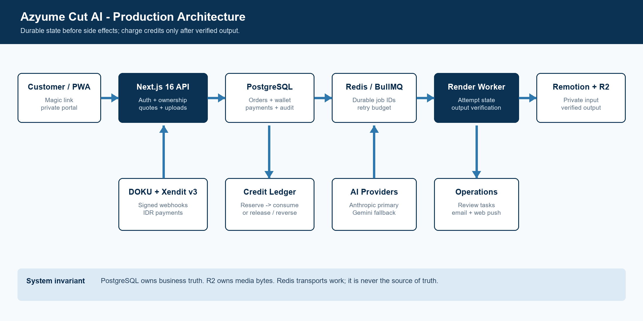
Figure 1. Azyume Cut AI production architecture.

Core components

Component | Responsibility | Primary storage | Failure behavior
Next.js web/API | Auth, ownership, quotes, orders, upload signing, and portal. | PostgreSQL | Fail closed before queue or gateway.
Billing + wallet | Signed DOKU/Xendit webhooks, FX quotes, and FIFO credits. | Payment + ledger tables | Reject invalid, mismatched, or replayed events.
Private media | Multipart R2 upload, FFprobe checks, and retention. | R2 + asset rows | Abort expiry; missing objects never succeed.
Render pipeline | Persistent attempts, Remotion jobs, checksums, and retries. | DB truth; Redis; R2 | Three retries, then release and review.
Operations | Admin review, flags, AI fallback, and operational alerts. | PostgreSQL + Resend/VAPID | Core state survives alert or AI failure.

5. Request Lifecycle
- An authenticated customer creates an idempotent order and chooses a tier; the server ignores client pricing.
- The API checks session, ownership, file schema, and idempotency before creating state or signed storage actions.
- The browser hashes and uploads multipart to private R2; completion verifies parts, size, and FFprobe duration.
- The server calculates credits, creates the render, and reserves the wallet in a serializable transaction.
- A RenderAttempt is persisted before submission; its attempt ID and input/output R2 keys are immutable.
- The worker polls durable states, heartbeats, retries with backoff, enforces 45 minutes, and never treats 404 as success.
- Success requires a matching non-empty R2 output. Credits are consumed on success or released with human review after final failure.

6. API and Data Contracts

Primary data contract

Field | Type | Required | Description
orderId | UUID | Yes | User-owned order; establishes authorization and audit boundary.
renderId | UUID | Yes | Stable render record and BullMQ job identity.
reservationId | UUID | Yes | Active wallet reservation consumed or released exactly once.
inputR2Key | String | Yes | Verified private source object; signed URL is derived only at execution.
outputR2Key | String | Yes | Immutable destination; returned key must match before success.
compositionId | Enum | Yes | Allowlisted Remotion composition selected from the requested style.
checksum | SHA-256 | On success | Stored with the terminal attempt and output for integrity checks.

Contract guarantees

- A verified upload and active credit reservation must exist before a render can be queued; the queue never creates business state by itself.
- Quotes, payments, ledger entries, uploads, renders, and provider events use unique idempotency keys or provider event IDs so a replay returns prior state without repeating side effects.
- Every payment stores the quote snapshot and FX version; every render stores the order, reservation, attempt number, input/output keys, progress, checksum, and terminal timestamps needed for audit and recovery.
- PostgreSQL is authoritative for money, credits, ownership, and lifecycle. R2 is authoritative for media bytes. Redis and provider redirect actions are transport data only.
Versioned contracts are implemented in the application and renderer repositories:
src/lib/payment, src/lib/queue, API v1 routes, and remotion-render-service/src/contracts.ts.

7. Consistency, Idempotency, and Replay

The design provides at-least-once delivery with exactly-once business effects. Queue jobs and webhooks may repeat, but unique keys, serializable wallet updates, and terminal-state checks prevent duplicate grants or charges. Partial work is acceptable only before a verified terminal state; it remains visible as an attempt or event for recovery.
Scenario | Expected behavior | Reasoning
Duplicate API call or webhook | Return prior record or no-op after terminal processing. | Unique idempotency and provider-event constraints prevent duplicate effects.
Required DB or R2 write fails | Fail request; do not queue, grant, consume, or publish. | Side effects start only after authoritative durable state exists.
Renderer timeout or restart | Persist failure, retry within budget, then release credits and review. | Attempt IDs and terminal state survive process restarts for audit.
FX or config changes mid-flow | The quote or attempt keeps its captured version and immutable keys. | Pinned inputs prevent price or behavior drift during execution.

8. Security and Privacy Considerations

- Magic-link sessions identify customers; every order, upload, download, wallet, and payment query is scoped by user ID. Admin routes require the admin role and production Cloudflare Access identity.
- Raw footage remains private in R2. The database stores object keys rather than permanent signed URLs. Payment events retain provider payloads for audit, while application logs avoid gateway secrets and media URLs.
- Database, R2, DOKU, Xendit, renderer, AI, Resend, and VAPID credentials are deployment secrets. Webhook and renderer secrets are compared with timing-safe functions and are never sent to browsers.
- Replay paths fail closed: missing secrets, amount or currency mismatches, stale DOKU timestamps, and duplicate credit grants are rejected.
e. Multipart sessions expire after 24 hours, raw uploads after 30 days, and deliveries at their retention date. Final legal and regional requirements remain a launch gate.

9. Operational Readiness
Signal | SLO or alert | Owner | Launch gate
Paid webhook completion | >=99.9% valid events processed in 5 min; page on backlog or rejected spike. | Payments / operations | Required
Render completion time | Queue start p95 <=2 min; alert on attempts beyond 45 min. | Render operations | Required
Retry or terminal error rate | Warn above 2% rolling 24h; page above 5% or repeated exhaustion. | Render operations | Required
FX and deployment drift | Warn at 24h FX age; pause checkout at 48h; alert on schema mismatch. | Platform owner | Required
Ledger and object integrity | Daily wallet reconciliation and sampled output HEAD/checksum verification. | Platform + finance | Required before public launch
Rollout constraint: migrate and seed first; certify DOKU/Xendit sandbox flows; run internal canary projects; keep recurring and 360 features disabled until their explicit gates pass.

10. Alternatives Considered

Alternative | Why it was considered | Why it was not selected
Stripe as primary | Broad international card coverage and mature tooling. | Not requested; adds another ledger and webhook surface before DOKU/Xendit stabilization.
Wise / Payoneer manual flow | Simple international transfer options. | Manual reconciliation and ambiguous confirmation weaken the automated credit invariant.
n8n as critical orchestrator | Fast visual automation and flexible integrations. | It is not the authoritative durable state machine for payments, credits, or render attempts.
ComfyUI / 360 at launch | More experimental styles and immersive output. | GPU cost, quality variability, and operational complexity exceed the launch boundary.

11. Open Questions
- Has Xendit enabled live card tokenization and recurring Payment Requests?
- Are DOKU live credentials, callbacks, and Checkout methods approved?
- Are the 30-day raw and 90-day delivery retention defaults contractually approved?
- Who owns SLOs, reconciliation, and after-hours render escalation?

12. Decision and Next Steps
Adopt the implemented architecture and deploy it through controlled gates. Code, schema, and local verification are complete; production rollout now depends on real infrastructure, sandbox-to-live payment certification, end-to-end media tests, and named operational ownership. Keep recurring plans unavailable in the UI until Xendit tokenization is activated.
Milestone | Deliverable | Exit criteria
M1 | Code, schema, migration, renderer durability, and local verification. | App build, renderer build, lint, typecheck, and 9 tests pass.
M2 | Production-like PostgreSQL, Redis, R2, FFprobe, DOKU sandbox, and Xendit test-mode E2E. | Signed callbacks grant once; failures release; output HEAD and download pass.
M3 | Internal canary with at least five representative projects. | Seven stable days, reconciliation clean, no severity-1 issue, rollback rehearsed.
M4 | Public packs, then recurring plans after separate provider activation. | Named on-call owner, SLO alerts live, provider approvals complete, gates signed off.

Use footnotes for definitions, assumptions, or terms that need precision without interrupting the main narrative.

