-- Database + Tables Creation

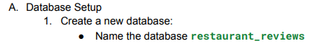

create database restaurant_reviews;

result:

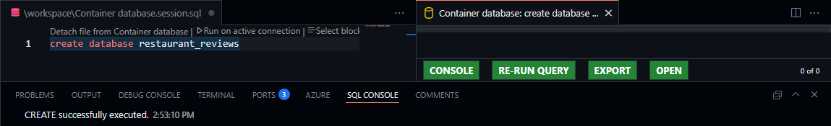

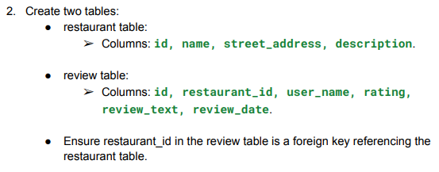

create table restaurant (

id INT NOT NULL,

name VARCHAR(255),

street_address VARCHAR(255),

description VARCHAR(255),

primary key (id)

);

create table review (

id INT NOT NULL,

restaurant_id INT NOT NULL,

user_name VARCHAR(255),

rating INT,

review_text VARCHAR(255),

review_date date,

primary key (id),

foreign key (restaurant_id) references restaurant(id) on delete cascade

);

Result:

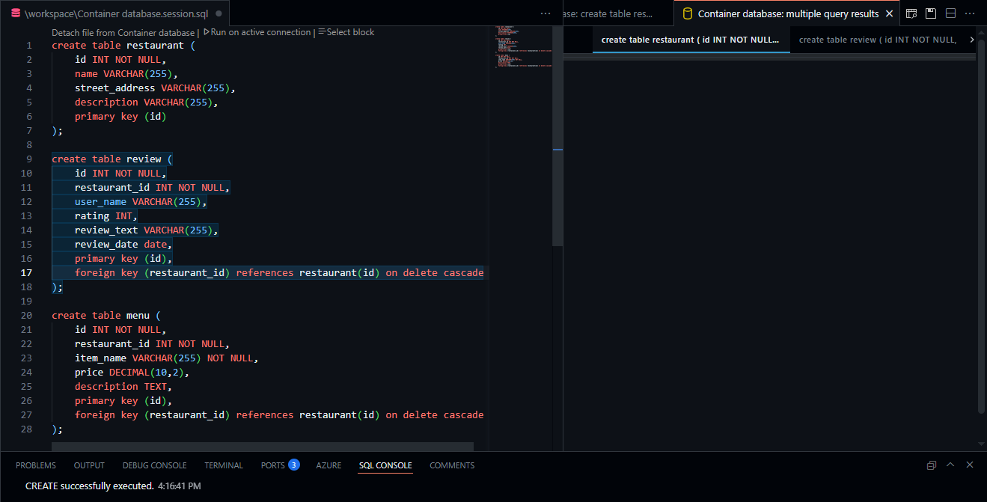

-- Sample Data Insertion

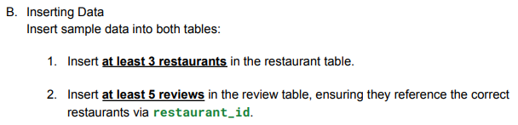

INSERT INTO restaurant

VALUES

('1','McD','jl. jangan lupa bahagia','nomer 1 ayam'),

('2','KFC','jl. napas manual','nomer 1 kentaki'),

('3','CFC','jl. kedip manual','nomer 1 root beer');

Result: 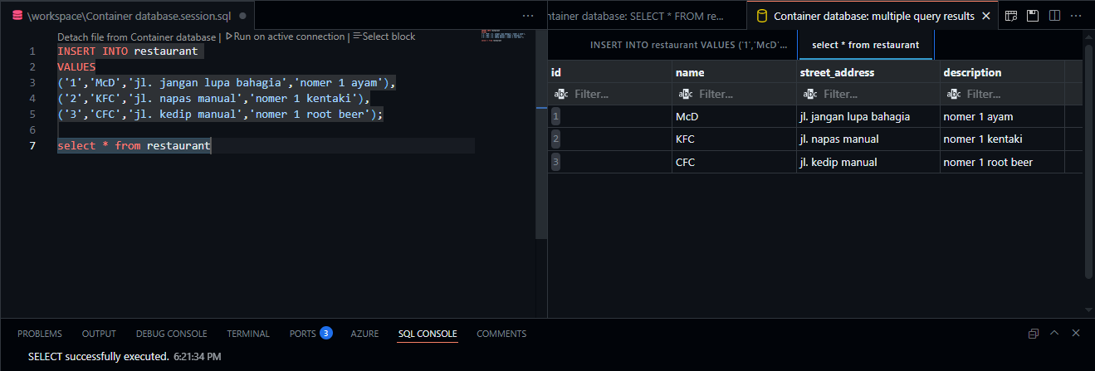

INSERT INTO review

VALUES

('1','1','ki joko pinter','4','pembohonk','01/01/2001'),

('2','2','jaka sembung','8','wenakk','02/02/2002'),

('3','3','reyna','9','mang eaaakkk','03/03/2003'),

('4','3','sova','3','g enak','04/04/2004'),

('5','3','jilljoy','10','b aja','05/05/2005');

Result: 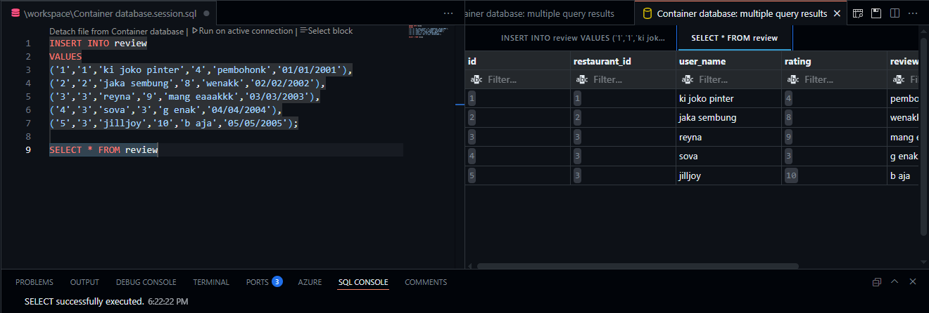

-- Queries for CRUD

-- Create

-- Case1

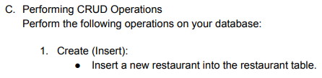

INSERT INTO restaurant

VALUES

('4','A&W','jl. jalan','nomer 1 diseluruh dunia');

Result: 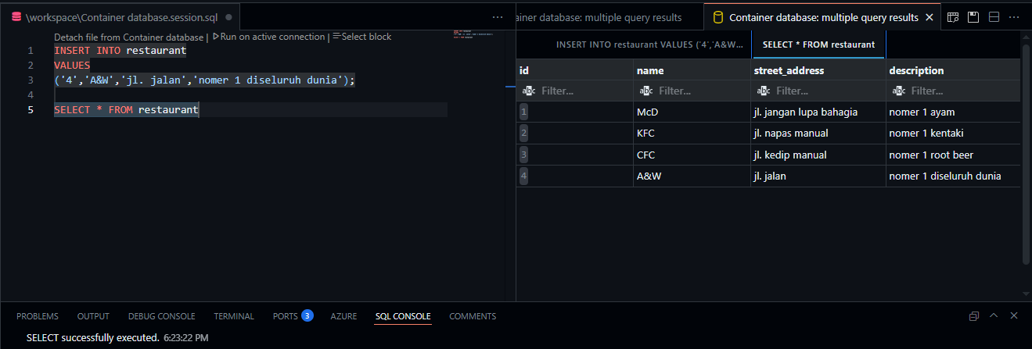

-- Case2



INSERT INTO review

VALUES

('6','4','Agoosh','1','ga enak bjir','06/06/2006');

Result:

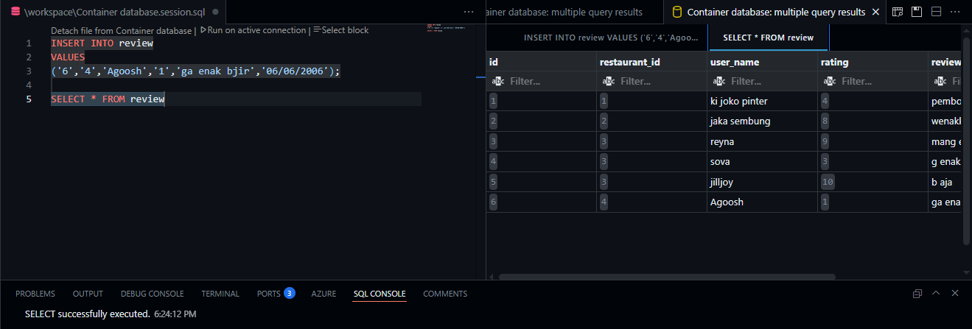

-- Read

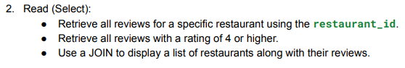

-- Case1

SELECT t2.name as restaurant_name,

t1.rating as restaurant_rating,

t1.review_text,

t1.review_date

FROM review as t1

JOIN restaurant as t2 ON t2.id = t1.restaurant_id

WHERE t1.restaurant_id = 3

Result: 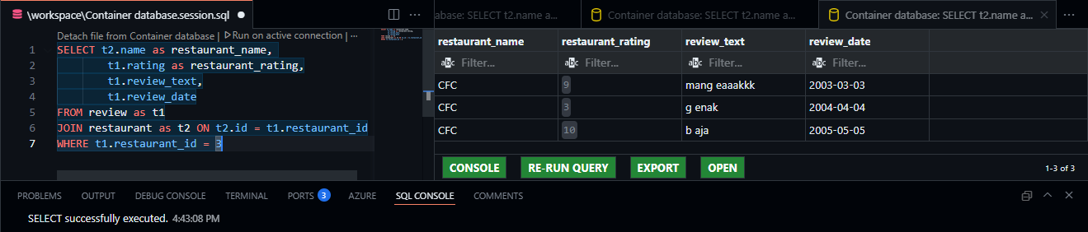

-- Case2

SELECT t2.name as restaurant_name,

t1.rating as restaurant_rating,

t1.review_text,

t1.review_date

FROM review as t1

JOIN restaurant as t2 ON t2.id = t1.restaurant_id

WHERE t1.rating >= 4

Result:

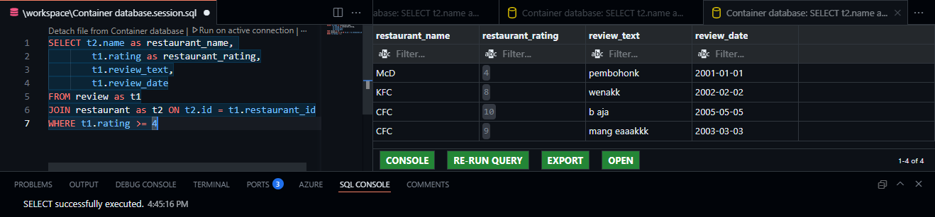

-- Case3

SELECT *

FROM review as t1

JOIN restaurant as t2 ON t2.id = t1.restaurant_id

Result:

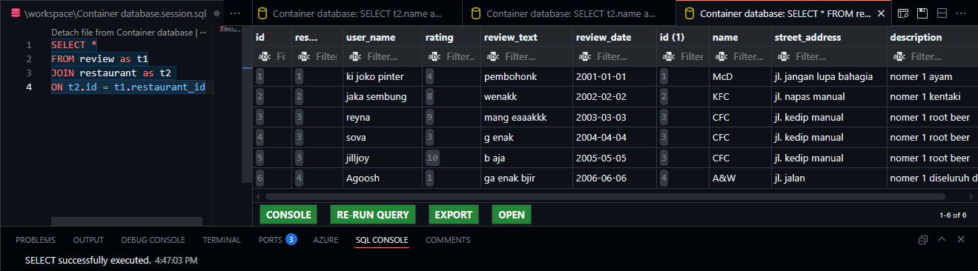

-- Update

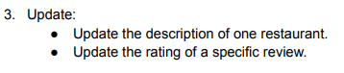

-- Case1

update restaurant

SET description = 'nomer 1 aja'

where id = 4

result: 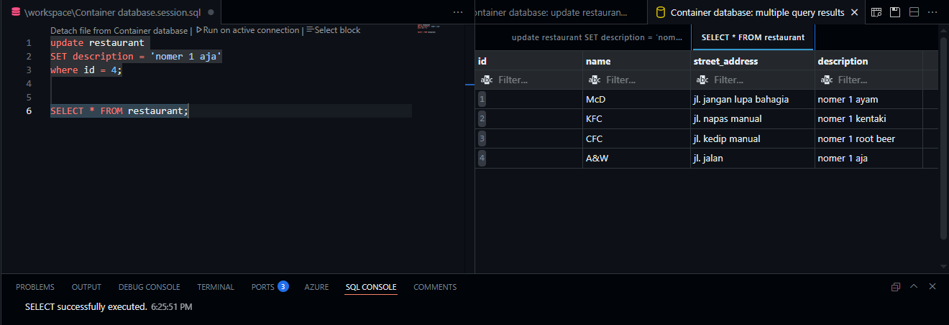

-- Case2

update review

SET rating = '2'

where id = 4

result: 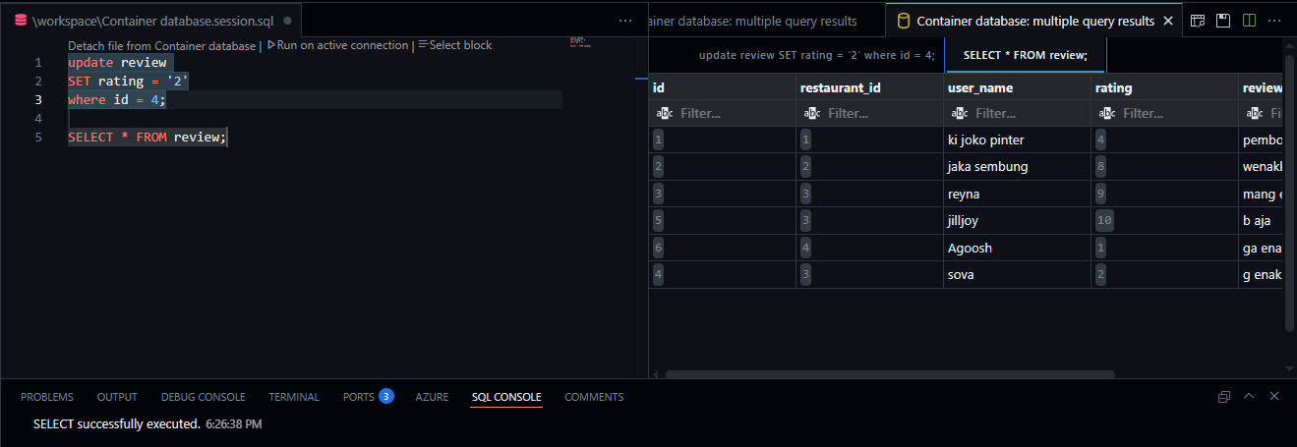

-- Delete

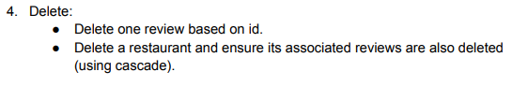

-- Case1

delete from review

where id = 1

Result: 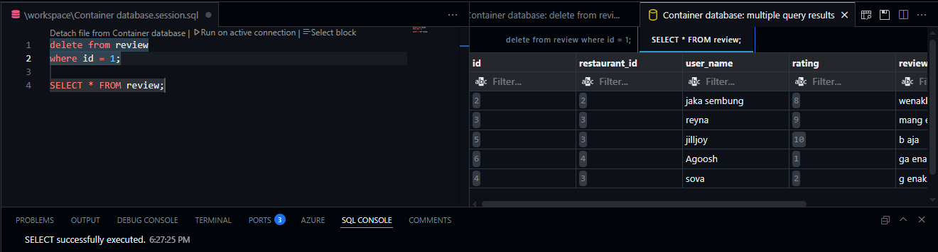

-- Case2

delete from restaurant

where id = 1

Result: 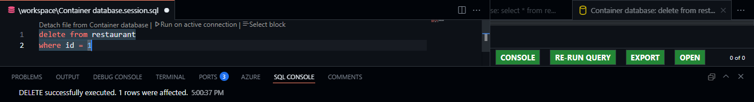

Before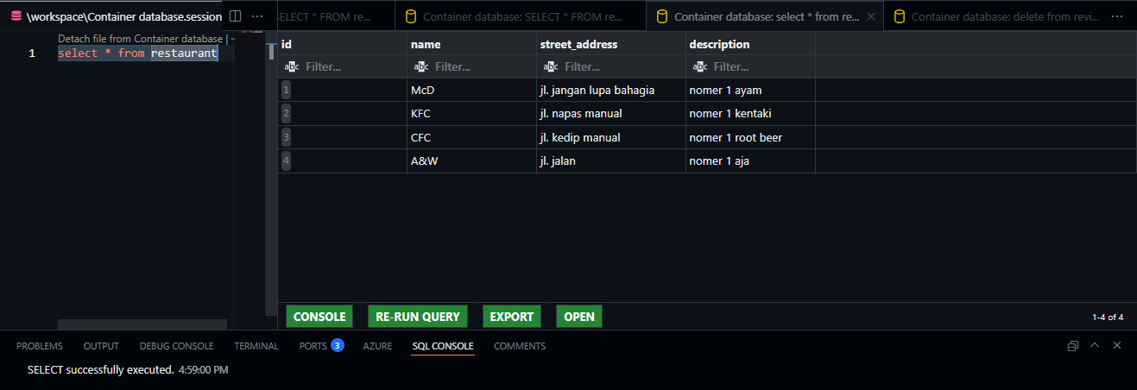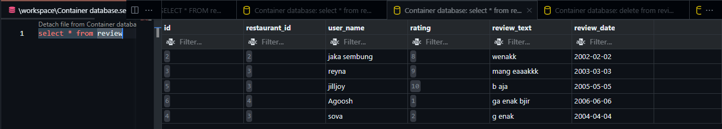

After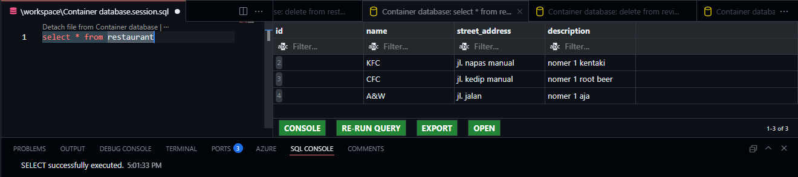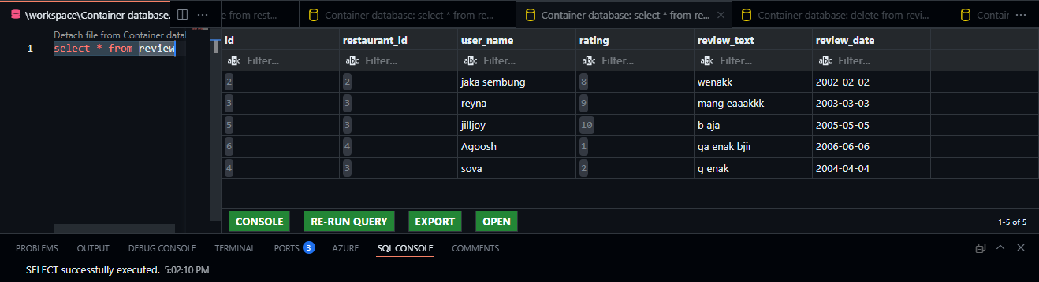

-- Additional Queries

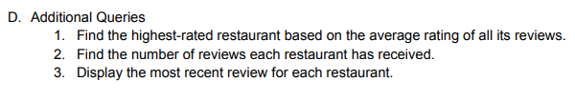

-- Case1

select t1.name as restaurant_name, avg(t2.rating) as restaurant_rating

from restaurant as t1

join review as t2 on t1.id = t2.restaurant_id

GROUP BY t1.id, t1.name

ORDER BY restaurant_rating DESC

limit 1

Result:

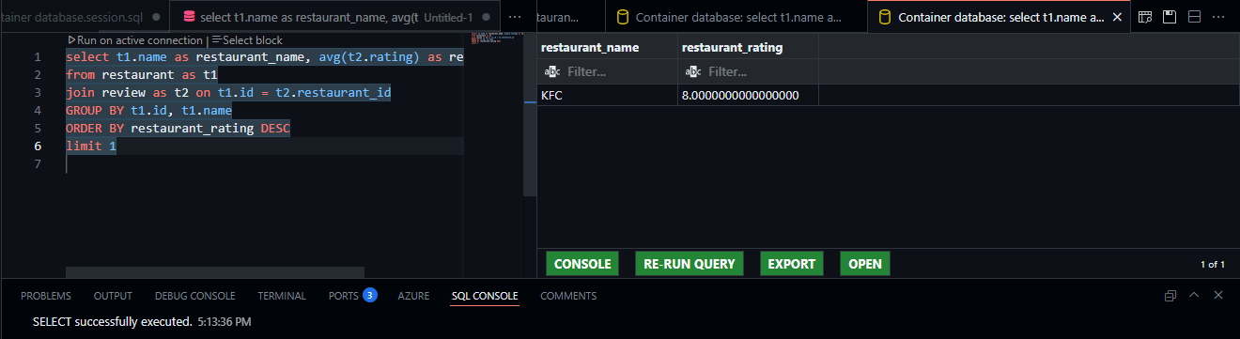

-- Case2

select t1.name as restaurant_name,

count(t2.id) as review_count

from restaurant as t1

LEFT JOIN review as t2 on t1.id = t2.restaurant_id

GROUP BY t1.id, t1.name

ORDER BY review_count

Result: 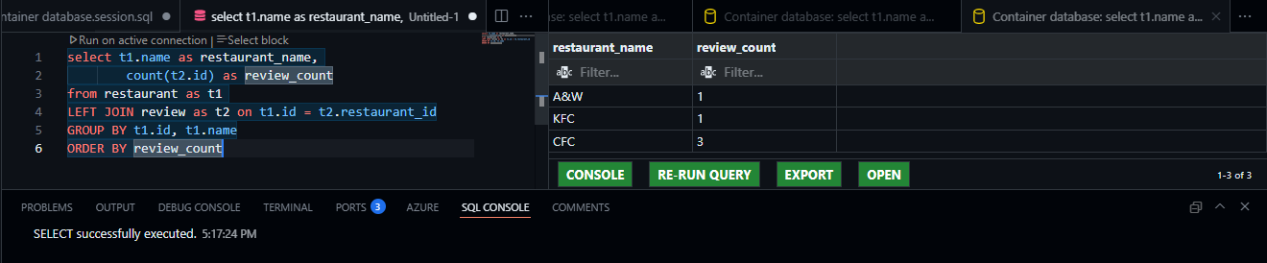

-- Case3

SELECT t1.name as restaurant_name,

t2.rating as restaurant_rating,

t2.review_text,

t2.review_date

FROM restaurant as t1

JOIN review as t2 ON t1.id = t2.restaurant_id

WHERE t2.review_date IN (

SELECT max(review_date)

FROM review

GROUP BY restaurant_id

)

ORDER BY t1.name

Result: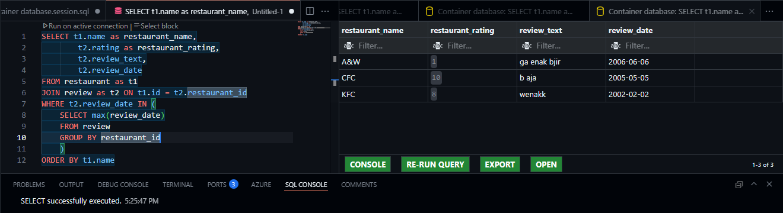

-- Extra Credits

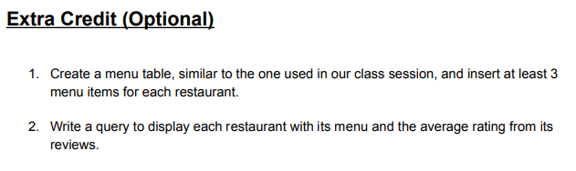

-- Case1

create table menu (

id INT NOT NULL,

restaurant_id INT NOT NULL,

item_name VARCHAR(255) NOT NULL,

price DECIMAL(10,2),

description TEXT,

primary key (id),

foreign key (restaurant_id) references restaurant(id) on delete cascade

);

INSERT INTO menu

VALUES

('1','2','babi kecap','50000','babi dikecapin'),

('2','2','babi panggang','45000','babi dipanggang'),

('3','2','babi goreng','30000','babi digoreng garing'),

('4','3','babi sambal matah','55000','babi dikasi sambel matah'),

('5','3','babi guling','75000','babi diguling'),

('6','3','sate babi','60000','babi disate'),

('7','4','sate kelelawar','20000','kelelawar disate'),

('8','4','rawon babi','25000','babi rawon item'),

('9','4','sop monyet','100000','monyet disop');

SELECT * FROM menu

Result: 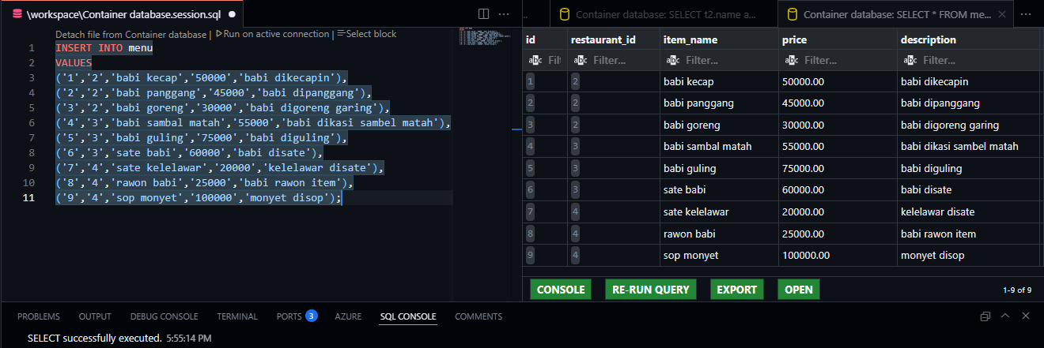

-- Case2

SELECT t2.name as restaurant_name,

t3.item_name as restaurant_menu,

AVG(t1.rating) as restaurant_rating

FROM review as t1

JOIN restaurant as t2 ON t1.restaurant_id = t2.id

JOIN menu as t3 ON t2.id = t3.restaurant_id

GROUP BY t2.id, t2.name, t3.item_name

ORDER BY restaurant_rating DESC

Result: 