**CS5787 Homework 0**

**Iris Flowers**

Xiran Sun, Ang Zhou

08/28/2018

1. Problem Statement
   1. How many feature/attributes are there per sample?

Answer: There are 4 features/attributes per sample. (4 features + 1 label)

* 1. How many different species are there?

Answer: There are 3 different species.

* 1. How many samples of each species did Anderson record?

Answer: 50 samples per species.

1. Program Idea Statement

*program is attached in the zip.file

* 1. Import the txt file：
     1. Open the file, parse each line, and append them into two arrays (2D-array for storing features data, labels array for storing labels data).
     2. Parse data from string to float number
     3. Note that the last line is an empty line, check if it is the last line
  2. Plots based on all pairs of features:
     1. Build a colors array representing the different labels for plots
     2. Build a feature array for storing vectors for each features
     3. Build a 4*4 subplot, iterate through the position and plot the graphs

(Graphs are on the next page.)

1. 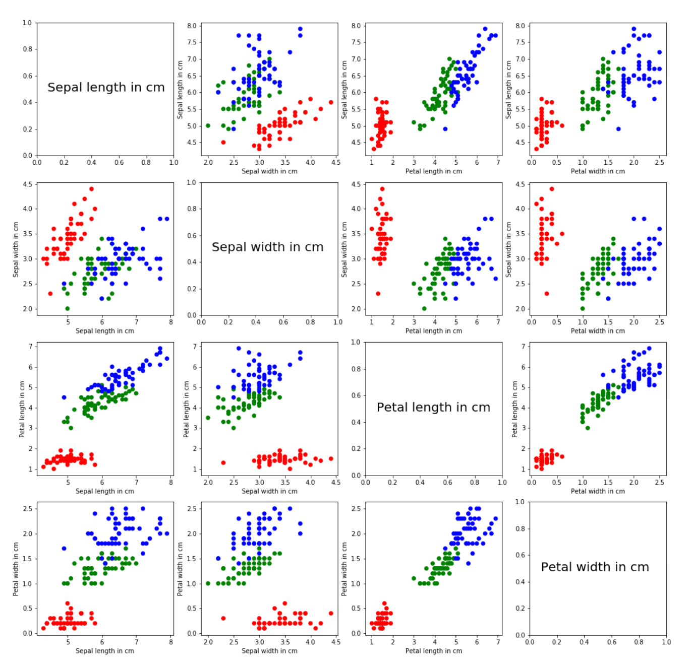Showing Graphs