Question 1:

1. Convert to linear program problem:

Decision variables:

x = # of pounds of corn

y = # of pounds of soybean

Objective:

min (0.2\*x+0.6\*y)

Constraints:

x + y = 90

0.001\*x + 0.002\*y <= 90\*1%

0.09\*x + 0.6\*y >= 90\*30%

0.02\*x + 0.06\*y <= 90\*5%

x, y >=0

1. Find the solution with Excel’s Solver.

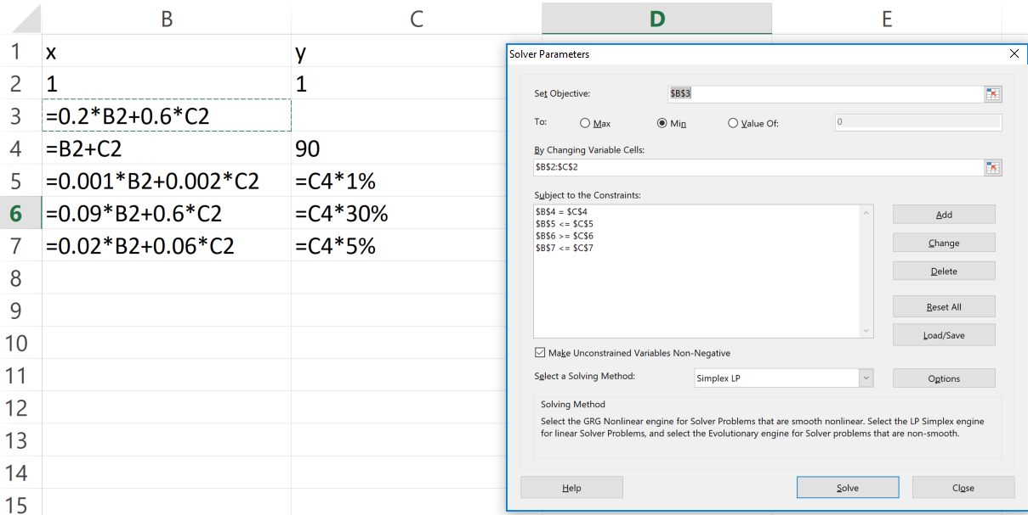

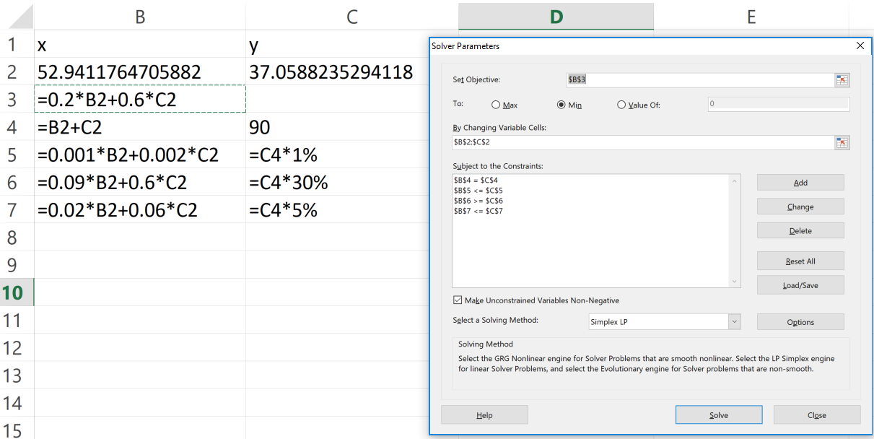

The optimal solution to our optimization problem is (x,y)=(52.94, 37.06) providing the objective value of 0.2\*x+0.6\*y = 32.82

Question 2:

1. Convert to linear program problem:
   1. Decision variables:

x11: # of labors with 1 month of employment recruited in the 1st month

x12: # of labors with 2 month of employment recruited in the 1st month

x13: # of labors with 3 month of employment recruited in the 1st month

x14: # of labors with 4 month of employment recruited in the 1st month

x15: # of labors with 5 month of employment recruited in the 1st month

x21: # of labors with 1 month of employment recruited in the 2nd month

x22: # of labors with 2 month of employment recruited in the 2nd month

x23: # of labors with 3 month of employment recruited in the 2nd month

x24: # of labors with 4 month of employment recruited in the 2nd month

x31: # of labors with 1 month of employment recruited in the 3rd month

x32: # of labors with 2 month of employment recruited in the 3rd month

x33: # of labors with 3 month of employment recruited in the 3rd month

x41: # of labors with 1 month of employment recruited in the 4th month

x42: # of labors with 2 month of employment recruited in the 4th month

x51: # of labors with 1 month of employment recruited in the 5th month

* 1. Objective:

min (110\*(x11+x21+x31+x41+x51)+140\*(x12+x22+x32+x42)+170\*(x13+x23+x33)+230\*(x14+x24)+250\*x15)

* 1. Constraints:

x11+x12+x13+x14+x15>=110

x12+x13+x14+x15+x21+x22+x23+x24>=130

x13+x14+x15+x22+x23+x24+x31+x32+x33>=70

x14+x15+x23+x24+x32+x33+x41+x42>=165

x15+x24+x33+x42+x51>=50

x11,x12,x13,x14,x15,x21,x22,x23,x24,x31,x32,x33,x41,x42,x51>=0

1. Find the solution with Excel’s Solver.

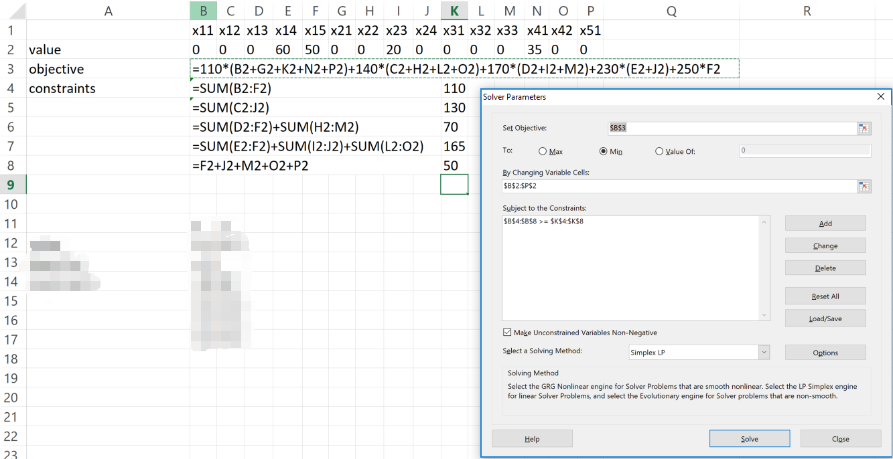

The optimal solution to our optimization problem is (x14,x15,x23,x41)=(60,50,20,35), where all the other decision variables = 0, providing the objective value of 33550.

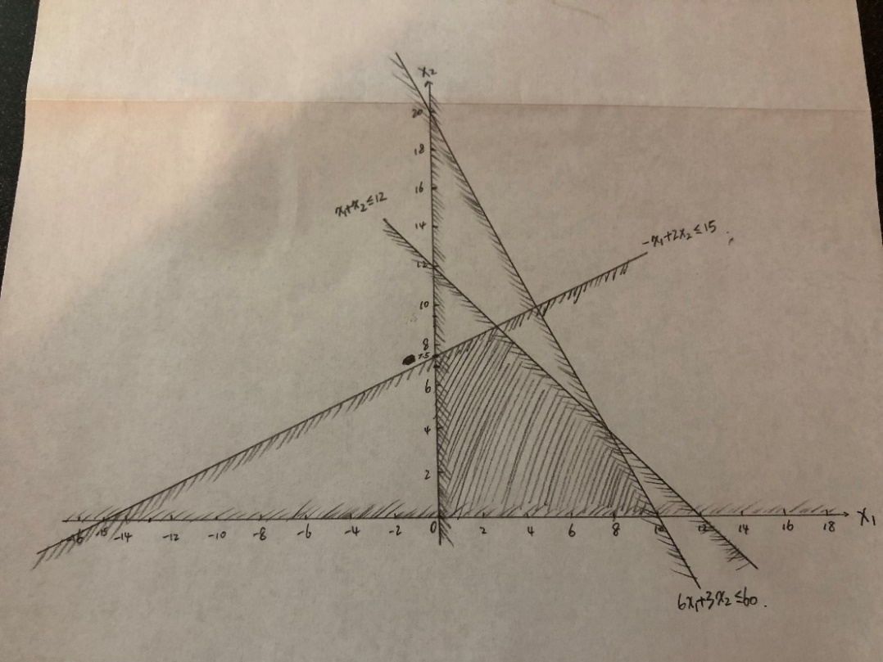Question 3:

(a)

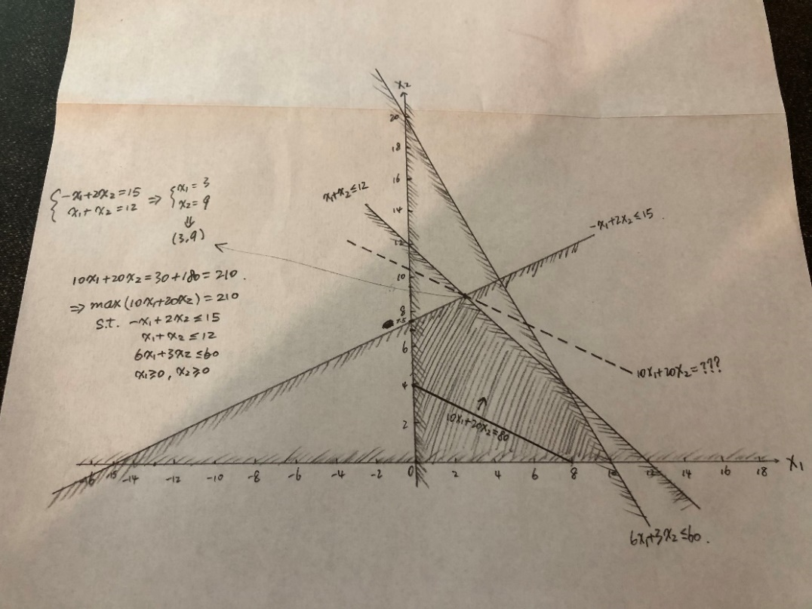(b)

Solution: The optimal values of the decision variables are (x1, x2) = (3, 9). The optimal value of the objective function is 210.

Question 4：

1. Convert to linear program problem:
   1. Decision variables:

x11: # of units shipped from factory 1 to Customer 1

x12: # of units shipped from factory 1 to Customer 2

x13: # of units shipped from factory 1 to Customer 3

x21: # of units shipped from factory 2 to Customer 1

x22: # of units shipped from factory 2 to Customer 2

x23: # of units shipped from factory 2 to Customer 3

* 1. Objective:

min (600\*x11+800\*x12+700\*x13+400\*x21+900\*x22+600\*x23)

* 1. Constraints:

x11+x12+x13<=400

x21+x22+x23<=500

x11+x21=300

x12+x22=200

x13+x23=400

x11,x12,x13,x21,x22,x23>=0

1. Find the solution with Excel’s Solver:

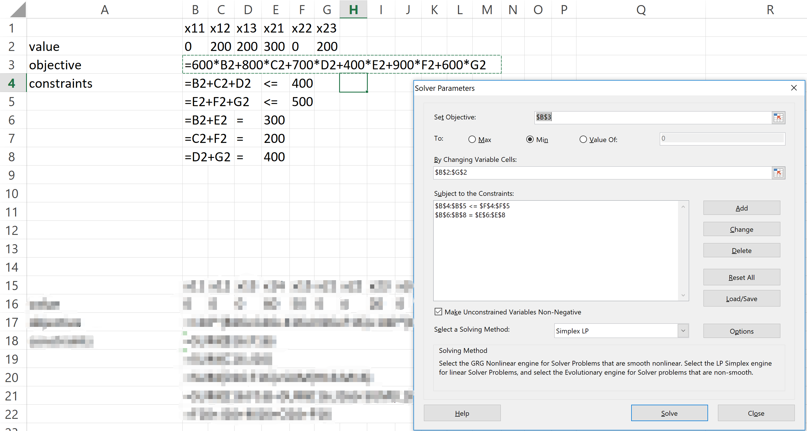

Optimal values of the decision variables are (x11,x12,x13,x21,x22,x23)=(0,200,200,300,0,200).

Optimal values of the objective function is 540000.