Optimization_Method_HW2_Report

Student: Ang Zhou

Question 1:

1. 3-days: MTW, TWR, WRF, RFS;

4-days: MTRF, MTFS, TWFS;

1. Decision Variables:

X11: # of high skill agents working on MTW

X12: # of high skill agents working on TWR

X13: # of high skill agents working on WRF

X14: # of high skill agents working on RFS

X21: # of high skill agents working on MTRF

X22: # of high skill agents working on MTFS

X23: # of high skill agents working on TWFS

Y11: # of low skill agents working on MTW

Y12: # of low skill agents working on TWR

Y13: # of low skill agents working on WRF

Y14: # of low skill agents working on RFS

Y21: # of low skill agents working on MTRF

Y22: # of low skill agents working on MTFS

Y23: # of low skill agents working on TWFS

Objective Function:

Min (X11+X12+X13+X14)*450+(X21+X22+X23)*540+(Y11+Y12+Y13+Y14)*300+(Y21+Y22+Y23)*360

Constraints:

M: X11+X21+X22 >= 60 X11+X21+X22+Y11+Y21+Y22 >= 100

T: X11+X12+X21+X22+X23 >= 90 X11+X12+X21+X22+X23+Y11+Y12+Y21+Y22+Y23 >= 120

W: X11+X12+X13+X23 >= 40 X11+X12+X13+X23+Y11+Y12+Y13+Y23 >= 90

R: X12+X13+X14+X21 >= 30 X12+X13+X14+X21+Y12+Y13+Y14+Y21 >=140

F: X13+X14+X21+X22+X23 >= 40 X13+X14+X21+X22+X23+Y13+Y14+Y21+Y22+Y23 >= 150

S: X14+X22+X23 >= 80 X14+X22+X23+Y14+Y22+Y23 >= 120

X11,X12,X13,X14,X21,X22,X23,Y11,Y12,Y13,Y14,Y21,Y22,Y23 > 0

1. Solve with Excel Solver

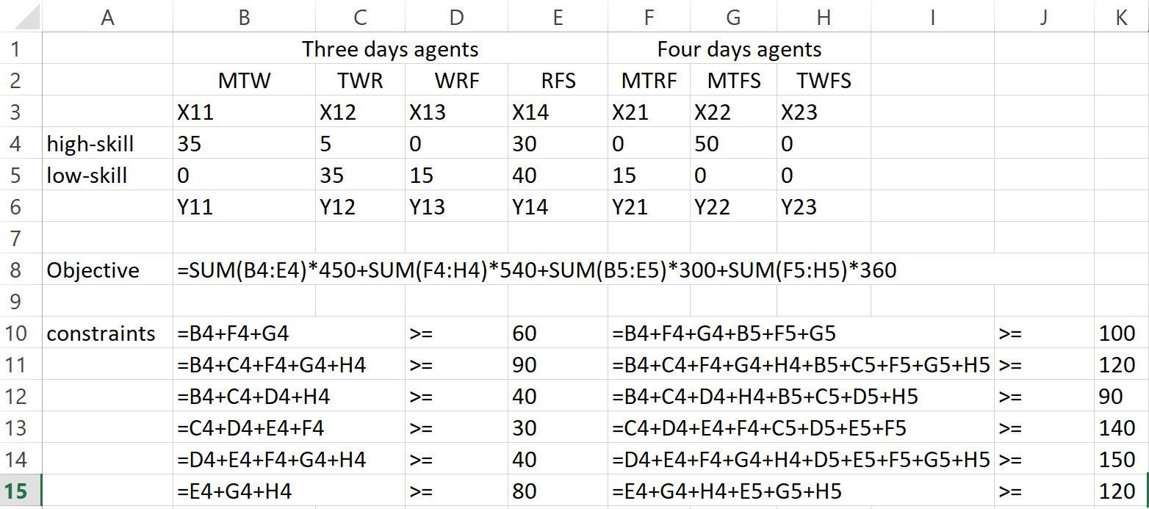

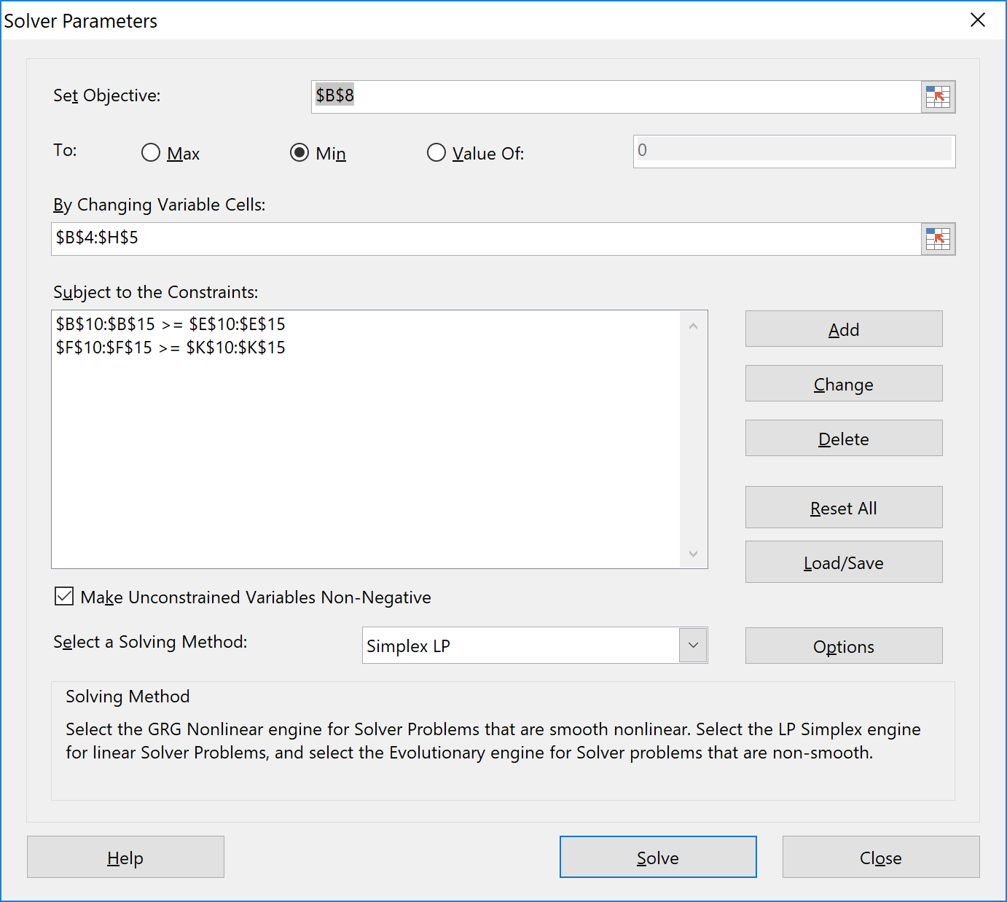

The optimal solution to our optimization problem is:

(X11,X12,X13,X14,X21,X22,X23,Y11,Y12,Y13)=(35,5,0,30,0,50,0,0,35,15,40,15,0,0), providing the objective value of 90900.

Question 2:

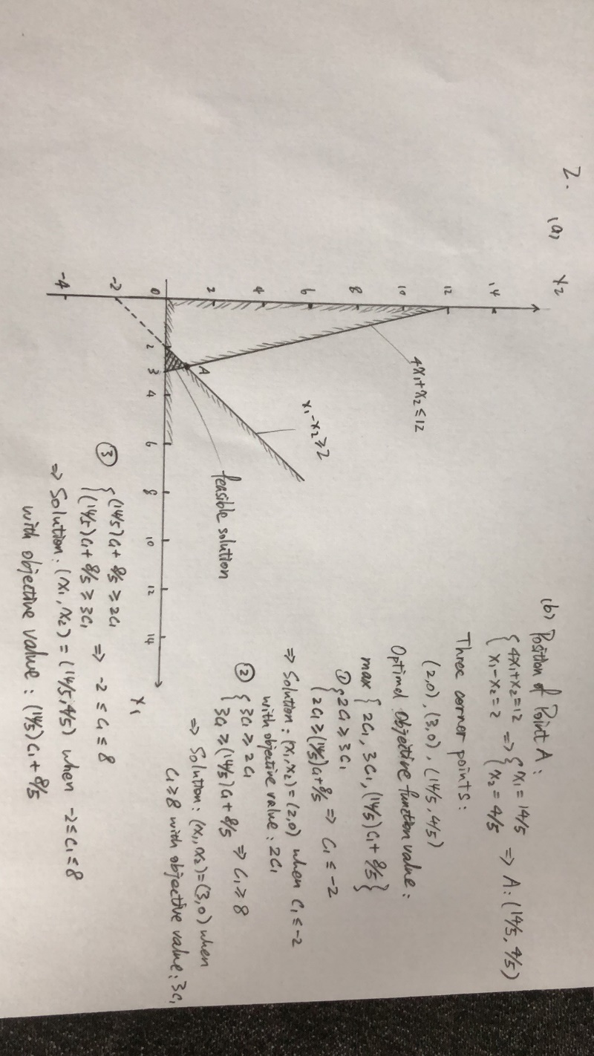



Optimal solution:

(x1, x2) = (2, 0) when c1<=-2, with objective value: 2*c1

(x1, x2) = (3, 0) when c1>=8, with objective value: 3*c1

(x1, x2) = (14/5, 4/5) when -2<=c1<=8, with objective value (14/5)*c1 + 8/5

Question 3:

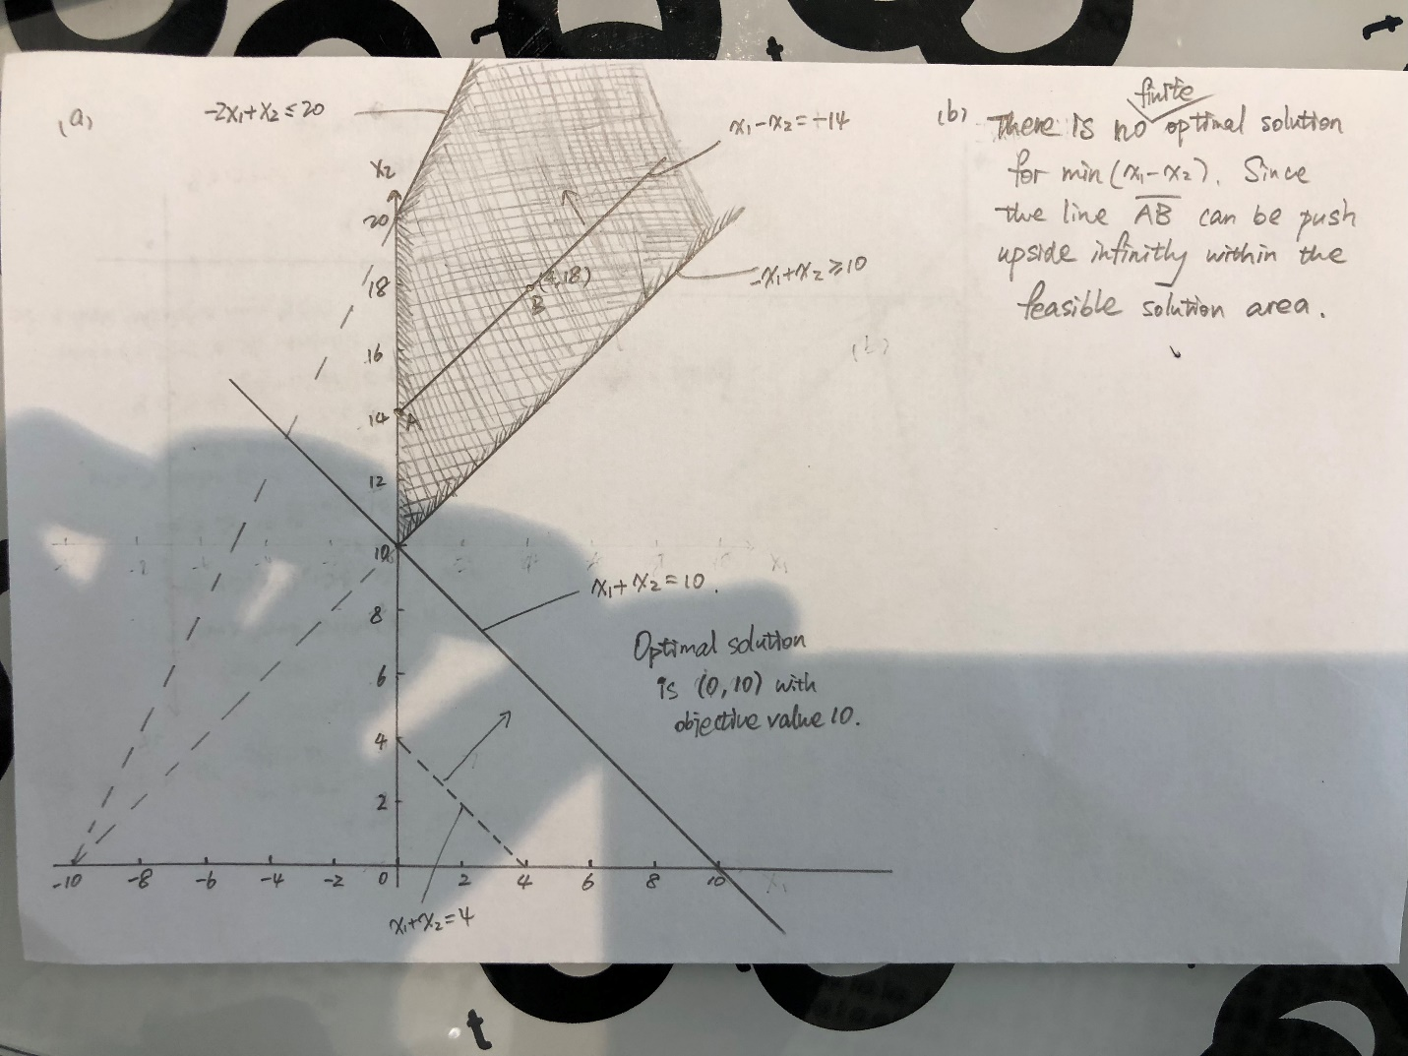

The Optimal solution is (0, 10) with objective value 10.

1. There is no finite optimal solution for min(x1-x2) since the line AB can be push upside infinitely within the feasible solution area.

Question 4:

