Optimization Method HW9 Student: Ang Zhou

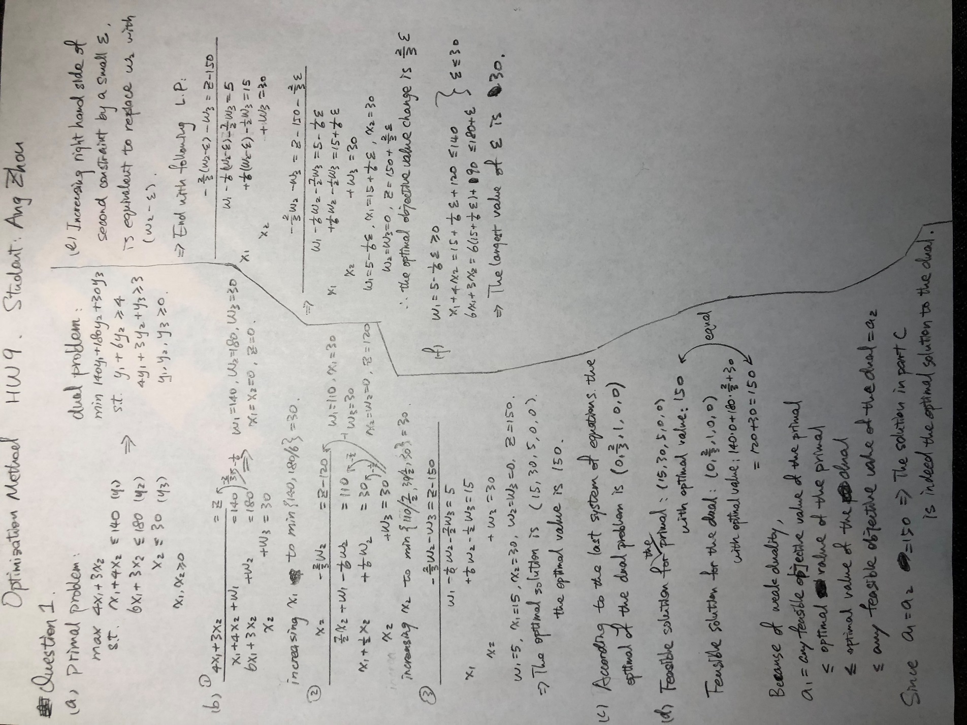

(g) ε= 6, set the second constrain from 180 to 180+6 = 186.

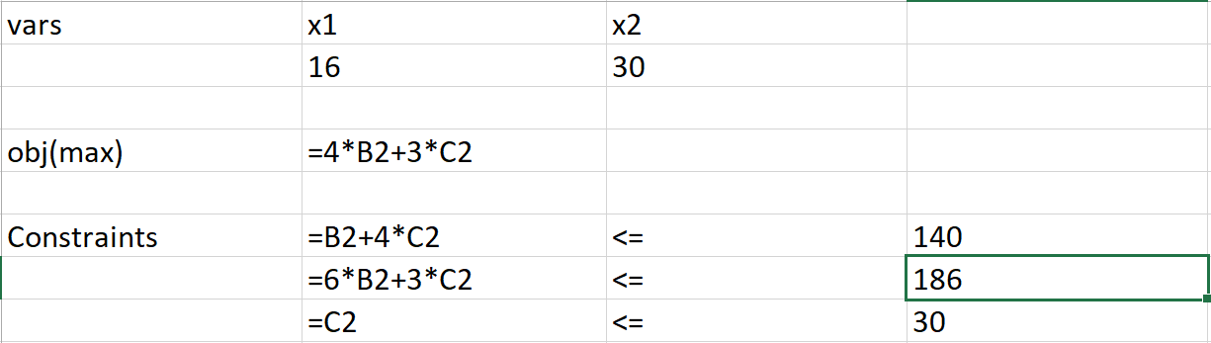

Get optimal solution: (16,30) with objective value goes to 154.

The optimal objective value increased by 4, which matches the conclusion from Part e. (2/3)\*6 = 4.

(h) ε= 36, set the second constrain from 180 to 180+36 = 216.

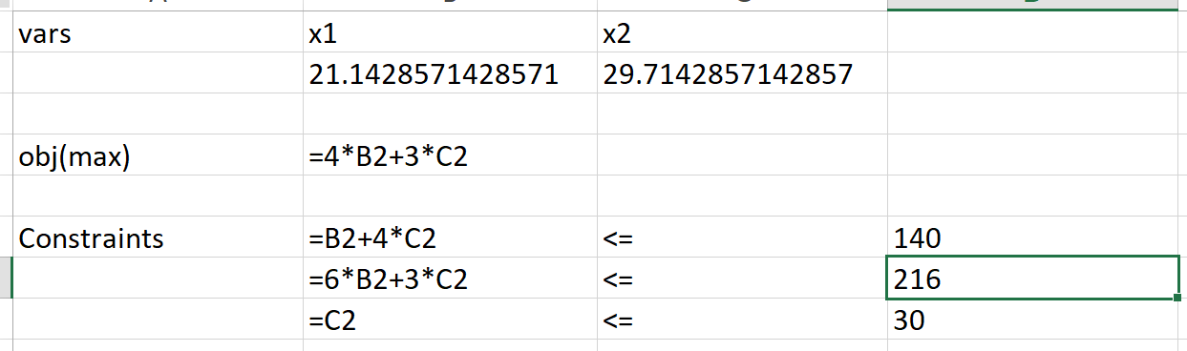

Get optimal solution: (21.14286, 29.71429) with optimal objective value: 173.7143

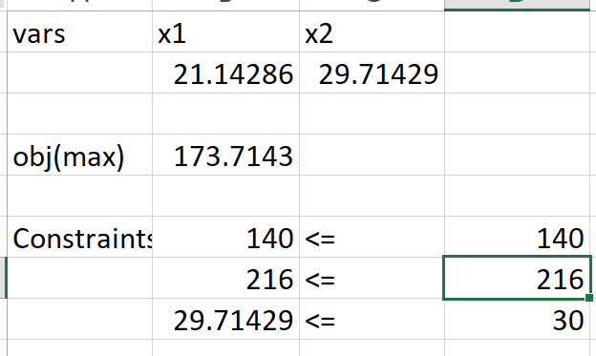

The objective value increased by 23.7143.

Since as what is said in part f, the largest ε is 30 in order to follow the conclusion of part e. When εis larger than 30, in this case is 36, then it will not follow the rule of the optimal objective value change in part e.