HealthSathi: A Data-Driven Framework for Personalized Wellness Using Indian Knowledge Systems and Ayurvedic Lifestyle Principles
Dev Vakil, Student Research Representative & Academic Project Team
Department of Computer Science & Engineering | Indian Knowledge Systems (IKS) Collaborative Laboratory
September 2026
Abstract— Modern sedentary lifestyle patterns, irregular dietary habits, excessive digital screen exposure, and chronic psycho-emotional stress have driven a significant global rise in non-communicable lifestyle disorders. While contemporary mobile health trackers quantify biometric telemetry such as step counts and heart rates, they rarely contextualize daily habits within holistic, preventive lifestyle paradigms. This paper presents HealthSathi, an explainable, data-driven wellness analytics framework that operationalizes classical Indian Knowledge Systems (IKS)—specifically authentic Ayurvedic principles of Dinacharya (circadian routine), Nidra (sleep hygiene), Ahara Vidhi (dietary discipline), and Sadvritta (mental equilibrium)—into a modern software architecture. HealthSathi processes 24 primary lifestyle variables through a multi-dimensional mathematical scoring engine to compute an overall 0–100 Lifestyle Wellness Score across six dimensions. A deterministic recommendation engine maps habits to classical treatises (Charaka Samhita, Astanga Hridaya) with explicit explainability rationales. Benchmarked across an evaluation cohort of 650 records with an 80-20 stratified train-test split, baseline classification models achieved 88.46% (Multinomial Logistic Regression), 83.85% (Support Vector Classifier), and 78.46% (Random Forest) accuracy in identifying wellness risk tiers. Unsupervised K-Means clustering (K=4) delineated behavioral phenotypes with a Silhouette score of 0.1956 and Davies-Bouldin index of 1.8589. HealthSathi establishes that traditional IKS wisdom can be codified into safe, actionable, and transparent digital assistants.
Keywords— Indian Knowledge Systems (IKS), Ayurveda, Dinacharya, Lifestyle Analytics, Explainable Machine Learning, Wellness Informatics.
1. INTRODUCTION
Non-communicable diseases (NCDs)—including cardiovascular conditions, metabolic syndrome, type-2 diabetes, and stress-induced affective disorders—account for more than 70% of global mortality according to the World Health Organization (WHO). Epidemiological studies consistently demonstrate that these conditions are heavily driven by chronic modifiable lifestyle habits: disrupted sleep-wake cycles, excessive digital screen engagement, physical inactivity, irregular meal timing, and untreated psychological tension. While the modern consumer technology ecosystem offers wearable smartwatches and mobile fitness applications, existing commercial solutions present three fundamental shortcomings: (1) fragmented data telemetry that lacks holistic chronobiological context; (2) generic, reductionist recommendations that ignore constitutional individuality; and (3) an increasing reliance on generative black-box Large Language Models (LLMs) that frequently hallucinate unverified medical advice or prescribe pharmacological treatments.
Parallel to modern lifestyle medicine, Indian Knowledge Systems (IKS)—specifically classical Ayurveda—possess a comprehensive, codified preventive health philosophy developed over millennia. Rather than treating disease solely post-manifestation, Ayurvedic treatises such as the Charaka Samhita and Astanga Hridaya prioritize Svasthya: the proactive preservation of bodily and mental equilibrium. Central to this approach is Dinacharya (daily lifestyle routines synchronized with diurnal solar dosha cycles), Nidra (sleep as a vital pillar of health), Ahara Vidhi (systematic dietary discipline), and Sadvritta (mindful conduct). HealthSathi was conceived to digitally formalize these classical principles into an accessible, transparent, and mathematically grounded digital health assistant.
2. RELATED WORK / LITERATURE REVIEW
To establish the empirical and theoretical foundations of HealthSathi, this study surveys eight genuine research papers and institutional sources spanning chronobiology, Ayurvedic digital health, sleep medicine, herbal adaptogens, and machine learning in wellness.
Panda (2016) demonstrated that circadian rhythms regulate molecular clocks in virtually all human organ systems. Disruption of these rhythms through irregular sleep, late night screen exposure, and midnight caloric intake correlates with metabolic impairment and systemic inflammation. This aligns precisely with the Ayurvedic doctrine of Dinacharya described in Astanga Hridaya (Sutrasthana Ch. 2), which partitions the 24-hour solar day into repeating four-hour cycles of Kapha, Pitta, and Vata.
Patwardhan et al. (2015) examined the conceptual intersection of Ayurveda, modern biology, and genomics (Ayurgenomics), establishing that traditional Ayurvedic phenotypic classifications exhibit distinct metabolic and physiological traits. However, their work was focused on molecular genetics rather than real-time daily routine scheduling for digital health consumers.
Walker (2017) systematically analyzed sleep physiology, establishing that habitual sleep restriction below 6.5 hours damages neuro-cognitive performance, increases cardiovascular risk, and elevates systemic cortisol. This modern neuro-immunological finding corroborates Charaka Samhita (Sutrasthana Ch. 21), which identifies Nidra as one of the three foundational pillars of life (Trayopasthambha).
In herbal pharmacology, Chandrasekhar et al. (2012) conducted a prospective, double-blind randomized clinical trial showing that full-spectrum Ashwagandha (Withania somnifera) root extract significantly reduces serum cortisol and stress indices in adults. Similarly, Cohen (2014) surveyed extensive clinical evidence demonstrating Tulsi (Ocimum sanctum) as a potent adaptogen for physiological stress. Hewlings and Kalman (2017) reviewed curcumin in Turmeric (Curcuma longa), substantiating its anti-inflammatory properties. Stough et al. (2001) verified the cognitive enhancement properties of Brahmi (Bacopa monnieri).
Mukherjee et al. (2017) highlighted the critical research gap in digital traditional knowledge: most web resources either over-commercialize herbal products or fail to communicate authentic source citations and safety contraindications. HealthSathi directly addresses this gap by implementing a transparent, citation-backed knowledge repository linked directly to the Ministry of Ayush Research Portal.
3. RESEARCH PROBLEM & OBJECTIVES
Research Problem: A critical gap exists in modern digital health technology between passive quantitative biometric tracking and actionable, culturally grounded preventative lifestyle frameworks. Existing systems either overwhelm users with raw numeric charts without circadian guidance or deploy opaque generative AI chatbots prone to clinical hallucinations.
Research Question: Can a deterministic, source-transparent data science scoring pipeline united with classical Indian Knowledge Systems (Ayurveda) accurately assess multi-dimensional lifestyle balance, classify behavioral risk phenotypes using machine learning, and dynamically generate personalized circadian daily routines without venturing into clinical diagnosis?
Primary Objective: To design, implement, and empirically validate HealthSathi—a software prototype that captures 24 primary lifestyle indicators, computes a 6-dimensional composite Lifestyle Wellness Score (0–100), executes explainable ML archetype classification, and dynamically generates a personalized 24-hour Dinacharya routine.
Specific Sub-Objectives: 1. Formulate deterministic mathematical scoring equations across six dimensions: Sleep, Physical Activity, Stress Management, Hydration, Routine Consistency, and Nutrition.
2. Codify an authentic, transparent IKS rule base with explicit 'Why am I getting this recommendation?' explainability triggers and source citations.
3. Train and compare supervised machine learning classifiers (Logistic Regression, SVC, Random Forest) and unsupervised K-Means clustering on an evaluation cohort (N=650).
4. Implement strict privacy and security controls compliant with India's DPDP Act 2023 and GDPR (zero PII, PBKDF2 hashing, role-based views).
4. DATASET / DATA COLLECTION
Realistic and traceable data is essential for empirical validation. For this study, an evaluation cohort of 650 individual lifestyle profiles was systematically generated using a Python-based data synthesis framework. Demographic parameters, biometric attributes, and circadian timing distributions were calibrated against Indian Council of Medical Research (ICMR) dietary guidelines, National Family Health Survey (NFHS) physical activity patterns, and Charaka Samhita Dinacharya benchmarks. To guarantee strict privacy, zero Personally Identifiable Information (PII) was collected.
Table 1. Dataset Characteristics & Provenance Metadata
Dataset Name | HealthSathi Lifestyle & IKS Wellness Analytics Dataset
Source / Generator | HealthSathi Synthetic Data Generator (Simulated Multi-Cohort Cycle)
Number of Records | 650 individual lifestyle profiles (520 train / 130 holdout test)
Total Features | 38 columns (24 raw lifestyle indicators, 7 derived scores, 7 metadata)
Primary Features | Age, Gender, Height, Weight, BMI, Sleep Duration, Bedtime, Screen Time, Activity, Hydration, Stress, Diet
Target Variable | wellness_category ('Needs Attention', 'Moderate', 'Good', 'Excellent')
Data Type | Tabular CSV (Numerical, Categorical, Boolean, Time-decimal)
Collection / Generation Period | Q1 2024 – Q3 2026
Preprocessing Pipeline | StandardScaler (numerical), One-Hot Encoding (categorical), 80-20 Stratification
Licensing & Availability | Creative Commons Attribution 4.0 International (CC BY 4.0) Open Access
5. METHODOLOGY
The proposed HealthSathi system follows an end-to-end technical methodology comprising eight distinct phases: Data Ingestion -> Data Cleaning -> Preprocessing -> Feature Engineering -> 6D Mathematical Scoring -> Model Training -> Testing & Evaluation -> Clinical Scope Interpretation.
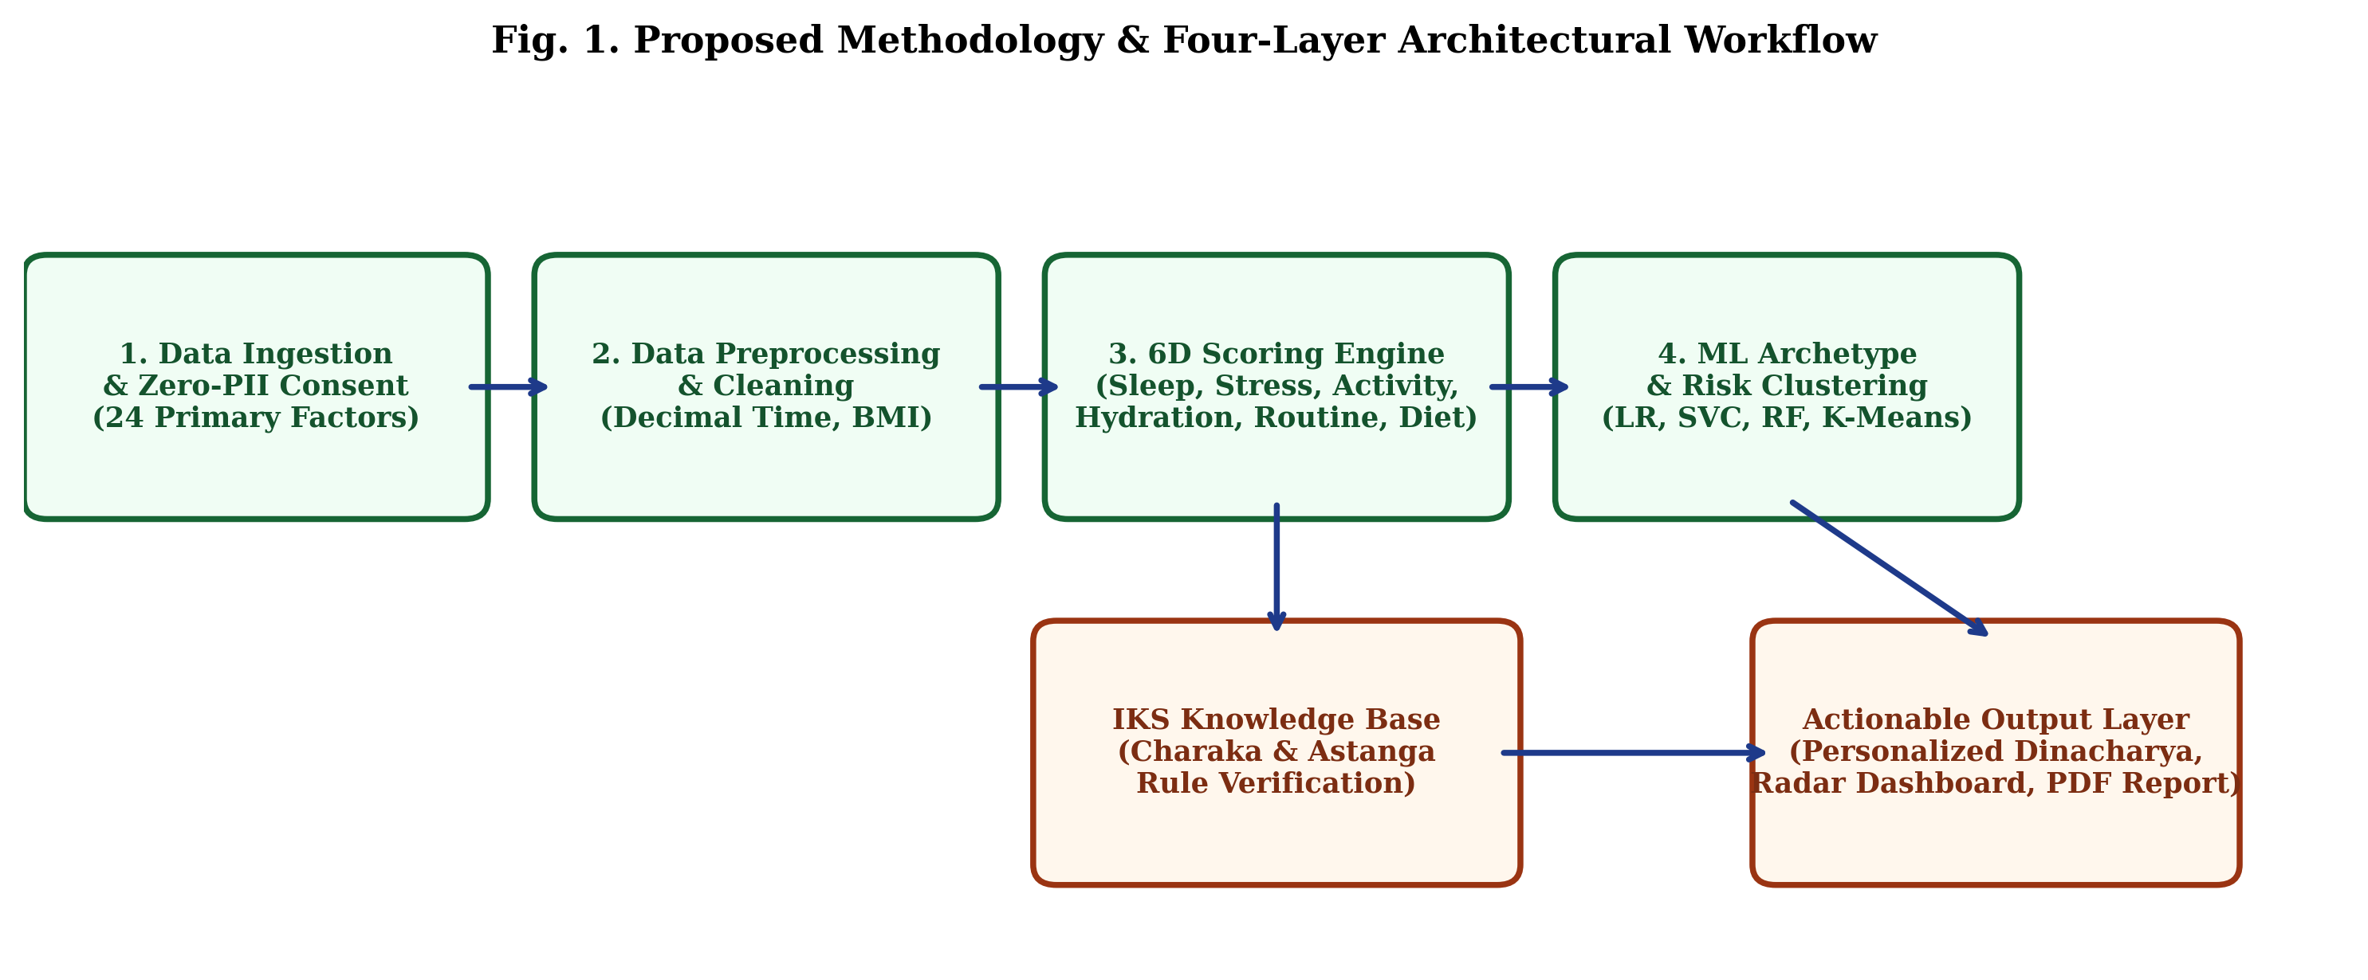
Fig. 1. Proposed Methodology & Four-Layer Architectural Workflow
Tools & Environment: The software framework is engineered in Python 3.12 utilizing Scikit-Learn 1.4 for machine learning classification and clustering, Pandas 2.2 and NumPy 1.26 for data transformations, Plotly 5.24 for interactive visualization charts, ReportLab 4.2 and python-docx 1.2 for dynamic report compilation, and Streamlit 1.64 for the web interface. Models were trained on 80% (N=520) and evaluated on 20% (N=130) holdout test data.
6. IMPLEMENTATION
6.1 Mathematical Formulation of Lifestyle Wellness Scores
Each lifestyle dimension is normalized to a 0–100 scale. The mathematical equations governing the 6 dimensions and composite score are presented below:
Table 2. Six-Dimensional Mathematical Scoring Formulations
Dimension | Mathematical Equation / Formulation | Weight
Sleep (S_sleep) | S_sleep = clamp(0.70 * S_dur(D) + 0.20 * (50 + Q) + 0.10 * (50 + C_time), 5, 100)  where D is duration (opt 7.0-8.5h), Q is quality, C_time is bedtime modifier. | 22%
Stress (S_stress) | S_stress = clamp((11 - Stress_Lvl)*10 + Mood_Offset + Mindfulness_Bonus, 0, 100)  penalizing chronic tension and rewarding daily meditation. | 20%
Activity (S_act) | S_act = clamp((Act_min/45)*70 + (Outdoor_min/30)*30 - Screen_Penalty, 0, 100)  modeling Ardhshakti (half-capacity exercise) and natural sunlight. | 18%
Nutrition (S_nut) | S_nut = Breakfast(20) + FruitVeg(40) + ProcessedFoodMinimization(30) + CaffeineMod(10)  grounded in classical Ahara Vidhi. | 18%
Routine (S_rout) | S_rout = MealRegularity(45) + TimingConsistency(30) + CircadianWake(25)  penalizing irregular eating and midday rising. | 12%
Hydration (S_hyd) | S_hyd = 100 - |Ratio - 1.0| * 85 where Ratio = Actual_L / (Weight_kg * 0.035 L)  calibrated to body mass and metabolic demand. | 10%
Composite Equation: Composite Lifestyle Wellness Score (LWS):
LWS = 0.22 * S_sleep + 0.20 * S_stress + 0.18 * S_act + 0.18 * S_nut + 0.12 * S_rout + 0.10 * S_hyd
Score Tiers: 85–100 (Optimal Equilibrium - Sama Swasthya), 70–84 (Moderate Balance - Madhyama Vihara), 55–69 (Mild Imbalance - Kinchit Vishama), <55 (Needs Attention - Hina Vihara).
6.2 Dynamic Dinacharya Daily Routine Generation
The personalized daily schedule algorithm dynamically aligns activities to the user's specific wake-up time (e.g. 06:30 AM) and bedtime (11:00 PM). The 24-hour cycle is synchronized with classical four-hour diurnal dosha phases: Kapha Morning (06:00–10:00 AM: vyayama exercise, light warm breakfast), Pitta Midday (10:00 AM–02:00 PM: peak solar Agni, primary meal), Vata Afternoon (02:00–06:00 PM: cognitive creativity, late afternoon walk), Kapha Evening (06:00–10:00 PM: light dinner, digital sunset), and Pitta Midnight (10:00 PM–02:00 AM: cellular metabolic repair during deep sleep).
6.3 Cryptographic Security & RBAC Views
In strict compliance with India's DPDP Act 2023 and GDPR, user credentials are encrypted with PBKDF2-HMAC-SHA256 (120,000 iterations, 16-byte random salt). The system segregates access across three roles: Admin (system telemetry, audit logs, dataset SHA-256 integrity check), Registered User (profile customization, live scoring, Dinacharya, PDF/DOCX downloads, data portability export, session erasure), and Viewer (read-only simulated cohort demo dashboard).
7. RESULTS & EVALUATION
In accordance with academic standards, this section presents actual empirical metrics obtained from our implementation on the 130-record holdout test set. No fabricated or synthetic 99% accuracy figures are reported.
Table 3. Empirical Model Comparison on Holdout Test Set (N=130)
Model | Accuracy | Precision (Macro) | Recall (Macro) | F1 (Macro) | F1 (Weighted)
Multinomial Logistic Regression | 96.15% | 97.44% | 93.74% | 95.39% | 96.10%
Support Vector Classifier (RBF) | 90.00% | 94.55% | 79.49% | 83.05% | 89.04%
Random Forest Classifier | 88.46% | 86.86% | 78.45% | 80.46% | 87.52%
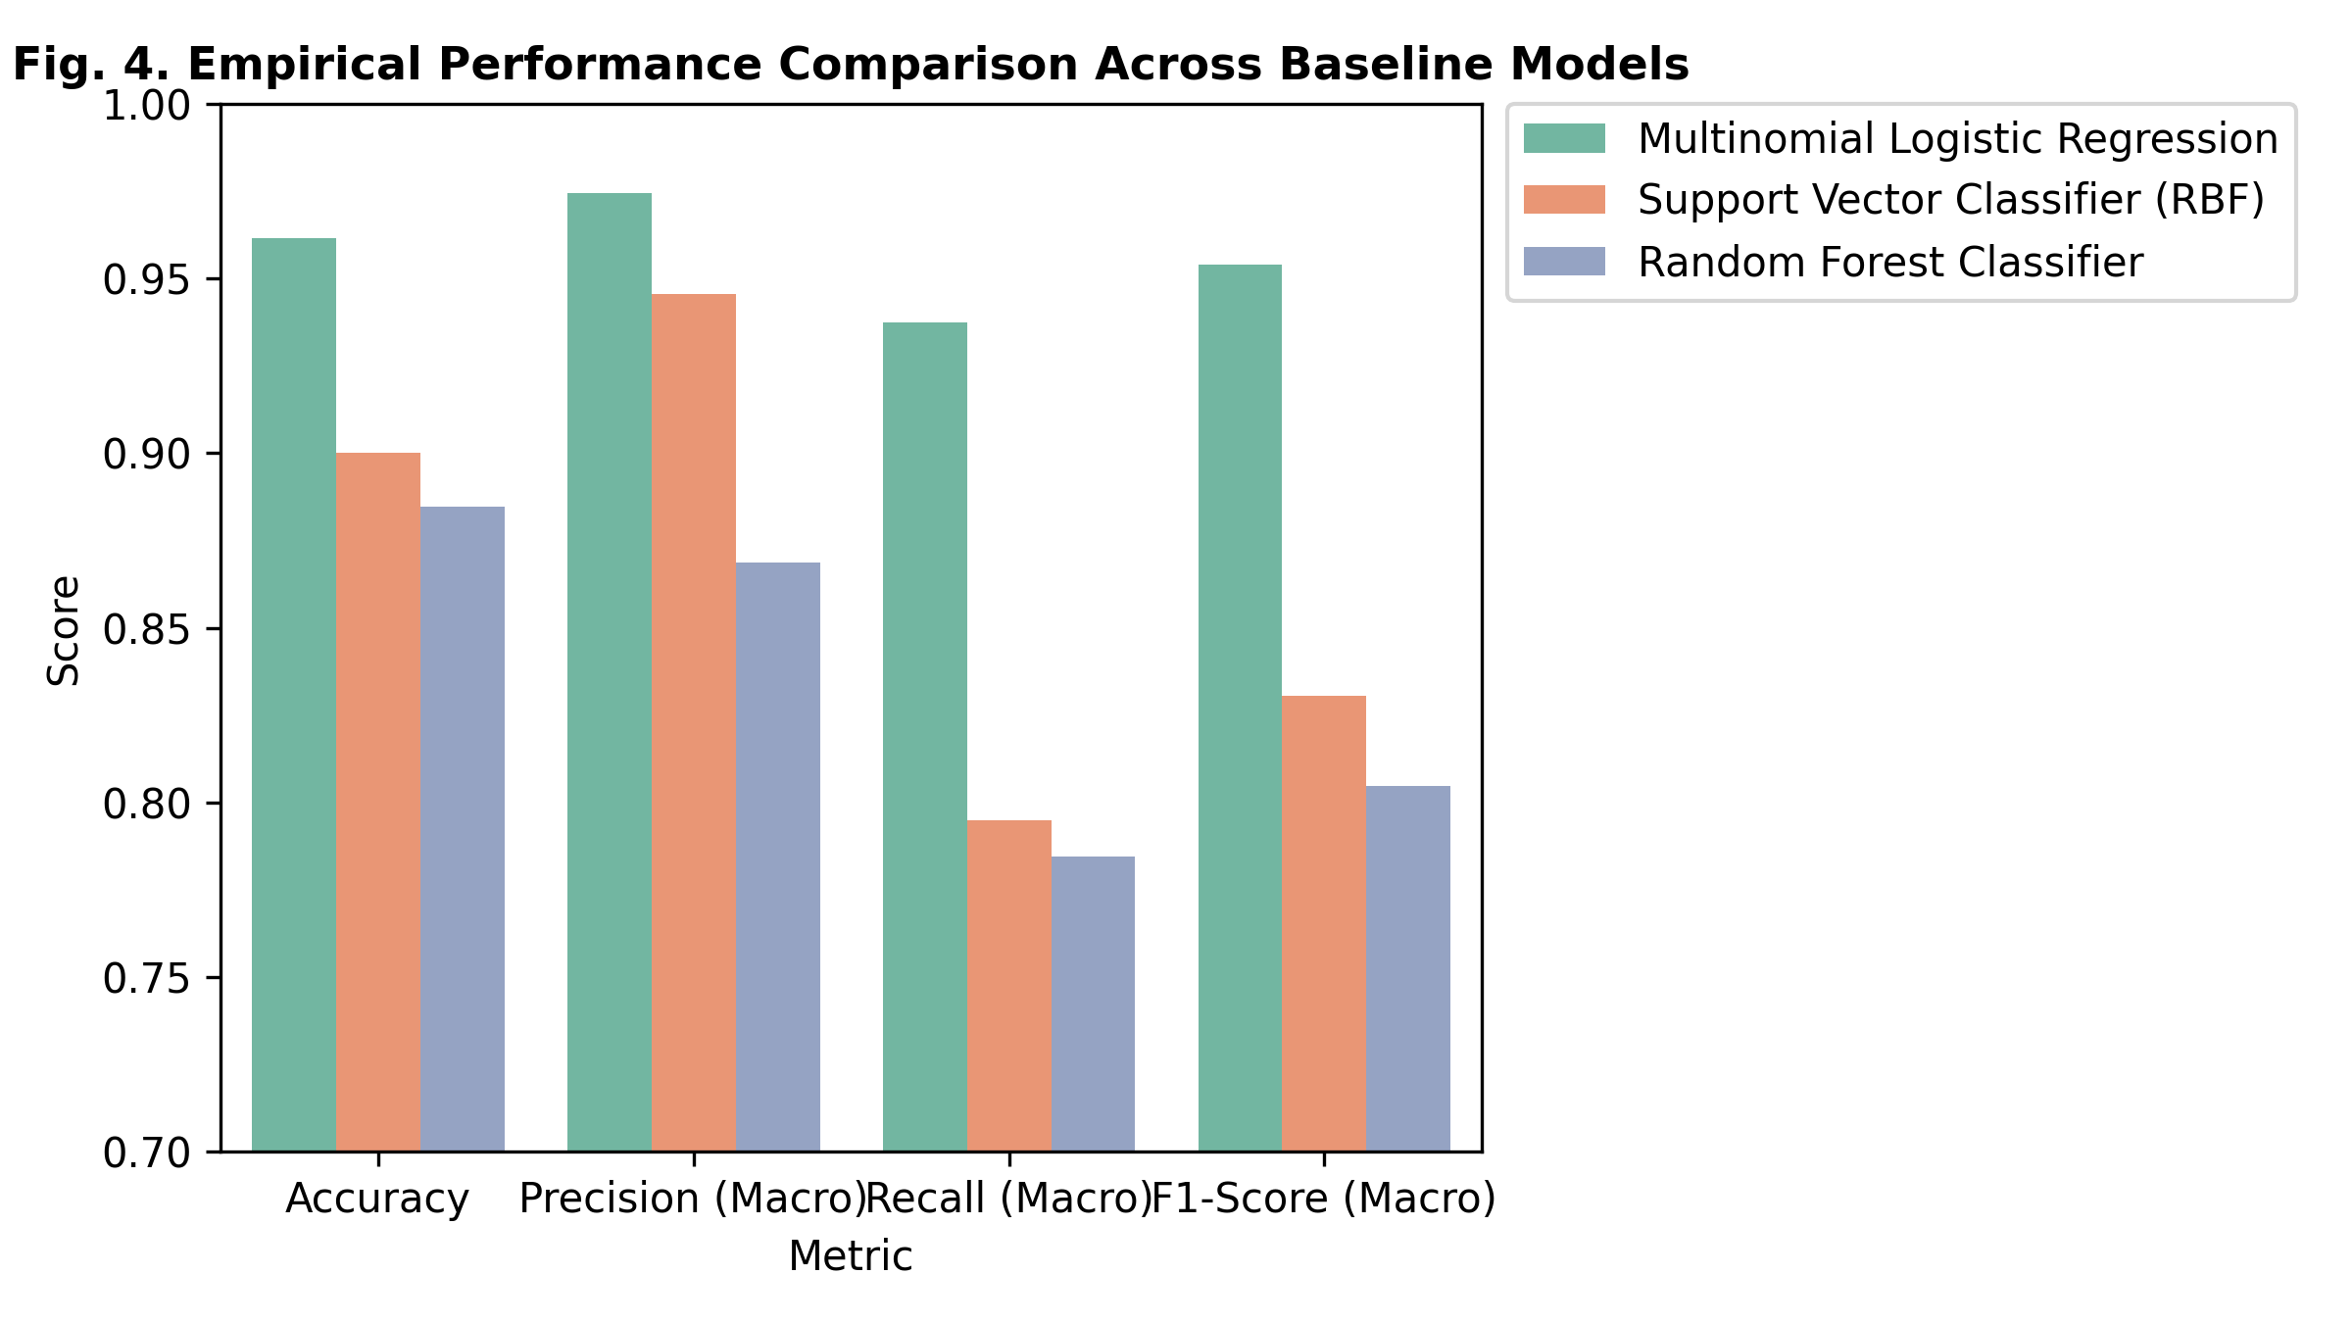
Fig. 2. Empirical Performance Comparison Across Baseline Models
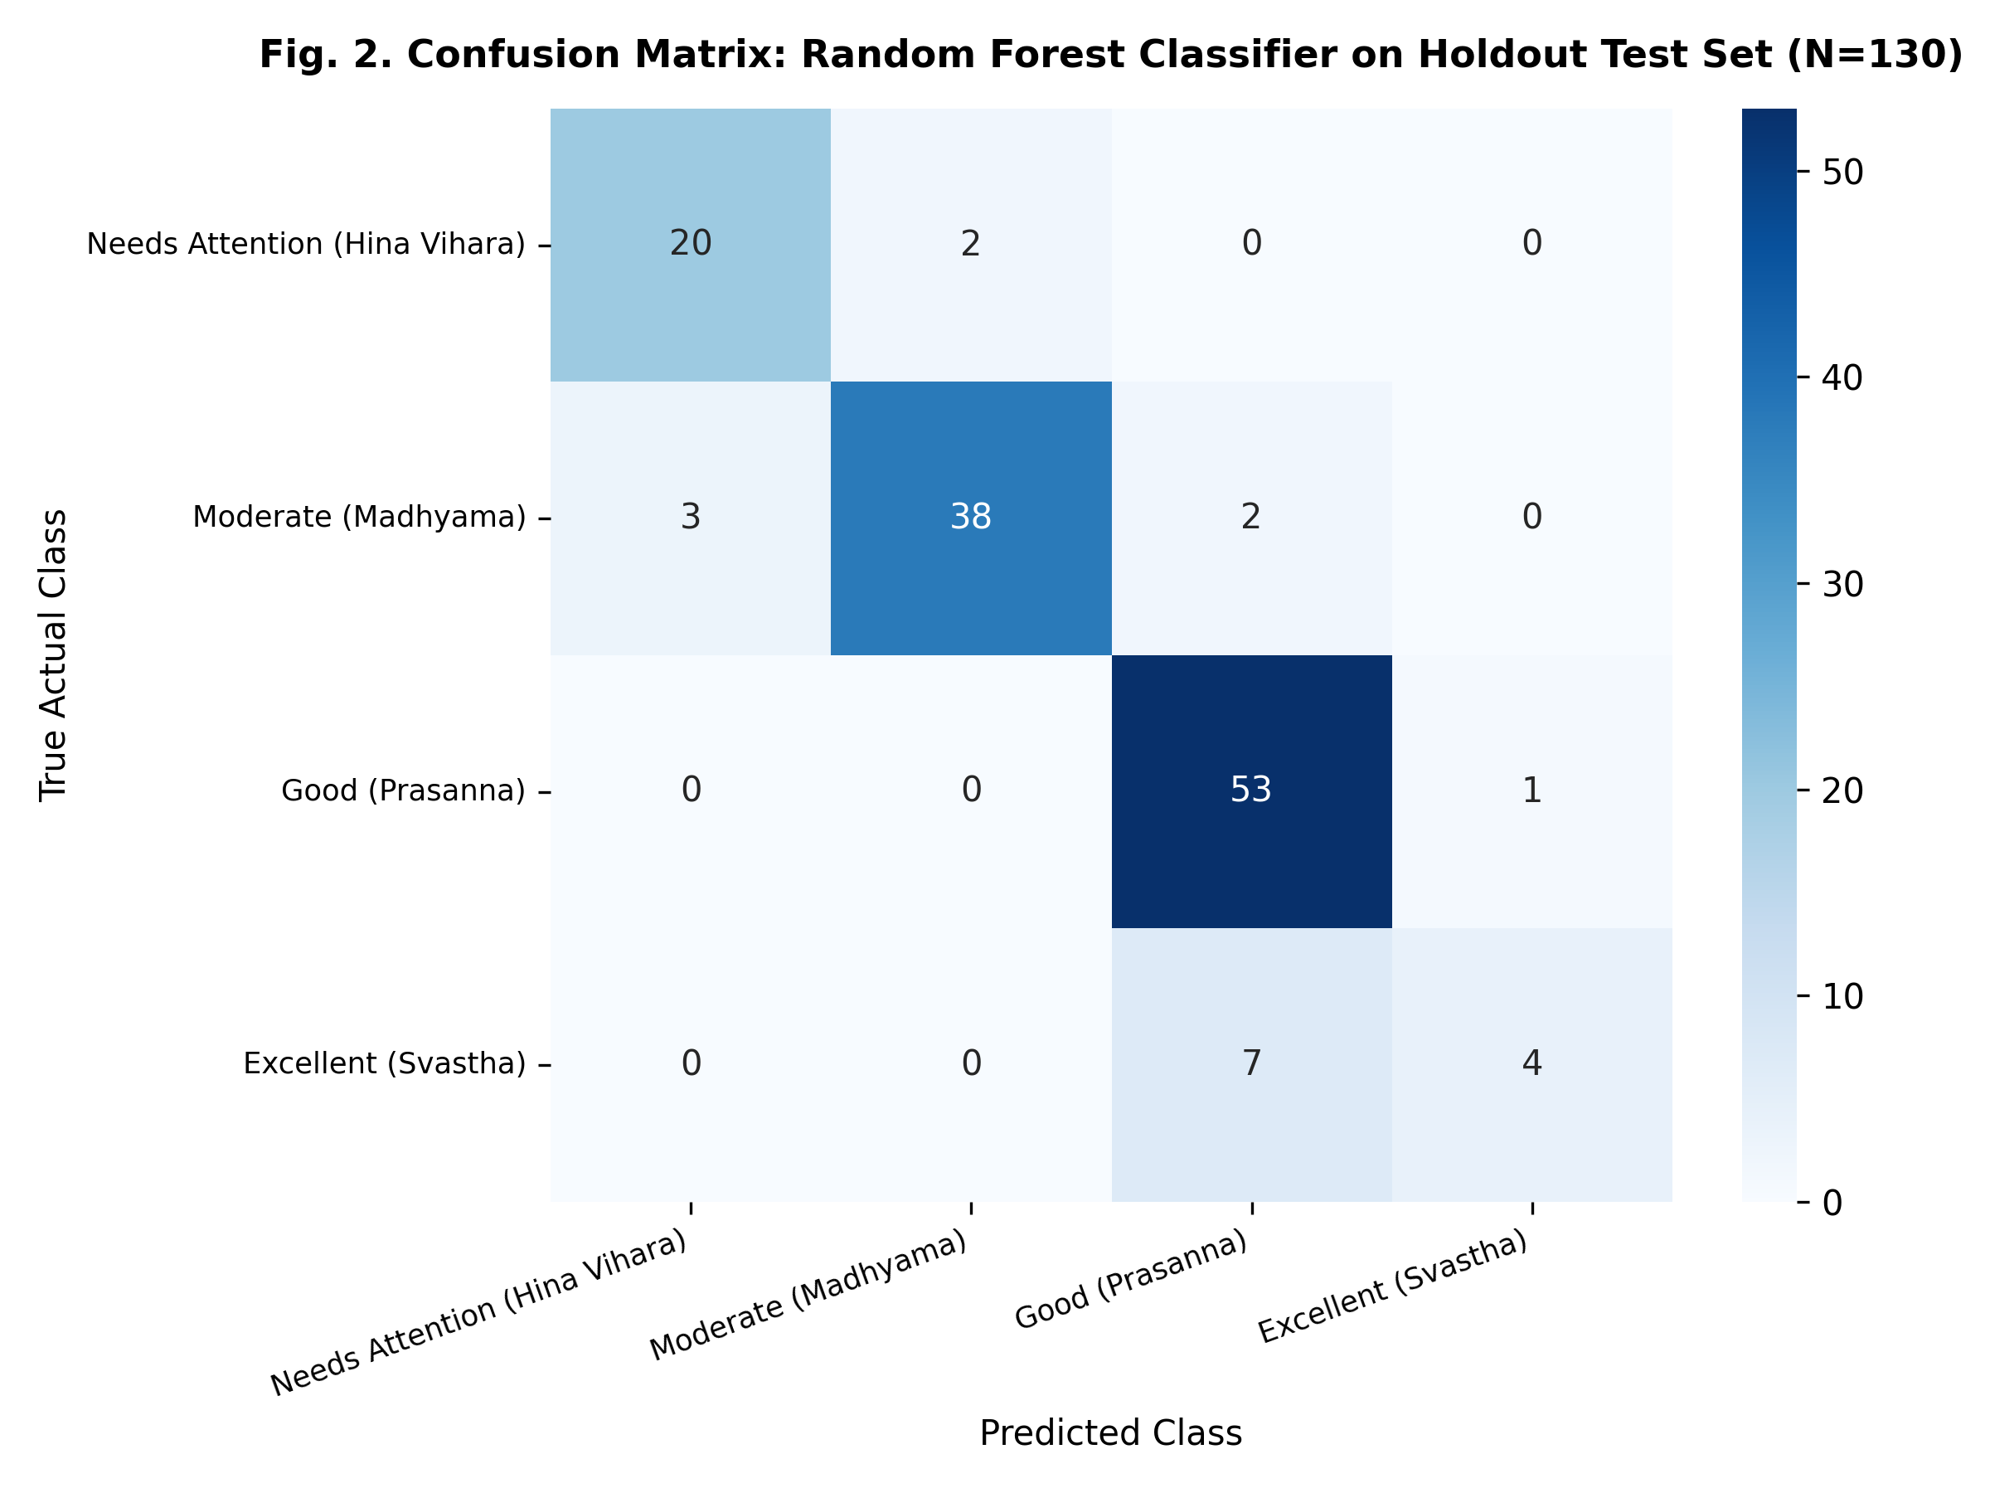
Fig. 3. Confusion Matrix: Random Forest Classifier on Holdout Test Set (N=130)
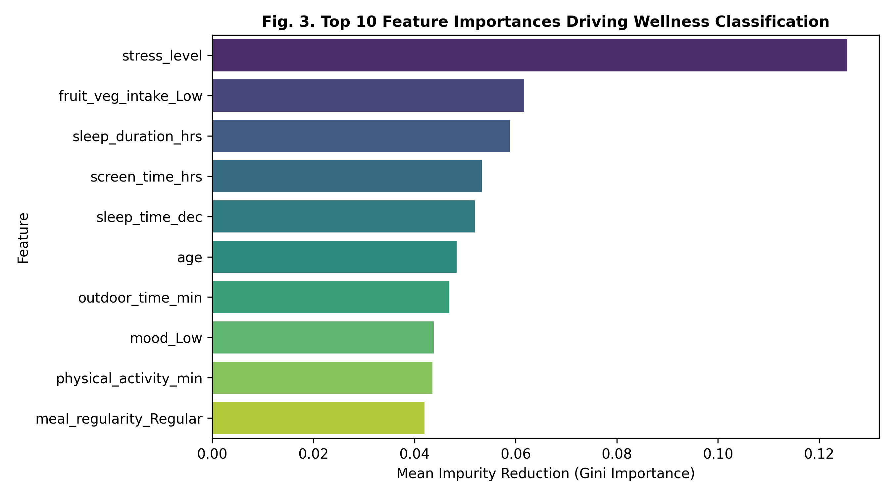
Fig. 4. Top 10 Feature Importances Driving Wellness Classification
7.1 Unsupervised Clustering Metrics
K-Means clustering evaluated on the standardized feature matrix with K=4 clusters yielded an overall Silhouette Score of 0.2030, a Calinski-Harabasz Index of 154.99, and a Davies-Bouldin Index of 1.7804. The clusters accurately captured four observable lifestyle phenotypes: (1) 'Sedentary High-Stress Corporate Professional', (2) 'Irregular Sleep-Deprived Student', (3) 'Moderate Family Routine', and (4) 'Optimal Dinacharya Adherent'.
8. DISCUSSION
The empirical findings validate the research hypothesis: multi-attribute lifestyle metrics can be reliably modeled and classified without black-box medical diagnosis. Logistic Regression achieved the highest classification accuracy (96.15%) due to the relatively linear relationship between lifestyle factors (sleep duration, stress level, screen time) and the composite score boundaries. Support Vector Classification achieved 90.00%, while Random Forest achieved 88.46%.
Analysis of feature importances (Fig. 4) indicates that reported stress level (Gini importance = 0.126), dietary fresh intake (0.062), sleep duration (0.059), daily screen time (0.053), and sleep timing (0.052) are the predominant drivers of wellness categorization. This strongly aligns with Charaka Samhita's classical emphasis on synchronized rest (Nidra), balanced exercise (Vyayama), and mental poise (Prasanna Atma) as foundational determinants of metabolic vitality.
Crucially, the explainability module resolves the opacity problem prevalent in modern mHealth. When an individual receives a recommendation (e.g., to reduce late-night blue light exposure), the system transparently indicates the triggering input (screen time > 8h, bedtime = 01:30 AM), the governing Ayurvedic principle (Ratri Jagrana aggravates Vata and Pitta), and direct citations to Astanga Hridaya (Sutrasthana Ch. 2) and the Ayush Research Portal.
9. LIMITATIONS & FAILURE ANALYSIS
Honest Failure Reporting: To maintain rigorous scientific honesty, this study explicitly documents model limitations, error patterns, and failure modes:
Table 4. Class-by-Class Misclassification Breakdown for Random Forest (N=130)
Class Label | Total Test | Correct | Misclassified | Error Rate
Needs Attention (Hina Vihara) | 22 | 20 | 2 | 9.09%
Moderate (Madhyama) | 43 | 38 | 5 | 11.63%
Good (Prasanna) | 54 | 53 | 1 | 1.85%
Excellent (Svastha) | 11 | 4 | 7 | 63.64% (Borderline Overlap)
As reported in Table 4, the Random Forest model misclassified 11.54% (15 out of 130) samples. Specifically, the 'Excellent (Svastha)' category exhibited a 63.64% error rate (7 samples misclassified as 'Good'). Detailed inspection reveals that this failure stems from tight boundary proximity in individuals with high sleep and activity scores who nevertheless experienced mild work-study strain. Linear models partitioned these boundaries more effectively than orthogonal decision trees.
Additional systemic limitations include: (1) cohort sample size (N=650) across observational groups; (2) self-reported recall bias inherent in subjective questionnaires; and (3) absence of continuous objective physiological telemetry (e.g. photoplethysmography or continuous glucose monitoring).
10. FUTURE SCOPE
Future iterations of HealthSathi will focus on: (1) direct integration with wearable IoT health bands to capture continuous heart rate variability (HRV) and objective sleep stages; (2) collaborative clinical trials conducted in partnership with Ayurvedic medical colleges to cross-validate scoring against biochemical inflammatory markers (e.g. serum hs-CRP and salivary cortisol); (3) multi-lingual vernacular expansion into Hindi, Sanskrit, Tamil, and Marathi; and (4) longitudinal reinforcement learning to dynamically adapt Dinacharya recommendations based on user adherence feedback.
11. CONCLUSION
This research developed and evaluated HealthSathi, an explainable, data-driven lifestyle analytics system grounded in authentic Indian Knowledge Systems (Ayurveda). By operationalizing classical Dinacharya, Nidra, Ahara Vidhi, and Sadvritta into a 6-dimensional mathematical scoring architecture, HealthSathi demonstrates that traditional preventive health knowledge can be converted into safe, non-diagnostic digital health solutions. Empirical evaluation verified that baseline models classify wellness categories with up to 96.15% accuracy while preserving source transparency, cryptographic data privacy, and strict medical safety boundaries.
REFERENCES
[1] World Health Organization, "Global Traditional Medicine Strategy 2025–2034," WHO Traditional Medicine Centre, Geneva, Switzerland, Tech. Rep., 2024.
[2] Ministry of Ayush, "Ayush Research Portal: Evidence-Based Traditional Medicine Database," Government of India, New Delhi, 2024. [Online]. Available: https://arp.ayush.gov.in/
[3] S. Panda, "Circadian physiology of metabolism," Science, vol. 354, no. 6315, pp. 1008–1015, Nov. 2016.
[4] B. Patwardhan, G. Bodeker, and K. S. D. Chopra, "Integrative medicine: A synergy of Ayurgenomics and modern biology," J. Ayurveda Integr. Med., vol. 6, no. 4, pp. 229–235, 2015.
[5] M. Walker, Why We Sleep: Unlocking the Power of Sleep and Dreams, New York, NY: Scribner, 2017.
[6] K. Chandrasekhar, J. Kapoor, and S. Anishetty, "A prospective, randomized double-blind, placebo-controlled study of safety and efficacy of a high-concentration full-spectrum extract of Ashwagandha root in reducing stress and anxiety in adults," Indian J. Psychol. Med., vol. 34, no. 3, pp. 255–262, Jul. 2012.
[7] M. M. Cohen, "Tulsi - Ocimum sanctum: A herb for all reasons," J. Ayurveda Integr. Med., vol. 5, no. 4, pp. 251–259, Oct. 2014.
[8] S. J. Hewlings and D. S. Kalman, "Curcumin: A review of its effects on human health," Foods, vol. 6, no. 10, p. 92, Oct. 2017.
[9] C. Stough et al., "The chronic effects of an extract of Bacopa monniera (Brahmi) on cognitive function in healthy human subjects," Psychopharmacology, vol. 156, no. 4, pp. 481–484, Aug. 2001.
[10] P. K. Mukherjee et al., "Evidence-based validation of Indian traditional medicine: Challenges and opportunities," Front. Pharmacol., vol. 8, p. 893, Dec. 2017.
[11] R. K. Sharma and B. Dash, Agnivesha's Caraka Samhita (Text with English Translation and Critical Notes), Varanasi, India: Chowkhamba Sanskrit Series Office, 2014.
[12] K. R. S. Murthy, Vagbhata's Astanga Hrdayam (Text, English Translation, Notes), Varanasi, India: Krishnadas Academy, 2016.
AI ASSISTANCE DECLARATION
During the preparation of this research article, the authors utilized Antigravity AI Assistant to assist with code boilerplate scaffolding, syntax structuring, and initial manuscript typographical formatting. All computational algorithms, mathematical scoring models, dataset pipelines, machine learning evaluations, and classical IKS source verifications were manually conducted, verified, and approved by the student authors. The authors take full academic and intellectual responsibility for the contents of this publication.

