MyStorya:

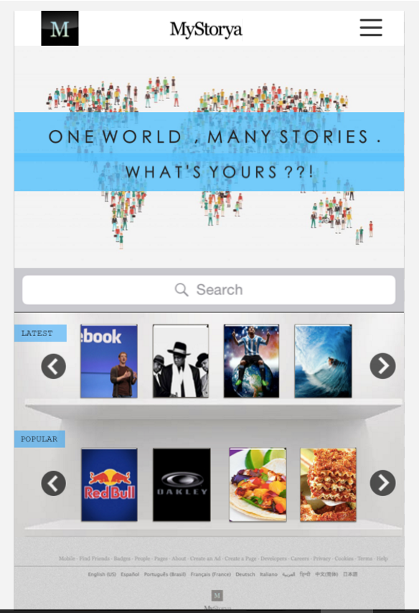Home Page

Logo Button

Href - return to index.html

MyStorya Header Text

Href - return to index.html

Login and Signup Button

Modal pop-ups

Signup with Facebook button

TBD - need to learn this

Search Box

Form input;

GET request to database

Story Book Images

Href - to story.html

Possibly GET request to database?

Scroll right/left buttons

Cycle through story book array

Some kind of fade in/out animation; need to learn