Progettazione e realizzazione di una dashboard per il monitoraggio di rete

Introduzione
Motivo: trovare un argomento inerente alle reti che trovi spazio in uno scenario professionale (es: fornitori cloud, ISP, monitoraggio di una grande rete interna aziendale o di ateneo).
Idea iniziale: monitorare il piano dati (packet inspection). Scartata perché non fattibile con gli strumenti scelti. Passati al monitoraggio degli apparati di rete, in particolare lo stato del protocollo OSPF. Perché OSPF? Molto usato nelle reti medio-grandi.
Questo può avere spunti per l’introduzione:
https://grafana.com/blog/a-beginners-guide-to-network-monitoring-with-grafana-and-prometheus/

Presentazione dell’argomento di tesi
Perché? In un’azienda con un’infrastruttura di rete medio-grande è fondamentale poter visualizzare facilmente lo stato della rete. Sono vari i fattori importanti da monitorare: consumo delle risorse, raggiungibilità dei servizi, carico computazionale, sulla memoria e di traffico, sui server e sugli apparati di rete. Ma perché serve il monitoraggio? Se ci sono porblemi di rete, si hanno disservizi ai clienti, il personale dell’azienda sarebbe limitato o impossibilitato ad accedere a servizi, locali o remoti, necessari per svolgere il proprio lavoro. E quindi se monitoro che migliora? Che sono in grado di rilevare prima se ci sono anomalie che interferiscono con il corretto funzionamento della rete; che posso rendermi conto se è necessario un upgrade hardware e di quali nodi.
Qui ci focalizziamo sullo stato degli apparati di rete, in particolare dei router. Sugli apparati di routing è importante controllare:
-

Dashboard
https://www.tableau.com/dashboard/what-is-dashboard
Finding the most important data and formatting it in a way that’s easy to understand.
Data visualization is the graphical representation of information and data. By using visual elements like charts, graphs, and maps, data visualization tools provide an accessible way to see and understand trends, outliers, and patterns in data.
When we see a chart, we quickly see trends and outliers.
A dashboard is a way of displaying various types of visual data in one place. Usually, a dashboard is intended to convey different, but related information in an easy-to-digest form.
Data visualization is a way of presenting data in a visual form to make it easier to understand and analyze.
Data dashboards are a summary of different, but related data sets, presented in a way that makes the related information easier to understand. Dashboards are a type of data visualization, and often use common visualization tools such as graphs, charts, and tables.

Monitoraggio di rete
https://www.ibm.com/think/topics/network-monitoring
Dal link sopra:
What is network monitoring?
Network performance monitoring (NPM) systems.
A network monitoring system watches for malfunctioning network devices and overloaded resources.
A key feature of NPM software is alerting network administrators when a performance issue is spotted.
One method of monitoring for performance issues and bottlenecks is configuring thresholds, so that you receive instant alerts when there is a threshold violation.
Why is network monitoring necessary?
Network failures can lead to business disruptions, which can mean a loss of customers, employee productivity and money.
Investing in network monitoring software, whether commercial or open source, means taking a proactive approach to keeping your network infrastructure healthy and maximizing uptime. This approach prevents waiting for an end-user to report network problems.
Infrastructure monitoring lets you know precisely where a network problem occurs, allowing for troubleshooting before the situation leads to an outage.
... reduce response time...
Types of network monitoring tools
There are three primary types of network monitoring tools.
1. SNMP-based tools use Simple Network Management Protocol (SNMP) to interact with network hardware. These tools track the real-time status and use of resources, such as CPU stats, memory consumption, bytes transmitted and received, and other metrics. SNMP is one of the most widely used monitoring protocols, along with Microsoft Windows Management Instrumentation (WMI) for Windows servers and Secure Shell (SSH) for Unix and Linux servers.
2. Flow-based tools monitor traffic flow to provide statistics about protocols and users. Some also inspect packet sequences to identify performance issues between two IP addresses. These flow tools capture traffic flow data and send them to a central collector for processing and storage.
3. Active network monitoring solutions inject packets into the network and measure end-to-end reachability, round-trip time, bandwidth, packet loss, link utilization and more. By conducting and measuring real-time transactions from a user’s perspective, these solutions enable faster and more reliable detection of outages and performance degradation.
There are also both agent and agentless network monitoring methods. Agent-based monitoring involves installing an agent, a small application or piece of software, onto the monitored device. Agent-less monitoring (using SNMP and SSH protocols) requires no installation; instead, network monitoring software logs directly into the monitored device.
How network monitoring tools work
When using a network monitoring tool, the first step is to determine which network devices to monitor and establish performance metrics. Then, decide on a monitoring interval that makes sense for your situation.
Methods can be as simple as a ping to ensure that a host is available. They can also be more extensive, such as monitoring firewall access, bandwidth usage, resource consumption, uptime and unexpected changes in network traffic.
These tools offer visualization of the entire network infrastructure with customizable dashboards. The dashboards provide real-time performance graphs and other reports showing how the components look and whether there are unusual parameters requiring further investigation.
Benefits of network monitoring systems
The primary benefit of network monitoring tools is straightforward and easy-to-understand visibility into an entire network’s connected devices and how data moves between them. Modern network performance monitoring systems provide baseline information that lets you automatically compare data and identify any network performance degradation. Seeing all this information on a dashboard means that your network administrators can quickly pinpoint issues anywhere within the network, identify the root cause, and determine who needs to fix it.
Detecting an issue earlier means you can troubleshoot and fix it much faster, saving time and money. Network performance monitoring also provides historical data and allows the troubleshooting of past network problems so you can avoid similar issues in the future.
The difference between network monitoring and network security monitoring
Organizations use network security monitoring to protect a network from unauthorized access, misuse and theft. In contrast, a network monitoring solution is primarily used to optimize network availability and overall performance.
Having visibility into and knowing how your network works can bring attention to early signs of compromise or attack. When network monitoring software points to performance anomalies, your IT team can more easily identify network threats and address data breaches and other attacks.
--------------------
Da docu grafana (https://grafana.com/docs/grafana/latest/fundamentals/intro-to-prometheus/#what-is-prometheus):
“Observability focuses on understanding the internal state of your systems based on the data they produce, which helps determine if your infrastructure is healthy.”
“[riguardo grafico read-write disk] Data like these form time series. The X-axis is a moment in time and the Y-axis is a number or measurement. [...] This data is simply some measurement (such as a company stock price or Disk I/O) through a series of time instants.”
“Why this is valuable
Software and systems are a difficult business. Sometimes things go wrong. Observability helps you understand a system’s state so that issues can be quickly identified and proactively addressed. [...] The three pillars of observability are metrics, logs, and traces. Prometheus supports the metrics pillar. When software on a computer runs slowly, observability can help you identify whether CPU is saturated, the system is out of memory, or if the disk is writing at maximum speed so you can proactively respond”
-----------------------
wiki:
“Observability is a measure of how well internal states of a system can be inferred from knowledge of its external outputs”
--------------------------
IBM (https://www.ibm.com/think/topics/observability):
“Observability is the ability to understand the internal state or condition of a complex system based solely on knowledge of its external outputs, specifically its telemetry.”
Telemetry is the automated collection and transmission of metrics, events, logs, and traces from your systems for monitoring and analysis. (https://www.logicmonitor.com/blog/what-is-telemetry)
-----------------------

Altre risorse da guardare:
- https://en.wikipedia.org/wiki/Network_monitoring
- https://www.paessler.com/lp/network-monitoring-tool?utm_term=network%20monitoring&utm_campaign=378524009&utm_content=&utm_source=google&utm_medium=cpc&utm_adgroup=25143705929&utm_device=c&gad_source=1&gad_campaignid=378524009&gbraid=0AAAAADmqWMjxmoCxZQZmWc1piVC37mU8Q&gclid=EAIaIQobChMI1NnEu6fLlgMVvplQBh2QlSfnEAAYASAAEgKRZ_D_BwE#Network-Monitoring-FAQ

---------------------
Possibile accenno ai metodi di troubleshooting (es: divide et impera)

Finalità del progetto

Svolgimento

Secifiche tecniche
È stato delineato che il sistema sviluppato come prova di tesi avrebbe dovuto:
- permettere il monitoraggio dei nodi di una rete da un endpoint arbitrario, anche esterno alla rete stessa;
- memorizzare in modo centralizzato (ovvero in un nodo arbitrariamente scelto) le informazioni inerenti i pacchetti che attraversano le interfacce dei nodi monitorati, sia in ingresso che in uscita;
- elaborare le informazioni registrate tramite filtraggio per parametri e aggregazione;
- mostrare i dati elaborati attraverso un’interfaccia grafica raggiungibile dal web;
- permettere una selezione basata su certi parametri (es: identificativo del nodo) dei dati mostrati.
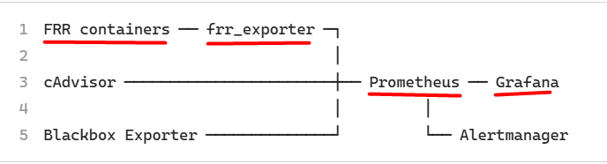

Strumenti
Da sito FRR (https://frrouting.org/):
“FRRouting (FRR) is a free and open source Internet routing protocol suite for Linux and Unix platforms. It implements BGP, OSPF, RIP, IS-IS, PIM, LDP, BFD, Babel, PBR, OpenFabric and VRRP, with alpha support for EIGRP and NHRP.

Containerlab
- Docker container
- FRR
--------------
Da docu containerlab:
“Containerlab provides a CLI for orchestrating and managing container-based networking labs. It starts the containers, builds a virtual wiring between them to create lab topologies of users choice and manages labs lifecycle”
“A topology definition deep-dive document provides a complete reference of the topology definition syntax. In this quickstart we keep it short, glancing over the key components of the file:
- Each lab has a name.
- The lab topology is defined under the topology element.
- Topology is a set of nodes and links between them.
- The nodes are always of a certain kind. The kind defines the node configuration and behavior.”

-----------------
da netpilot, what is containerlab (https://www.netpilot.io/blog/what-is-containerlab):
“What ContainerLab is great at
Network-as-code
Real NOS, real CLIs. These aren't simulations — show output matches production because you're running the actual network operating system
Free and open-source”
“The setup
A Linux host with Docker (and usually root) — ContainerLab doesn't run natively on macOS or Windows.
You still write every config. “
-------------------
da medium, network automation with containerlab (https://medium.com/@garykoys/network-automation-engineering-with-containerlab-45b24baa2c23):
“Unlike traditional VM-based simulators, Containerlab uses Docker containers to emulate network devices, which offers resource efficiency, rapid deployment, and vendor diversity.”
“Network topologies are defined declaratively using simple YAML files called topology definition files (.clab.yml), specifying nodes (devices), links (connections), and node types (vendor-specific images or generic Linux containers).”
“Containerlab automatically manages virtual wiring between containers and the host, creating a management network (default subnet 172.20.20.0/24) for device communication1”
-----------
da https://aws.amazon.com/compare/the-difference-between-docker-vm/:
“virtual machines (VMs) provide virtualization of an entire machine (server). A virtual machine emulates the hardware components of a physical machine, such as the CPU, memory, network interface card, USB controllers, and sound cards.”
“Docker containers have their own file system, dependency structure, processes, and network capabilities. The application has everything it requires inside the container and can run anywhere. Docker container technology uses the underlying host operating system kernel resources directly”
“Docker, on the other hand, was designed to provide a lightweight and portable way to package and run applications in an isolated and reproducible environment. Docker abstracts operating system...“
“Architecture
A virtual machine runs its own kernel and host operating system, along with applications and their dependencies like libraries and other binary files. A hypervisor coordinates between the hardware (host machine or server) and the virtual machine. It allocates the physical hardware resources outlined during instantiation to the virtual machine for its exclusive use. Multiple virtual machines can exist on a single powerful server, managed by a single hypervisor, with hundreds of applications running on each virtual machine.
A Docker container contains only its dependencies. The software Docker Engine powers virtualization in Docker. It provides coordination between running containers and the underlying operating system, whether it’s a physical or virtual machine.”
---------------
da wikipedia (https://en.wikipedia.org/wiki/Docker_(software)):
“Docker is a set of products that uses operating system-level virtualization to deliver software in packages called containers. Docker automates the deployment of applications within lightweight containers, enabling them to run consistently across different computing environments”
--------
da Claude (https://claude.ai/share/42f6f8ba-cc0f-4399-ada0-86c326cc3c1f):
Ecco un esempio minimale, pensato apposta per essere leggero da spiegare in documentazione — un router FRR e un host Linux generico collegati da un unico link:

yaml
name: esempio-rete # Nome del laboratorio. Containerlab lo usa come prefisso
# per i nomi dei container generati, es. "clab-esempio-rete-router1"

topology:
nodes:
router1: # Nome del nodo, arbitrario — sarà anche il nome host del container
kind: linux # "kind" dice a containerlab CHE TIPO di nodo istanziare:
# "linux" è il kind generico per un container Docker qualsiasi
image: frrouting/frr:latest # Immagine Docker da cui avviare il container

host1:
kind: linux
image: alpine:latest # Un semplice host Linux, per rappresentare un endpoint/client

links:
- endpoints: ["router1:eth1", "host1:eth1"]
# Ogni link è una coppia di endpoint nel formato "nodo:interfaccia".
# Containerlab crea automaticamente una coppia veth e assegna un'interfaccia
# con questo nome dentro ciascuno dei due container.

Gli elementi chiave da evidenziare in documentazione
name: identifica il laboratorio ed è il prefisso di ogni container/interfaccia/rete generata da containerlab — utile spiegarlo subito, perché è la chiave con cui poi ci si riferisce ai container (docker exec clab-esempio-rete-router1 ..., come hai fatto tu stessa più volte in questa conversazione).
topology.nodes: la mappa dei dispositivi della rete. Ogni chiave è il nome del nodo così come apparirà anche nella topologia (endpoint dei link, riferimenti in groups, ecc.).
kind: il concetto più importante da spiegare — determina come containerlab tratta il nodo (immagine richiesta, meccanismo di avvio, opzioni specifiche disponibili). linux è il kind più generico e flessibile: qualunque immagine Docker "normale" ci entra, che sia FRR, un tool di rete, o un semplice Alpine.
image: l'immagine Docker effettiva. Vale la pena far notare che è qui che si sceglie quale software gira nel nodo — il kind dice "è un container Linux qualsiasi", l'image dice "e questo è FRR" oppure "questo è un host generico".
links: la lista dei collegamenti punto-punto. La sintassi "nodo:interfaccia" è la forma più compatta — hai già visto nella tua topologia reale anche la forma estesa (endpoints: con node:/interface: su righe separate), utile quando serve specificare parametri aggiuntivi come un IP statico o il tipo di link (veth, dummy, ecc.), ma per un esempio introduttivo la forma compatta comunica l'idea con meno rumore visivo.

Se la tua documentazione prevede una sezione successiva più avanzata, un'estensione naturale di questo stesso esempio è aggiungere un blocco exec: su router1 con un paio di comandi ip address add/vtysh -c per mostrare come si dà un indirizzo IP e si configura qualcosa via CLI — così il lettore vede subito la topologia "vuota" prima, e poi il primo passo di configurazione, senza dover introdurre tutto insieme in un unico esempio.
--------

Prometheus
- rappresentazione delle time series, metriche
  - struttura di una time serie: metrica{labels} value @timestamp
- prometheus server
  - configurazioni
- prometheus TSDB e promQL
  - query
  - rules
  - alerts
--------------------------------
Da: https://prometheus.io/docs/introduction/overview/
Prometheus is an open-source systems monitoring and alerting toolkit. Prometheus collects and stores its metrics as time series data, i.e. metrics information is stored with the timestamp at which it was recorded, alongside optional key-value pairs called labels.
Prometheus's main features are (solo quelle usate):
- a multi-dimensional data model with time series data identified by metric name and key/value pairs
- PromQL, a flexible query language to leverage this dimensionality
- time series collection happens via a pull model over HTTP
- targets are discovered via service discovery or static configuration
- multiple modes of graphing and dashboarding support

What are metrics?
Metrics are numerical measurements in layperson terms. The term time series refers to the recording of changes over time. What users want to measure differs from application to application. For a web server, it could be request times; for a database, it could be the number of active connections or active queries, and so on.
Prometheus provides a functional query language called PromQL (Prometheus Query Language) that lets the user select and aggregate time series data in real time.
------------------
Da docu grafana (https://grafana.com/docs/grafana/latest/fundamentals/intro-to-prometheus/#prometheus-as-data):
“Prometheus is a technology that collects and stores time series data. Time series are fundamental to Prometheus; its data model is arranged into:
- metrics that consist of a timestamp and a sample, which is the numeric value, such as how many disk bytes have been read or a stock price
- a set of labels called dimensions, for example, job and device”
“To properly monitor disk performance, you need to also see spikes in activity that illustrate if and when the system is under load, and whether disk performance is at risk. PromQL includes a rate() function that shows the per-second average rate of increase over 5m (5-minute) intervals. This view provides a much clearer picture of what’s happening with the system”
--------------------------------------------------
da PromLabs (https://training.promlabs.com/training/introduction-to-prometheus/prometheus-an-overview/system-architecture/):
“Note: Each scrape only transfers the current value of each time series of a target to Prometheus, so the scrape interval determines the final sampling frequency of the stored data. The target processes do not retain any historical metrics data themselves.”
“An organization will typically run one or more Prometheus servers, which form the heart of a Prometheus monitoring setup. [...] set of metrics sources (so-called targets) [...] you can also configure targets statically when needed. Prometheus then periodically pulls (or "scrapes") metrics in a text-based format from these targets over HTTP and stor. es the collected data in a time series database (TSDB) on its local filesystem. A monitored target can be: [...] An exporter, which is an intermediary piece of software that translates or generates metrics from an existing system (like a database server, a Linux host, or a network device) into the Prometheus metrics exposition format.
The Prometheus server then makes the collected data available for queries, either via its built-in web UI, using dashboarding tools such as Grafana.”
promql
Prometheus provides a functional query language called PromQL (Prometheus Query Language) that lets the user select and aggregate time series data in real time.
When you send a query request to Prometheus, it can be an instant query, evaluated at one point in time, or a range query at equally-spaced steps between a start and an end time. PromQL works exactly the same in each case; the range query is just like an instant query run multiple times at different timestamps.

Exporter
- Cosa fa un exporter (principio di funzionamento, giusto una frase)
- magari un esempio di come viene raccolta una metrica
--------
da: https://nhimg.org/glossary/prometheus-metrics-exporter/:
“A metrics exporter is a small service that reads operational data from a system and exposes it in Prometheus format. In this context, it bridges syslog-ng or AxoSyslog into Prometheus so teams can monitor message flow, queue health, latency, and delivery problems from a standard observability stack.”
“The exporter does not replace the logging pipeline or the monitoring stack. It exposes selected measurements so Prometheus can scrape them and alerting tools can act on them. That boundary matters: the exporter should reveal system health, not become a second control plane or a place to infer message content.”
“The common misunderstanding is to treat exporter output as proof of correctness when it is really a view of operational conditions.”
“One practical tradeoff is granularity versus overhead. More detailed metrics improve troubleshooting, but they also increase collection cost and can make dashboards harder to interpret if every internal counter is exposed without curation.”
“Another failure mode is false confidence. Healthy exporter metrics do not guarantee that all logs are being handled correctly, only that the exporter is reporting what it can observe. If the exporter itself is blind to a stalled thread, a broken scrape path, or a partial failure in the underlying pipeline, operators may miss the early signs of degradation.”
-------------
da Prometheus Demystified: Exporters, Libraries, and Metric Types (https://medium.com/@maeydhaw/prometheus-demystified-exporters-libraries-and-metric-types-d8f2b3e5dd22):
“How exporters work:
It fetches metrics from the target system (OS, database, hardware, etc.). Exposes them on an HTTP /metrics endpoint. Prometheus scrapes this endpoint at regular intervals.”
“Exporters expose metrics for systems you can’t instrument directly”
“Common Use Cases
- Monitoring server health
- Capacity planning
- Detecting resource bottlenecks
- Alerting on CPU, memory, disk, or network saturation”
-------------------
Da A Comprehensive Guide to Prometheus Exporters (https://betterstack.com/community/guides/monitoring/prometheus-exporter/):
“They act as translators, converting metrics from diverse systems into a format compatible with Prometheus. With Exporters, your monitoring capabilities become virtually limitless. Regardless of the system or technology, there's likely an exporter available to integrate it into your observability stack”

Grafana
Da documentazione grafana (https://grafana.com/docs/grafana/latest/fundamentals/):
“Grafana Open Source
Grafana open source is open source visualization and analytics software. It allows you to query, visualize, alert on, and explore your metrics, logs, and traces no matter where they are stored. It provides you with tools to turn your time-series database (TSDB) data into insightful graphs and visualizations.”
-----------------
Feature interessanti e utili:
- raggruppamento per tab e row
- ripetizone pannelli in base a variabili
- ripetizione di righe in base a variabili
- filtraggio di quali time serie mostrare in certe sezioni o pannelli in base a valori scelti per le variabili (controllabili dall’utente)

Realizzazione del sistema
Definiamo sistema:
- rete (nodi router) + nodi exporter, prometheus, grafana
- configurazioni e recorded rules prometheus
- dashboard grafana
nodi router
immagine (frr vers qualcosa), però modificata per snmp e frr expo (mettere immagine, o almeno parte rilevante con modifiche).
Configurazioni (ospf, interf di mgmt, reti loop x simulare reti esterne da redistrib)
x supporto SNMP
è stato necessario modificare:
- build di FRR con enable di supporto snmp
- dockerfile per installare net-snmp e net-snmp-tool
- script di avvio del container per abilitare i moduli snmp per i daemon
- in fine rifare build dell’immagine
prometheus & exporter
configurazione prometheus, recorded rules con join, relabel -> x correlare diverse metriche (es: interfaccia – area).
Esporter con metriche + rilevanti
frr (limitazioni) -> snmp exporter
accenno a snmp, vista sistema come struttura ad albero, con foglie che sono le variabili di cui si può leggere il valore.
cadvisor (in realtà per container, ma va bene per prendere stat di cpu, memoria, ecc)
---------
frr expo
pensando a quali exporter mettere, il primo che è venuto in mente è stato frr exporter. La documentazione presente su github ricopriva in modo generico quali metriche fosse possibile estrarre, quindi, non avendo ulteriori dettagli, l’unico modo per valutare l’utilità delle metriche era provarlo. L’exporter è disponibile sotto due forme: file sorgenti compilabili o immagine docker. L’exporter legge le metriche dai socket unix del processo FRR (e i daemon vari), quindi le opzioni erano compilare, fare bind con i container router e avviare l’exporter dal container, oppure utilizzare un tipo di configurazione docker per cui il container exporter condivide il namespace di quello router (è necessario perché?), un approccio più container-like, secondo il principio di 1 container = 1 applicazione. Si è scelta la prima opzione per realismo, per avere anche la misura di quanto impattasse il processo exporter sulle risorse del router (poco). L’integrazione finale è stata fatta modificando ancora una volta l’immagine del router FRR, così da avviare anche l’exporter con lo script di avvio, l’entrypoint. Si è ritenuto necessario utilizzare questo approccio, in quanto
grafana
sezioni, focus su routing. Variabili per controllare le info da mostrare. overview dei grafici + rilevanti.
---
possibile ordine degli argomenti: rete, poi partire da grafici grafana per illustrare le query e le funzioni degli exporter. L’overview degli expo e di tuttecose la faccio prima nella sezione strumenti.

Risultati
- rete realizzata (diagramma e spiegazione topologia)
- dashboard
  - divisa (per ora) in 3 sezioni:
    - stato sistemi di monitoraggio, per far vedere se sono up
    - routing
    - utilizzo risorse generale (+ specifico nei router per rate Tx/Rx)
- test per associare determinati avvenimenti ad un certo andamento dei grafici

Conclusioni

Considerazioni

Limitazioni
- FRR Exporter non fornisce la metrica su quanti LSA vengono scambiati in totale. Quindi non è possibile, usando solo quello, avere un grafico del rate degli LSA scambiati, da cui, per esempio, si potrebbe vedere un aumento degli scambi in corrispondenza di cambi di topologia
^ risolto con SNMP
- svolgimento test: causa (es: spegnimetno di un’interfaccia) -> effetto (ricalcolo SPF, scambio LSA): conosco già la causa. In un ambiente reale, osservo prima l’effetto, e poi cerco di risalire alla causa.
- per questioni di tempo, l’aspetto dell’alerting è stato trascurato, anche se in un sistema di monitoraggio ha un grande apporto. Ci si è concentrati più sullo step precedente, quello in cui si decide quali aspetti monitorare e si selezionano i dati rilevanti per tale scopo.

Possibili sviluppi
alerting (nominare anche i tool, tipo alert manager)
Prometheus alerting (https://prometheus.io/docs/prometheus/latest/configuration/alerting_rules/):
“Alerting rules allow you to define alert conditions based on Prometheus expression language expressions and to send notifications about firing alerts to an external service. Whenever the alert expression results in one or more vector elements at a given point in time, the alert counts as active for these elements' label sets.”
“Prometheus will check that the alert continues to be active during each evaluation for 10 minutes before firing the alert”
“Prometheus's alerting rules are good at figuring what is broken right now, but they are not a fully-fledged notification solution. Another layer is needed to add summarization, notification rate limiting, silencing and alert dependencies on top of the simple alert definitions. In Prometheus's ecosystem, the Alertmanager takes on this role. Prometheus may be configured to periodically send information about alert states to an Alertmanager instance”
“The Alertmanager handles alerts sent by client applications such as the Prometheus server. It takes care of deduplicating, grouping, and routing them to the correct receiver integration such as email, PagerDuty, or OpsGenie”
-----
aggiungere nodi server per stress test, reachability, end2end latency, ecc. e vedere effetti traffico “vero” su rete
--------
panel x alert su grafana, con definizione di threshold.

Bibliografia

LINE NUMBERS
per copiare il testo carino da notepad:
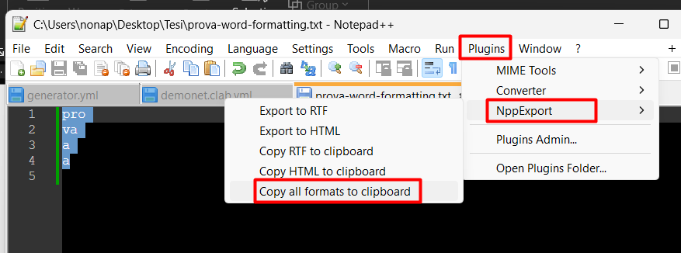

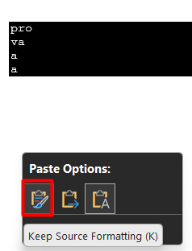

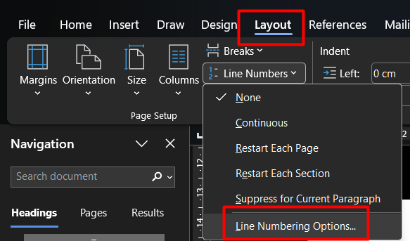

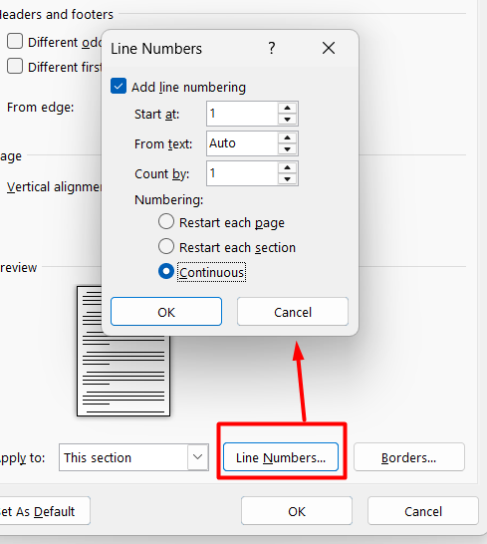
poi metterci i bordi perché è più bello

pro
va
a
a

syslog-ng is a free and open-source implementation of the syslog protocol for Unix and Unix-like systems (https://en.wikipedia.org/wiki/Syslog-ng).

