**CHAPTER 1**

**INTRODUCTION**

The past few years have seen a variety of diseases defeated by improvements in biomedicine and human intelligence, yet due to cancer's unpredictable character, individuals continue to suffer from it. For humanity, this sickness continues to be a major issue. The managerial station of the human body is the brain. It is in charge of carrying out all activities via a vast network of connections and neurons. One of the most dangerous conditions is a brain tumor, which develops when brain cells grow abnormally and interfere with the nervous system's operations. Brain tumors come in a variety of forms and can be either benign or malignant. One of the most severe and urgent diseases is cancerous brain tumors. Because the tumor cells in brain tumors are diverse, radiologists have a difficult time classifying this fatal condition. Recently, computer-aided diagnosis-based systems claimed to use magnetic resonance imaging to assist in the diagnosis of brain tumors (MRI).

A tumor is a medical term for abnormal cell growth inside the brain. The behavior of brain tumors in the human body varies based on a variety of characteristics, including the cell of origin, the site of occurrence, the morphology, and the pattern of spread. The human brain, which processes sensory data such as sight, sound, touch, taste, and pain, is the most sensitive portion of the body. It also governs muscle movements. Any tumor may interfere with these sensory details and muscular actions, or it may even lead to more dangerous events including fatalities.

The tumor can develop in any area of the brain because its location is unknown. Primary and secondary cancers can be distinguished based on where the tumor originated. The term "primary brain tumor" refers to a tumor that started inside the skull; the term "secondary brain tumor" refers to a tumor that started elsewhere in the body and later spread to the brain. The tumor might damage any of the brain lobes where it arises because its location is not fixed to one particular area. A range of imaging modalities, including CT scan, MRI, fMRI, PET, and others, are used in clinical approaches for the treatment of brain neoplasms, with each imaging modality playing a specific role in disease diagnosis. Radiology relies on imaging for clinical diagnosis at various phases of treatment, and Magnetic Resonance Imaging (MRI) is the most popular imaging modality. More than any other imaging technique, MRI aids in the visibility of soft tissues.

Today, image processing plays a significant role in early disease detection, allowing doctors to treat conditions like breast, lung, and brain malignancies. Currently, the majority of cancer diagnoses were successfully made using a visual examination approach. Due to inter and intra-observer differences, human visual assessment of tiny biopsy images is incredibly laborious, subjective, and contradicting. The classification of brain cancer is a crucial phase that depends on the training and expertise of the doctor. In order to assist radiologists and doctors in identifying brain tumors, an automated tumor categorization system is very necessary. For effective treatments, the accuracy of the current methods must be increased. As it provides highly reliable and exact detection findings, machine learning (ML) based techniques have recently garnered great favor for identifying brain tumors from MR images.

**1.1 PRINCIPAL TYPES OF BRAIN TUMORS**

Brain tumors in the brain can occur in tissues close to it. Therefore, the tumors are named according to the cells in which they are occurred. Glioma, meningioma and pituitary tumors are the most common brain tumors. Glioma is a type of tumor that occurs in the brain and spinal cord. Glioma-typed tumors occur in glial cells, which are the supporting tissue of the brain [3]. Meningioma, another type of brain tumor, is a tumor that surrounds the brain, protects it, and originates from the membrane called the diameter. It is one of the most common tumors in the brain. It is generally known that they constitute 15-20% of brain tumors.

**1.1.1 PRIMARY BRAIN TUMORS**

Unlike metastatic brain and spine tumors, primary brain tumors originate in the brain. They can be either malignant (cancerous) or benign (noncancerous) and high-grade (fast-growing) or low-grade (slow-growing). There are more than 125 types of primary brain tumors and other primary CNS tumors. Many of the primary brain tumors are derived from supportive cells (glial cells) where Glioblastomas represent the most common type. The primary brain tumors can be classified into several subgroups based on their cellular and molecular characteristics, where the most common are described below. In many cases cancer cells may break away from the brain tumor and spread to other parts of the central nervous system. This represents a serious treatment problem. The cause of primary brain tumors is unknown.

**1.1.2 SECONDARY BRAIN TUMORS**

Cancers such as breast cancer, lung cancer, kidney cancer, bowel cancer, and melanoma skin cancer can spread to the brain causing secondary brain tumor, which is approximately 10 times more frequent compared to primary brain tumor. The cerebral cortex is the high risk area where secondary brain tumors develop, while 15% of secondary brain tumors develop in the cerebellum and 5% develop in the stem of the brain. In the US, approximately 100,000 individuals are diagnosed with secondary brain tumor annually. Brain metastases may form one tumor or many tumors in the brain. As the metastatic brain tumors grow, they create pressure on and change the function of surrounding brain tissue. This causes signs and symptoms, such as headache, personality changes, memory loss and seizures.

**1.2 CONVOLUTIONAL NEURAL NETWORKS**

Convolutional neural networks (CNNs) are a type of deep learning algorithm that has been used in a variety of real-world applications. CNNs can be trained to classify images, detect objects in an image, and even predict the next word in a sentence with incredible accuracy. A CNN-based algorithm will support medical professionals in their treatment role to accelerate the recovery process instead of manually analyzing the MRI images. Face recognition, picture categorization, and other computer vision applications are examples of CNN. It is comparable to the fundamental neural network. Similar to neural networks, CNN also has learnable parameters, such as weights and biases.

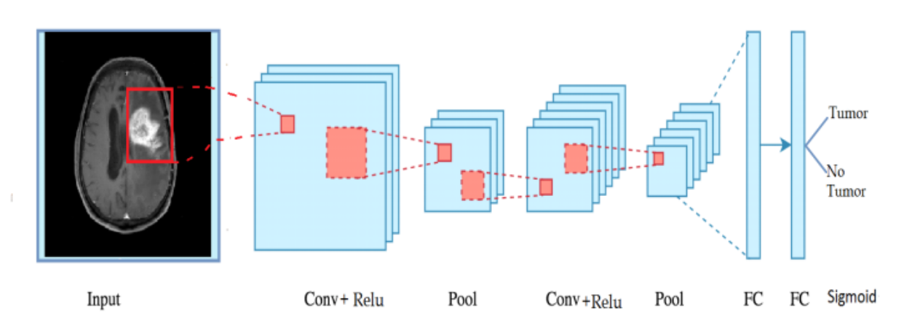CNNs provide in-depth findings despite their complexity in terms of resources and skill. At its core, everything is all about seeing patterns and nuances that are so minute and undetectable that the human eye ignores them.

**Figure 1.1** **Architecture of CNN**

**1.2.1 CONVOLUTION LAYERS**

The convolution layer's goal is to take or extract a feature from the input data (an image), and only a portion of the image is connected to the next convolution layer for this reason: if all of the input pixels were connected to the next convolution layer, the architecture would be difficult to calculate. In CNN, the entire image is the dot product between the receptive field and a particle [3*3 filter].

**1.2.2 RECTIFIER ACTIVATION FUNCTION**

The ReLU is the most used activation function in the world right now. Since, it is used in almost all the convolutional neural networks or deep learning. After applying convolution on the input volume, we have to apply ReLU [Nonlinear activation function] to the feature map to get the non-linearity to the system.

**1.2.3 POOLING LAYERS**

Pooling layer reduces input image dimension and controls overfitting. Max pooling, average pooling, and mean pooling are the three different types of pooling. The primary objective of the pooling layer is to reduce the size of the convolved feature map in order to reduce computational costs.

**1.2.4 FULLY CONNECTED LAYERS**

Based on the training data set, the final Fully Connected Layer provides a categorised image. In this instance, either a tumor image or a normal image of the brain will be displayed as the final class.

**1.2.5 SIGMOID**

The sigmoid function's ability to transform any real number to one between 0 and 1 is advantageous in data science and many other fields such as, in deep learning as a non-linear activation function within neurons in artificial neural networks to allow the network to learn non-linear relationships between the data.

**1.3 MRI IMAGES**

Brain tumor image classification is an important part of medical image processing. It assists doctors to make accurate diagnosis and treatment plans. Magnetic resonance (MR) imaging is one of the main imaging tools to study brain tissue. Magnetic resonance imaging (MRI) is commonly used to help diagnose brain tumors. The main benefit of MRI is its capacity to detect abnormalities that CT may miss or just imperfectly detect. The MR can establish the precise amount and location of a tumor when only a generic bulk effect can be seen on a CT scan.

**1.4 SYMPTOMS OF BRAIN TUMOR**

The symptoms of a brain tumor depend on tumor size, type, and location. Symptoms may be caused when a tumor presses on a nerve or harms a part of the brain. Also, they may be caused when a tumor blocks the fluid that flows through and around the brain, or when the brain swells because of the buildup of fluid.

These are the most common symptoms of brain tumors:

* Headaches (usually worse in the morning)
* Nausea and vomiting
* Changes in speech, vision, or hearing
* Problems balancing or walking
* Changes in mood, personality, or ability to concentrate
* Problems with memory
* Muscle jerking or twitching (seizures or convulsions)
* Numbness or tingling in the arms or legs
* Imbalance of body repeated falls.

Most often, these symptoms are not due to a brain tumor. Another health problem could cause them. If you have any of these symptoms, you should tell your doctor so that problems can be diagnosed and treated.

**1.5 BRAIN TUMOR CAUSES**

Brain tumors' exact causes is yet unknown. However, there are a number of risk factors that raise an individual's likelihood of developing these malignant cells. The risk elements consist of:

1. **Age:** They are common in children and older individuals (60+ years of age).
2. **Gender:**Men have an increased risk of brain tumors. However, there are a few types that are found more in women.
3. **Genetic Background:** There are a few of them that show increased linkage to genetic inheritance.
4. **Environmental Exposure:** This is one of the most crucial risk factors that lead to brain tumor. Exposure to chemicals like solvents, and pesticides either at home or at work is one of the primary risk factors. Other environmental causes like allergens, viruses, and infections might also lead to this disease.
5. **Exposure to Electromagnetic and Ionising Radiations:** EM radiations that emit from cell phone use or power lines have not yet been proven to increase the risk of getting this tumor disease; however it is controversial. Exposure to ionizing radiations like X-rays also increases the chances.
6. **People with the compromised immune systems**such as those suffering from AIDS are more likely to have this condition.
7. **Radiation Therapy**to the head received previously for any treatment can increase the risk of brain tumor.

**1.6 TREATMENT OF BRAIN TUMORS**

The treatment of a brain tumor depends on:

* The type of tumor
* The size of the tumor
* The location of the tumor
* our general health

The most common treatment for malignant brain tumors is surgery. The goal is to remove as much of the cancer as possible without causing damage to the healthy parts of the brain. While the location of some tumors allows for safe removal, other tumors may be located in an area that limits how much of the tumor can be removed. Even partial removal of brain cancer can be beneficial. Risks of brain surgery include infection and bleeding. Clinically dangerous benign tumors are also surgically removed. Metastatic brain tumors are treated according to guidelines for the type of original cancer. Surgery can be combined with other treatments, such as radiation therapy and chemotherapy. Physical therapy, occupational therapy, and speech therapy can help you recover after neurosurgery.

**1.7 ADVANTAGES**

* Brain tumor detection at early stages can increase the chances of the patient's recovery after treatment.
* CNN segmentation algorithm System detects the proper shape and size accurately.

**1.8 APPLICATIONS**

* It is used in Medical field.
* Image Polishing and restoration.
* Video Processing.
* Pattern recognition
* Evaluation
* Ranking of Segmentation Algorithms.

**1.9 OBJECTIVE**

* To analyse brain tumors from 2D MRIs using a convolutional neural network, followed by conventional classifiers and deep learning techniques.
* To learn representative complex features for both tumor tissues and healthy brain tissues from the multi - modal MRI images.
* To identify brain tumors in MRI images, by using CNN based model.
* To increase accuracy for the purpose of medical image research.

**CHAPTER - 2**

**SYSTEM ANALYSIS**

The process of examining and comprehending complex systems, identifying their constituent parts and interactions, and determining how to increase their efficacy and efficiency is known as system analysis. In order to analyse and improve systems, it is an interdisciplinary field that mixes concepts from engineering, mathematics, computer science, and other fields.

System analysis seeks to increase a system's efficiency, dependability, and functionality while lowering its expenses and hazards. This entails looking at the system's inputs, procedures, and outputs in order to spot areas that could be improved. Additionally, it entails assessing how any suggested modifications will affect the system as a whole, as well as specific components and stakeholders.

**2.1 EXISTING SYSTEM**

Convolutional Neural Network is a well-ordered technique in the field of the medical image process. A convolutional neural network (CNN) could be a type of artificial neural network works in image recognition and process that’s specifically designed for method component knowledge. A CNN uses a system very like a multilayer view-point that has been designed for reduced process necessities. The removal of limitations and increase in potency for image process ends up in a system which is way more effective, easier to train data for image process and linguistic communication process. In our nine-layer CNN model, there are fourteen aphases in addition to the hidden layers that provide us the best possible outcome for detecting the tumor. The intended methodology is represented in fig 2.1 along with a brief narration.

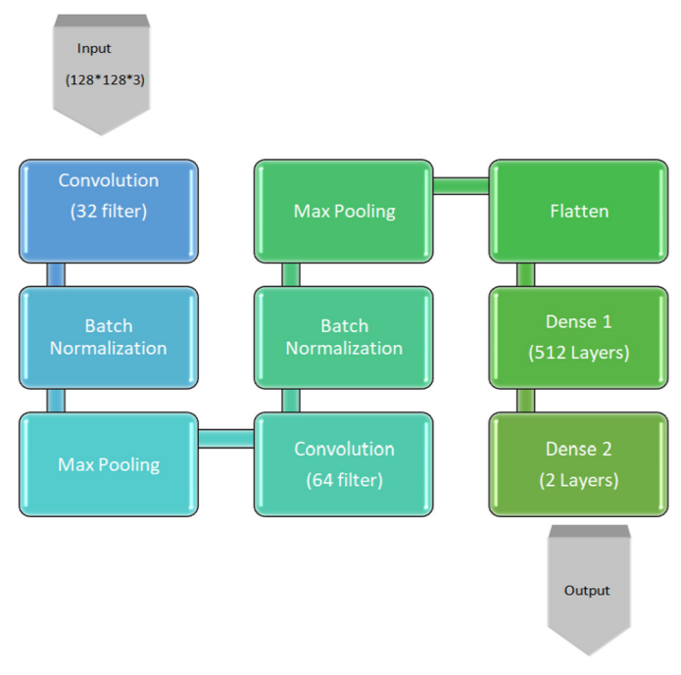

**Figure 2.1** **Methodology for tumor detection using 9-Layer Convolutional Neural Network.**

In technique we have taken a complete variety of pictures as input and converted all the images into constant size to form those unvaried dimensions. We tend to create a convolutional kernel that is convoluted with the input layer administering with thirty-two convolutional filters of size every with the support of three channel tensors. It is also used to ReLU because of the activation function. The corrected linear activation function or ReLU could be a piecewise linear operate which will output the input directly if it is positive, otherwise, it will output zero. Next, we have applied batch normalization by Sergey Ioffe et al. in the year 2015. Batch normalization could be a technique that not only creates neural networks quicker and additional stability through normalization of the layers’ inputs by re-centering and rescaling. We used it to form our algorithm quicker as shown in the following figure 2.2.

Next, the pooling operation implies sliding a 2D filter over each channel of the feature map and summarizing the features lying within the region covered by the filter. The dimensions of output obtained after a pooling layer for a feature

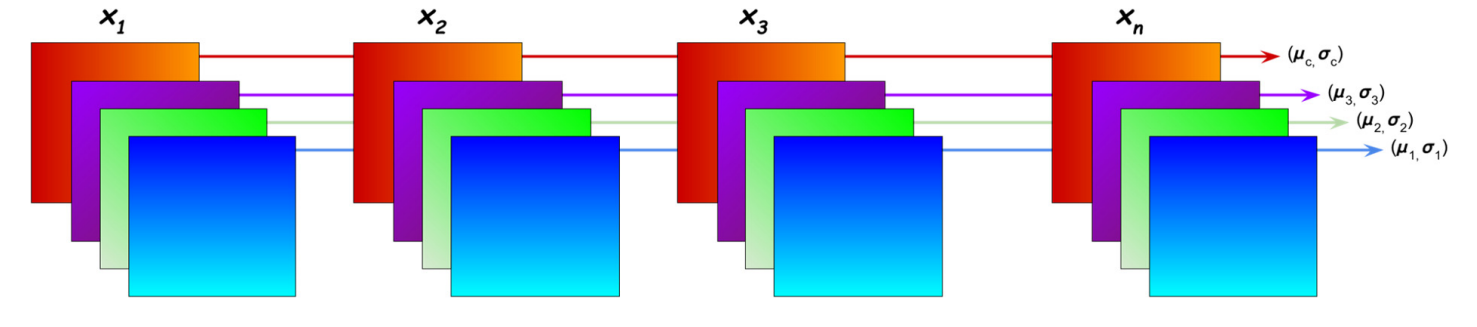

**Figure 2.2 Batch Normalization**

map with dimensions is,

(3.1)

Where,

- Height of feature map

- Width of feature map

- No of channel in the feature map

– Size of filter

– Stride length.

A normal CNN model architecture is to have many convolutional and pooling layers piled up one after the other. Pooling layers are used to decrease the dimensions of the feature maps. Thus, it decreases the number of parameters to learn the amount of computation performed in the network. The pooling layer summerise the features present in a range of the feature map generated by a convolutional layer. Therefore, further operations are performed on summarize features instead of accurately positioned features created by the convolutional layer. This makes the model more powerful to dissimilar in the position of the features in the input image. Here, we have used a Max pooling operation, which selects the maximum element from the range of the feature map covered by the filter.

**2.2 PROBLEMS IN THE EXISTING SYSTEM**

* It takes a lot of time because hand segmentation is doctor dependent and outcomes are subject to significant intra and inter rater variability.
* Needs a large quantity of brain MRI scans images from different cases to train.
* Automatic segmentation of gliomas is a very tuff and important problem.
* Several modalities need to significantly segment tumor sub-regions even adds to this complexity.
* Brain tumor MRI data obtained from clinical scans or synthetic databases are naturally complicated.

**2.3 SYSTEM REQUIREMENTS**

**2.3.1 HARDWARE REQUIREMENTS**

* System : Pentium IV 2.4 GHz.
* Hard Disk : 1 TB.
* RAM : 512 Mb.
* Monitor : Acer EK22OQ
* Mouse : Logitech.

**2.3.2 SOFTWARE REQUIREMENTS**

* Operating system : Windows 10.
* Coding Language : Python language
* Tool : Anaconda Jupyter

**2.4 PROPOSED SYSTEM**

A brain tumor is formed by uncontrolled increase of and development of cells in the skull. Since the brain is the control center of the human body, developing tumors can put pressure on the skull and cause negative human health. The number of deaths due to brain tumors are increasing day by day. Therefore, early diagnosis is important for all brain tumors, as if all diseases. Brain tumor is the main cause of cancer deaths worldwide. Brain tumor can affect people at any age. Brain tumor increases mortality among children and adults. The brain is one of the complex organs in the human body. There are more than 100 billion nerves present in human brain that are in an overlapped form. The tumor is due to uncontrollable growth of cells in the brain. The tumor is small in size. The identification of the tumor is based on their growth pattern. Benign tumor grows slowly and it has well defined borders. It can be removed completely by surgery and it does not spread in the spinal cord, other parts of brain or other areas of the body. The malignant type of tumor is fast-growing and affects the healthy brain cells and may spread to other parts of the brain or spinal cord. It is more harmful and may remain untreated. So detection of such brain tumor location, identification and classification in earlier stage is a serious issue in medical science. Imaging technology in Medicine helps doctors to observe the interior portions of the human body for easy diagnosis. Artificial neural networks are a technique developed by mimicking the way the human brain works. This technique has many important features such as learning from data, generalization and working with many variables. Convolutional Neural Network (CNN), a deep learning algorithm, is inspired by artificial neural networks. The aim of this work is to detect the brain tumor by using CNN based method.

**2.5 METHODOLOGY**

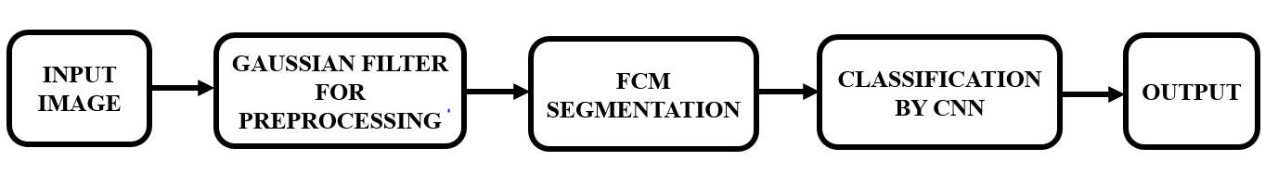

**Figure 2.3 Block Diagram for Proposed System**

The input image is pre-processed using the Gaussian filter. This image is sent into the FCM segmentation block after pre-processing. Tumor segmentation employs FCM segmentation, and accurate tumor size and shape are obtained through morphological operation. The machine then produces the image with the tumor segmented. The selected characteristics are fed into the convolutional neural network (CNN) classifier for machine learning image classification. The number of features in an image should be kept to a minimum using this CNN classifier approach. Finally, for improved accuracy, CNN's classification method is employed.

**2.5.1 PREPROCESSING**

Pre-processing aims to improve the image data by minimizing unwanted distortions or enhancing certain elements of the image that are important for subsequent processing, even though geometric changes of images.

**2.5.2 GAUSSIAN FILTER**

A Gaussian filter is a linear filter. It's usually used to blur the image or to reduce noise. If we use two of them and subtract, we can use them for "unsharp masking" (edge detection). The Gaussian filter alone will blur edges and reduce contrast. In electronics and signal processing mainly in digital signal processing, a Gaussian filter is a filter whose impulse response is a Gaussian function. A Gaussian filter has the advantage that its Fourier transform is also a Gaussian distribution centered around the zero frequency (with positive and negative frequencies at both sides). One can then control the effectiveness of the low-pass nature of the filter by adjusting its width.

**2.5.3 IMAGE SEGMENTATION**

Image segmentation is a commonly used technique in digital image processing and analysis to partition an image into multiple parts or regions, often based on the characteristics of the pixels in the image. Image Segmentation involves converting an image into a collection of regions of pixels that are represented by a mask or a labeled image. A common technique is to look for abrupt discontinuities in pixel values, which typically indicate edges that define a region. Another common approach is to detect similarities in the regions of an image. Some techniques that follow this approach are region growing, clustering, and thresholding. A variety of other approaches to perform image segmentation have been developed over the years using domain specific knowledge to effectively solve segmentation problems in specific application areas. So let us start with one of the clustering-based approaches in Image Segmentation which is FCM segmentation.

**2.5.4 FCM SEGMENTATION**

Image segmentation is considered an important step in image processing. Fuzzy c-means clustering is one of the common methods of image segmentation. Fuzzy c-means clustering methods have great potential to extracting detailed features from image pixels. Fuzzy c-means (FCM) clustering is one of the important unsupervised learning algorithms. It requires knowledge of the initial details of some of the parameters, such as the number of clusters and the position of the centroid of the clusters, and its performance depends on the input parameters.

**2.5.5 CONVOLUTIONAL NEURAL NETWORKS**

Convolutional neural networks (CNNs) have undergone substantial development in the radar imaging and semantic segmentation fields in recent years. A CNN is a thorough learning technique created specifically for picture recognition and classification. CNN has been used in a variety of real-world applications. Similar to multi-layered neural networks, this network was created. CNNs are the same as biological neural networks used in speech recognition, picture processing, and other applications. CNNs can be trained to classify images, detect objects in an image, and even predict the next word in a sentence with incredible accuracy.

A CNN-based algorithm will support medical professionals in their treatment role to accelerate the recovery process instead of manually analyzing the MRI images. Face recognition, picture categorization, and other computer vision applications are examples of CNN. It is comparable to the fundamental neural network. Similar to neural networks, CNN also has learnable parameters, such as weights and biases. CNNs provide in-depth findings despite their complexity in terms of resources and skill.

**2.6 LITERATURE REVIEW**

In the developing technology normal-abnormal classification of MRI brain images proposes, level based approach, and compares the result with the existing methods. The existing works does not consider the anatomical structure of the brain slices for the classification of MRI brain images. In the aspect of image processing, the anatomically similarity of the brain slices can be treated as the similarity of brain slices in the viewing aspect along with the actual anatomical structure. This work aimed to prove that the consideration of the anatomical structure for the normal - abnormal classification will improve the result of the classification. In the existing work shows that the feature vector, gray level co-occurrence matrix (GLCM) statistical features alongside support vector machine (SVM) and Back Propagating Neural Network (BPNN) produce better results than other methods. It uses Multifractal segmentation along with intensity features as feature vector and classifier. Related works in current literatures for the normal/abnormal classification of MRI images does not consider the anatomical structure of the brain slices. Because of the dissimilarity in the anatomical structure, it may produce undesirable results. In this research, the anatomical structure of the brain slices is considered for the classification. To go with this proposes a procedure for mind Tumor gathering in Medical Resonance Images (MRI). In this paper, CAD (Computer Aided Diagnosis) framework is produced utilizing FDA features and machine learning based back propagation Neural Network and using Near Infrared Imaging Technology to detect the brain Tumor of the size below 3mm which could not be detected using CT and MRI images and transmit the thermal information through WSN. Infrared sensor is one of the successful electronic instrument which identifies certain qualities of its surroundings by either exuding or moreover distinguishing infrared radiation. Infrared sensors are in like manner prepared for evaluating the glow being delivered by a challenge and recognizing development. Highlight extraction is finished by utilizing dark level covariance network and further arrangement is finished by MLBPNN idea is presented here. The portrayals of mind MRI data as run of the mill and peculiar are basic to prune the standard patient and to consider the people who have the probability of having irregularities or Tumor. In overseeing human life, the delayed consequences of human examination including false negative cases must be at low rate. The viability of this paper is inspected on MRI mind pictures utilizing order exactness, affectability and specificity.

**Neelum Noreen *et al* [2020]** explained the deadly disease and its classification is a challenging task for radiologists because of the heterogeneous nature of the tumor cells. Recently, computer-aided diagnosis-based systems have promised, as an assistive technology, to diagnose the brain tumor, through magnetic resonance imaging (MRI). In recent applications of pre-trained models, normally features are extracted from bottom layers which are different from natural images to medical images. A method of multi-level features extraction and concatenation for early diagnosis of brain tumor. Two pretrained deep learning models i.e. Inception-v3 and DensNet201 make this model valid. With the help of these two models, two different scenarios of brain tumor detection and its classification were evaluated. First, the features from different Inception modules were extracted from pre-trained Inception-v3 model and concatenated these features for brain tumor classification. Then, these features were passed to softmax classifier to classify the brain tumor. Second, pre-trained DensNet201 was used to extract features from various DensNet blocks. Then, these features were concatenated and passed to softmax classifier to classify the brain tumor. Both scenarios were evaluated with the help of three-class brain tumor dataset that is available publicly. This method produced 99.34 %, and 99.51% testing accuracies respectively with Inception-v3 and DensNet201 on testing samples and achieved highest performance in the detection of brain tumor.

**Abdu Gumaei *et al* [2019]** proposed an important step that depends on the physician's knowledge and experience. An automated tumor classification system is very essential to support radiologists and physicians to identify brain tumors. The accuracy of current systems needs to be improved for suitable treatments. A hybrid feature extraction method with a regularized extreme learning machine (RELM) for developing an accurate brain tumor classification approach. The approach starts by preprocessing the brain images by using a min - max normalization rule to enhance the contrast of brain edges and regions. Then, the brain tumor features are extracted based on a hybrid method of feature extraction. Finally, a RELM is used for classifying the type of brain tumor. To evaluate and compare the proposed approach, a set of experiments is conducted on a new public dataset of brain images.

**Andres Anaya-Isaza *et al* [2022]** proposed the exponential growth of deep learning networks has allowed us to tackle complex tasks, even in fields as complicated as medicine. However, using these models requires a large corpus of data for the networks to be highly generalizable and with high performance. In this sense, data augmentation methods are widely used strategies to train networks with small data sets, being vital in medicine due to the limited access to data. A clear example of this is magnetic resonance imaging in pathology scans associated with cancer. The effect of several conventional data augmentation schemes on the ResNet50 network for brain tumor detection. In addition the strategy based on principal component analysis. The training was performed with the network trained from zeros and transfer-learning, obtained from the ImageNet dataset. The investigation allowed us to achieve an F1 detection score of 92.34%. The score was achieved with the ResNet50 network through the proposed method and implementing the learning transfer. It was also concluded that the proposed method is different from the other conventional methods with a significance level of 0.05 through the Kruskal Wallis test statistic.

**Mohamed Shakeel *et al* [2019]** explained the image processing placed an important role for recognizing various diseases such as breast, lung, and brain tumors in earlier stage for giving the appropriate treatment. Presently, most cancer diagnosis worked according to the visual examination process with effectively. Human visual reviewing of infinitesimal biopsy pictures is exceptionally tedious, subjective, and conflicting due to between and intra-onlooker varieties. The malignancy and it's compose will be distinguished in a beginning time for finish treatment and fix. This brain tumor classification system using machine learning based back propagation neural networks (MLBPNN) causes pathologists to enhance the exactness and proficiency in location of threat and to limit the entomb onlooker variety. The technique may assist doctors with analyzing the picture cell by utilizing order and bunching calculations by recoloring qualities of the phones. The different picture preparing steps required for disease location from biopsy pictures incorporate procurement, upgrade, and division; include extraction, picture portrayal, characterization, and basic leadership. MLBPNN is analyzed with the help of infra-red sensor imaging technology. Then, the computational multifaceted nature of neural distinguishing proof incredibly diminished when the entire framework is deteriorated into a few subsystems. The features are extracted using fractal dimension algorithm and then the most significant features are selected using multi fractal detection technique to reduce the complexity. This imaging sensor is integrated via wireless infrared imaging sensor which is produced to transmit the tumor warm data to a specialist clinician to screen the wellbeing condition and for helpful control of ultrasound measurements level, especially if there should arise an occurrence of elderly patients living in remote zones.

**Gunasekaran Manogaran *et al* [2018]** proposed an artificial intelligence applications in magnetic resonance imaging have been applied in several clinical studies. The analysis of brain tumors without human intervention is considered a significant area of research because the extracted brain images need to be optimized using a segmentation algorithm that is highly resilient to noise and cluster size sensitivity problems and automatically detects the region of interest (ROI). An improved orthogonal gamma distribution-based machine-learning approach is used to analyze the under segments and over-segments of brain tumor regions to automatically detect abnormalities in the ROI. Further data imbalances due to improper edge matching in the abnormal region is sampled by matching the edge coordinates and sensitivity, and the selectivity parameters are measured using the machine learning algorithm. The benchmark medical image database was collected and analyzed to validate the efficiency and accuracy of the optimal automatic detection in tumor and non-tumor regions. The mean error rate of the algorithm was determined using a mathematical formulation.

**Ankit Vidyarthi *et al* [2022]** proposed the malignant and non-malignant brain tumors is done using a computer-aided diagnosis system by practitioners worldwide. Radiologists refer computer-assisted techniques to draw conclusions using image modalities and inferences. Pedagogically, various machine learning approaches have been used, which usually focus on the classification of imaging modality into two categories, either normal and abnormal images or differentiating between benign and malignant tumors. Still, the work requirement is to classify these multi-class malignant tumors into their specific class with better precision. The proposed work focuses on distinguishing between the types of high-grade malignant brain tumors. The vast feature set from six domains to capture most of the hidden information in the extracted region of interest. Later, relevant features are extracted from the feature set pool using a new proposed feature selection algorithm named the Cumulative Variance method (CVM). Next, the selected features are used for model training and testing using K-Nearest Neighbour (KNN), multi-class Support Vector Machine (mSVM), and Neural Network (NN) for predicting multi-class classification accuracy.

**Saif Ahmad *et al* [2022]** proposed to be identified in its early stage, otherwise it may cause severe condition that cannot be cured once it is progressed. A precise diagnosis of brain tumor can play an important role to start the proper treatment, which eventually reduces the survival rate of patient. Recently, deep learning based classification method is popularly used for brain tumor detection from 2D Magnetic Resonance (MR) images. In this article, several transfer learning based deep learning methods are analyzed using number of traditional classifiers to detect the brain tumor. For transfer learning, seven methods are used such as VGG-16, VGG-19, ResNet50, InceptionResNetV2, InceptionV3, Xception, and DenseNet201. Each of them is followed by five traditional classifiers, which are Support Vector Machine, Random Forest, Decision Tree, AdaBoost, and Gradient Boosting. All the combinations of deep learning based feature extractor and classifier are investigated to evaluate the relevant performance in terms of accuracy, precision, recall, F1-score, Cohen's kappa, AUC, Jaccard, and Specificity. Later on, learning curves for all of the combinations that achieved the highest accuracies were presented.

**Mohammad Shahjahan Majib *et al* [2021]** briefs that the life-threatening neurological condition caused by the unregulated development of cells inside the brain or skull. The death rate of people with this condition is steadily increasing. Early diagnosis of malignant tumors is critical for providing treatment to patients, and early discovery improves the patient's chances of survival. The patient's survival rate is usually very less if they are not adequately treated. If a brain tumor cannot be identified in an early stage, it can surely lead to death. Therefore, early diagnosis of brain tumors necessitates the use of an automated tool. The segmentation, diagnosis, and isolation of contaminated tumor areas from magnetic resonance (MR) images is a prime concern. It is a tedious and time-consuming process that radiologists or clinical specialists must undertake, and their performance is solely dependent on their expertise. To address these limitations, the use of computer-assisted techniques becomes critical. The different traditional and hybrid ML models were built and analyzed in detail to classify the brain tumor images without any human intervention. Along with these, 16 different transfer learning models were also analyzed to identify the best transfer learning model to classify brain tumors based on neural networks.

**Chao Ma *et al* [2018]** explained the segmentation of brain tumors from magnetic resonance imaging (MRI) data sets is of great importance for improved diagnosis, growth rate prediction, and treatment planning. However, automating this process is challenging due to the presence of severe partial volume effect and considerable variability in tumor structures, as well as imaging conditions, especially for the gliomas. A new methodology that combines random forests and active contour model for the automated segmentation of the gliomas from multimodal volumetric MR images. A feature representations learning strategy to effectively explore both local and contextual information from multimodal images for tissue segmentation by using modality specific random forests as the feature learning kernels. Different levels of the structural information is subsequently integrated into concatenated and connected random forests for gliomas structure inferring.

**Hasan Ucuzal *et al* [2019]** briefs that the automated machine learning (AutoML) algorithms developed using deep learning algorithms have been the focus of interest in many studies recently. To develop a free web-based software based on deep learning that can be utilized in the diagnosis and detection of brain tumors (Glioma/Meningioma/Pituitary) on T1-weighted magnetic resonance imaging. The Keras library, which is used in Python programming language, is utilized in the construction of the deep learning algorithm in this software.

**Zhenyu Tang *et al* [2019]** proposed a glioblastoma (GBM) is the most common and deadly malignant brain tumor. For personalized treatment, an accurate pre-operative prognosis for GBM patients is highly desired. Recently, many machine learning-based methods have been adopted to predict overall survival (OS) time based on the pre-operative mono- or multi-modal imaging phenotype. The genotypic information of GBM has been proven to be strongly indicative of the prognosis; however, this has not been considered in the existing imaging-based OS prediction methods. The main reason is that the tumor genotype is unavailable pre-operatively unless deriving from craniotomy. A new deep learning-based OS prediction method for GBM patients, which can derive tumor genotype-related features from pre-operative multimodal magnetic resonance imaging (MRI) brain data and feed them to OS prediction. Propose a multi-task convolutional neural network (CNN) to accomplish both tumor genotype and OS prediction tasks jointly. As the network can benefit from learning tumor genotype-related features for genotype prediction, the accuracy of predicting OS time can be prominently improved.

**Wu Deng *et al* [2020]** proposes a strategy where a structure is developed to recognize and order the tumor type. Over a time of years, numerous specialists have been examined and proposed a technique in this space. A brain tumor segmentation approach is developed based on efficient, deep learning techniques implemented in a unified system to achieve the appearance and spatial accuracy outcomes through Conditional Radom Fields (CRF) and Heterogeneous Convolution Neural Networks (HCNN). In these steps the 2D image patching and picture slices of the deep-learning model is developed. The Proposed method has following steps as follows: 1) train HCNN by image patches; 2) train CRF with CRF-Recurrent Regression based Neural Network (RRNN) by means of image slices with fixed variables of HCNN; 3) fine tune with HCNN and CRF-RRNN image slices. In general, 3 segmentation models have been trained using axial, coronary-and sagittal image patches and slices, further assembled into brain tumor segments using a voting fusion technique and it can be examined with Internet of Medical Things (IoMT) Platform.

**Sohaib Asif *et al* [2022]** explained the brain tumors from magnetic resonance imaging (MRI) plays an important role in the diagnosis of such diseases. There are many diagnostic imaging methods used to identify tumors in the brain. MRI is commonly used for such tasks because of its unmatched image quality. The relevance of artificial intelligence (AI) in the form of deep learning (DL) has revolutionized new methods of automated medical image diagnosis. To develop a robust and efficient method based on transfer learning technique for classifying brain tumors using MRI. In this article, the popular deep learning architectures are utilized to develop brain tumor diagnostic system. The pre-trained models such as Xception, NasNet Large, DenseNet121 and InceptionResNetV2 are used to extract the deep features from brain MRI. The experiment was performed using two benchmark datasets that are openly accessible from the web. Images from the dataset were first cropped, preprocessed, and augmented for accurate and fast training. Deep transfer learning models are trained and tested on a brain MRI dataset using three different optimization algorithms (ADAM, SGD, and RMSprop). The performance of the transfer learning models is evaluated using performance metrics such as accuracy, sensitivity, precision, specificity and F1-score.

**Deepa *et al* [2022]** proposed a Magnetic Resonance Imaging (MRI) is a significant technique used to diagnose brain abnormalities at early stages. A novel method to classify brain abnormalities (tumor and stroke) in MRI images using a hybridized machine learning algorithm. The proposed methodology includes feature extraction (texture, intensity, and shape), feature selection, and classification. The texture features are extracted by intending a neoteric directional-based quantized extrema pattern. The intensity features are extracted by proposing the clustering-based wavelet transform. The shape-based extraction is performed using conventional shape descriptors. Maximum a Priori (MAP) based firely algorithm is proposed for feature selection. The MRI brain tumor and stroke images are detected and categorized into four classes which are a high- grade tumor, a low-grade tumor, an acute stroke, and a sub-acute stroke. Besides, three different regions are identified in tumor detection such as edema, and tumor (necrotic and non-enhancing) region. The proposed methodology successfully achieves a reliable accuracy of 88.3% for classifying brain tumor cases and 99.2% for brain stroke classification. The best F-score of 0.91 and the least FPR of 0.06 are attained while considering brain tumor classification against the proposed HSVFC.

**Mohammad Ashraf Ottom *et al* [2022]** explained the detection and segmentation of brain tumors using MR images are challenging and valuable tasks in the medical field. Early diagnosing and localizing of brain tumors can save lives and provide timely options for physicians to select efficient treatment plans. Deep learning approaches have attracted researchers in medical imaging due to their capacity, performance, and potential to assist in accurate diagnosis, prognosis, and medical treatment technologies. A novel framework for segmenting 2D brain tumors in MR images using deep neural networks (DNN) and utilizing data augmentation strategies. The idea of skip-connection, encoder-decoder architectures, and data amplification to propagate the intrinsic affinities of a relatively smaller number of expert delineated tumors, e.g., hundreds of patients of the low-grade glioma (LGG), to many thousands of synthetic cases.

**CHAPTER-3**

**SYSTEM SPECIFICATION**

A system's requirements and capabilities are described in great detail in system specifications. It contains all the technical and functional requirements required for the system to carry out the tasks for which it was designed. The requirements for the system's hardware and software, compatibility with operating systems, data storage and processing power, input and output capabilities, network and communication protocols, security and privacy features, and user interface design are examples of information that is generally included in system specifications. System specifications are crucial since they offer a thorough and concise description of the system's capabilities, assisting stakeholders in comprehending the function and range of the system. They serve as a foundation for assessing the system's effectiveness and success.

**3.1 OPERATING SYSTEM**

An operating system (OS) is a software program that acts as an intermediary between the computer hardware and application software. It manages computer hardware and provides services for application software. It acts as a bridge between computer hardware and software, and allows users to interact with the computer system through a user interface. The primary functions of an operating system are to manage computer resources such as memory, CPU, storage, and input/output devices, and to provide security and stability for the system. Operating systems are essential components of most computing devices, including personal computers, smartphones, tablets, servers, and other embedded systems.

**WINDOWS 10**

Windows 10 is a major release of Microsoft's Windows NT operating system. It is the direct successor to Windows 8.1, which was released nearly two years earlier. It was released to manufacturing on July 15, 2015, and later to retail on July 29, 2015. Windows 10 was made available for download via MSDN and TechNet, as a free upgrade for retail copies of Windows 8 and Windows 8.1 users via the Windows Store, and to Windows 7 users via Windows Update. Windows 10 receives new builds on an ongoing basis, which are available at no additional cost to users, in addition to additional test builds of Windows 10, which are available to Windows Insiders. Devices in enterprise environments can receive these updates at a slower pace, or use long-term support milestones that only receive critical updates, such as security patches, over their ten-year lifespan of extended support. In June 2021, Microsoft announced that support for Windows 10 editions which are not in the Long-Term Servicing Channel (LTSC) will end on October 14, 2025. Windows 10 is the final version of Windows that supports 32-bit processors (IA-32 and ARMv7-based) and devices with BIOS firmware.

The ARM version of Windows 10 allows running applications for x86 processors through 32-bit software emulation. On Windows 10, the Microsoft Store serves as a unified storefront for apps, video content, and eBooks. Windows 10 also allows web apps and desktop software (using either Win32 or .NET Framework) to be packaged for distribution on the Microsoft Store. Desktop software distributed through Windows Store is packaged using the App-V system to allow sandboxing. Windows 10 supports up to two physical processors. A maximum of 32 cores is supported in 32-bit versions of Windows 8, whereas up to 256 cores are supported in the 64-bit versions.

**3.2 APPLICATION OF WINDOWS 10**

Windows 10 is a versatile operating system that is used in a wide range of applications, including personal computing, gaming, business, education, and more. Some common applications of Windows 10 include:

**1.Personal Computing:** Windows 10 is widely used on personal computers for everyday tasks such as web browsing, email, social media, streaming media, and gaming.

**2.Business:** Windows 10 is also used in the business environment for productivity, communication, and collaboration. Applications such as Microsoft Office, Teams, and OneDrive are commonly used to create and share documents, presentations, and other business-related materials.

**3.Education:** Windows 10 is used in educational settings for teaching and learning, including online learning, research, and collaboration. Tools such as Microsoft Whiteboard, OneNote, and Teams are commonly used for classroom activities, project-based learning, and remote learning.

**4.Gaming:** Windows 10 is a popular platform for gaming, with a large library of games available on the Microsoft Store and other online gaming platforms.

**5.Creative applications:** Windows 10 is also used for creative applications such as video and audio editing, graphic design, and animation. Tools such as Adobe Creative Cloud, Blender, and SketchBook are commonly used for these applications.

Overall, Windows 10 is a versatile operating system that can be used in a wide range of applications, from personal computing to business and education, making it a popular choice for many users.

**3.3 SOFTWARE DESCRIPTION**

Software refers to a set of instructions or programs that are designed to perform specific tasks on a computer system. It includes all the applications, programs, and operating systems that are used to operate and control computer hardware.

Software is typically developed using programming languages such as C++, Java, Python, and others, and can be run on different types of hardware platforms such as personal computers, servers, mobile devices, and embedded systems.

There are two main types of software: system software and application software. System software is responsible for managing and controlling the hardware resources of a computer system, while application software is designed to perform specific tasks for the user, such as word processing, web browsing, or gaming.

Software plays a critical role in modern computing, enabling users to perform a wide range of tasks on their devices, from basic functions such as word processing and email to more advanced tasks such as scientific computing, data analysis, and machine learning.

**ANACONDA JUPYTER**

Anaconda software helps you create an environment for many different versions of Python and package versions. Anaconda is also used to install, remove, and upgrade packages in your project environments. Furthermore, you may use Anaconda to deploy any required project with a few mouse clicks. The Jupyter Notebook application allows you to create and edit documents that display the input and output of a Python or R language script. Once saved, you can share these files with others.

**PYTHON**

Python is a high-level, general-purpose programming language. Its design philosophy emphasizes code readability with the use of significant indentation. Python is dynamically typed and garbage-collected. It supports multiple programming paradigms, including structured (particularly procedural), object-oriented and functional programming. It is often described as a "batteries included" language due to its comprehensive standard library. Guido van Rossum began working on Python in the late 1980s as a successor to the ABC programming language and first released it in 1991 as Python 0.9.0. Python 2.0 was released in 2000. Python 3.0, released in 2008, was a major revision not completely backward-compatible with earlier versions. Python 2.7.18, released in 2020, was the last release of Python 2. Python consistently ranks as one of the most popular programming languages.

**CHAPTER - 4**

**SYSTEM DESIGN**

System design is the process of defining and specifying the components, modules, interfaces, and data for a system to satisfy specified requirements. It involves making decisions about how the system will be structured, how its components will interact with each other, and how data will be stored, processed, and communicated. The goal of system design is to create a system that meets the needs of its stakeholders, is efficient, reliable, and maintainable, and can be implemented and tested effectively. System design is a critical step in the development of any complex system, whether it be a software application, a hardware device, or a complex infrastructure system

**4.1 STRUCTURE CHART**

****A structure chart is a graphical representation of the overall architecture or structure of a software system, application, or program. It is a hierarchical diagram that shows the different modules or components of the system, how they are related to each other, and how they interact. Structure charts are commonly used in software engineering as a design tool for developing large software systems. They help developers to visualize the overall structure of the system, and to understand how its different components fit together. By breaking down the system into smaller modules and defining their relationships, structure charts can help to simplify the development process, making it easier to manage and maintain complex software systems.

**Figure 4.1 Structure Chart for Proposed System**

**4.3 INPUT IMAGE**

An input image is a digital image that is provided as an input to a computer vision system or image processing algorithm. It can be any type of image, such as a photograph, a scanned document, a medical image, or a satellite image. In computer vision and image processing, input images are typically analyzed and processed to extract useful information or features, such as object recognition, image segmentation, edge detection, or color analysis. The quality and characteristics of the input image can have a significant impact on the accuracy and effectiveness of these algorithms.

**4.4 GAUSSIAN FILTER FOR PREPROSESSING**

A Gaussian filter is a type of image filter that is commonly used in image processing and computer vision as a preprocessing step to reduce noise and smooth images. It works by convolving the image with a Gaussian kernel, which is a 2D bell-shaped function centered around the pixel being processed. The Gaussian filter has several properties that make it an effective tool for preprocessing images. Firstly, it is a linear filter, meaning that it can be applied to the image without changing its overall brightness or contrast. Secondly, it is a low-pass filter, meaning that it suppresses high-frequency components of the image, which often correspond to noise or unwanted details. Thirdly, the degree of smoothing can be controlled by adjusting the standard deviation of the Gaussian kernel. Applying a Gaussian filter to an input image can have several benefits. It can help to reduce noise, such as salt and pepper noise or Gaussian noise, that can be present in the image due to factors such as sensor noise or compression artifacts. It can also help to smooth out small details and texture in the image, which can be useful for certain applications, such as edge detection or segmentation, where it is important to have a simplified representation of the image. However, it is important to note that applying a Gaussian filter can also cause some loss of information or detail in the image, especially if the standard deviation of the kernel is too large. Therefore, the degree of smoothing should be chosen carefully based on the specific requirements of the application.

**4.5 FCM SEGMENTATION**

FCM segmentation, or fuzzy c-means segmentation, is a clustering-based image segmentation technique that assigns each pixel in an image to a cluster based on its similarity to the cluster centroid. It uses a fuzzy membership function to allow each pixel to belong to multiple clusters simultaneously, and iteratively updates the membership values and cluster centroids until convergence. FCM segmentation is effective at handling images with complex structures or overlapping regions, and can be used for tasks such as object detection, image segmentation, and feature extraction.

**4.6 CLASSIFICATION BY CNN**

Convolutional Neural Networks (CNN) are a type of artificial neural network that are commonly used for image classification tasks. CNNs use convolutional layers to extract relevant features from the input image, followed by fully connected layers to classify the image into different categories. In the first convolutional layer, the network applies a set of filters to the input image, creating a set of feature maps that highlight different aspects of the image, such as edges, textures, or colors. The feature maps are then passed through a non-linear activation function, such as ReLU, to introduce non-linearities into the network.

**4.7 OUTPUT**

The term "output" generally refers to the result or outcome of a computation, process, or system. In the context of image processing or computer vision, the output could refer to various things, depending on the specific task or algorithm being used. For example, the output of an image classification algorithm could be a predicted label or category for the input image, such as "dog" or "cat". The output of an object detection algorithm could be a set of bounding boxes and labels for the objects detected in the image. The output of a segmentation algorithm could be a binary mask or contour map indicating the boundaries of the segmented objects in the image.

**CHAPTER-5**

**SYSTEM DESCRIPTION**

**5.1 CNN(Convolutional Neural Network)**

Convolutional Neural Networks (CNN) are a type of deep learning model that is commonly used for image and video processing tasks. CNNs use a combination of convolutional layers and pooling layers to automatically learn relevant features from the input data, followed by one or more fully connected layers to classify the input data into different categories. During training, the network adjusts the weights of the filters and fully connected layers using backpropagation and gradient descent to minimize the classification error on a training dataset. Once trained, the network can be used to classify new images or videos based on the learned features.

**5.2 CLASSIFICATION OF CNN**

Feature extraction is a procedure that uses a convolution tool to separate and identify the distinct characteristics of an image for study. There are numerous pairs of convolutional or pooling layers in the feature extraction network. A fully connected layer that makes use of the convolutional process's output and determines the class of the image using the features that were previously extracted. This CNN feature extraction model seeks to minimize the quantity of features in a dataset. It generates new features that compile an initial set of features' existing features into a single new feature. As shown in fig 5.1 the CNN architecture diagram, there are numerous CNN levels.

The CNN is made up of three different kinds of layers:

* Convolutional layers
* Fully-connected (FC) layers
* Pooling layers.

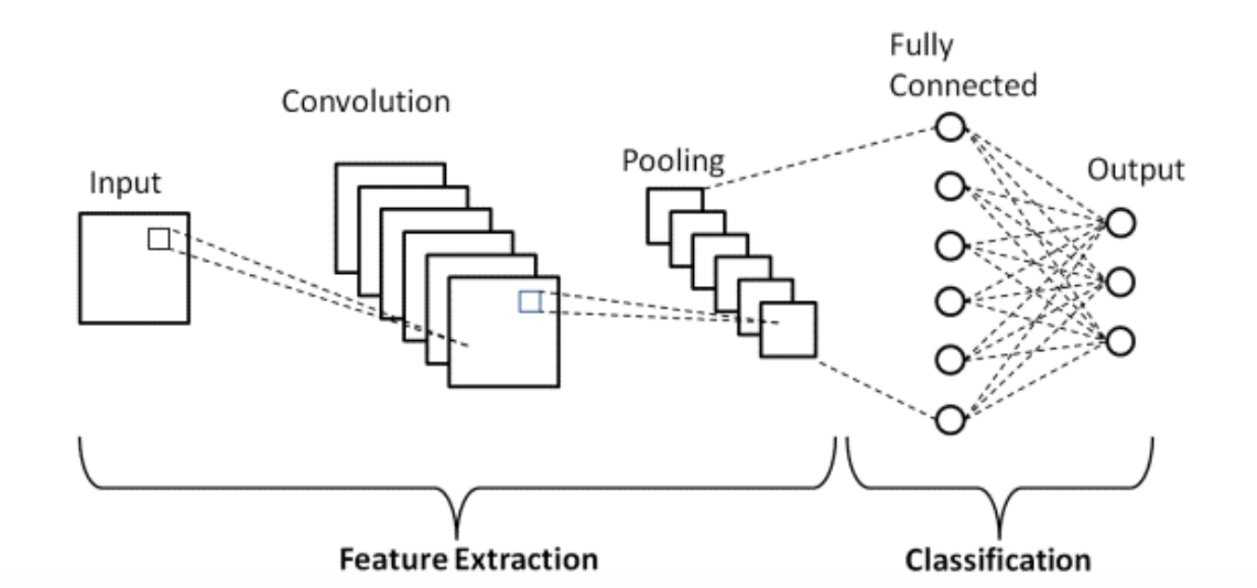

**Figure 5.1 CNN architecture diagram**

**5.3 CONVOLUTIONAL LAYER**

The first layer utilized to extract the different features from the input photos is this one. Convolution is a mathematical process that is carried out at this layer between the input image and a filter of a specific size, MxM. The dot product is taken between the filter and the input image's components with regard to the filter's size by sliding the filter over the input image (MxM).

After applying the convolution operation to the input, CNN's convolution layer moves the output to the following layer. As guarantee the spatial relationship between the pixels is preserved, convolutional layers in CNN are very advantageous.

* 1. **POOLING LAYER**

A Pooling Layer often comes after a Convolutional Layer. This layer's main goal is to lower the convolved feature map's size in order to save on computational expenses. This is done independently on each feature map and by reducing the links between layers. There are various sorts of pooling operations, depending on the mechanism utilized. Essentially, it is a summary of the features produced by a convolution layer.

Typically, the Pooling Layer acts as a link between the FC Layer and the Convolutional Layer. This CNN approach allows the networks recognize the features on their own by generalizing the characteristics extracted by the convolution layer. This assists in decreasing computations within a network.

**5.5 FULLY CONNECTED LAYER**

The Fully Connected (FC) layer, which links the neurons between two layers, is made up of the weights and biases as well as the neurons. The final few layers of a CNN Architecture are often placed before the output layer. The input image from the layers below is flattened and supplied to the FC layer in this. The flattened vector is then put through a few additional FC layers, where the standard operations on mathematical functions happen. The classification procedure starts to take place at this point. Because two fully connected layers will function better than one connected one, two layers are connected. These CNN layers lessen the need for human oversight.

**CHAPTER - 6**

**SYSTEM IMPLEMENTATION**

Experimental results and discussion are explained in this chapter. A brief description of implementation is given below. First the MR image is taken as input; the input image is taken as .jpg format. The preprocessing is done to remove noise. Then the image is segmented and it uses fully automatic convolutional neural network for classification. To perform this experiment Windows 10 have been used and the software have been executed in computer Pentium IV 2.4 GHz.

**6.1 INPUT IMAGE**

MR image is given as an input as it has high resolution. Input image is also a grey scale image. The input itself a grey scale image and so we don’t need to go for any color conversion procedure. The database consists of images of normal and abnormal brain tumor images. Among those images single image is taken as the input.

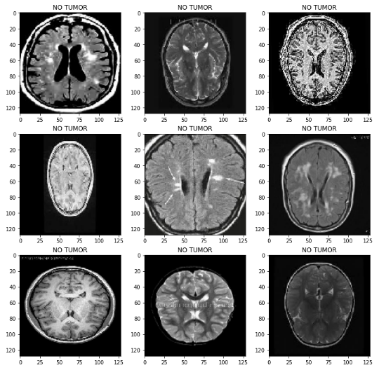

**Figure 6.1** Input Image

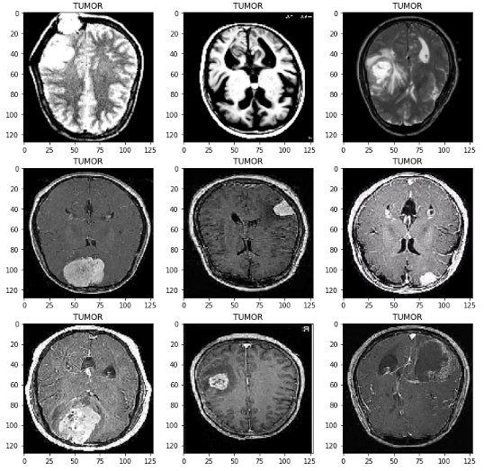

**Figure 6.2** Input Image

**Figures 6.1 and 6.2 display the input images of the normal and the brain tumor, respectively.**

**6.2 PRE-PROCESSING IMAGE**

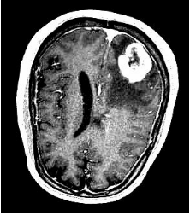

**Figure 6.3** Pre-Processed Image

Figure 6.3 shows the pre-processed image. Every image requires a minimal amount of pre-processing before applying actual procedure to make it appropriate for further processing. The pre-processing is done with the help of adaptive median filter. It is done to remove the salt and pepper noise and also for the image enhancement. This filter removes the noise and unwanted distortion in the image to make further process easier. In pre-processing the image is resized into 256*256 pixels in size. It is a process which is used to boost the precision and interpretability of an image. The main advantage of using this filter is this does not erode away edges in the image.

**6.3 SEGMENTED IMAGE**

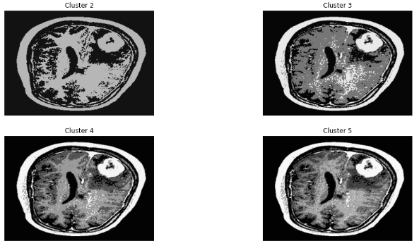The gray scale images are converted to binary data. The image segmentation is used to mask the brain and non-brain areas. Segmentation is the process of partitioning a digital image into multiple segments. First segmentation involves the intensity standardization in order to standardize the pixel range so that brain and non-brain areas are differentiated. Then masking is done for the non-brain regions then segmentation result is obtained. Figure 6.4 Presents The Brain Image Kmeans Cluster Segmentation.

**Figure 6.4 Kmeans Cluster Segmentation**

**6.4 NORMALIZATION**

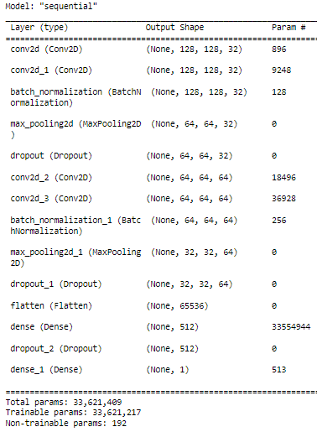

**Figure 6.5 The Normalization image**

**6.5 CLASSIFICATION**

The CNN based classification is divided into two phase such as training and testing phase. The number of images is divided into different category by using labels such as tumor and non-tumor images. It consists of three hidden layers. Training is done through RProop which is the fastest weight updating mechanism. The test image is given to the pre-trained neural network then CNN classifies the input image by taking test images as a reference. Figure 6.6 shows the accuracy report of the CNN classifier.

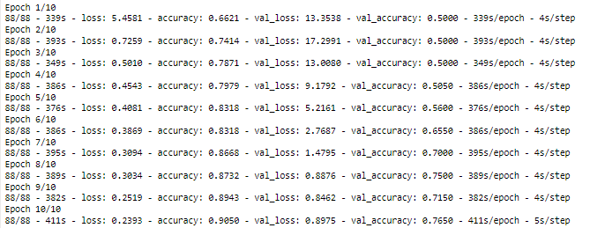

**Figure 6.6 Classifier-CNN**

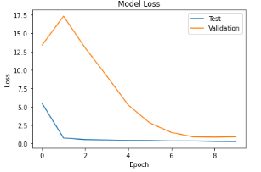

**Figure 6.7 Model Loss**

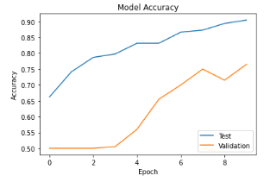

**Figure 6.8 Model Accuracy**

**Figures 6.7 and 6.8 show illustrations of the model loss and model accuracy, respectively.**

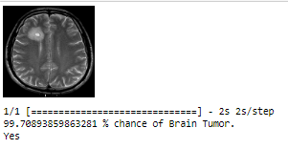

**Figure 6.9 Predicted Output with Tumor**

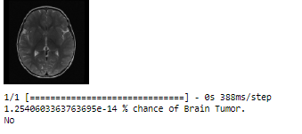

**Figure 6.10 Predicted Output with No Tumor**

The output images of the tumor and the non-tumor are separately displayed in Figures 6.9 and 6.10. The proposed method gives clear classification on types of tumor and brain tumor. This method is not only used for classification and also effective in edge detection in the stroke lesion areas which is very much useful for the radiologist for the immediate treatment.

**CHAPTER – 7**

**FUTURE ENHANCEMENT**

There are several feature enhancements that could potentially improve the performance of a CNN-based method for detecting brain tumors in MRI images. Here are some suggestions:

1. Data augmentation: By applying different transformations to the existing MRI images, such as rotation, flipping, scaling, or adding noise, we can increase the size of the training dataset and improve the model's ability to generalize to new data.
2. Transfer learning: Pre-training the CNN on a larger dataset of general images, such as ImageNet, and then fine-tuning it on the brain MRI dataset can improve the model's ability to extract useful features from the input images.
3. Attention mechanisms: By adding attention mechanisms to the CNN architecture, the model can learn to focus on specific regions of the input image that are most relevant for tumor detection, leading to better performance.
4. Ensemble models: Training multiple CNN models with different architectures or hyperparameters, and then combining their predictions, can improve the overall performance of the system.
5. Multi-modal data fusion: By combining different imaging modalities, such as T1-weighted, T2-weighted, and FLAIR MRI images, the model can learn to extract complementary information from each modality, leading to better performance.
6. Explainability: By incorporating methods for visualizing the learned features and decision-making process of the CNN, we can gain insights into the model's behavior and improve its interpretability for clinical use.
7. Incorporating domain knowledge: Expert knowledge about brain anatomy and tumor characteristics can be incorporated into the CNN architecture to guide the feature extraction process and improve the accuracy of the model.
8. Semi-supervised learning: Unlabeled MRI images can be used to augment the training dataset and improve the model's performance by leveraging self-supervision techniques or incorporating unsupervised learning methods.
9. Active learning: By incorporating active learning techniques, the model can learn to select the most informative samples for labeling, thereby reducing the amount of labeled data needed for training and improving the model's performance.
10. Adversarial training: Adversarial training can be used to improve the robustness of the CNN by training it to resist perturbations to the input images that are designed to fool the model.
11. Handling class imbalance: Since brain tumors are relatively rare, class imbalance can be a problem for the CNN. Techniques such as oversampling, undersampling, or using weighted loss functions can be used to address this issue.
12. Optimization techniques: Using advanced optimization techniques, such as adaptive learning rates or batch normalization, can improve the convergence speed and stability of the CNN during training, leading to better performance.

Overall, there are many ways to enhance the features of a CNN-based method for detecting brain tumors in MRI images. Choosing the appropriate techniques depends on the specific characteristics of the dataset and the performance goals of the system.

**CHAPTER - 8**

**CONCLUSION**

Early classification of brain tumors from magnetic resonance imaging (MRI) plays an important role in the diagnosis of such diseases. There are many diagnostic imaging methods used to identify tumors in the brain. MRI is commonly used for such tasks because of its unmatched image quality. This project's purpose is to detect the brain tumor using CNN classification. The proposed technique achieved the maximum performance in brain tumor detection, with 99.70% validation accuracy. This demonstrates the project's efficacy and the possibility of employing CNN to quickly identify brain tumors using MRI.

**CHAPTER - 9**

**BIBLIOGRAPHY**

**9.1 JOURNAL REFERENCES**

1. Neelum Noreen, Sellappan Palaniappan, Abdul Qayyum , Iftikhar Ahmad, Muhammad Imran, Muhammad Shoaib, 2020, “A Deep Learning Model Based on Concatenation Approach for the Diagnosis of Brain Tumor”, IEEE Access, vol. 08, pp. 55135-55144.
2. Abdu Gumaei, Mohammad Mehedi Hassan, Md Rafiul Hassan, Abdulhameed Alelaiwi, Giancarlo Fortino, 2019, “A Hybrid Feature Extraction Method with Regularized Extreme Learning Machine for Brain Tumor Classification”, IEEE Access, vol. 07, pp. 36266-36273.
3. Andres Anaya-Isaza, Leonel Mera-Jimenez, 2022, “Data Augmentation and Transfer Learning for Brain Tumor Detection in Magnetic Resonance Imaging”, IEEE Access, vol. 10, pp. 23217-23233.
4. Mohamed Shakeel.P, Tarek E. El.Tobely, Haytham Al-Feel, Gunasekaran Manogaran, Baskar.S, 2019, “Neural Network Based Brain Tumor Detection Using Wireless Infrared Imaging Sensor”, IEEE Access, vol. 07, pp. 5577-5588.
5. Gunasekaran Manogaran, P. Mohamed Shakeel, Azza S. Hassanein, Priyan Malarvizhi Kumar, Gokulnath Chandra Babu, 2018, “Machine Learning Approach-Based Gamma Distribution for Brain Tumor Detection and Data Sample Imbalance Analysis”, IEEE Access, vol. 07, pp. 12-19.
6. Ankit Vidyarthi, Ruchi Agarwal, Deepak Gupta, Rahul Sharma, Dirk Draheim, Prayag Tiwari, 2022, “Machine Learning Assisted Methodology for Multiclass Classification of Malignant Brain Tumors”, IEEE Access, vol. 10, pp. 50624-50640.
7. Saif Ahmad, Pallab K. Choudhury, 2022, “On the Performance of Deep Transfer Learning Networks for Brain Tumor Detection Using MR Images”, IEEE Access, vol. 10, pp. 59099-59114.
8. Mohammad Shahjahan Majib, Mahbubur Rahman, T.M. Shahriar Sazzad, Nafiz Imtiaz Khan, Samrat Kumar Dey, 2021, “VGG-SCNet: A VGG Net-Based Deep Learning Framework for Brain Tumor Detection on MRI Images”, IEEE Access, vol. 09, pp. 116942-116952.
9. Chao Ma, Gongning Luo, Kuanquan Wang, 2018, “Concatenated and Connected Random Forests With Multiscale Patch Driven Active Contour Model for Automated Brain Tumor Segmentation of MR Images”, IEEE Transactions On Medical Imaging, vol. 37, no. 8, pp. 1943-1954.
10. Hasan Ucuzal, Seyma Yasar, Cemil Colak, 2019, “Classification of brain tumor types by deep learning with convolutional neural network on magnetic resonance images using a developed web-based interface”, IEEE Access, pp. 01-05.
11. Zhenyu Tang, Yuyun Xu, Lei Jin, Abudumijiti Aibaidula, Junfeng Lu, Zhicheng Jiao, Jinsong Wu, Han Zhang, Dinggang Shen, 2019, “Deep Learning of Imaging Phenotype and Genotype for Predicting Overall Survival Time of Glioblastoma Patients”, IEEE Transactions on Medical Imaging, pp. 01-10.
12. Wu Deng, Qinke Shi, Miye Wang, Bing Zheng, Ning Ning, 2020, “Deep Learning-Based HCNN and CRF-RRNN Model for Brain Tumor Segmentation”, IEEE Access, vol. 08, pp. 26665-26674.
13. Sohaib Asif, Wenhui Yi, Qurrat Ul Ain, Jin Hou, Tao Yi, Jinhai Si, 2022, “Improving Effectiveness of Different Deep Transfer Learning-Based Models for Detecting Brain Tumors From MR Images”, IEEE Access, vol. 10, pp. 34716-34730.
14. B.Deepa, M.Murugappan, M.G.Sumithra, Mufti Mahmud, Mabrook S. Al-Rakhami, 2022, “Pattern Descriptors Orientation and MAP Firefly Algorithm Based Brain Pathology Classification Using Hybridized Machine Learning Algorithm”, IEEE Access, vol. 10, pp. 3848-3863.
15. Mohammad Ashraf Ottom, Hanif Abdul Rahman, Ivo D. Dinov, 2022, “Znet: Deep Learning Approach for 2D MRI Brain Tumor Segmentation”, Medical Imaging and Diagnostic Radiology, vol. 10, pp. 01-08.

**9.2 BOOK REFERENCES**

* Martin C. Brown, Python: The Complete Reference, Fourth Edition, McGraw Hill Education, 2018.
* Wes McKinney, Python for Data Analysis, Second Edition, O’Reilly Media Inc., 2017.
* Manaranjan Pradhan, U Dinesh Kumar, Machine Learning Using Python, Wiley, 2019.
* Aurélien Géron, Hands-On Machine Learning with Scikit-Learn, Keras, and TensorFlow: Concepts, Tools, and Techniques to Build Intelligent Systems, Third Edition, O’Reilly, 2022.
* Ian Sommerville, Software Engineering, Tenth Edition, Pearson Education, 2017.
* Bob Hughes, Mike Cotterell, Rajib Mall, Software Project Management (SIE), 6th Edition, 2017
* Alan Dennis, Barbara Haley Wixom, Roberta M. Roth, Systems Analysis and Design, 4th Edition, 2009.
* Mohit Sewak, Md. Rezaul Karim, Pradeep Pujari, Practical Convolutional Neural Networks: Implement advanced deep learning models using Python, Packt Publishing Limited, 2018.
* Charu C. Aggarwal, Neural Networks and Deep Learning, 1st edition, Springer; 2018.

**9.3 WEBSITE REFERENCES**

<https://en.wikipedia.org/wiki/Convolutional_neural_network> <https://en.wikipedia.org/wiki/Artificial_neural_network>

<https://www.geeksforgeeks.org/introduction-convolution-neural-network> <https://en.wikipedia.org/wiki/Brain_tumor>

<https://iopscience.iop.org/article/10.1088/1757-899X/1055/1/012115/pdf>