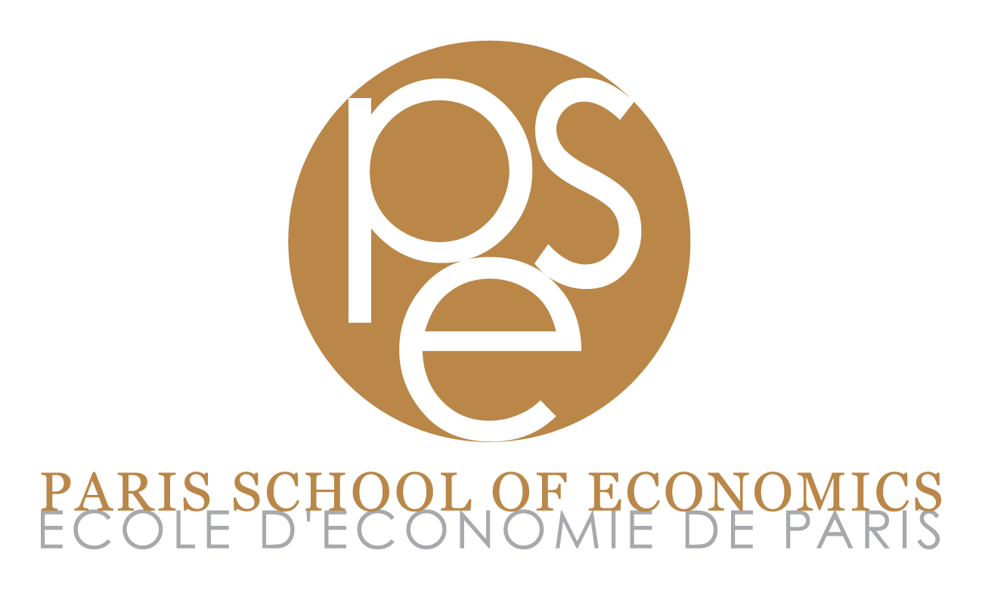

Name: Anna Ziff

Affiliation: Duke University

Current Position: Ph.D. Candidate (degree expected in May 2024)

Please answer the following three questions:

1. Explain why you are interested by a position at the Paris School of Economics (150 words maximum).
PSE provides a riogrous environment to grow as an economist after graduating from the Ph.D. I seek this type of opportunity to develop my research agenda and collaborate with colleagues working on issues in applied microeconomics.

2. Which research group(s) of the Paris School of Economics would you be willing to interact with? Please explain why (150 words maximum). See https://www.parisschoolofeconomics.eu/en/research/pse-research-groups/
I would be interested in interacting in the (1) Labour and Public Economics, (2) Regulation, Environment, Market, and (3) Development groups. I am intereested in topics in these areas. Currently as a Ph.D. student, I attend seminars in these fields.

3. Have you ever had any connection to economics profession or economics education in France? If yes, please provide a detailed description (150 words maximum).
I have not had any connection.

