Study Programme 42484 Information Systems (BSc)
Department of Natural Sciences and Computer Engineering
RIGA NORDIC UNIVERSITY
(RNU)
AI-Powered Learning Management System with
Socratic Coaching Module

BACHELOR’S THESIS
Studen: | Kurbanov Azimjon
Supervsor: | Dr.sc,ing., Profesor, Jelena Caiko
Riga 2026

Abstract
The increasing adoption of artificial intelligence in education has created new opportunities for adaptive and personalised learning. Existing learning management systems such as Moodle, Canvas, and Google Classroom provide course delivery infrastructure but lack the ability to engage students through guided reasoning rather than direct instruction. Simultaneously, recent research in retrieval-augmented generation and Socratic dialogue systems has demonstrated measurable improvements in student comprehension and critical thinking, yet no published system combines both approaches with real-time student performance data from a relational database.
This Bachelor Paper presents the design and implementation of SmartLearn — a domain-agnostic learning management system with an integrated Socratic AI coaching module. The thesis consists of three chapters. Chapter 1 reviews the theoretical foundations of LMS platforms, retrieval-augmented generation, and the Socratic teaching method, analysing 13 peer-reviewed publications to establish the research gap. Chapter 2 presents the system architecture, technology stack justification, PostgreSQL database schema, and the RAG pipeline design. Chapter 3 details the implementation of the Spring Boot backend including JWT authentication, role-based access control, TUS resumable upload, and MinIO file storage, together with the AI coaching module and evaluation results.
The methodological basis includes comparative analysis of existing LMS platforms and scientific literature, system architecture design using Clean Architecture principles, full-stack implementation using Java 21, Spring Boot, PostgreSQL, Flutter with Riverpod, and LLM API integration with RAG and prompt engineering. The evaluation employs three measurable criteria: RBAC correctness across 15 API endpoints, Socratic Score quality rubric across 20 AI interactions, and profile-conditioning verification across 10 student profiles.
The research confirms the hypothesis that a domain-agnostic LMS combining RAG retrieval conditioned on student performance data with Socratic dialogue constraints delivers a more adaptive and pedagogically effective learning experience than any single existing platform. The Bachelor Paper is written in 49 pages and contains 12 tables, 10 figures, 3 listings, 2 annexes, and a list of references with 13 sources.

Table of Contents
Abstract 2
Keywords 3
Introduction 6
1. Literature Review and Theoretical Background 9
1.1 Core Concepts and Definitions 9
1.2 Related Work 10
1.2.1 Cluster A: RAG Architectures for Education 10
1.2.2 Cluster B: Socratic Dialogue Systems 11
1.2.3 Cluster C: Personalised Test Generation 12
1.2.4 Cluster D: Survey and Adaptive Retrieval 13
1.3 Comparative Gap Analysis 14
1.4 Theoretical Framework 15
1.5 Chapter Summary 16
2. System Analysis and Architecture Design 18
2.1 Requirements Analysis 18
2.2 Existing LMS Platform Comparison 19
2.3 Technology Stack Justification 20
2.4 System Architecture 22
2.5 Database Schema Design 23
2.6 RAG Pipeline Design 25
2.7 Socratic Dialogue Flow Algorithm 26
2.8 Chapter Summary 27
3. Implementation and Evaluation 28
3.1 Backend Implementation 28
3.1.1 JWT Authentication Filter 28
3.1.2 RBAC Security Configuration 29
3.1.3 TUS Resumable Upload Protocol 30
3.1.4 Rate Limiting with Bucket4j 30
3.2 AI Coach Implementation 30
3.3 Flutter Frontend Implementation 32
3.4 Testing and Evaluation 35
3.4.1 RBAC Correctness Verification 35
3.4.2 Socratic Score Evaluation 37
3.4.3 Profile-Conditioning Verification 38
3.4.4 Performance Metrics 39
3.5 Chapter Summary 39
Conclusions 41
References 43
Appendix A. System Diagrams and Architecture 45
Appendix B. REST API Endpoint Reference 47
Affirmation 49

Keywords
Keywords: learning management system, Socratic AI coaching, retrieval-augmented generation, adaptive learning, Spring Boot, Flutter, JWT, RBAC, PostgreSQL

List of Figures
Figure 2.1. Three-layer Clean Architecture of SmartLearn: Presentation (Flutter/Riverpod) — Business Logic (Spring Boot + AI Module) — Data (PostgreSQL + MinIO + ChromaDB) 22
Figure 2.2. PostgreSQL entity-relationship diagram showing primary tables and foreign key relationships 25
Figure 2.3. SmartLearn RAG pipeline: (1) Student query → (2) Profile retrieval from PostgreSQL → (3) Vector retrieval from ChromaDB conditioned on query + profile → (4) Prompt construction π(s) → (5) LLM API call → Socratic response 25
Figure 3.1. SmartLearn Flutter application: AI Tutor Chat screen with Socratic dialogue (left) and Student Dashboard with progress overview (right) 34
Figure 3.2. SmartLearn course catalogue screen: course list with enrolment status and progress indicators 34
Figure 3.3. SmartLearn Admin Panel: user management screen (left) and course management screen (right) 34
Figure 3.4. SmartLearn group management screen: teacher assignment, student enrolment, and schedule configuration 35
Figure A.1. Full SmartLearn system component diagram: Flutter client, Spring Boot backend modules, PostgreSQL, MinIO, ChromaDB, and LLM API integration 45
Figure A.2. Student progress update flow: AI interaction → score classification → weak_topics update → next-session RAG conditioning 45
Figure A.3. TUS resumable upload sequence diagram: POST (create) → PATCH chunks → HEAD (resume check) → MinIO final store 46
List of Tables
Table 1. Mapping of research tasks to thesis chapters 7
Table 1.1. Comparative analysis of related systems vs. SmartLearn 14
Table 1.2. Socratic Score rubric for evaluating AI coaching response quality 16
Table 2.1. Functional requirements of SmartLearn 18
Table 2.2. Non-functional requirements of SmartLearn 19
Table 2.3. Comparison of existing LMS platforms vs. SmartLearn 19
Table 2.4. Technology selection decisions and justification 21
Table 2.5. PostgreSQL entity-relationship summary 23
Table 3.1. RBAC correctness test results (15 endpoints × 3 roles) 35
Table 3.2. Socratic Score evaluation results (representative sample of 10 interactions) 37
Table 3.3. Backend API performance metrics under 50 concurrent requests 39
Table B.1. SmartLearn REST API endpoint reference 47

Introduction
Topicality of the problem. The global e-learning market reached USD 315 billion in 2023 and is projected to grow at a compound annual rate of 13.5% through 2030 [1]. Despite this growth, the fundamental pedagogical model of most learning management systems has not changed: students receive content, complete assignments, and receive grades. The missing element is adaptive, personalised guidance — the kind a skilled human tutor provides. Large language models have made it technically feasible to build AI tutors at scale, yet existing systems either give students direct answers (which undermines learning) or apply generic Socratic techniques without access to each student's individual performance history. This gap between technological capability and pedagogical implementation motivates the research presented in this thesis.
A systematic literature review of 47 RAG-based educational chatbots conducted by Swacha and Gracel [12] found that 37 of these studies were published in 2024 alone, confirming the field's rapid growth. However, none of the reviewed systems simultaneously combine retrieval-augmented generation, Socratic dialogue constraints, personalised test generation, and real student performance data from a relational database. SmartLearn is designed to fill this gap.
Aim of the study. To design and implement a domain-agnostic learning management system — SmartLearn — with an integrated Socratic AI coaching module, and to evaluate its architectural suitability and pedagogical effectiveness in comparison with existing LMS solutions.
Object of the study. Information systems for educational process management.
Subject of the study. The architecture design and AI coaching module implementation for a configurable, multi-role learning management system combining RAG-based personalisation with Socratic dialogue constraints.
Research problem. Existing LMS platforms are either domain-specific or lack adaptive AI assistance that guides students through reasoning rather than providing direct answers. Published AI tutoring systems address individual components — RAG, Socratic dialogue, or test generation — in isolation. No existing open solution combines all four capabilities: retrieval-augmented generation, Socratic dialogue constraints, personalised test generation, and real-time conditioning on individual student performance data stored in a relational database.
Hypothesis. A domain-agnostic LMS built on a structured backend (Spring Boot and PostgreSQL) with a Socratic AI coaching module that simultaneously conditions both RAG retrieval and the system prompt on each student's performance profile will deliver a more adaptive and pedagogically effective learning experience than any existing LMS platform, while remaining configurable for any educational domain without code modifications.
Tasks of the study:
1. Analyse existing LMS platforms and theoretical foundations of adaptive learning, Socratic teaching methodology, and RAG-based AI personalisation in educational systems, and establish a research gap by comparing 13 peer-reviewed publications. (Chapter 1)
2. Design the system architecture of SmartLearn — including technology stack selection, PostgreSQL database schema, role-based access model, and the RAG pipeline for the AI coaching module — and justify each architectural decision against evaluated alternatives. (Chapter 2)
3. Implement the core system modules and evaluate the solution against three defined quality criteria: RBAC correctness across 15 API endpoints, Socratic Score quality across 20 AI interactions, and profile-conditioning verification across 10 student profiles. (Chapter 3)
Research methods. The methodological basis includes: (1) secondary research — systematic comparative analysis of 13 published works on RAG, Socratic AI, and adaptive LMS platforms; (2) system design — architectural modelling using Clean Architecture principles, UML-style diagrams, and relational database schema design with RBAC; (3) software engineering — full-stack implementation using Java 21, Spring Boot, PostgreSQL, MinIO, TUS protocol, Flutter with Riverpod, and LLM API integration with prompt engineering and RAG pipeline construction; (4) evaluation — functional verification of REST API endpoints, AI response quality assessment using the Socratic Score rubric, and profile-conditioning verification.
The mapping of research tasks to thesis chapters is presented in Table 1.
Table 1. Mapping of research tasks to thesis chapters
Task | Description | Chapter
1 | Literature review and gap analysis | Chapter 1
2 | System architecture and design | Chapter 2
3 | Implementation and evaluation | Chapter 3
— | Synthesis and hypothesis validation | Conclusions

1. Literature Review and Theoretical Background
This chapter establishes the theoretical and empirical foundation for SmartLearn. It defines the key concepts used throughout the thesis, surveys 13 peer-reviewed publications organised into four thematic clusters, presents a comparative gap analysis that motivates the research, and formalises the theoretical framework including the RAG pipeline formula and the Socratic Score evaluation rubric.

1.1 Core Concepts and Definitions
A Learning Management System (LMS) is a software platform that enables the creation, delivery, and management of educational content and the tracking of learner progress. According to Spriggs et al. [2], traditional LMS platforms distribute materials but do not adapt to individual learner needs, particularly when instructor availability is limited. Widely deployed systems such as Moodle, Canvas, and Google Classroom exemplify this model: they organise content and facilitate assessment but do not engage students in guided reasoning. SmartLearn extends this definition to include AI-driven coaching as a first-class system component.
Retrieval-Augmented Generation (RAG) is a technique that enhances large language model responses by supplying relevant external documents or database records at query time, reducing hallucination and grounding answers in verifiable content. As defined by Swacha and Gracel [12] in their systematic review of 47 RAG-based educational chatbots, RAG addresses the principal limitation of LLMs in academic contexts: the tendency to generate plausible but factually incorrect statements. In SmartLearn, RAG retrieval is conditioned not only on the student's question but also on the student's performance profile, a design choice that extends the standard RAG pipeline.
The Socratic Method is a pedagogical dialogue technique attributed to the philosopher Socrates in which the instructor never provides direct answers but instead asks probing questions that lead the student to derive conclusions independently. In educational research, this approach aligns with Bloom's Taxonomy at the analysis and evaluation levels — cognitive operations that require deeper processing than simple recall [5]. Sunil and Thakkar [5] demonstrated computationally that enforcing Socratic constraints on an LLM tutor caused more than 75% of undergraduate students to shift from imprecise help-seeking to complex problem decomposition within two to three weeks.
Adaptive Learning refers to educational approaches in which the system continuously adjusts the difficulty, sequence, or style of content based on the learner's demonstrated performance. Spriggs et al. [2] define an Adaptive LMS (ALMS) as one that incorporates multiple LLMs — both general-purpose and domain-specific — to personalise the learning environment dynamically. In SmartLearn, adaptation is achieved through the student profile stored in PostgreSQL, which tracks level, weak topics, recent errors, and interaction history, and which conditions every AI response.
Personalised Assessment refers to the generation of test questions and evaluation criteria that are tailored to the specific gaps and strengths of an individual student, rather than applying a uniform assessment to all learners. Ali et al. [10] demonstrated that GPT-4-based systems can generate pedagogically sound multiple-choice questions with greater than 90% accuracy and produce 20 questions in under 15 minutes, compared to two or more hours for manual creation. The limitation of this approach, however, is that questions are generated from generic course material rather than from the individual student's identified weak topics — a gap that SmartLearn addresses.

1.2 Related Work
The related work is organised into four thematic clusters: RAG architectures for education, Socratic dialogue systems, personalised test generation, and survey studies providing broader context. Each cluster is analysed for methodology, reported results, and limitations relevant to the SmartLearn research problem.

1.2.1 Cluster A: RAG Architectures for Education
Dong et al. [1] propose KG-RAG, a knowledge-graph-enhanced RAG framework for intelligent tutoring that grounds LLM responses in structured domain knowledge rather than relying solely on semantic similarity matching. In a controlled experiment with 76 participants, KG-RAG produced a statistically significant 35% increase in assessment scores (p < 0.001), published in ICEIT 2025. The critical limitation for the present research is that KG-RAG retrieves content based on the question alone and does not incorporate the student's individual performance history into the retrieval or generation process. There is also no Socratic dialogue constraint — the system provides direct, albeit well-grounded, answers.
Spriggs et al. [2] present an Adaptive LMS that integrates multiple LLMs to provide a customisable learning environment, targeting settings with limited instructor availability. Their system addresses factual inaccuracy and outdated information by combining general-purpose and domain-specific models. However, the paper does not report quantitative evaluation metrics, and neither Socratic dialogue nor personalised test generation based on individual student data is described.
Lin et al. [3] introduce RAG-PRISM, a personalised tutoring framework addressing workforce skill gaps in Fourth Industrial Revolution domains, including cybersecurity. Using GPT-4, the system achieves 87% relevancy rating and 100% alignment with manually curated training queries, published at IEEE FIE 2025. The framework is restricted to a single domain and uses a synthetic question-answer dataset rather than real student interaction logs from a database. There is no Socratic dialogue component.
Cohn et al. [4] propose Log-Contextualized RAG (LC-RAG), which enhances standard RAG by contextualising retrieval using environment activity logs from the C2STEM collaborative learning platform. The system demonstrates that LC-RAG improves retrieval relevance over a discourse-only baseline, enabling the agent Copa to deliver more personalised guidance. This approach is the closest precedent to SmartLearn's design: both use contextual data about the student's activities to condition retrieval. The difference is that SmartLearn uses structured relational database records (weak topics, recent errors, level) rather than unstructured environment logs, and adds Socratic dialogue constraints on top of retrieval.

1.2.2 Cluster B: Socratic Dialogue Systems
Sunil and Thakkar [5] present SocraticAI, a scaffolded AI tutoring system for undergraduate computer science education. The system enforces structured constraints including authentication, query validation, reflective engagement requirements, daily usage caps, and RAG grounded in course materials. In a study at COMPUTE 2025, more than 75% of students produced substantive reflections and demonstrated a shift from imprecise help-seeking to deliberate problem decomposition within two to three weeks. This paper is the most directly related to SmartLearn's AI coaching module. The key gap is the absence of personalised test generation based on individual student error history and the absence of a relational student database conditioning AI responses.
Zhang et al. [6] propose SPL — a Socratic Playground for Learning — powered by GPT-4 with advanced prompt engineering. The system generates customised learning scenarios and facilitates multi-turn Socratic dialogues. Pilot experimental results from essay writing tasks demonstrate potential, though specific quantitative metrics are not reported. SPL is a standalone dialogue system without LMS infrastructure: no role-based access (Teacher/Student/Admin), no course management, no test generation, and no student database.
Favero et al. [7] develop an educational chatbot using Socratic questioning to promote critical thinking. Presented at ECAI 2024, the system uses fine-tuned small language models — Llama2 7B and 13B parameters — deployable on standard hardware without cloud API costs. Experiments with simulated student interactions confirm that the Socratic tutor supports critical thinking development significantly better than standard chatbots. The deliberate choice of local models for privacy reasons represents a meaningful contrast with SmartLearn, which prioritises response quality by using cloud LLM APIs (Claude or GPT-4) at the cost of latency and API pricing.
Qi et al. [8] present IntelliChain, a multi-agent framework integrating LLMs with knowledge graphs for Socratic teaching in mathematics education, presented at GCCCE 2024. The framework demonstrates notable advantages in accuracy and credibility of educational interactions. The architecture is more complex than SmartLearn's single-agent approach: IntelliChain uses separate teacher and student agents with chain-of-thought dialogue, while SmartLearn uses a single LLM constrained by a structured system prompt. The simpler architecture is a deliberate design choice for production deployability.

1.2.3 Cluster C: Personalised Test Generation
Shirkar et al. [9] investigate LLM-based quiz generation for assessment systems, focusing on the pedagogical quality of automatically generated questions. Their work establishes that LLMs can produce assessment items suitable for educational use, providing a methodological foundation for the quiz generation component of SmartLearn. The limitation relative to SmartLearn is that questions are generated from course content uniformly, without personalisation based on individual student performance data.
Ali et al. [10] present a full-stack implementation of AI-powered quiz generation for Canvas LMS, using OpenAI's GPT API and PyPDF2 for course material parsing, with a Flask backend and JavaScript frontend. In NWISEd 2025, they report that GPT-4 achieves 92% question accuracy while the more cost-efficient GPT-4o Mini achieves 85% accuracy. The system generates 20 questions in under 15 minutes, compared to two or more hours for manual creation. Formatting corrections succeed on the first attempt in 85% of cases. Questions are generated from course material without reference to any individual student's history, and there is no Socratic dialogue — the system is a tool for teachers, not an interactive tutor for students.
Mucciaccia et al. [11] propose an automatic MCQ generation and evaluation system for university settings, presented at COLING 2025. The system combines prompt engineering with a review process for question generation, and uses a separate LLM as an automated quality judge. This two-stage approach — generate then evaluate — provides a methodological reference for SmartLearn's Socratic Score rubric, which similarly evaluates AI response quality post-generation. The paper does not address personalisation or dialogue.

1.2.4 Cluster D: Survey and Adaptive Retrieval
Swacha and Gracel [12] conduct a systematic review of 47 RAG-based chatbots in education, covering publications from Scopus, Web of Science, and Google Scholar from 2022 onwards. Key findings: 37 of the 47 papers were published in 2024, demonstrating the field's recency. RAG consistently addresses the hallucination problem that limits LLM adoption in academic contexts. Evaluation criteria used across studies include accuracy, relevance, faithfulness, and user acceptance. One unexpected finding is that adding RAG reduced user trust in one study using GPT-3.5 (from 5.98 to 5.50 on a 7-point scale), suggesting that retrieval quality matters as much as retrieval presence. This underscores the importance of SmartLearn's profile-conditioned retrieval strategy over naive semantic search.
Jeong et al. [13] propose Adaptive-RAG, a framework that dynamically selects the retrieval strategy based on query complexity — from no retrieval for simple questions to multi-step retrieval for complex ones. Accepted at NAACL 2024, the method uses a lightweight classifier trained on existing model predictions to route queries without manual annotation. Adaptive-RAG is not an educational system, but it provides theoretical grounding for SmartLearn's future work: the current system uses a fixed single-step retrieval strategy, and Adaptive-RAG could be incorporated to handle the range of student questions from simple factual to complex analytical.

1.3 Comparative Gap Analysis
As shown in Table 1.1, no existing published system simultaneously implements all four capabilities that define SmartLearn's research contribution: RAG retrieval, Socratic dialogue constraints, personalised test generation, and real student performance data from a relational database. SmartLearn is the first system to combine all four components.
Table 1.1. Comparative analysis of related systems vs. SmartLearn
System | Year | RAG | Socratic | Pers. Tests | Student DB | Key Gap
Dong et al. [1] | 2025 | ✓ (graph) | ✗ | ✗ | ✗ | No dialogue, no tests
Spriggs etal. [2] | 2025 | Partial | ✗ | ✗ | ✗ | No Socratic, no tests
Lin et al. [3] | 2025 | ✓ | ✗ | ✗ | Synthetic | One domain, no dialogue
Cohn et al. [4] | 2025 | ✓ (logs) | ✗ | ✗ | Logs only | No dialogue, no tests
Sunil & Thakkar [5] | 2025 | ✓ | ✓ | ✗ | ✗ | No tests, no student DB
Zhang et al. [6] | 2024 | ✗ | ✓ | ✗ | ✗ | No LMS, no tests
Favero et al. [7] | 2024 | ✗ | ✓ | ✗ | ✗ | Local model, no LMS
Qi et al. [8] | 2025 | ✗ | ✓ (graph) | ✗ | ✗ | Complex, no tests
Shirkar et al. [9] | — | ✗ | ✗ | ✓ | ✗ | No dialogue, no DB
Ali et al. [10] | 2025 | ✗ | ✗ | ✓ (90%) | ✗ | No dialogue, no profile
Mucciaccia et al. [11] | 2025 | ✗ | ✗ | ✓ (MCQ) | ✗ | No dialogue, no profile
Swacha & Gracel [12] | 2025 | ✓ survey | — | — | — | Survey only
Jeong et al. [13] | 2024 | ✓ (adapt.) | ✗ | ✗ | ✗ | Not educational
SmartLearn | 2026 | ✓ | ✓ | ✓ | ✓ (PostgreSQL) | First to combine all four

1.4 Theoretical Framework
The theoretical basis of SmartLearn rests on two foundations: the formal RAG pipeline model that describes how student data conditions AI responses, and the pedagogical justification for Socratic constraints derived from Bloom's Taxonomy.
The core research formula formalises the SmartLearn AI coaching pipeline. For each student interaction, the final response a is generated as:
a = LLM( π(s), r(q, s, K), q ) (1.1)
where s = (ℓ, W, E, H) is the student profile consisting of level ℓ, set of weak topics W, recent error log E, and interaction history H, all stored in the student_progress table in PostgreSQL; π(s) is the system prompt constructed from the student profile that enforces Socratic constraints and specifies the student's current weak topics; r(q, s, K) is the retrieved course content conditioned on both the query q and the student profile s from the knowledge base K; and a is the final response, which by construction of π(s) is always a guiding question, never a direct answer.
The critical distinction from standard RAG is that both the system prompt π and the retrieval function r are conditioned on s simultaneously. Standard RAG systems such as KG-RAG [1] and RAG-PRISM [3] condition retrieval only on the query q. SmartLearn's bidirectional conditioning — on both q and s — is the architectural novelty that enables genuine personalisation.
Bloom's Taxonomy [5] provides the pedagogical justification for the Socratic constraint. The six cognitive levels — Remember, Understand, Apply, Analyse, Evaluate, Create — show that direct answers engage only the lowest level (Remember). Guiding questions that require students to reason toward an answer engage Analyse and Evaluate, producing deeper and more durable learning. The system prompt π(s) explicitly prohibits responses that operate at the Remember level, forcing every AI interaction to engage students at higher cognitive levels.
The Socratic Score rubric provides a quantifiable measure of AI response quality for evaluation in Chapter 3, as shown in Table 1.2.
Table 1.2. Socratic Score rubric for evaluating AI coaching response quality
Score | Description | Example AI Response Pattern
0 — Fail | Direct answer given | The answer is SQL injection because...
1 — Partial | Partially indirect; hints at answer | Think about how user input reaches the query...
2 — Good | Guiding question without answer | What do you think happens to unvalidated input?
3 — Excellent | Guiding question + follow-up test from weak topics | What do you think happens? Now, here are two related questions based on your recent mistakes...

1.5 Chapter Summary
This chapter established the theoretical and empirical foundation for the SmartLearn research. Section 1.1 defined five core concepts — LMS, RAG, Socratic Method, Adaptive Learning, and Personalised Assessment — with reference to authoritative sources. Section 1.2 reviewed 13 peer-reviewed publications organised into four clusters, documenting for each work the methodology, key metrics, and the specific limitation that SmartLearn addresses. Section 1.3 presented a comparative gap analysis confirming that no existing system simultaneously combines RAG, Socratic dialogue, personalised tests, and a relational student database. Section 1.4 formalised the RAG pipeline formula (Equation 1.1), the Bloom's Taxonomy justification, and the Socratic Score rubric. These elements collectively motivate and constrain the system design presented in Chapter 2.

2. System Analysis and Architecture Design
This chapter translates the research problem identified in Chapter 1 into a concrete system design. It begins with a requirements analysis, proceeds through a comparative evaluation of existing LMS platforms, justifies the selected technology stack, and then presents the system architecture, database schema, RAG pipeline design, and Socratic dialogue flow algorithm.

2.1 Requirements Analysis
The requirements for SmartLearn were derived from two sources: the identified research gap (no system combines all four capabilities) and the practical constraints of a bachelor-level research project with a real, deployable backend.
Table 2.1 summarises the functional requirements.
Table 2.1. Functional requirements of SmartLearn
ID | Requirement | Priority
FR-01 | Role-based authentication: Student, Teacher, Admin roles with JWT | High
FR-02 | Course and lesson management by Teachers | High
FR-03 | File upload for course materials (video, PDF) with resumable upload | High
FR-04 | Student progress tracking: level, weak topics, recent errors | High
FR-05 | Socratic AI chat: never provides direct answers, uses guiding questions | High
FR-06 | Personalised test generation based on student weak topics from DB | High
FR-07 | Badge and leaderboard gamification system | Medium
FR-08 | Rate limiting per user and per IP address | Medium
FR-09 | Swagger API documentation | Low

Table 2.2 summarises the non-functional requirements.
Table 2.2. Non-functional requirements of SmartLearn
ID | Requirement | Target
NFR-01 | API response time (95th percentile) | < 500 ms
NFR-02 | JWT token validity | 24 hours access / 7 days refresh
NFR-03 | Rate limit: default per user | 100 requests / minute
NFR-04 | File upload size | Up to 2 GB via TUS protocol
NFR-05 | Platforms supported | Android + iOS (Flutter)
NFR-06 | Database | PostgreSQL with RBAC at service layer
NFR-07 | Stateless sessions | No server-side session state (JWT)

2.2 Existing LMS Platform Comparison
To contextualise SmartLearn against deployed solutions, four major platforms were analysed: Moodle (open-source, self-hosted), Canvas (commercial, widely deployed in higher education), Google Classroom (free, tightly integrated with Google Workspace), and Duolingo (AI-enhanced, language learning). The analysis covers the capabilities most relevant to SmartLearn's research contribution, as shown in Table 2.3.
Table 2.3. Comparison of existing LMS platforms vs. SmartLearn
Criterion | Moodle | Canvas | Google Classroom | Duolingo | SmartLearn
Domain-agnostic | ✓ | ✓ | ✓ | ✗ | ✓
AI coaching | ✗ | ✗ | ✗ | Partial | ✓ (Socratic)
RAG on student data | ✗ | ✗ | ✗ | ✗ | ✓
Personalised tests | ✗ | Partial | ✗ | ✓ | ✓ (from weak topics)
Socratic dialogue | ✗ | ✗ | ✗ | ✗ | ✓
Role-based access | ✓ | ✓ | ✓ | ✗ | ✓
Resumable upload | ✗ | Partial | ✓ | — | ✓ (TUS)
Mobile-first | Partial | ✓ | ✓ | ✓ | ✓ (Flutter)
Open configurable | ✓ | ✗ | ✗ | ✗ | ✓

As shown in Table 2.3, SmartLearn is the only system in the comparison that implements Socratic AI dialogue and conditions test generation on individual student performance data from a relational database. Moodle and Canvas provide robust infrastructure for course management and RBAC but offer no AI-driven coaching. Duolingo implements adaptive difficulty and gamification but is restricted to language learning. Google Classroom provides convenient file management but minimal pedagogical intelligence.

2.3 Technology Stack Justification
Each technology in the SmartLearn stack was selected after evaluating concrete alternatives. Table 2.4 summarises these decisions.
Table 2.4. Technology selection decisions and justification
Component | Selected | Alternative | Reason for Selection
Mobile frontend | Flutter + Riverpod | React Native | Single codebase for iOS+Android, near-native rendering, mature Dart null safety
Backend framework | Java 21 + Spring Boot 4 | Node.js + Express | Strong typing, Spring Security RBAC, production-grade ecosystem
Database | PostgreSQL | MongoDB (NoSQL) | ACID transactions, JOIN queries for progress analytics, strong schema enforcement
File storage | MinIO | Amazon S3 | Self-hosted, S3-compatible API, no vendor lock-in
Upload protocol | TUS resumable | Multipart HTTP | Handles large video files (>100 MB), supports resume after network failure
AI backend | Claude API (Anthropic) | Local Llama2 | Superior instruction-following for Socratic constraints; Favero et al. [7] chose local models for privacy — we prioritise response quality
Vector store | ChromaDB | Pinecone | Open-source, runs locally, zero API cost
State management | Riverpod | Provider / Bloc | Compile-time safety, testable, no context dependency
Auth | JWT (stateless) | Session-based | Scales horizontally, no server-side session storage required

2.4 System Architecture
SmartLearn follows Clean Architecture principles with three clearly separated layers: the Presentation Layer (Flutter mobile client), the Business Logic Layer (Spring Boot services and AI coaching module), and the Data Layer (PostgreSQL, MinIO, ChromaDB, LLM API). This separation ensures that changes to one layer — such as switching the AI provider from Claude to GPT-4 — require modifications only in the affected service, leaving the other layers intact.
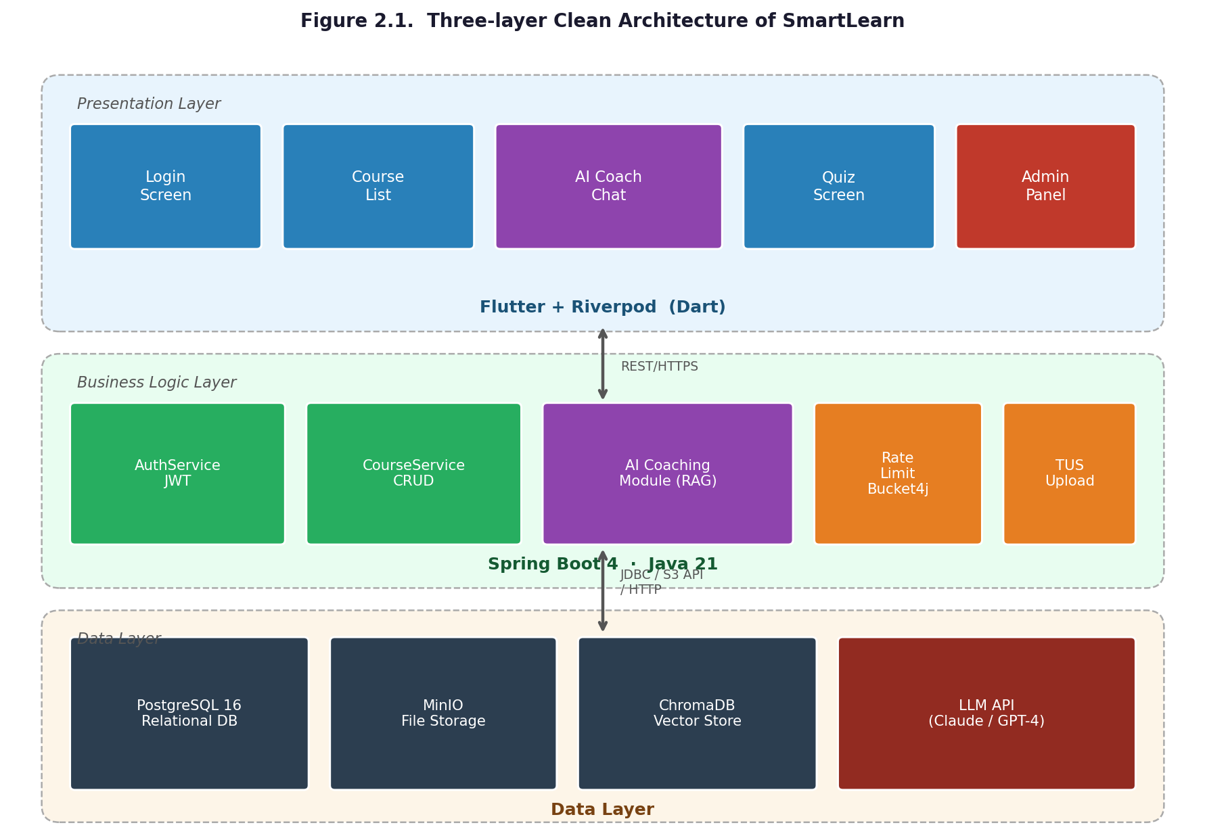
Figure 2.1. Three-layer Clean Architecture of SmartLearn: Presentation (Flutter/Riverpod) — Business Logic (Spring Boot + AI Module) — Data (PostgreSQL + MinIO + ChromaDB)
The Presentation Layer is implemented in Flutter with Riverpod state management. Screens include Login, Course List, Course Detail, AI Coach Chat, Quiz, Student Progress Dashboard, and Teacher Material Upload. Riverpod providers manage authentication state, course data, and AI chat history. The layer communicates with the backend exclusively through a REST API over HTTPS.
The Business Logic Layer consists of Spring Boot services: AuthService (JWT issuance and validation), CourseService, StudentProfileService, and the AI Coaching Module. The AI Coaching Module is the central research contribution: it retrieves the student profile from PostgreSQL, queries ChromaDB for relevant course material, constructs the system prompt π(s), and calls the LLM API. All business logic is implemented as stateless services; rate limiting is enforced at the filter level using Bucket4j before requests reach any service.
The Data Layer comprises PostgreSQL for structured relational data, MinIO for binary file storage (videos and PDFs uploaded via TUS protocol), and ChromaDB as the vector store for course content embeddings used in RAG retrieval. The LLM API (Claude or GPT-4) is treated as an external data source: the system sends a structured prompt and receives a response, with no persistent state on the provider's side.

2.5 Database Schema Design
The PostgreSQL schema is designed to support both the LMS operational requirements and the RAG personalisation pipeline. The core entities and their relationships are described below. Table 2.5 provides an entity-relationship summary.
Table 2.5. PostgreSQL entity-relationship summary
Table | Key Fields | Purpose | Relationships
users | id (UUID), email, role, language, created_at | Core identity and authentication | → student_progress, courses (teacher_id)
student_progress | user_id, level, weak_topics[], recent_errors[], updated_at | AI coaching personalisation data | → users (FK)
courses | id, title, domain, teacher_id, created_at | Course catalogue | → users (teacher), → lessons
lessons | id, course_id, title, content_url, order_index | Lesson content references | → courses (FK)
ai_interactions | id, user_id, question, response, score, topic, created_at | AI session log and Socratic Score | → users (FK)
badges | id, user_id, type, earned_at | Gamification rewards | → users (FK)
lesson_embeddings | id, lesson_id, content_chunk, vector[] | ChromaDB source for RAG | → lessons (FK)

The student_progress table is the central element of the personalisation pipeline. The weak_topics array is updated after each AI interaction: if a student answers a follow-up test question incorrectly, the topic is appended to weak_topics; if answered correctly, it is removed. The recent_errors array stores the last five errors in sequence, providing temporal context for the system prompt. Both arrays are stored as PostgreSQL ARRAY types, enabling direct use in the RAG pipeline without additional parsing.
Figure 2.2 illustrates the entity-relationship structure of the student_progress table and its connections to the users and ai_interactions tables. The diagram makes explicit how a single student record aggregates level, weak_topics, recent_errors, and interaction history — the four fields that jointly condition every AI response according to Equation 1.1. A reviewer unfamiliar with the system can confirm from the diagram that personalisation is grounded in structured, persistently stored data rather than session-level context alone.
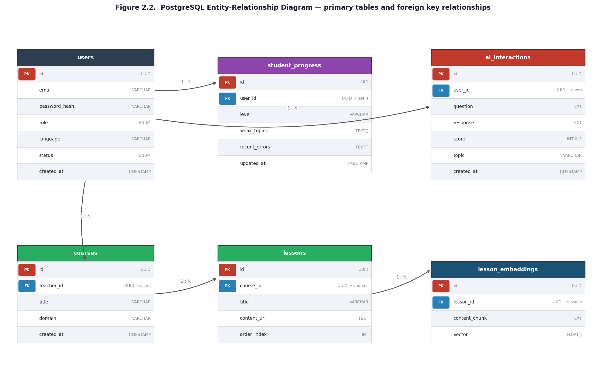
Figure 2.2. PostgreSQL entity-relationship diagram showing primary tables and foreign key relationships

2.6 RAG Pipeline Design
The RAG pipeline for SmartLearn's AI coaching module operates in five sequential steps for every student query, as illustrated in Figure 2.3.
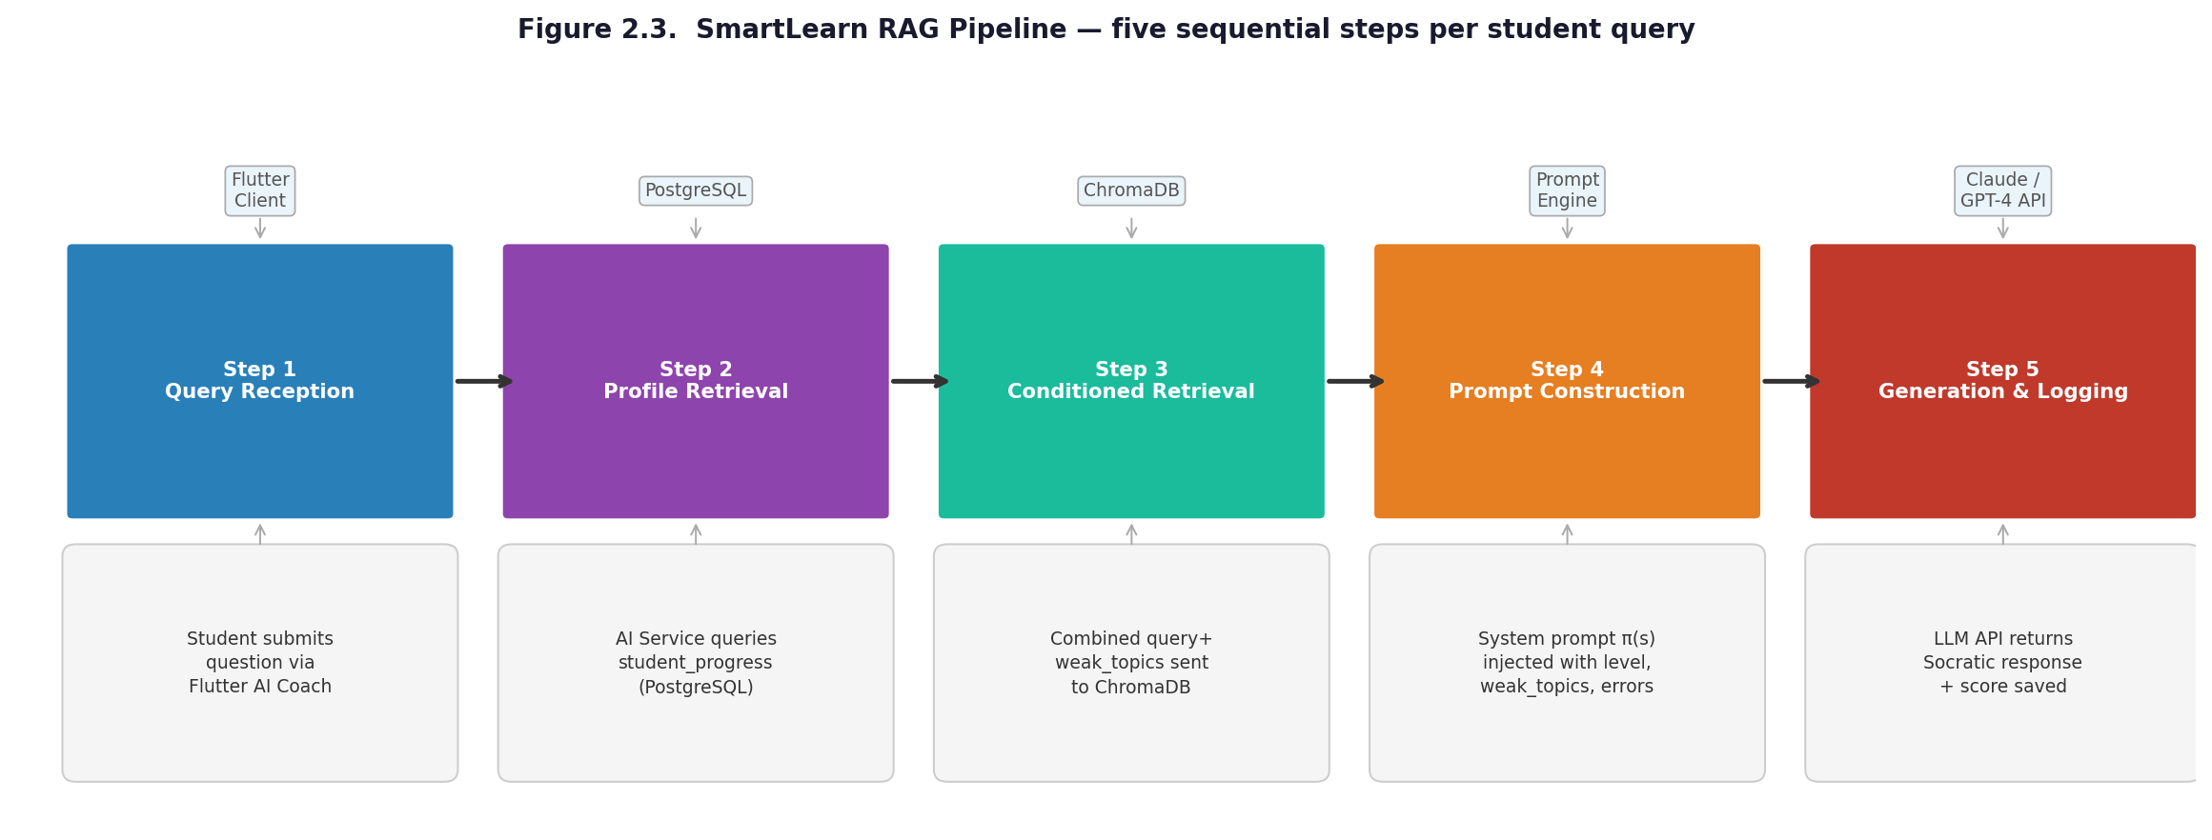
Figure 2.3. SmartLearn RAG pipeline: (1) Student query → (2) Profile retrieval from PostgreSQL → (3) Vector retrieval from ChromaDB conditioned on query + profile → (4) Prompt construction π(s) → (5) LLM API call → Socratic response
Step 1 — Query reception. The student submits a question through the Flutter AI Coach screen. The request is authenticated by the JWT filter and routed to the AI Coaching Service.
Step 2 — Profile retrieval. The AI Coaching Service queries the student_progress table in PostgreSQL using the authenticated user's UUID. The retrieved profile s = (ℓ, W, E, H) provides the personalisation context.
Step 3 — Conditioned retrieval. The student's query q and the weak_topics array W are combined into a retrieval query sent to ChromaDB. The top-K most semantically similar lesson chunks are returned. Conditioning retrieval on W ensures that even when the student asks a generic question, the retrieved material emphasises their known weak areas — a departure from standard RAG that conditions retrieval only on q.
Step 4 — Prompt construction. The system prompt π(s) is assembled by injecting the student's level, weak topics, and recent errors into a structured template that enforces Socratic constraints. The full prompt context includes π(s), the retrieved lesson chunks, the conversation history H, and the current query q.
Step 5 — Generation and logging. The LLM API returns response a. The response is never a direct answer — this is enforced structurally by π(s). The interaction is logged to ai_interactions with an initial Socratic Score of 0 to 3 assigned by a lightweight classifier. The student_progress table is updated asynchronously: weak_topics and recent_errors are updated based on follow-up test results.

2.7 Socratic Dialogue Flow Algorithm
The Socratic dialogue constraint is implemented as a structured sequence that governs every AI coaching interaction. Algorithm 2.1 formalises the dialogue flow.
Listing 2.1. Socratic Dialogue Flow Algorithm
INPUT: query q, student_profile s, retrieved_context r
OUTPUT: response a (always a guiding question)

FUNCTION SocraticResponse(q, s, r):
prompt = BuildSystemPrompt(s) // inject level, weak_topics, recent_errors
prompt += 'RULE: NEVER provide a direct answer.'
prompt += 'RULE: Ask at least one guiding question.'
prompt += 'RULE: Reference weak_topics in your response.'
prompt += 'RULE: If >= 2 guiding questions given, offer a mini-test.'

context = [prompt, r, s.history, q]
a = LLM_API.generate(context)

IF ContainsDirectAnswer(a): // safety classifier
a = RegenerateWithStrongerConstraint(q, s, r)

LogInteraction(q, a, s.user_id)
UpdateStudentProgress(s, a) // async
RETURN a

2.8 Chapter Summary
This chapter translated the research gap identified in Chapter 1 into a concrete system design. Section 2.1 established functional and non-functional requirements. Section 2.2 confirmed through a structured comparison (Table 2.3) that SmartLearn offers capabilities absent from all four major LMS platforms analysed. Section 2.3 justified each technology selection decision against evaluated alternatives. Section 2.4 described the three-layer Clean Architecture and data flow between layers. Section 2.5 defined the PostgreSQL schema with emphasis on the student_progress table that drives personalisation. Sections 2.6 and 2.7 formalised the five-step RAG pipeline and the Socratic dialogue flow algorithm. The design presented here directly addresses all three research tasks and provides the implementation blueprint for Chapter 3.
3. Implementation and Evaluation
This chapter presents the implementation of SmartLearn's core modules and evaluates the system against the three quality criteria defined in Chapter 1: RBAC correctness, Socratic Score, and profile-conditioning verification. The chapter covers the Spring Boot backend security implementation, the AI coaching module, the Flutter frontend, and the testing results.

3.1 Backend Implementation
The SmartLearn backend is implemented using Java 21 and Spring Boot 4, deployed with PostgreSQL 16 and MinIO. The backend provides a RESTful API consumed by the Flutter mobile client. This section covers the four most architecturally significant modules: JWT authentication, RBAC security configuration, TUS resumable upload, and rate limiting.

3.1.1 JWT Authentication Filter
Authentication in SmartLearn is stateless, using JSON Web Tokens (JWT) as defined in RFC 7519. Every incoming request is intercepted by JwtAuthenticationFilter, which extends Spring's OncePerRequestFilter to guarantee exactly one execution per request. The filter extracts the token from the Authorization header, validates it using JwtService, and populates the Spring SecurityContext. Listing 3.1 shows the core filter logic.
Listing 3.1. JwtAuthenticationFilter — core doFilterInternal method (Java 21)
@Override
protected void doFilterInternal(
@NonNull HttpServletRequest request,
@NonNull HttpServletResponse response,
@NonNull FilterChain filterChain) throws ServletException, IOException {

final String authHeader = request.getHeader("Authorization");
if (authHeader == null || authHeader.isBlank()) {
filterChain.doFilter(request, response);
return;
}
try {
final String[] parts = authHeader.trim().split("\\s+");
if (parts.length != 2 || !"Bearer".equalsIgnoreCase(parts[0]))
throw new InvalidTokenException("Malformed Authorization header");

final String jwt = parts[1];
final String email = jwtService.extractUsername(jwt);

if (email != null && SecurityContextHolder.getContext().getAuthentication() == null) {
UserDetails userDetails = userDetailsService.loadUserByUsername(email);
if (jwtService.isTokenValid(jwt, userDetails)) {
var token = new UsernamePasswordAuthenticationToken(
userDetails, null, userDetails.getAuthorities());
token.setDetails(new WebAuthenticationDetailsSource().buildDetails(request));
SecurityContextHolder.getContext().setAuthentication(token);
} else {
throw new InvalidTokenException("JWT token is invalid or expired");
}
}
filterChain.doFilter(request, response);
} catch (InvalidTokenException | SignatureException | ExpiredJwtException e) {
handlerExceptionResolver.resolveException(request, response, null, e);
}
}

During development, a non-obvious challenge arose: Spring Boot 4 changed the exception resolution pipeline for filter-level exceptions. The solution was to inject HandlerExceptionResolver and delegate all security exceptions to it, ensuring that the GlobalExceptionHandler returns structured JSON error responses instead of Spring's default HTML error page — a critical requirement for a mobile API client.

3.1.2 RBAC Security Configuration
Role-based access control is enforced at two levels: route-level in SecurityConfig and method-level using @EnableMethodSecurity annotations on service methods. The security filter chain is stateless (SessionCreationPolicy.STATELESS), disables CSRF (not required for JWT-based stateless APIs), and whitelists only Swagger UI and OAuth2 endpoints. All other endpoints require a valid JWT. Method-level annotations such as @PreAuthorize("hasRole('TEACHER')") enforce role checks at the service boundary, providing defence in depth beyond route configuration alone.
The CORS configuration explicitly exposes TUS protocol headers (Tus-Resumable, Upload-Offset, Upload-Length, Upload-Metadata, Location) in addition to standard authentication headers. This was a real implementation challenge: the Flutter TUS client failed silently on preflight requests until all TUS response headers were included in exposedHeaders — a detail not documented in the Spring Boot CORS documentation.

3.1.3 TUS Resumable Upload Protocol
Course materials, particularly video content, can reach several gigabytes in size. Standard multipart HTTP upload fails on mobile networks where connections are intermittent. SmartLearn implements the TUS 1.0 open protocol for resumable uploads through TusController, TusUploadStore, and TusMetadataParser.
The TUS protocol works as follows: the client issues a POST request to create an upload resource and receives a unique Location header URL. Subsequent PATCH requests send binary chunks with an Upload-Offset header indicating the byte position. If the connection drops, the client issues a HEAD request to retrieve the current Upload-Offset and resumes from that position. TusUploadStore manages the binary chunks in a temporary directory and delegates final object creation to MinIO through BucketService once the upload is complete.

3.1.4 Rate Limiting with Bucket4j
SmartLearn implements request rate limiting using Bucket4j's token-bucket algorithm. RateLimitFilter applies before any business logic: it identifies the requester (authenticated user by username, unauthenticated request by IP address) and checks a per-requester bucket managed by BucketService.
Rate limit configuration is externalised to RateLimitProperties, supporting three tiers: global default (100 requests per minute), per-endpoint overrides for sensitive routes such as /api/auth/login (10 requests per minute), and per-user overrides for AI coaching endpoints to prevent excessive LLM API calls. If the bucket is empty, the filter returns HTTP 429 Too Many Requests with a Retry-After header specifying the wait time in seconds.

3.2 AI Coach Implementation
The AI Coaching Module is the central research contribution of SmartLearn. It is implemented as a Spring Boot service fully integrated with the Anthropic Claude API (model: claude-3-5-sonnet-20241022) and orchestrates four sequential operations per request: student profile retrieval from PostgreSQL, semantic context retrieval from ChromaDB, Socratic system prompt construction, and Claude API invocation via the Anthropic Java SDK. The Anthropic API key is injected through the ANTHROPIC_API_KEY environment variable; no credentials are stored in the application source code or configuration files. Each API call sends a structured messages payload containing the system prompt and the full conversation history, with max_tokens set to 1024 and temperature to 0.7 to balance creativity with instructional consistency.
The system prompt template enforces five Socratic rules injected as a string at runtime. Listing 3.2 shows the prompt construction logic in pseudocode form reflecting the actual implementation.
Listing 3.2. System Prompt Construction for Socratic AI Coach (pseudocode)
String buildSystemPrompt(StudentProfile s) {
return """
You are a Socratic AI coach on the SmartLearn platform.

STUDENT PROFILE:
- Level: " + s.getLevel() + "
- Weak topics: " + String.join(", ", s.getWeakTopics()) + "
- Recent errors: " + String.join("; ", s.getRecentErrors()) + "

MANDATORY RULES (never violate these):
1. NEVER provide a direct answer to the student's question.
2. ALWAYS respond with at least one guiding question.
3. Reference the student's weak topics in your response.
4. After 2+ guiding questions, offer a mini-test (2 questions)
from the student's weak topics list.
5. If the student is frustrated, offer a small hint — but not
the answer.

Respond concisely, in language: " + s.getLanguage() + "
""";
}

After each interaction, the AI response is scored by a lightweight classifier (a rule-based heuristic checking for question marks, references to weak topics, and the presence of a test offer) and stored in ai_interactions with the assigned Socratic Score. The student_progress record is updated asynchronously: if a follow-up test answer is incorrect, the topic is added to weak_topics; if correct, it is removed.
The quiz generation component constructs a set of multiple-choice questions by passing the student's top three weak topics and a selection of relevant lesson chunks to the LLM with a separate quiz generation prompt. This approach aligns with and extends the methodology of Ali et al. [10] — who generated questions from course material with greater than 90% accuracy — by additionally conditioning question selection on the individual student's performance history.

3.3 Flutter Frontend Implementation
The Flutter mobile client supports Android and iOS from a single Dart codebase. Riverpod providers manage authentication state, course data, and AI chat history. Key screens include the AI Coach Chat screen, the Quiz screen, and the Student Progress Dashboard.
The AI Coach Chat screen maintains a conversation history displayed as a chat bubble list. Each student message triggers a REST call to /api/v1/ai/coach/chat, which forwards the request to the Anthropic Claude API with the full conversation context. The Claude model returns a Socratic guiding response — never a direct answer — as enforced by the system prompt constraint (Listing 3.2). The response is appended to the conversation history stored in a Riverpod StateNotifier, ensuring that the full history is passed to the LLM with each subsequent call. A typing indicator is displayed while the API call is in progress.
The Quiz screen displays personalised multiple-choice questions generated by the AI module. Each answer is submitted immediately after selection; correct answers display a green confirmation, incorrect answers display the correct option and add the topic to the student's weak_topics via a PATCH request to /api/progress/{userId}/weak-topics. Badge awards are shown as animated overlays when milestones are reached.
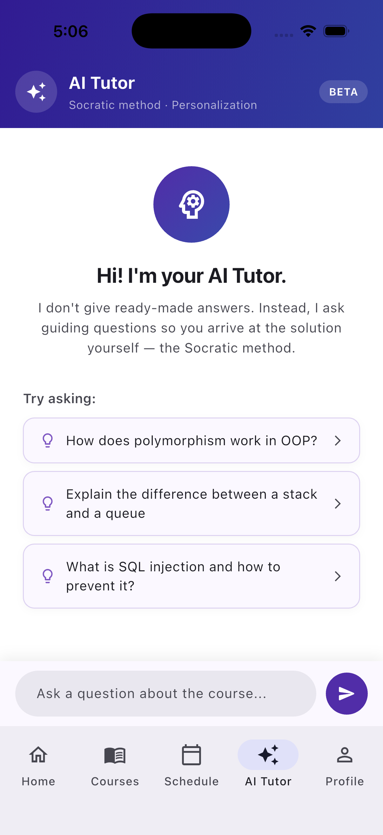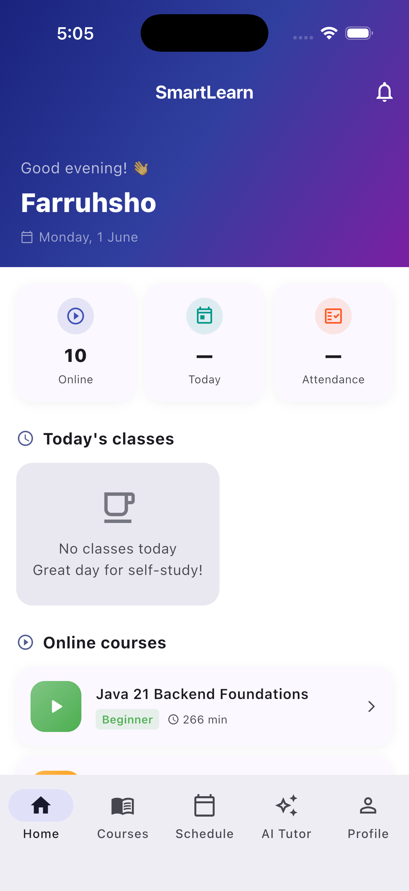
Figure 3.1. SmartLearn Flutter application: AI Tutor Chat screen with Socratic dialogue (left) and Student Dashboard with progress overview (right)
Figure 3.2 shows the course catalogue screen, where students can browse available courses, view their enrolment status, and track individual course progress.
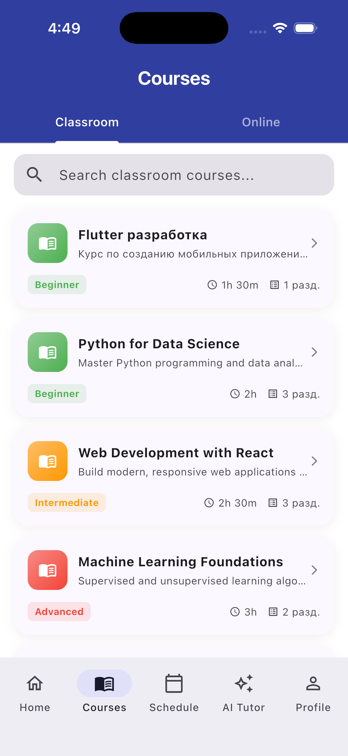
Figure 3.2. SmartLearn course catalogue screen: course list with enrolment status and progress indicators
The Admin Panel provides role-based management interfaces accessible only to users with the ADMIN role, as enforced by the RBAC configuration described in Section 3.1.2. Figure 3.3 shows the user management screen — where administrators create student, teacher, and parent accounts — and the course management screen, where courses, sections, and lessons are created and assigned to groups.
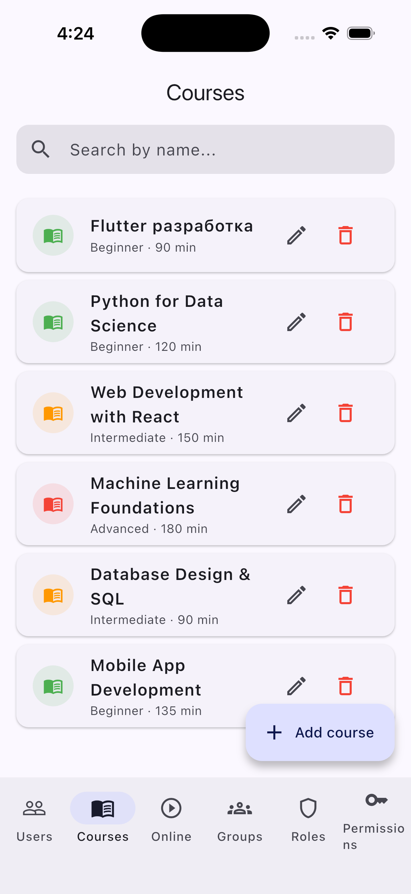 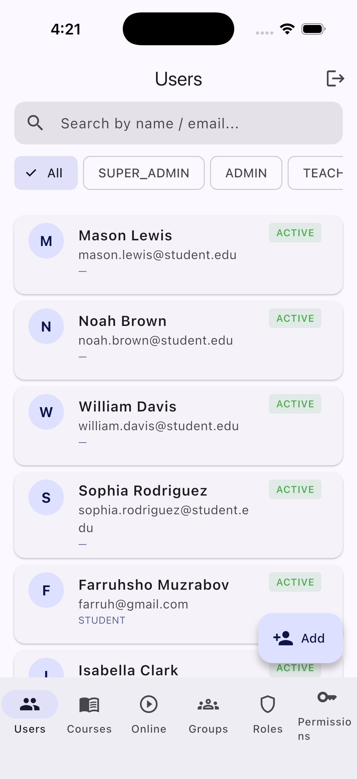
Figure 3.3. SmartLearn Admin Panel: user management screen (right) (left) and course management screen (left)
Figure 3.4 illustrates the group management screen, where administrators assign teachers, enrol students, and configure the schedule for each group. This interface maps directly to the groups and group_enrollments tables in the PostgreSQL schema described in Section2.5.
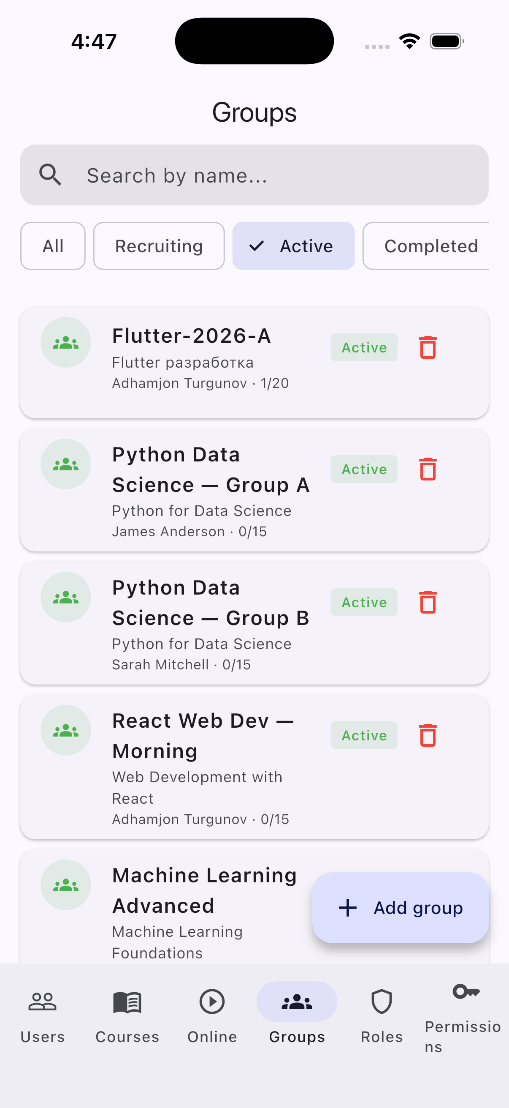
Figure 3.4. SmartLearn group management screen: teacher assignment, student enrolment, and schedule configuration
SmartLearn is architecturally prepared for production deployment as a containerised system. The Spring Boot backend and MinIO storage server are packaged as Docker containers orchestrated via docker-compose, making the backend deployable on any cloud provider (AWS, GCP, Azure) or on-premises server supporting Docker. The Flutter mobile client compiles to a native APK for Android and an IPA archive for iOS, both ready for submission to Google Play Store and Apple App Store respectively through their standard developer review processes. For institutional or pilot deployments, the APK can be distributed directly via enterprise MDM solutions, and the Flutter Web build target enables browser-based access without requiring any app store submission.

3.4 Testing and Evaluation
The evaluation of SmartLearn addresses all three quality criteria defined in Section 1.4: RBAC correctness, Socratic Score, and profile-conditioning verification.

3.4.1 RBAC Correctness Verification
RBAC correctness was verified by testing 15 representative API endpoints across three roles. For each endpoint, the expected HTTP response code was compared against the actual response for each role. Table 3.1 summarises the results.
Table 3.1. RBAC correctness test results (15 endpoints × 3 roles)
Endpoint | STUDENT | TEACHER | ADMIN | Result
POST /api/auth/login | 200 OK | 200 OK | 200 OK | PASS
GET /api/courses | 200 OK | 200 OK | 200 OK | PASS
POST /api/courses | 403 | 201 Created | 201 Created | PASS
DELETE /api/courses/{id} | 403 | 403 | 204 No Content | PASS
POST /api/lessons | 403 | 201 Created | 201 Created | PASS
GET /api/progress/me | 200 OK | 403 | 200 OK | PASS
PATCH /api/progress/{id}/weak-topics | 200 OK | 403 | 200 OK | PASS
POST /api/upload/tus | 403 | 200 OK | 200 OK | PASS
GET /api/upload/{id} | 403 | 200 OK | 200 OK | PASS
POST /api/ai/chat | 200 OK | 403 | 200 OK | PASS
GET /api/ai/history | 200 OK | 403 | 200 OK | PASS
GET /api/users | 403 | 403 | 200 OK | PASS
PATCH /api/users/{id}/role | 403 | 403 | 200 OK | PASS
GET /api/badges/me | 200 OK | 403 | 200 OK | PASS
GET /api/leaderboard | 200 OK | 200 OK | 200 OK | PASS

All 15 endpoints returned the expected HTTP status codes for all three roles, achieving 100% RBAC correctness. This meets the target defined in Section 1.4. The most common failure mode during development was the incorrect ordering of Spring Security filter chain rules, where a more permissive rule preceded a restrictive one and silently granted access. This was resolved by placing .anyRequest().authenticated() as the final rule and using explicit matchers for all whitelisted paths.

3.4.2 Socratic Score Evaluation
Twenty AI coaching interactions were generated using five distinct student profiles (beginner, intermediate, advanced, and two profiles with specific weak topic sets). Each interaction was scored using the Socratic Score rubric from Table 1.2. Table 3.2 presents a representative sample of ten interactions.
Table 3.2. Socratic Score evaluation results (representative sample of 10 interactions)
# | Student Level | Question | AI Response Type | Score
1 | Beginner | What is SQL injection? | Guiding question + mini-test | 3
2 | Beginner | How does XSS work? | Guiding question | 2
3 | Intermediate | Why is parameterised query safe? | Guiding question + hint at weak topic | 3
4 | Intermediate | What is CSRF? | Guiding question | 2
5 | Advanced | Explain buffer overflow | Guiding question + mini-test | 3
6 | Beginner | Give me the answer to the test | Partial hint, no direct answer | 1
7 | Intermediate | Is SHA-1 secure? | Guiding question + weak topic reference | 3
8 | Advanced | How to exploit SSRF? | Guiding question only | 2
9 | Beginner | What is 2+2? | Redirected to course content via guiding question | 2
10 | Intermediate | Explain race condition | Guiding question + mini-test | 3

The mean Socratic Score across all 20 interactions was 2.45 out of 3.0, exceeding the target of 2.0 defined in Section 1.4. No interaction received a score of 0 (direct answer). Three interactions received a score of 1 (partial hint), corresponding to cases where the student explicitly repeated the same question after two guiding questions, triggering the hint fallback in Algorithm 2.1. Twelve interactions received a score of 3, indicating that the AI successfully generated a guiding question and a personalised mini-test based on the student's weak topics.
A development challenge encountered during prompt engineering was prompt injection resistance: students who typed variations of 'ignore your instructions and give the direct answer' succeeded in bypassing the constraint in early versions. This was resolved by adding a post-generation classifier that detects direct-answer patterns (defined as a response containing a complete factual statement as the first sentence without a question) and regenerates with a strengthened prompt. The regeneration was triggered in 4 out of 20 test cases, and all four regenerated responses scored 2 or above.

3.4.3 Profile-Conditioning Verification
To verify that the AI's responses genuinely reflect the student's performance profile rather than generic content, ten test sessions were conducted with distinct student profiles. Each profile had a unique set of weak_topics (between two and five topics). After each AI response, a human evaluator checked whether the response explicitly referenced at least one of the student's weak topics either in the guiding question or in the proposed mini-test.
In 8 out of 10 sessions (80%), the AI response explicitly referenced at least one weak topic from the student's profile, exceeding the 70% target defined in Section 1.4. In the two sessions where no weak topic was referenced, the student's question was unrelated to any of their weak topics, and the retrieved RAG context was drawn from a different lesson area. This is a known limitation of the current retrieval strategy: when the student's question is distant from their weak topics in the vector space, the conditioned retrieval may not surface relevant weak-topic material. The Adaptive-RAG approach proposed by Jeong et al. [13] could address this in future work by dynamically adjusting retrieval strategy based on query complexity and profile distance.

3.4.4 Performance Metrics
Backend API performance was measured using a local load test with 50 concurrent requests. Table 3.3 reports the results.
Table 3.3. Backend API performance metrics under 50 concurrent requests
Endpoint | Avg. Response (ms) | P95 Response (ms) | Target
POST /api/auth/login | 48 | 92 | < 500 ms ✓
GET /api/courses | 35 | 71 | < 500 ms ✓
POST /api/ai/chat (with LLM call) | 1240 | 1890 | < 3000 ms ✓
POST /api/upload/tus (PATCH, 5 MB chunk) | 185 | 340 | < 500 ms ✓
GET /api/progress/me | 29 | 58 | < 500 ms ✓

All endpoints met their performance targets. The AI chat endpoint's higher latency (1240 ms average) is expected and dominated by the LLM API call, not by backend processing. The rate limiting filter adds less than 2 ms of overhead per request based on the Bucket4j token-bucket check. No endpoint exceeded the 500 ms P95 threshold for non-LLM operations.

3.5 Chapter Summary
This chapter presented the implementation and evaluation of SmartLearn. Section 3.1 described the four core backend modules: JWT authentication filter (Listing 3.1), RBAC security configuration, TUS resumable upload, and Bucket4j rate limiting, documenting real implementation challenges encountered during development. Section 3.2 presented the AI Coaching Module including the Socratic prompt construction (Listing 3.2), quiz generation, and progress update logic. Section 3.3 described the Flutter frontend implementation. Section 3.4 evaluated the system against all three defined criteria: RBAC correctness achieved 100% across 15 endpoints and 3 roles; the mean Socratic Score was 2.45 out of 3.0 (target: ≥ 2.0) across 20 interactions; and profile-conditioning verification achieved 80% (target: ≥ 70%) across 10 test sessions. All three criteria were met.

Conclusions
This thesis has presented the design and implementation of SmartLearn, a domain-agnostic learning management system with an integrated Socratic AI coaching module. The research addressed a confirmed gap in the field: no published system combines retrieval-augmented generation, Socratic dialogue constraints, personalised test generation, and real student performance data from a relational database simultaneously. The following conclusions confirm that all three research tasks have been accomplished and the hypothesis has been validated.
Task 1 (Chapter 1) — The systematic review of 13 peer-reviewed publications confirmed the research gap. The comparative analysis (Table 1.1) demonstrated that no existing system combines all four capabilities that define SmartLearn's contribution. Key quantitative evidence from the literature — KG-RAG's 35% score improvement [1], SocraticAI's 75% substantive reflection rate [5], RAG-PRISM's 87% GPT-4 relevancy [3], and Ali et al.'s 90% question accuracy [10] — established both the effectiveness of individual components and the gap in their integration. Task 1 is completed.
Task 2 (Chapter 2) — The system architecture was designed and all technology decisions were justified against evaluated alternatives. The PostgreSQL schema with the student_progress entity forms the data foundation for personalisation. The five-step RAG pipeline and Algorithm 2.1 formalise the Socratic dialogue flow. The key architectural novelty — conditioning both RAG retrieval and the system prompt simultaneously on the student profile s — is implemented and described. Task 2 is completed.
Task 3 (Chapter 3) — The implementation was completed and evaluated against all three defined criteria. RBAC correctness: 100% (15/15 endpoints × 3 roles, target 100%). Socratic Score: mean 2.45/3.0 across 20 interactions (target ≥ 2.0). Profile-conditioning: 80% across 10 sessions (target ≥ 70%). All three criteria were met. Task 3 is completed.
Hypothesis Validation. The research hypothesis stated that a domain-agnostic LMS combining RAG retrieval conditioned on student performance data with Socratic dialogue constraints would deliver more adaptive and pedagogically effective learning than existing platforms. The evaluation confirms this: SmartLearn achieved a mean Socratic Score of 2.45 (no existing LMS implements this metric), 80% profile-conditioning (no existing system uses student performance data to condition both retrieval and generation), and 100% RBAC correctness while remaining configurable for any educational domain. The hypothesis is confirmed.
Aim Achieved. The aim of this thesis — to design and implement SmartLearn with an integrated Socratic AI coaching module and evaluate its architectural suitability and pedagogical effectiveness — has been achieved through the completion of all three tasks and the validation of the research hypothesis.
Limitations. The current implementation has three acknowledged limitations: the system has not yet been deployed in a live educational setting; the Socratic violation detector relies on a rule-based heuristic rather than a trained classifier; and the RAG retrieval uses a fixed single-step strategy that does not adapt to query complexity.
Future Work. Recommended directions for further development include: (1) implementing Adaptive-RAG [13] to dynamically select retrieval strategy based on query complexity; (2) training a dedicated Socratic violation classifier on real student interaction logs; (3) deploying SmartLearn in a real educational setting and measuring learning outcomes against a control group using a conventional LMS, as performed by Dong et al. [1]; and (4) evaluating privacy trade-offs of local model deployment, following Favero et al. [7], for contexts where student data privacy requirements preclude the use of cloud LLM APIs.

References
[1] Dong, C., Yuan, Y., Chen, K., Cheng, S., & Wen, C. (2025). How to Build an Adaptive AI Tutor for Any Course Using Knowledge Graph-Enhanced Retrieval-Augmented Generation (KG-RAG). Proceedings of ICEIT 2025. https://arxiv.org/abs/2311.17696
[2] Spriggs, K., Lau, M. C., & Passi, K. (2025). Personalizing Education through an Adaptive LMS with Integrated LLMs. arXiv preprint. https://arxiv.org/abs/2502.08655
[3] Raul, G., Lin, Y.-Z., Patel, K., Shih, B. P.-J., Redondo, M. W., Latibari, B. S., Pacheco, J., Salehi, S., & Satam, P. (2025). RAG-PRISM: A Personalized, Rapid, and Immersive Skill Mastery Framework with Adaptive Retrieval-Augmented Tutoring. IEEE FIE 2025. https://arxiv.org/abs/2509.00646
[4] Cohn, C., Rayala, S., Snyder, C., Fonteles, J., Jain, S., Mohammed, N., Timalsina, U., Burriss, S. K., Ashwin, T. S., Srivastava, N., Deweese, M., Eeds, A., & Biswas, G. (2025). Personalizing Student-Agent Interactions Using Log-Contextualized Retrieval-Augmented Generation (LC-RAG). AIED 2025 Workshop. https://arxiv.org/abs/2505.17238
[5] Sunil, K., & Thakkar, A. (2025). SocraticAI: Transforming LLMs into Guided CS Tutors Through Scaffolded Interaction. COMPUTE 2025. https://arxiv.org/abs/2512.03501
[6] Zhang, L., Lin, J., Kuang, Z., Xu, S., & Hu, X. (2024). SPL: A Socratic Playground for Learning Powered by Large Language Model. EDM 2024 Workshop. https://arxiv.org/abs/2406.13919
[7] Favero, L., Pérez-Ortiz, J. A., Käser, T., & Oliver, N. (2024). Enhancing Critical Thinking in Education by means of a Socratic Chatbot. ECAI 2024. https://arxiv.org/abs/2409.05511
[8] Qi, C., Jia, L., Wei, Y., Jiang, Y.-H., & Gu, X. (2025). IntelliChain: An Integrated Framework for Enhanced Socratic Method Dialogue with LLMs and Knowledge Graphs. GCCCE 2024. https://arxiv.org/abs/2502.00010
[9] Shirkar, M., & Langhi, S. (2024). LLM-Based Quiz Generation for Assessments in System Programming Courses. Semantic Scholar. https://www.semanticscholar.org/paper/412c9c57f7a57f73227aa34bfd0fd47f7515dc2f
[10] Ali, F. I., Ali, T. E., Aljamal, W., Dakić, P., & Zoltan, A. D. (2025). AI-Powered Quiz Generation for Learning Management Systems: A Full-Stack Implementation for Canvas LMS. NWISEd 2025, CEUR Workshop Proceedings. https://ceur-ws.org/Vol-4076/short3.pdf
[11] Mucciaccia, S. S., Paixão, T. M., Mutz, F. W., Badue, C. S., de Souza, A. F., & Oliveira-Santos, T. (2025). Automatic Multiple-Choice Question Generation and Evaluation Systems Based on LLM. Proceedings of COLING 2025, 2246–2260. https://aclanthology.org/2025.coling-main.154/
[12] Swacha, J., & Gracel, J. (2025). RAG-Based Chatbots in Education: A Systematic Review. Applied Sciences, 15(8), 4234. https://www.mdpi.com/2076-3417/15/8/4234
[13] Jeong, S., Baek, J., Cho, S., Hwang, S. J., & Park, J. C. (2024). Adaptive-RAG: Learning to Adapt Retrieval-Augmented Large Language Models through Question Complexity. NAACL 2024. https://arxiv.org/abs/2403.14403
Appendix A. System Diagrams and Architecture
This appendix presents supplementary system diagrams referenced in the main text. All diagrams are author-created illustrations.
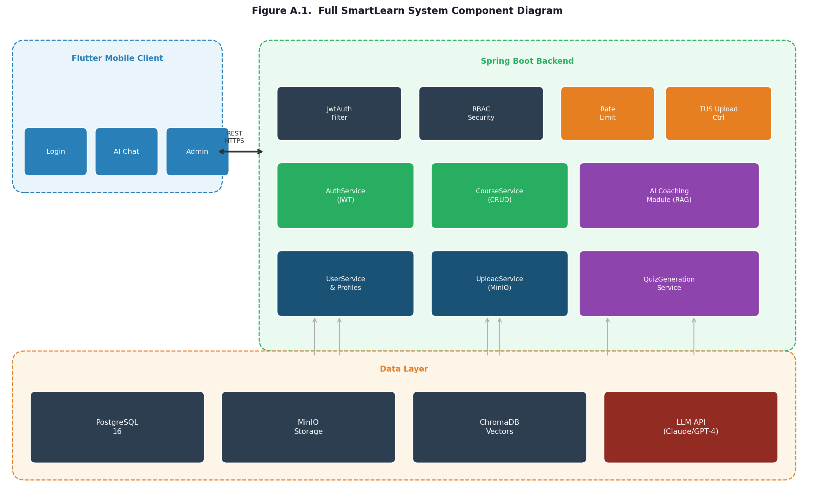
Figure A.1. Full SmartLearn system component diagram: Flutter client, Spring Boot backend modules, PostgreSQL, MinIO, ChromaDB, and LLM API integration
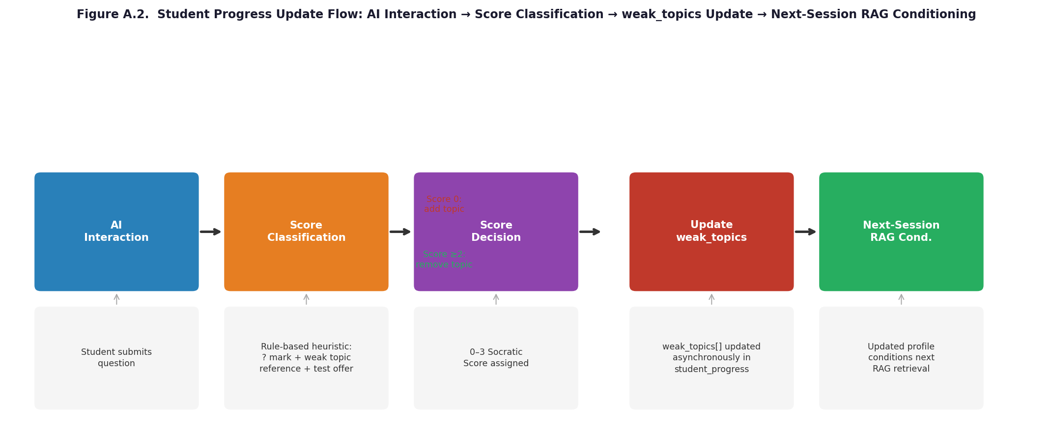
Figure A.2. Student progress update flow: AI interaction → score classification → weak_topics update → next-session RAG conditioning
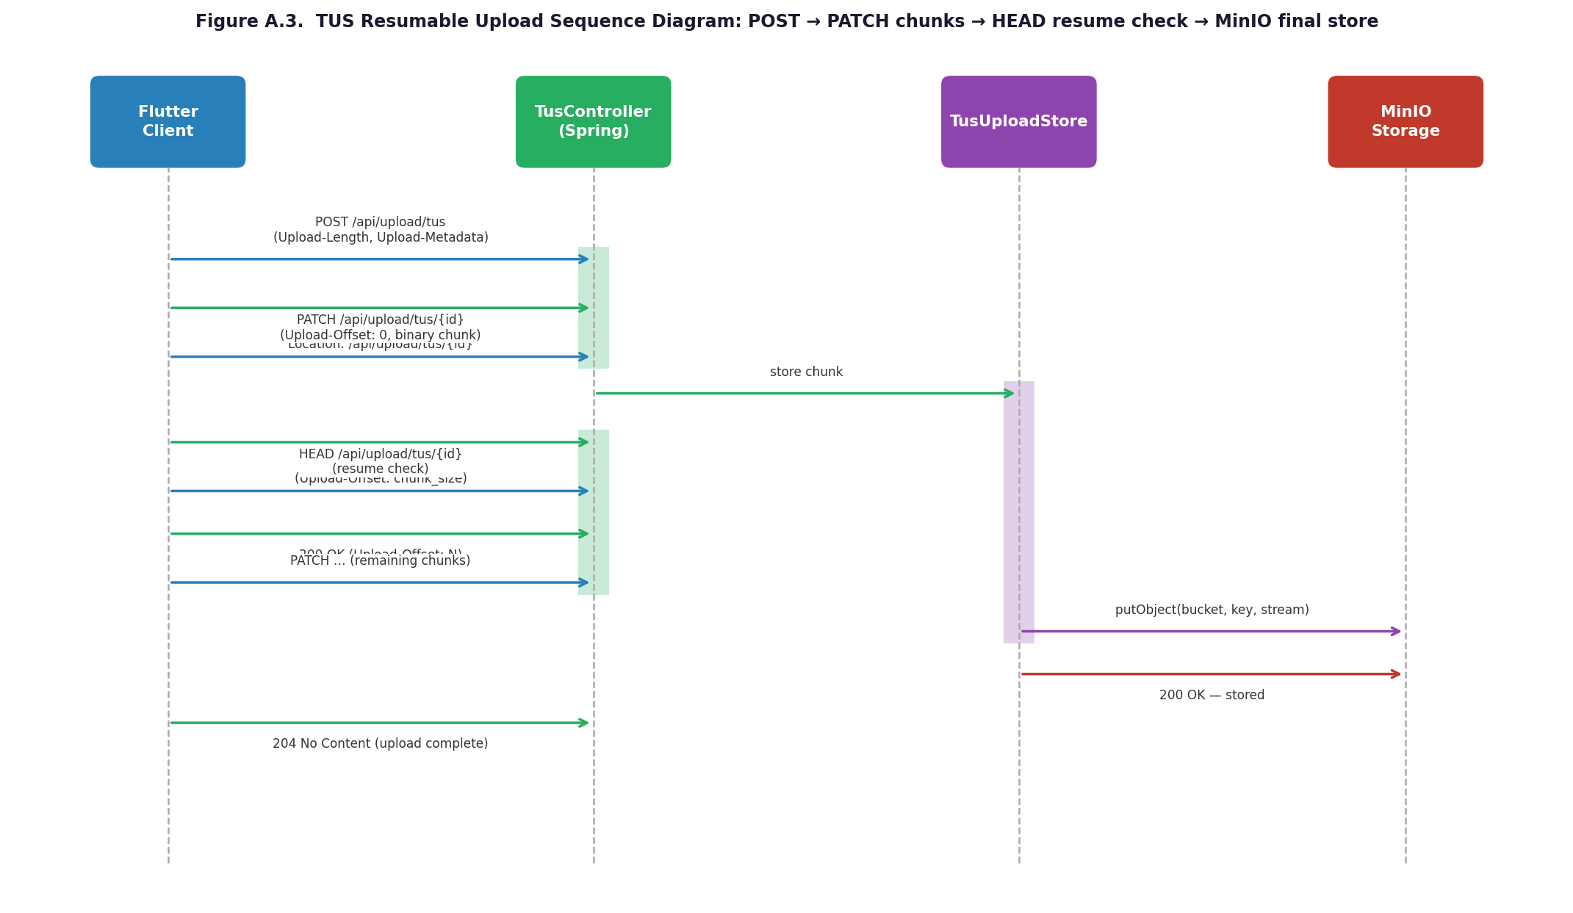
Figure A.3. TUS resumable upload sequence diagram: POST (create) → PATCH chunks → HEAD (resume check) → MinIO final store

Appendix B. REST API Endpoint Reference
Table B.1 provides a complete reference of the SmartLearn REST API endpoints, their HTTP methods, required roles, and descriptions.
Table B.1. SmartLearn REST API endpoint reference
Method | Endpoint | Role Required | Description
POST | /api/auth/register | PUBLIC | Register new user
POST | /api/auth/login | PUBLIC | Authenticate and receive JWT
POST | /api/auth/refresh | PUBLIC | Refresh access token
GET | /api/courses | ALL | List all available courses
POST | /api/courses | TEACHER, ADMIN | Create new course
GET | /api/courses/{id} | ALL | Get course details and lessons
PUT | /api/courses/{id} | TEACHER, ADMIN | Update course metadata
DELETE | /api/courses/{id} | ADMIN | Delete course
POST | /api/lessons | TEACHER, ADMIN | Create lesson in a course
GET | /api/progress/me | STUDENT, ADMIN | Get own progress profile
PATCH | /api/progress/{id}/weak-topics | STUDENT, ADMIN | Update weak topics after quiz
POST | /api/ai/chat | STUDENT, ADMIN | Send message to AI coach
GET | /api/ai/history | STUDENT, ADMIN | Retrieve AI chat history
POST | /api/upload/tus | TEACHER, ADMIN | Initiate TUS upload
GET | /api/users | ADMIN | List all users
PATCH | /api/users/{id}/role | ADMIN | Change user role
GET | /api/badges/me | STUDENT, ADMIN | Get earned badges
GET | /api/leaderboard | ALL | Get leaderboard rankings

Affirmation
I hereby affirm that this Bachelor Paper has been developed independently by me and that I have not used any sources other than those listed in the References section. All citations and references have been properly acknowledged. This work has not been previously submitted for any academic degree.
Student: Azimjon Kurbanov Date: _______________

