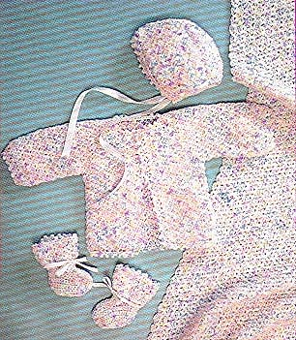

Crochet Baby Set
Lion Brand® Jamie®Baby
GAUGE:
16 sc + 16 rows = 4 inches (10 cm).
BE SURE TO CHECK YOUR GAUGE.
STITCH EXPLANATION:
Inc 1 sc Work 2 sc in 1 sc.
Dec 1 sc Draw up loop in each of 2 sc, yo and draw yarn through all 3 loops on hook.

BLANKET
Ch 100.
Row 1 Starting in the 5th ch from hook, work (1 dc, ch 2, 1 sc) in same st, * skip 2 ch, (2 dc, ch 2, 1 sc) in next st *, repeat from * to * across, end (2 dc, ch 2, 1 sc) in last ch. Ch 2, turn.
Row 2 Work (1 dc, ch 2, 1 sc) in first ch-space, * work (2 dc, ch 2, 1 sc) in next ch-space *, repeat from * to * across. Ch 2, turn. Repeat Row 2 for pattern until blanket measures 33 ½". End off.
Edging Returning to ch foundation row, join yarn and insert hook into space between first and 2nd sts of first row and work * (ch 2, 1 dc, ch 2, 1 sc) in that space *, repeat from * to * in each ch-2 space across first row. End off. Weave in ends.

