**1.**

|  |  |
| --- | --- |
| URL | GET /books |
| Response Body | Array of Book objects. Each object would contain details of the Book. |
| Response JSON | [  {  bookId : “string”,  name : “string”,  author : “string”,  copiesAvailable : number,  totalCopies : number  }  ] |
| Response Http Status code | 200 |

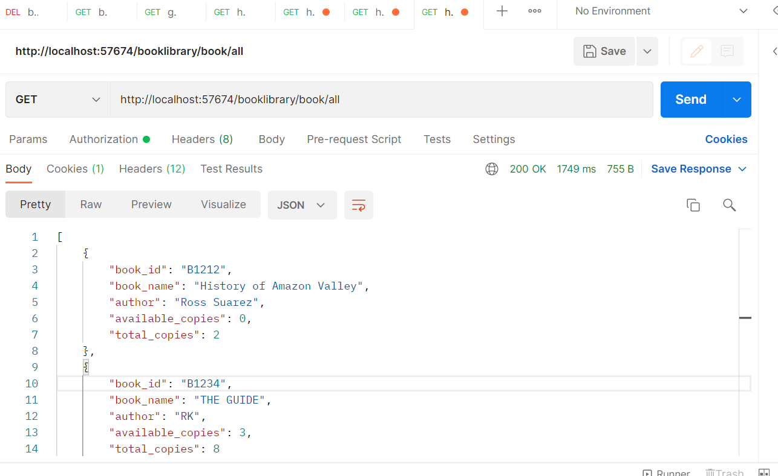

**2.**

|  |  |
| --- | --- |
| URL | GET /subscriptions |
| Response Body | Array of Subscription objects. Each object would contain details of the books subscribed. |
| Optional Query parameter | subscriberName.  If provided, show the record for that particular subscriber name. |
| Response JSON | [  {  subscriberName : “string”,  bookId : “string”,  dateSubscribed : date,  dateReturned : date  }  ] |
| Response Http Status code | 200 |

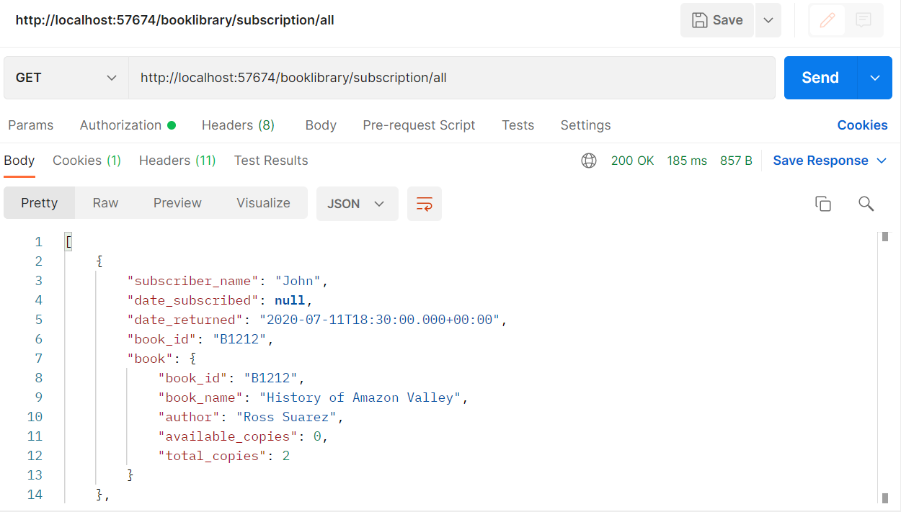

**3.**

|  |  |
| --- | --- |
| URL | POST /subscriptions |
| Request Body | A single Subscription object. |
| Request body JSON | {  subscriberName : “string”,  bookId : “string”,  dateSubscribed : date  } |
| Response Http Status code | 201 – Successful creation of subscription record  422 – If book copies not available for subscription. |
| Notes | * Create a record in the SUBSCRIPTION table. For the given bookId check if one or more copies are available in the BOOK table. If not available, then fail the operation. * Use a **@Transactional** annotation to try the spring managed Commit/Rollback transaction management feature. |

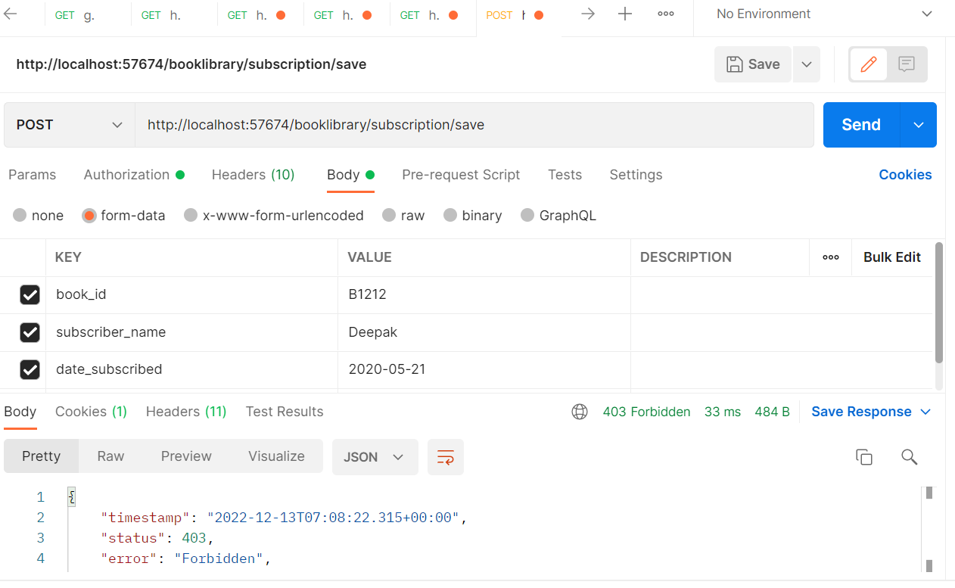

**Database**



