MyGym Mobile App Report

By Pixel Pioneers

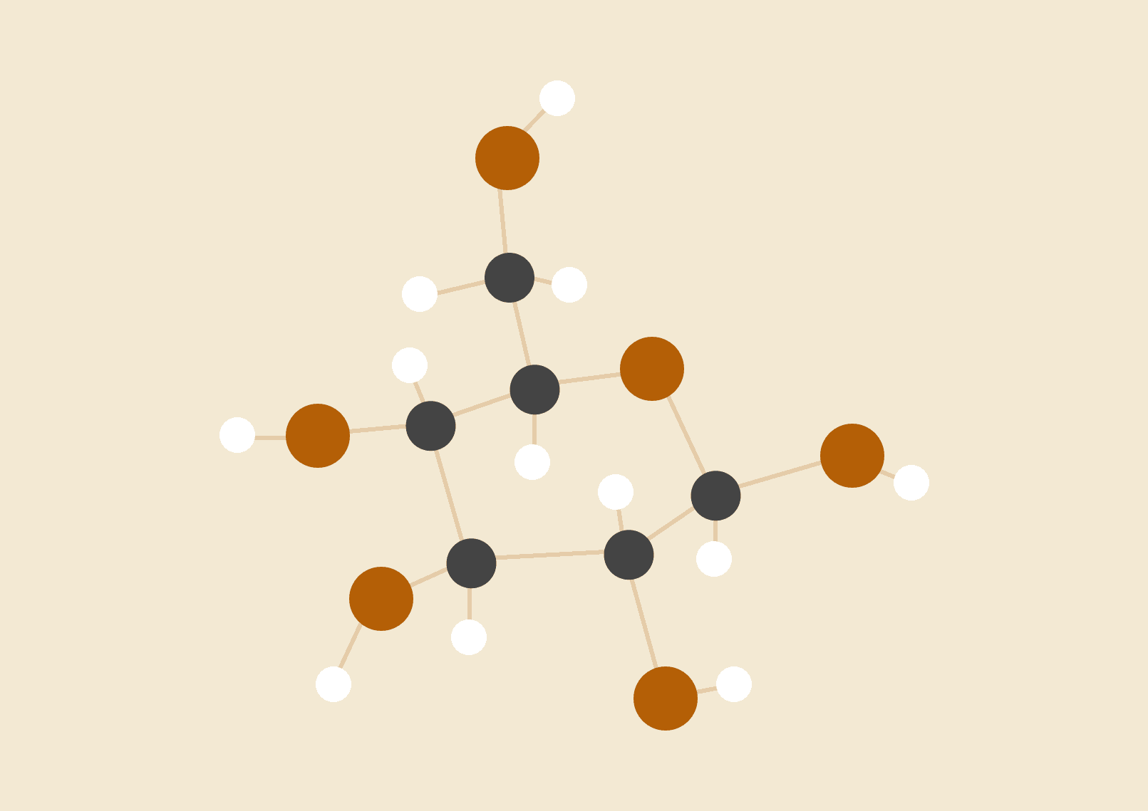

**Sardor Eslamasov 210170**

**A’zimjon Alijonov 210040**

**Mirzohid Mizamov 210113**

**Abrorbek Butaev 210120**

02.02.2024

Mobile Programming Course

# FUNCTIONAL REQUIREMENTS:

# User Registration:

Description: Users must be able to create accounts by providing their email address, username, and password. The system should validate the uniqueness of the email address and enforce password strength requirements.

# User Login:

Description: Registered users should be able to log in to the application using their credentials. The system should authenticate users and grant access to personalized features based on their account status.

# Book Gym Sessions:

Description: Users should be able to book sessions at their preferred gym locations. They should be able to specify the date, time, and duration of the session. The system should confirm the booking and update the user's schedule accordingly.

# Track Workout Progress:

Description: Users should be able to track their workout progress over time. They should be able to log details such as exercises performed, sets, reps, and weights lifted. The system should provide visualizations and statistics to help users monitor their fitness goals.

# NON-FUNCTIONAL REQUIREMENTS:

# Performance:

Description: The application must respond to user interactions within two seconds, ensuring a smooth and responsive user experience. Response times may vary based on network conditions and server load.

# Security:

Description: User data, including login credentials and personal information, must be securely stored and encrypted to prevent unauthorized access. The application should implement industry-standard security practices such as HTTPS encryption and secure password hashing.

# Scalability:

Description: The application should be designed to handle increasing user loads and data volumes without sacrificing performance. The system architecture should support horizontal scalability, allowing additional resources to be added dynamically as needed.

# Accessibility:

Description: The application should adhere to accessibility standards such as WCAG 2.0, ensuring that users with disabilities can access and use the application effectively. This includes support for screen readers, keyboard navigation, and alternative text for images.

# Compatibility:

Description: The application should be compatible with a wide range of devices and web browsers, including desktop computers, laptops, tablets, and smartphones. Compatibility testing should be performed on popular browsers such as Chrome, Firefox, Safari, and Edge.

# APPLICATION PORTABILITY

# 1. Planning and Requirements Gathering:

Task: Define project goals, target audience, features, and requirements.

Deliverables: Project proposal, user personas, feature list, and wireframes.

Example: Conducting market research to identify user needs and preferences. For instance, analyzing user reviews and feedback on existing fitness applications to understand common pain points and desired features.

# 2. Design:

Task: Create user interface (UI) designs, user experience (UX) flows, and interaction models.

Deliverables: UI mockups, wireframes, prototype designs.

Example: Using tools like Sketch or Adobe XD to design the interface for the MyGym application, ensuring ease of navigation and intuitive user interactions based on best practices in mobile app design.

# 3. Development:

Task: Implement the application based on the defined requirements and designs.

Deliverables: Functional application with core features implemented.

Example: Writing code in languages like Java or Kotlin for Android development, or Swift for iOS development. Integrating third-party APIs for features such as location-based services or payment processing.

# 4. Testing:

Task: Conduct various testing activities including unit testing, integration testing, and user acceptance testing (UAT).

Deliverables: Test cases, bug reports, and test documentation.

Example: Using automated testing frameworks like Appium or XCTest to ensure the functionality and performance of the application across different devices and platforms. Soliciting feedback from beta testers to identify usability issues and areas for improvement.

# 5. Deployment:

Task: Prepare the application for release to the app stores (e.g., Google Play Store, Apple App Store).

Deliverables: Signed application packages, release notes, and promotional materials.

Example: Following platform-specific guidelines for app submission, including preparing app metadata, screenshots, and app icons. Conducting beta testing and addressing any critical issues before the final release.

# 6. Maintenance and Updates:

Task: Monitor application performance, address user feedback, and release updates with new features or bug fixes.

Deliverables: Release notes, patch updates, and documentation.

Example: Analyzing crash reports and user analytics to identify areas for optimization or feature enhancements. Iteratively improving the application based on user feedback and changing market trends.

# System Requirements:

Operating System: Android 7.0 (Nougat) or higher.

Justification: Android 7.0 (Nougat) provides essential features and APIs required for modern mobile applications.

Processor: Quad-core 1.5 GHz processor or higher.

Justification: A quad-core processor ensures smooth performance, especially during resource-intensive tasks like GPS tracking and rendering graphics.

Memory (RAM): 2 GB RAM or higher.

Justification: 2 GB RAM ensures adequate memory for running the application and other background processes without performance degradation.

Storage: 100 MB of available storage space.

Justification: The application requires minimal storage space for installation and storing user data such as preferences and cached content.

Minimum SDK Version: Android SDK 24 (Android 7.0, Nougat).

Justification: Android SDK 24 is chosen as the minimum SDK version to leverage the features and optimizations introduced in Nougat while maintaining compatibility with a significant portion of Android devices in the market.

# Hardware Requirements:

Camera:

A device with a built-in camera is required for functionalities such as capturing and uploading workout photos or videos.

Internet Connectivity:

The device must have access to the internet via Wi-Fi or mobile data to fetch gym location details, synchronize user data, and communicate with external services such as payment gateways.

GPS (Global Positioning System):

The device must support GPS functionality for location-based services, allowing users to find nearby gym locations and track their workout sessions accurately.

Accelerometer and Gyroscope:

The presence of an accelerometer and gyroscope sensors enables features like motion tracking and gesture recognition, enhancing the user experience during workout sessions.

# 

# 

# 

# BLACK BOX TESTING:

| Test Description | Expected Results | Actual Results | Comments |
| --- | --- | --- | --- |
| User Registration | User can successfully create an account with valid credentials. | User account is created with the provided credentials | Registration process is smooth and error-free |
| User Login | User can log in with correct credentials and access the app features. | User successfully logs in and successes the app features. | Login functionality is working as expected. |
| Booking Gym Session | User can book a gym session by selecting a date, time and location. | User successfully books a gym session with chosen details. | Booking process proceeds without errors. |
| Workout Progress Tracking | User can log and track workout progress, including exercises, sets and reps. | User logs workout and sees progress reflected in the app. | Progress tracking feature works as intended. |
| Payment Processing | User can make payments for booked gym sessions securely and efficiently. | Payments are processed successfully and bookings are confirmed. | Payment integration is smooth and error-free. |

# User Registration:

Test Type: Unit Test

Description: Verify that users can successfully create accounts with valid credentials. Test the backend functionality related to user registration.

# User Login:

Test Type: Unit Test

Description: Ensure that users can log in with correct credentials and access the app features. Test the authentication and session management functionalities.

# Booking Gym Session:

Test Type: Widget Test

Description: Test the booking process to ensure that users can select a date, time, and location to book a gym session successfully. Verify the functionality and user interface components related to booking sessions.

# Workout Progress Tracking:

Test Type: Widget Test

Description: Test the workout progress tracking feature to ensure that users can log and track their workout progress accurately, including exercises, sets, and reps. Verify the functionality and user interface components related to progress tracking.

# Payment Processing:

Test Type: Integration Test

Description: Verify the integration between the app and the payment gateway to ensure that users can make payments for booked gym sessions securely and efficiently. Test the interaction and data exchange between the app and external payment services.

# SCHEMA DESIGN:

