**Retreat of Devon Ice Cap, 1978 – 2024**

Anna Zirkes

1. ***Introduction***

The Arctic is warming two to four times faster than the global average, which has led to unprecedented and widespread glacial retreat[1],[2]. It is critical to understand these changes as they have cascading impacts on sea level rise and can provide insight into future changes. Due to the spatial and temporal scale of changes and the remoteness of glaciers, remote sensing is often used to study glacial changes. For example, optical imagery is used to investigate retreat and velocity, while radar and lidar is used to measure structural changes such as thinning[3].

Devon ice cap, which covers 14,400 km2 of Devon Island in Nunavut, Canada (see Fig. 1), is one of the largest ice caps in the world[4]. Monitoring of this ice cap began in the 1960s and has continued to the present. Multiple studies have observed decreases in mass balance[5] and elevation[6], and increases in velocity[7] on Devon ice cap, although changes are often complex and some increases have also been measured[8]. In this study I will measure the retreat of Devon ice cap using Landsat imagery and investigate changes in velocity and elevation using global datasets published by Hugonnet et al. (2021) and Gardner et al. (2022)[9],[10].

1. ***Methods***
   1. *Retreat*

To measure the retreat of Devon ice cap, I used Google Earth Engine (GEE) and ArcGIS Pro to conduct SWIR 1 band differencing. See Appendix 1 for the full GEE code. First, I created two composite Landsat images composed of images from June, July, and August of 1987 (Landsat 5) and 2024 (Landsat 8). This involved cloud masking and re-scaling images. Next, I subtracted the 2024 SWIR 1 band from the 1987 SWIR 1 band. Then, I thresholded this difference image to highlight retreat. I did not include a threshold highlighting advances in the glacier as SWIR band differencing did not visually appear to be a reliable method. To remove false positives, I used Global Land Ice Measurements from Space (GLIMS) data to contain my study to the ice cap. The output of this analysis is a three-class map that depicts ice loss, stable ice, and non-ice. I brought this image into ArcGIS Pro to further clip the image to a 500m buffer of the GLIMS boundary, which removed additional false positives. Lastly, I calculated areas with a high density of retreat in ArcGIS Pro using the focal statistics tool. This tool generated the majority value in a 5x5 window.

* 1. *Velocity*

I obtained data about global ice velocity from Gardner et al. (2021). This data was collected as part of the Inter-Mission Time Series of Land Ice Velocity and Elevation (ITS_LIVE) project and NASA’s Making Earth System Data Records for Use in Research Environments (MEaSUREs) program, which used Landsat 4, 5, 7, and 8 imagery to calculate velocity.

First, I downloaded data for two time periods - 2000 and 2020. Using ArcGIS Pro, I clipped the data to the study area and subtracted the 2020 data from the 2000 data to create an image showing the change in velocity. Lastly, I visualized the data in ArcGIS Pro.

* 1. *Elevation*

I used a global dataset about glacial elevation change between 2000 and 2021 from Hugonnet et al. (2021) to investigate elevation changes on Devon ice cap. I clipped, mosaiced, and visualized the data using ArcGIS Pro.

1. ***Results***

In total, 617 km2 of ice disappeared from Devon ice cap between 1987 and 2024, which is shown in Figure 2. Most of this loss is seen on the western portion of the ice cap, and Figure 3 highlights this pattern of loss. Table 1 provides accuracy information for this analysis. The overall accuracy was 75.6%, the user’s accuracy for retreat was 73.0%, and the producer’s accuracy for retreat was 82.6%.

As for velocity, which is depicted in Figure 4, the velocity of the interior of the ice cap has largely remained unchanged or increased slightly, while the velocity of the margins of the ice cap has mostly increased. Notably, multiple tidewater glaciers have drastically decreased in velocity.

Elevation (Figure 5) appears to follow an inverse pattern compared to velocity. Increases in elevation are restricted to the interior of the ice cap, while the margins, and especially the western portion of the ice cap, have decreased in elevation.

1. ***Discussion***

Looking at the big picture, 600 km2 of retreat is a substantial amount of melt that aligns with the rapid retreat of glaciers observed globally and previous studies of Devon ice cap. However, with a total surface area of about 14,000 km2 , this retreat encompasses less than 1% of the total surface area.

These data also provide insight into largescale flow dynamics on Devon ice cap.

Multiple tidewater glaciers show a substantial increase in velocity alongside a drastic decrease in elevation at the lower reaches and an increase in elevation in the upper reaches, which may be characteristic of surge-type glaciers[11].

One tidewater glacier that especially stands out is highlighted in the bottom right inset maps of Figures 4 and 5. This glacier has drastically increased in velocity and decreased in elevation yet Figure 2 does not indicate retreat of this glacier. This is likely because sea ice and glacial ice have similar SWIR 1 values, which makes SWIR 1 band difference inadequate for measuring the retreat of tidewater glaciers. Further research using lidar data, potentially from NASA’s ICESat, could provide more accurate information about tidewater glaciers on Devon ice cap.

1. ***Conclusion***

It is important to understand glacial dynamics as they are indicators of climate change. As temperature rises, melt increases, and sea levels rise. The largest amount land of ice in the Northern Hemisphere, outside Greenland, is found in the Canadian High Arctic[12]. At 14,000 km2, Devon ice cap plays a large role in the Canadian High Arctic and the global cryosphere. Using SWIR 1 band differencing, this study found rates of retreat that are consistent with prior research that dates to the 1960s. For example, Burges and Sharp (2018) found a 2.4% decrease in surface area between 1960 and 2000, primarily due to shrinkage in the southwest arm and tidewater glaciers[13]. As Earth experiences an unprecedented rate of warming, continued monitoring and research is needed to understand how Devon ice cap changes in the coming decades.

1. ***Appendix***

*Figure 1. Location and boundary of Devon ice cap. Data from GLIMS and NSIDC (2005, updated 2018)[14].*

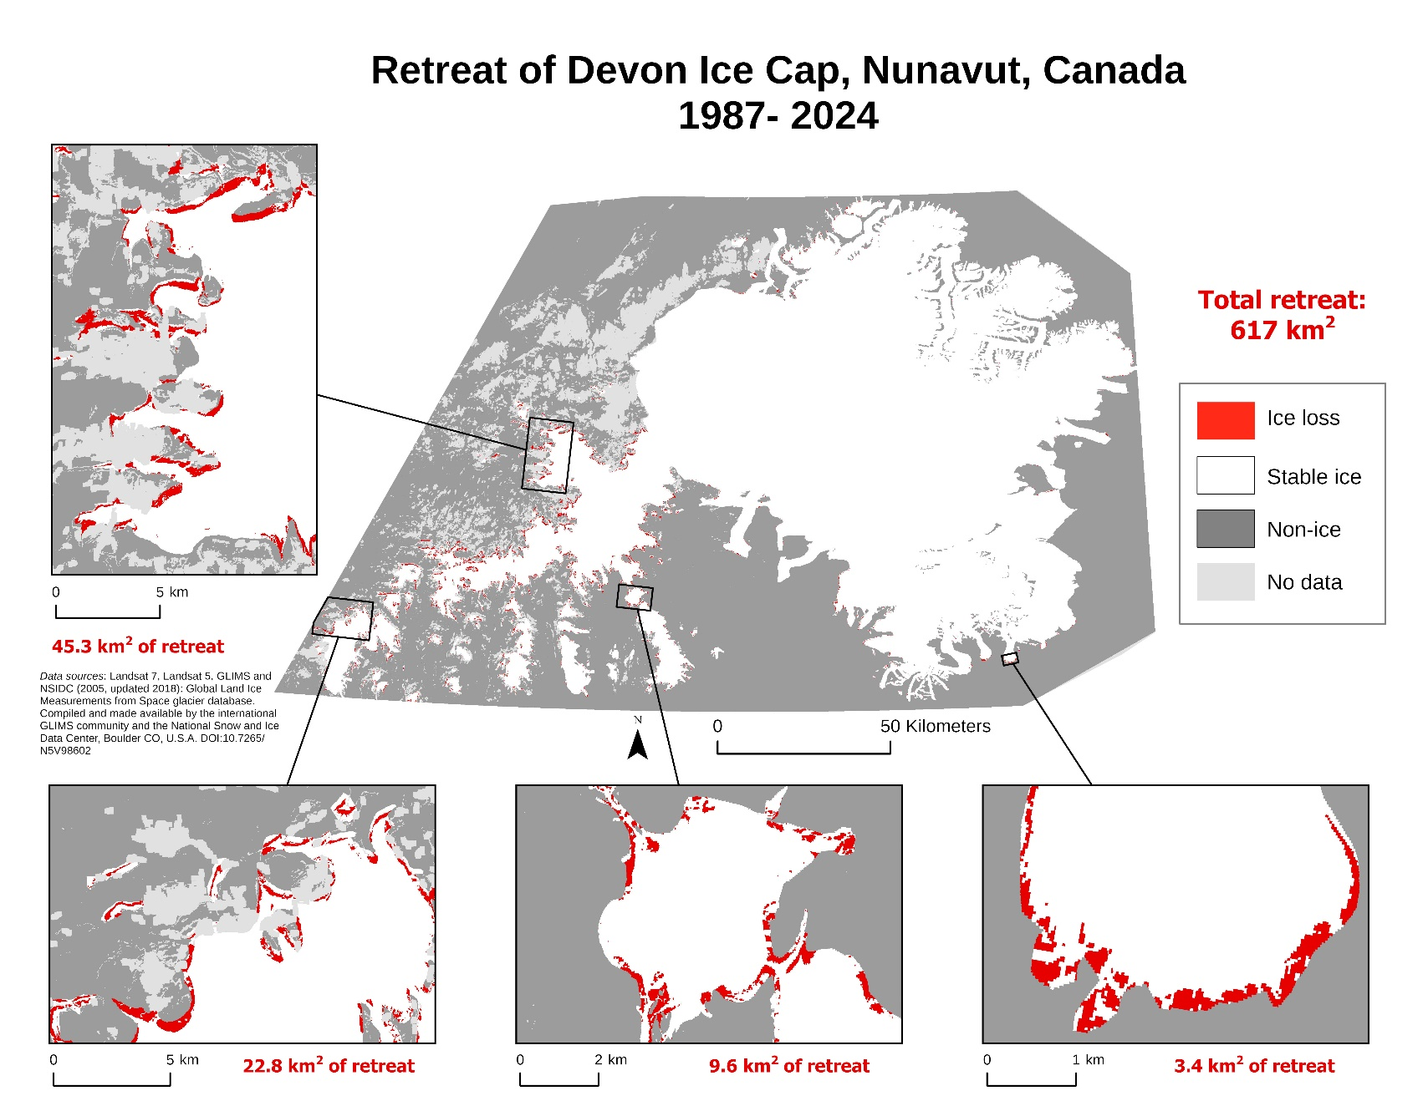

*Figure 2. Retreat of Devon Ice Cap 1987 – 2024 calculated using Landsat 5 and Landsat 8 SWIR 1 band differencing. Total retreat measured is 617 km2. Note most of the retreat is observed on the western edge of the ice cap.*

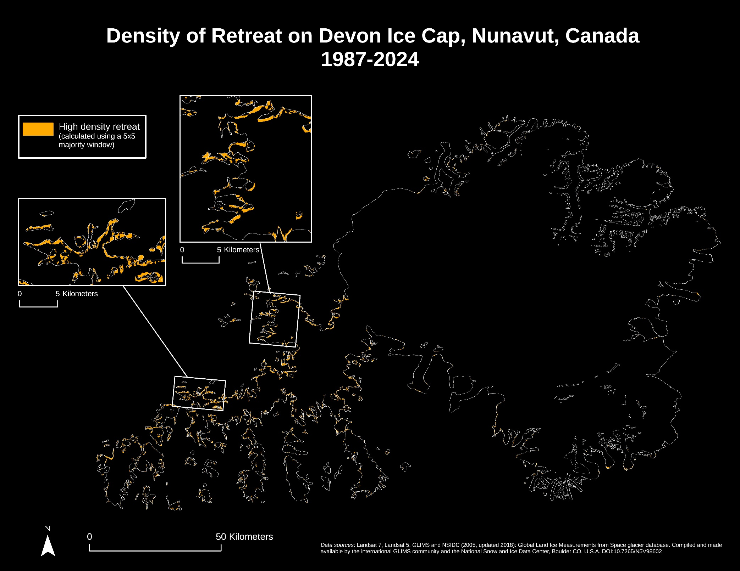

*Figure 3. Areas of high density of retreat between 1987 and 2024 on Devon ice cap. Calculated using a 5x5 majority window on the retreat data from Figure 2. Note the high density of retreat on the western edge of the ice cap.*

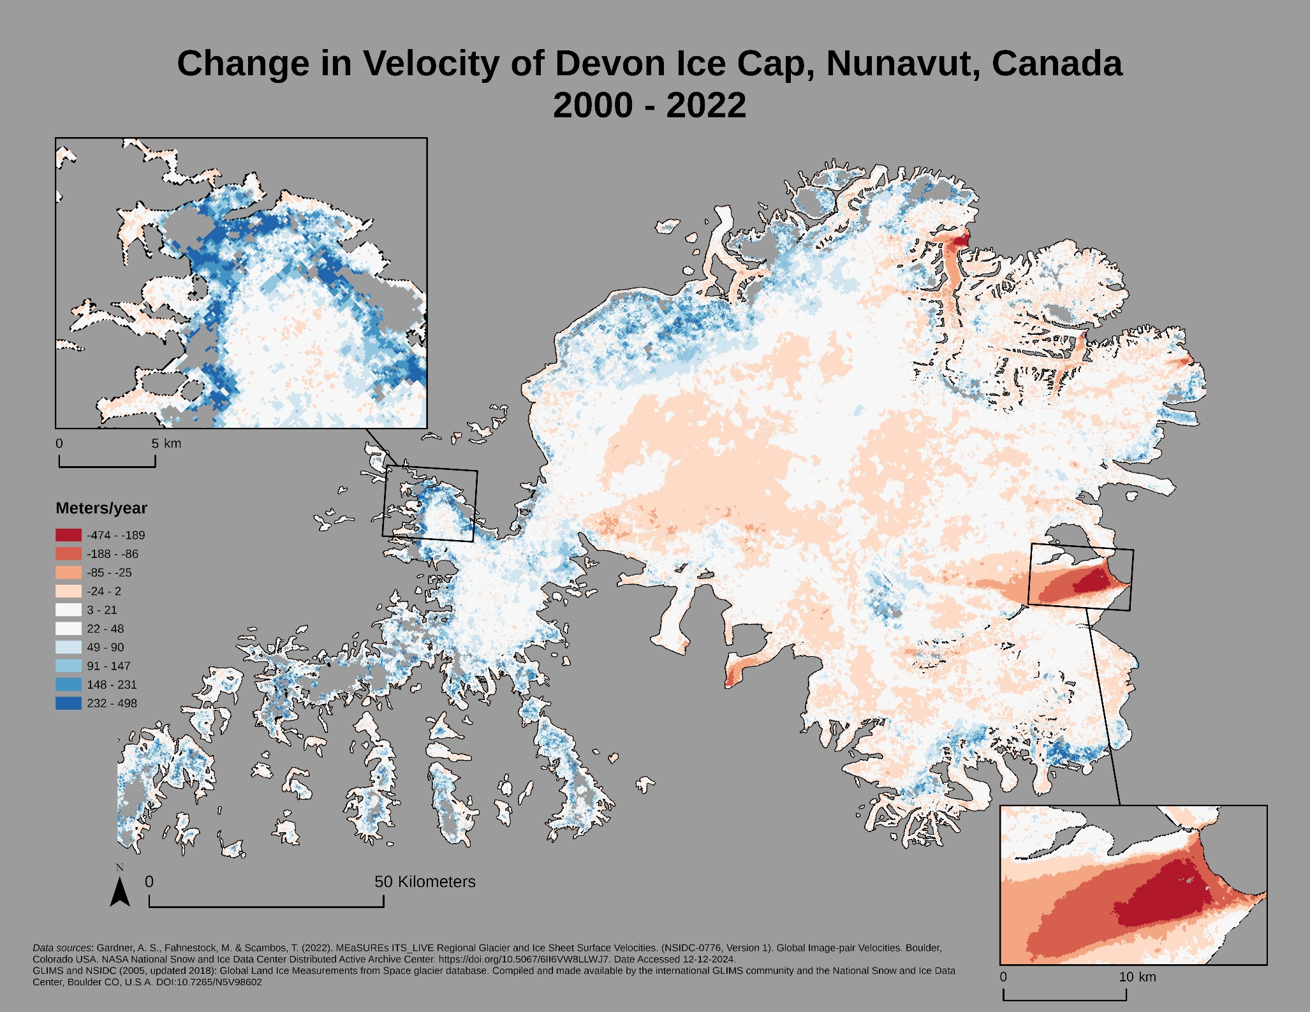

*Figure 4. Change in velocity of Devon ice cap between 2000 and 2022. Blue areas indicate a decrease in velocity, while red areas indicate an increase in velocity. In the interior, the velocity has remained stable or increased slightly, while the margins have largely decreased in velocity. Note the drastic increase in velocity in the tidewater glaciers. Data from Gardner et al. (2022) and GLIMS and NSDIC (2005, updated 2018).*

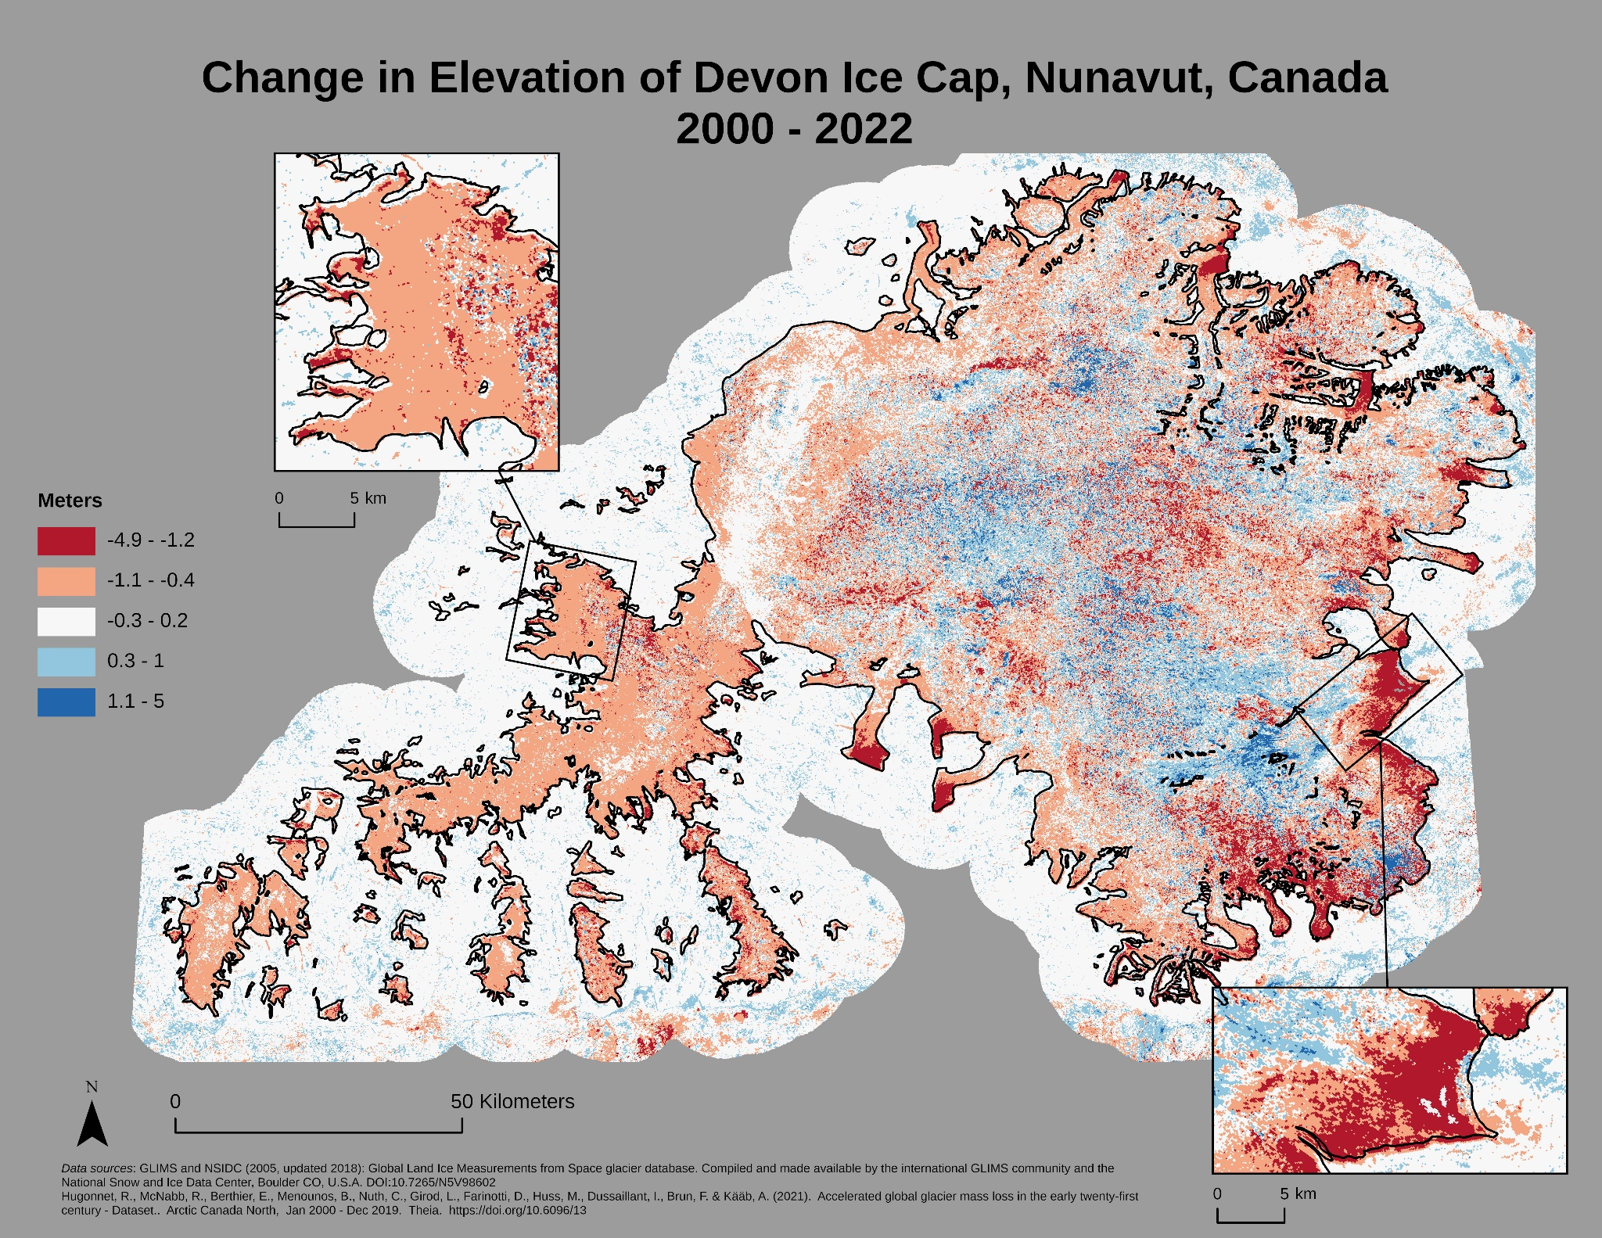

*Figure 5. Change in elevation of Devon ice cap between 2000 and 2022. Red areas indicate a decrease in elevation, while blue areas indicate an increase in elevation. Note that increases in elevation are largely confined to the interior of the ice cap, whereas decreases in elevation are more common on the margins of the ice cap.*

|  |  |  |  |  |  |  |
| --- | --- | --- | --- | --- | --- | --- |
|  | **Truth** |  |  |  |  |  |
| **Classification** | Retreat | Not ice | Stable ice | Total | User's accuracy | |
| Retreat | 19 | 2 | 5 | 26 | 0.73 |  |
| Not ice | 1 | 21 | 4 | 26 | 0.807 |  |
| Stable ice | 3 | 4 | 19 | 26 | 0.73 |  |
| Total | 23 | 27 | 28 | 78 |  |  |
| Producer's accuracy | 0.826 | 0.777 | 0.678 |  | 0.756 |  |
| Kappa |  |  |  |  |  | 0.634 |

*Table 1. Accuracy assessment confusion matrix for SWIR 1 band differencing (figure 2).*

GEE code link for SWIR 1 band differencing: <https://code.earthengine.google.com/6366a95d81a5ebc52e3a54cb3bcc44b3>

1. Serreze, M. C., A. P. Barrett, J. C. Stroeve, D. N. Kindig, and M. M. Holland. “The Emergence of Surface-Based Arctic Amplification.” *The Cryosphere* 3, no. 1 (February 4, 2009): 11–19. <https://doi.org/10.5194/tc-3-11-2009>.
2. Zemp, Michael, Holger Frey, Isabelle Gärtner-Roer, Samuel U. Nussbaumer, Martin Hoelzle, Frank Paul, Wilfried Haeberli, et al. “Historically Unprecedented Global Glacier Decline in the Early 21st Century.” *Journal of Glaciology* 61, no. 228 (January 2015): 745–62. <https://doi.org/10.3189/2015JoG15J017>.
3. Davies, Bethan. “Observing Glacier Change from Space.” *AntarcticGlaciers.Org* (blog), November 28, 2023. <https://www.antarcticglaciers.org/glaciers-and-climate/observing-and-monitoring-glaciers-and-ice-sheets/observing-glacier-change-space/>.
4. Boon, Sarah, David O. Burgess, Roy M. Koerner, and Martin J. Sharp. “Forty-Seven Years of Research on the Devon Island Ice Cap, Arctic Canada.” *ARCTIC* 63, no. 1 (March 22, 2010). <https://doi.org/10.14430/arctic643>.
5. Mair, Douglas, David Burgess, and Martin Sharp. “Thirty-Seven Year Mass Balance of Devon Ice Cap, Nunavut, Canada, Determined by Shallow Ice Coring and Melt Modeling.” *Journal of Geophysical Research: Earth Surface* 110, no. F1 (2005). <https://doi.org/10.1029/2003JF000099>.
6. Rinne, Eero, Andrew Shepherd, Alan Muir, and Duncan Wingham. “A Comparison of Recent Elevation Change Estimates of the Devon Ice Cap as Measured by the ICESat and EnviSAT Satellite Altimeters.” *IEEE Transactions on Geoscience and Remote Sensing* 49, no. 6 (June 2011): 1902–10. <https://doi.org/10.1109/TGRS.2010.2096472>.
7. Wychen, Wesley Van, Luke Copland, Laurence Gray, Dave Burgess, Brad Danielson, and Martin Sharp. “Spatial and Temporal Variation of Ice Motion and Ice Flux from Devon Ice Cap, Nunavut, Canada.” *Journal of Glaciology* 58, no. 210 (January 2012): 657–64. <https://doi.org/10.3189/2012JoG11J164>.
8. Colgan, William, James Davis, and Martin Sharp. “Is the High-Elevation Region of Devon Ice Cap Thickening?” *JOURNAL OF GLACIOLOGY* 54, no. 186 (2008): 428–36. <https://doi.org/10.3189/002214308785837084>.
9. Hugonnet, R., McNabb, R., Berthier, E., Menounos, B., Nuth, C., Girod, L., Farinotti, D., Huss, M., Dussaillant, I., Brun, F. & Kääb, A. (2021). Accelerated global glacier mass loss in the early twenty-first century - Dataset. Arctic Canada North, Jan 2000 - Dec 2019. Theia. <https://doi.org/10.6096/13>
10. Gardner, A. S., Fahnestock, M. & Scambos, T. (2022). MEaSUREs ITS_LIVE Regional Glacier and Ice Sheet Surface Velocities. (NSIDC-0776, Version 1). Global Image-pair Velocities. Boulder, Colorado USA. NASA National Snow and Ice Data Center Distributed Active Archive Center. https://doi.org/10.5067/6II6VW8LLWJ7. Date Accessed 12-12-2024
11. Davies, Bethan. “Surging Glaciers.” Accessed December 19, 2024. <https://www.antarcticglaciers.org/glacier-processes/glacier-flow-2/surging-glaciers/>.
12. Boon, Sarah, David O. Burgess, Roy M. Koerner, and Martin J. Sharp. “Forty-Seven Years of Research on the Devon Island Ice Cap, Arctic Canada.” *ARCTIC* 63, no. 1 (March 22, 2010). <https://doi.org/10.14430/arctic643>.
13. Burgess, David O., and Martin J. Sharp. “Recent Changes in Areal Extent of the Devon Ice Cap, Nunavut, Canada.” *Arctic, Antarctic, and Alpine Research* 36, no. 2 (May 2004): 261–71. [https://doi.org/10.1657/1523-0430(2004)036[0261:RCIAEO]2.0.CO;2](https://doi.org/10.1657/1523-0430(2004)036%5b0261:RCIAEO%5d2.0.CO;2).
14. GLIMS and NSIDC (2005, updated 2018): Global Land Ice Measurements from Space glacier database. Compiled and made available by the international GLIMS community and the National Snow and Ice Data Center, Boulder CO, U.S.A. DOI:10.7265/N5V98602