Assignment
Name: Azit Rana
- What is position property in CSS and its type?
CSS Position is a very powerful technique used to control the layout of elements on a web page. We can easily specify the position of an element within the document flow and can also control the behaviour of elements when they are rendered on the screen.

Why to use CSS Position?
- Control over element position
- Positioning relative to other elements
- Removing elements from document flow
- Overlapping elements
- Positioning relative to viewport
- Create scroll effect
- Accessibility
CSS position property
There are majorly 5 position properties named-
- Static
- Relative
- Absolute
- Fixed
- Sticky

Top, Bottom, Left and Right properties
- These properties are used to position an element relative to its parent container or to the viewport.
- The value of top, bottom, left and right can be negative.
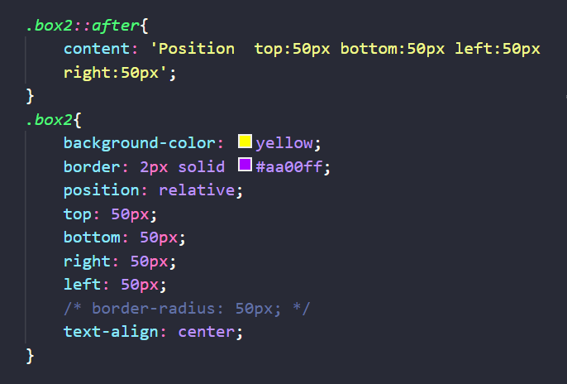
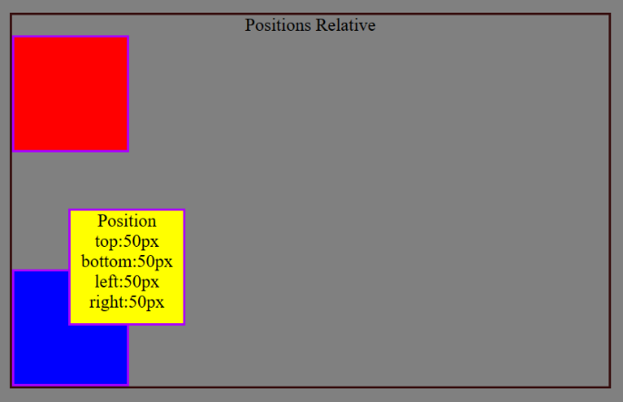

- How many types of positioning are there in CSS?
Types of CSS positions
- Static
- Relative
- Absolute
- Fixed
- Sticky

Static
This is the default position set for all the HTML elements.
Properties of position static
- It is the default position of an element.
- It will not break the normal document flow to position the element on the page.
- The properties like top, left, right, bottom and z-index have no effect to position the element.
Note: We will learn more about z-index property in further classes.
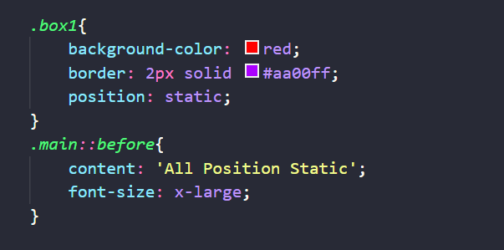
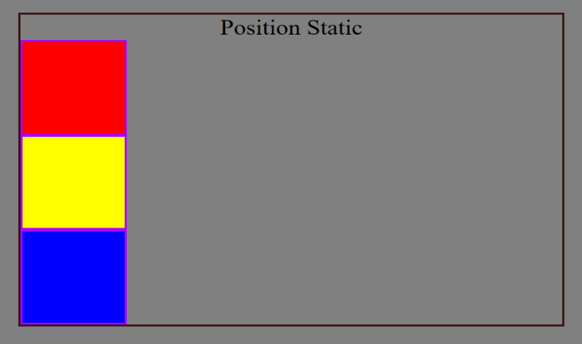

Relative
The element will be positioned according to the normal document flow and will change its position according to the given values of top, left, right and bottom.
Properties of position relative
- It will not break the normal document flow to position the element on the page.
- The properties like top, left, right, bottom and z-index will have an effect on the element.
- The element will leave the space at its original position.

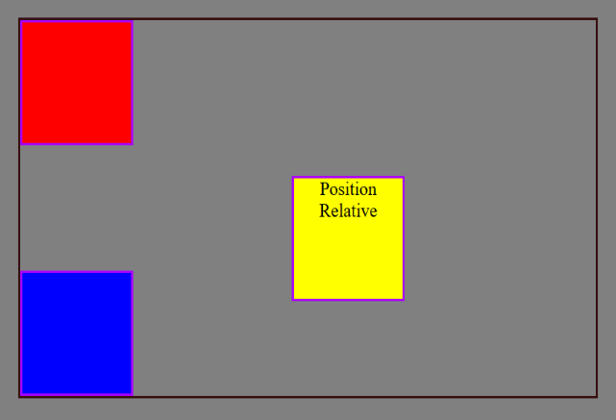
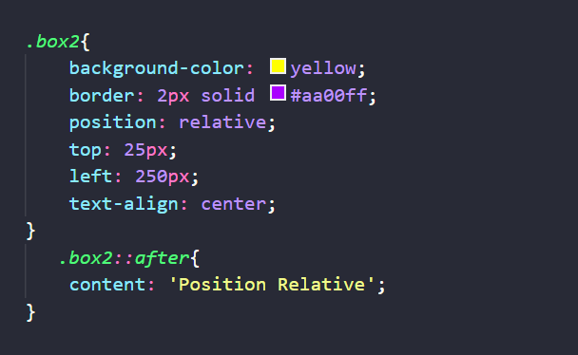

Absolute
The element will break the normal document flow to position the element on the page according to the given values of top, left, right and bottom.
Properties of position absolute
- It will break the normal document flow to position the element on the page.
- The properties like top, left, right, bottom and z-index will have an effect on the element.
- The element will not leave any space at its original position.
- The element will be positioned in respect of its closest positioned ancestor.
- If there is no positioned ancestor element then it will take the document body as his ancestor.
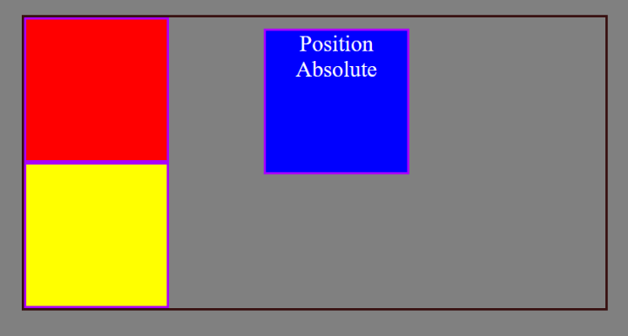
Note: Positioned Ancestor means an element which will be using any position property like relative, absolute, fixed or sticky.
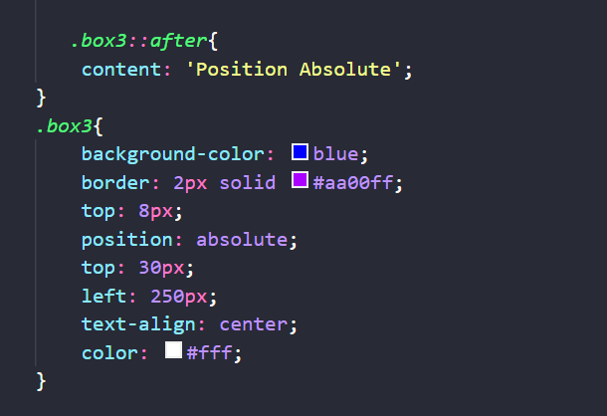

Fixed
As the name suggests, the element will be fixed to a particular position on the page, which means the element will be at the same position always even if the user scrolls the page.
Properties of position fixed
- It will break the normal document flow to position the element on the page.
- The element will be positioned relative to the browser window (width and height of
- screen) and will be in the same position even if the user is scrolling the page.
- The properties like top, left, right, bottom and z-index will have an effect on the element.
- The element will not leave any space in its original position.
Example :- We can see the chat support icon on the PW Skills website, which is always fixed
on the bottom right side of the screen even if we scroll the page.
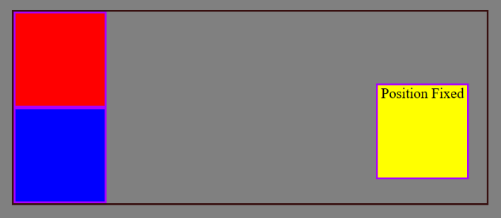
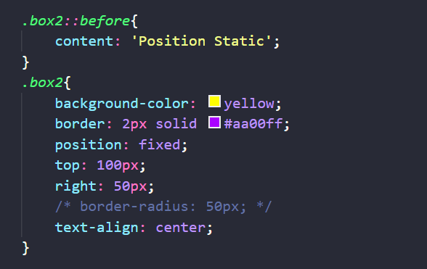

Sticky
The element is positioned based on the user’s scroll position.
Properties of position sticky
- It will not break the normal flow of the document to position the element on the page.
- It toggles between the position relative and fixed.
- It will behave like a relative position unless it reaches the given position, after reaching
- the given position it will behave like a fixed position.
- The properties like top, left, right, bottom and z-index will have an effect on the element.
- It will work only if any of the property (top, left, right or bottom) is specified.
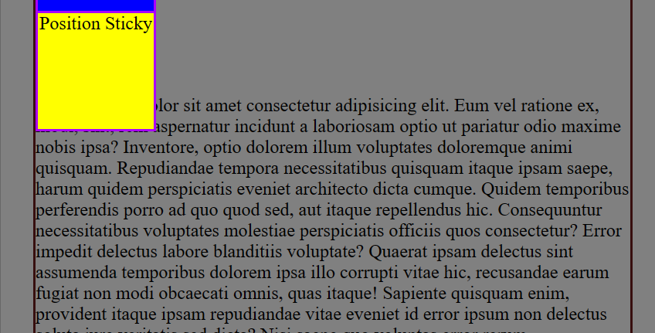
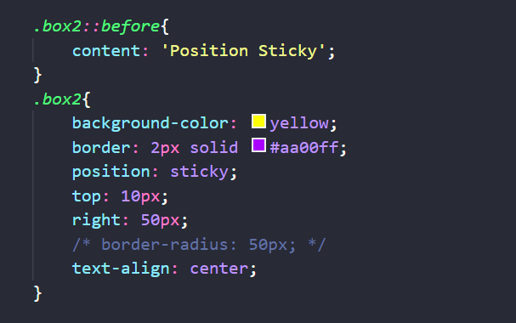

- What is Z-index and why to use it?
Z-Index.
- The z-index property in CSS is used to specify the stack order of an element. An element with a higher z-index value will be placed in front of an element with a lower z-index value.
- The value of the z-index property is an integer, the element with a higher number is placed on top of the elements with lower numbers.

Use Z-index
It's important to use the z-index property when creating complex or layered designs, or when creating UI elements like modal dialogs, drop-down menus, or tooltips that need to appear "on top" of other elements. By assigning different z-index values to elements, you can control the stacking order of the elements and ensure that they display correctly, regardless of their HTML order.

