Project Report

Team ID | LTVIP2026TMIDS64613
Project Name | visualizing housing market trends: an analysis of sale prices and features using tableau

1. INTRODUCTION

1.1 Project Overview

The project titled “Visualizing Housing Market Trends: An Analysis of Sale Prices and Features using Tableau” aims to transform raw housing data into meaningful visual insights. It focuses on analyzing factors such as years since renovation, house age, number of bathrooms, bedrooms, and floors, and how these impact house sale prices.
Using Tableau and Tableau Prep Builder, this project cleans, processes, and visualizes the data through interactive dashboards and storytelling features. The result is a powerful tool that helps users understand pricing trends, observe buyer behavior, and explore property feature patterns through engaging, data-driven visuals.

1.2 Purpose

The purpose of this project is to:
- Provide an interactive platform to explore housing market data.

- Identify and visualize how specific features and renovations influence house sale prices.

- Help users understand sales distribution trends based on age and renovations.

- Deliver clear, visual narratives for analytical insights using Tableau's storytelling capability.

2. IDEATION PHASE

2.1 Problem Statement
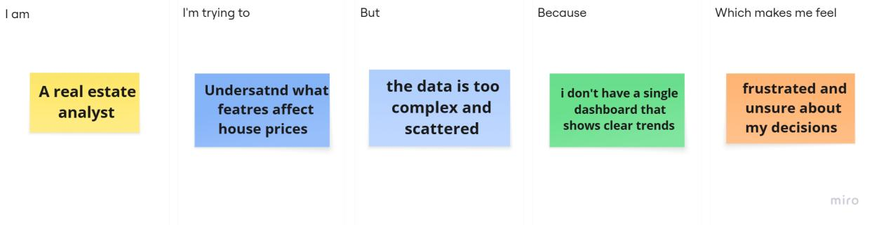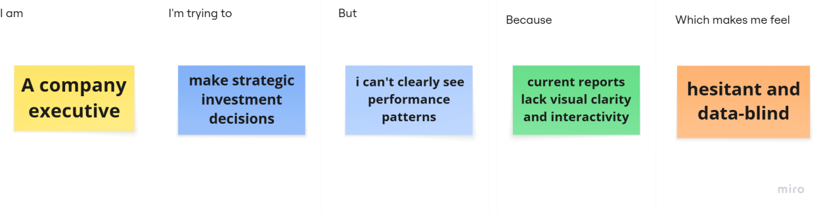

Problem  Statement (PS) | I am  (Customer) | I’m trying to | But | Because | Which makes me feel
PS-1 | A real estate analyst | understand what features affect house prices | the data is too complex and scattered | I don’t have a single dashboard that shows clear trends | frustrated and unsure about my decisions
PS-2 | A marketing strategist | target the right segment of buyers | I don’t  know what trends are | I can’t link buyer behavior to house characteristics | ineffective and misaligned
 |  |  | influencing sales
PS-3 | A company executive | make strategic investment decisions | I can’t  clearly see  performanc e patterns | current reports lack visual clarity and interactivity | hesitant and data-blind

2.2 Empathy Map Canvas
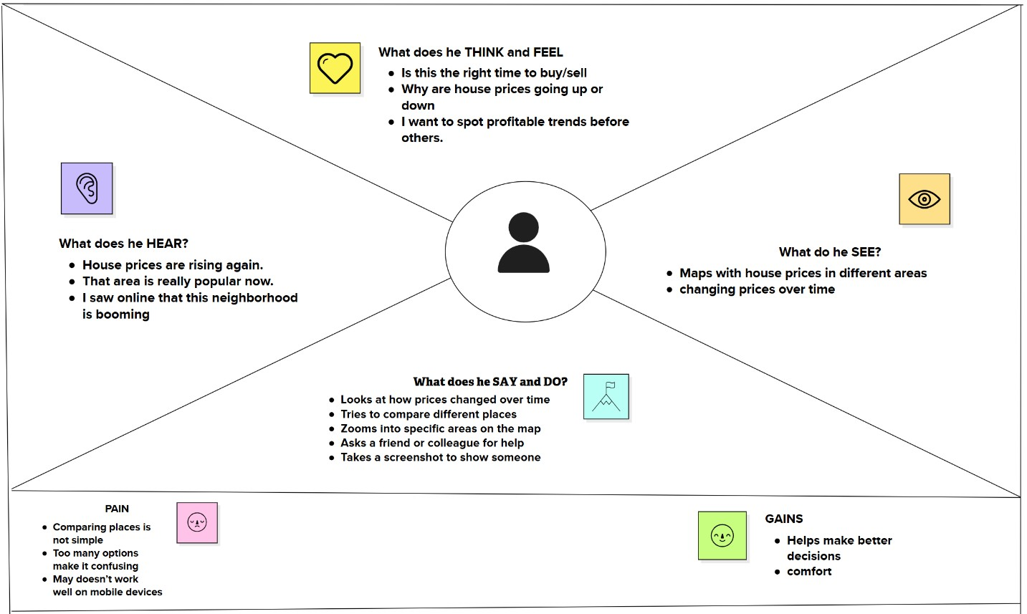

2.3 Brainstorming

Step-1: Team Gathering, Collaboration and Select the Problem Statement

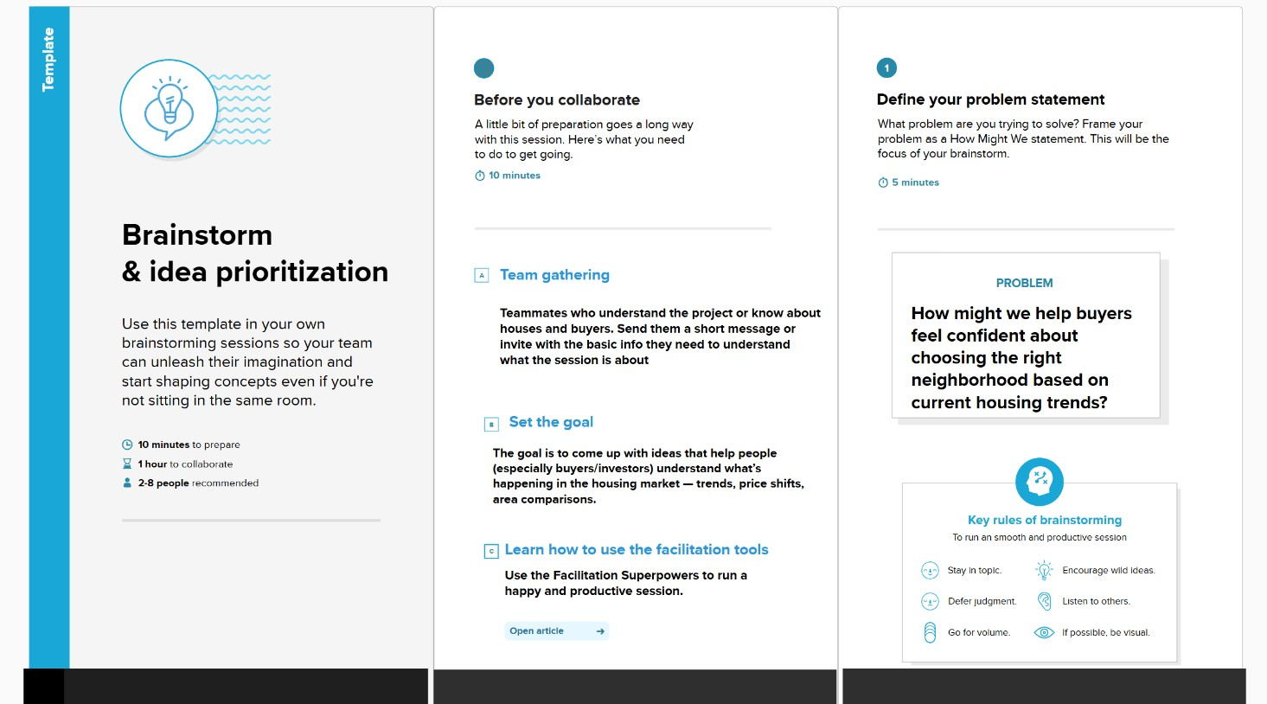
Step-2: Brainstorm, Idea Listing and Grouping

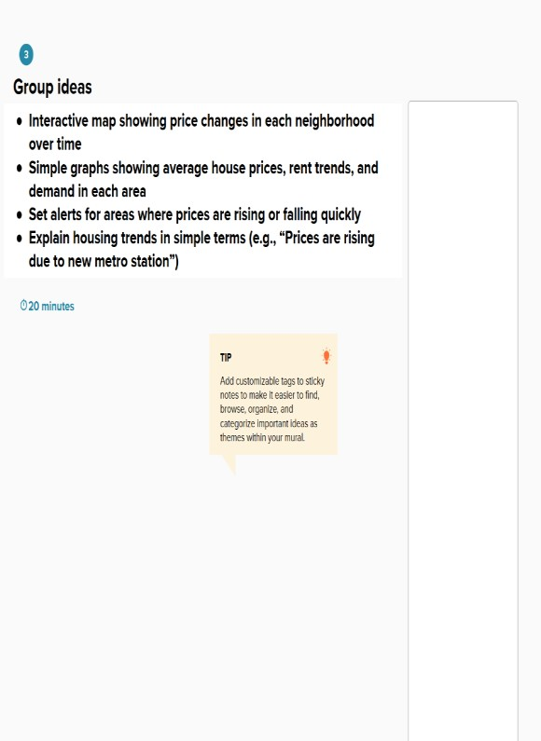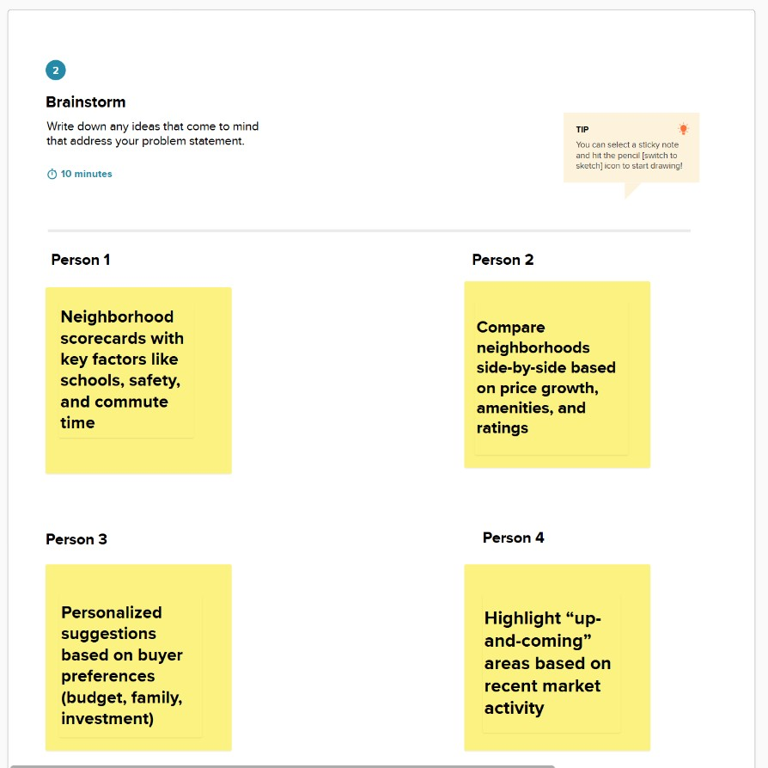

Step-3: Idea Prioritization

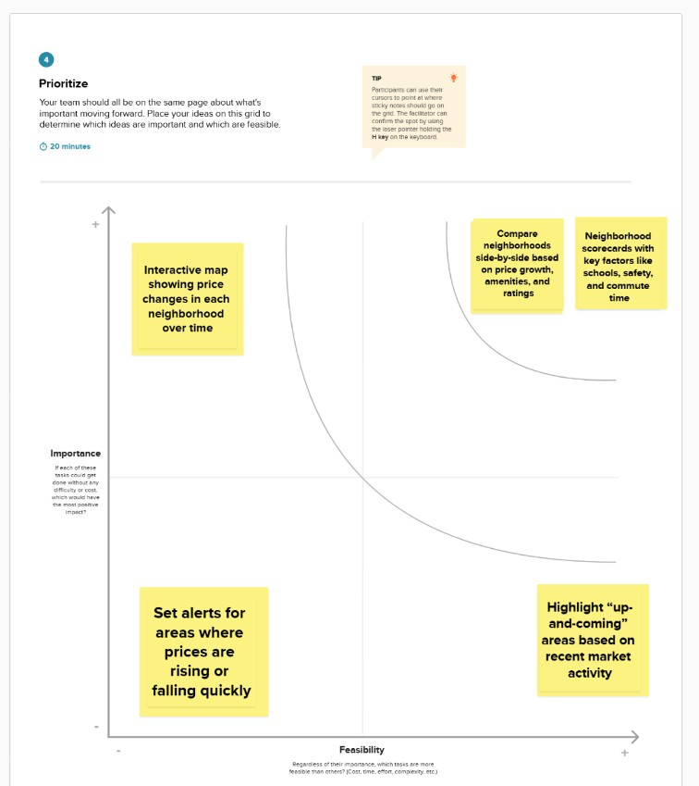

3. REQUIREMENT ANALYSIS

3.1 Customer Journey map
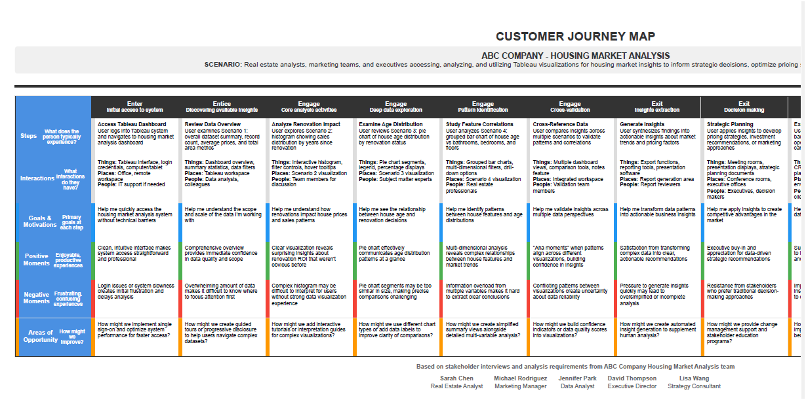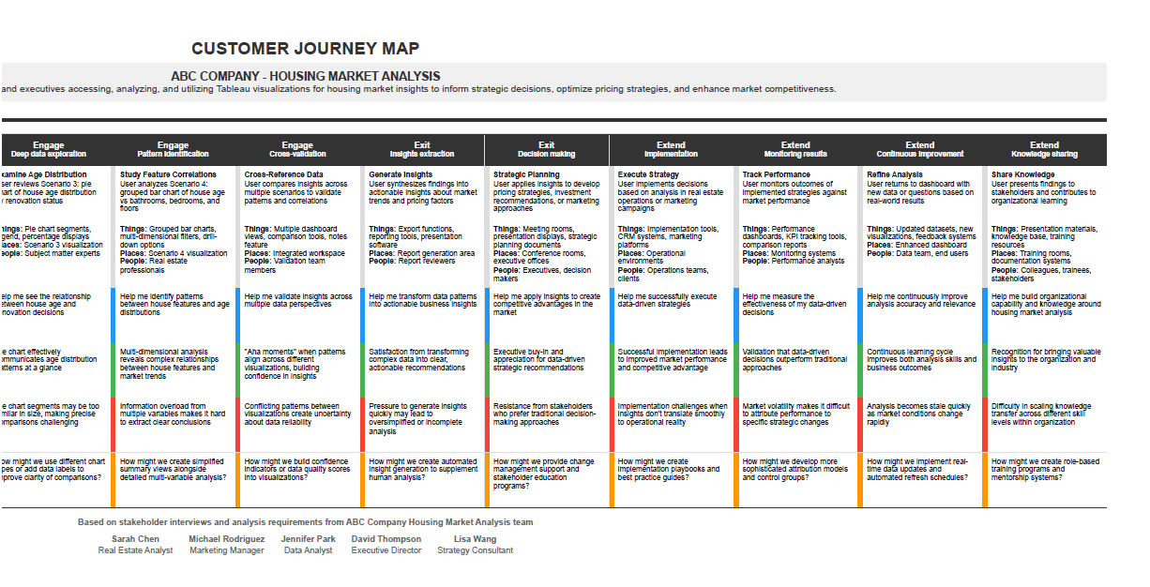

3.2 Solution Requirement
Functional Requirements:
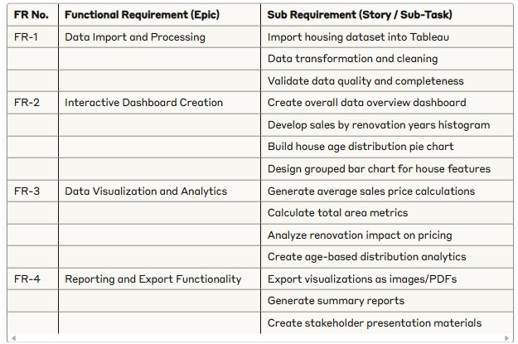
Non-functional Requirements:
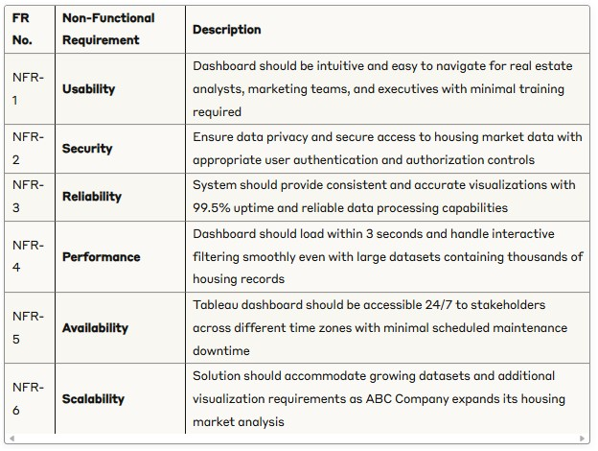

3.3 Data Flow Diagram
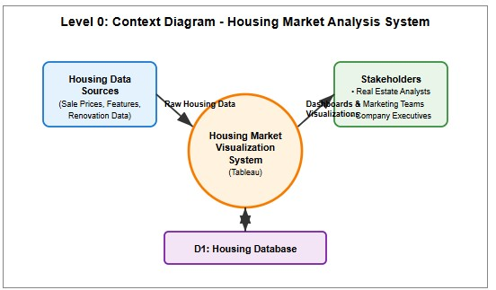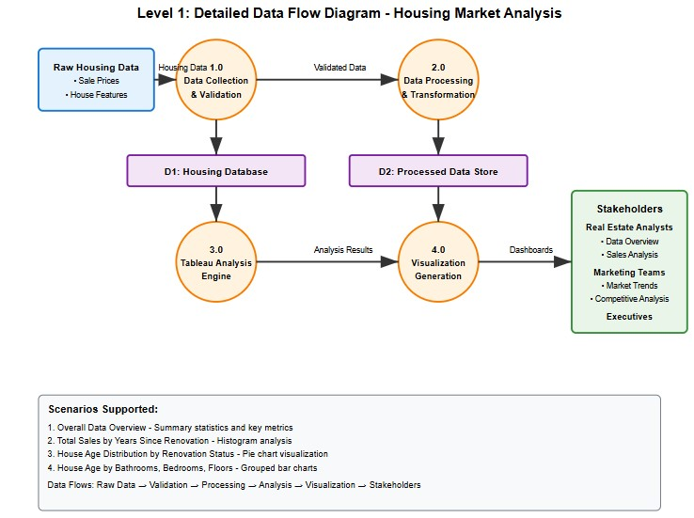

User Stories

Use the below template to list all the user stories for the product.
User Type | Functional Requiremen  t (Epic) | User  Story  Number | User Story / Task | Acceptance  criteria | Priority | Release
Real  Estate  Analyst | Data analysis & Visualization | USN-1 | As a real estate analyst, I can view the overall data overview dashboard to understand the dataset scale and key metrics | I can see count of housing records, average sales price, and total basement area | High | Sprint-1
Real  Estate  Analyst | Renovation Impact analysis | USN-2 | As a real estate analyst, I can analyze total sales by years since renovation through histogram visualization | I can identify correlation between renovation timing and price ranges | High | Sprint-1
Real  Estate  Analyst | House Age  Distribution | USN-3 | As a real estate analyst, I can view house age distribution by renovation status through pie chart | I can assess age characteristi cs and renovation prevalence | HIgh | Sprint-1
Real  Estate  Analyst | Feature analysis | USN-4 | As a real estate analyst, I can analyze house age distribution by number of bathrooms, bedrooms, and floors | I can identify patterns in housing characteristi cs over time | High | Sprint-2
Real  Estate  Analyst | Interactive dashboard | USN-5 | As a real estate analyst, I can access an interactive dashboard combining all visualizations | I can navigate between different views and filter data dynamically | Medium | Sprint-2

3.4 Technology Stack

Table-1 : Components & Technologies:

S.N  o | Component | Description | Technology
1. | User Interface | Web-based dashboards for viewing and interaction | Tableau Public
2. | Application Logic-1 | Data preprocessing and transformation workflows | Tableau Prep Builder
3. | Application Logic-2 | Interactivity using filters, parameters, and actions | Tableau Filters, Parameters, Actions
4. | Dashboard/Story Logic | Logical flow of insights using story features | Tableau Story Feature
5. | Data Source | Flat files used as housing market datasets | CSV
6. | File Storage | Housing datasets stored locally | Local File System / Google Drive

Table-2: Application Characteristics:

S.N  o | Characteristics | Description | Technology
1. | Open-Source Frameworks | yes | Tableau Public
2. | Security Implementations | N/A | N/A
3. | Scalable Architecture | Can scale by publishing to Tableau Cloud for wider access | Tableau Public
4. | Availability | Dashboards available online 24/7 | Tableau Public
5 | Performance | Good \ Better performance | Tableau Public

Technical Architecture:

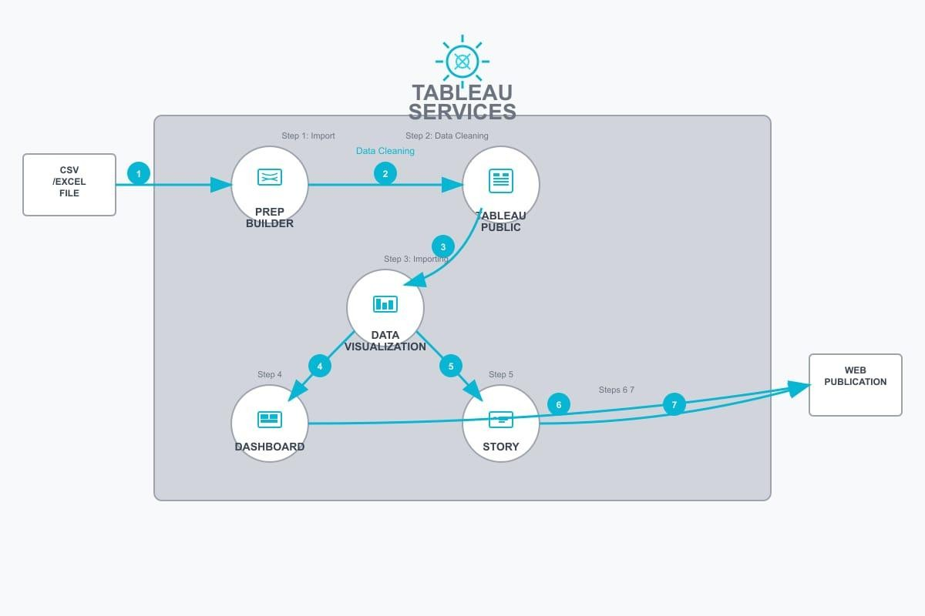

4. PROJECT DESIGN

4.1 Problem Solution Fit
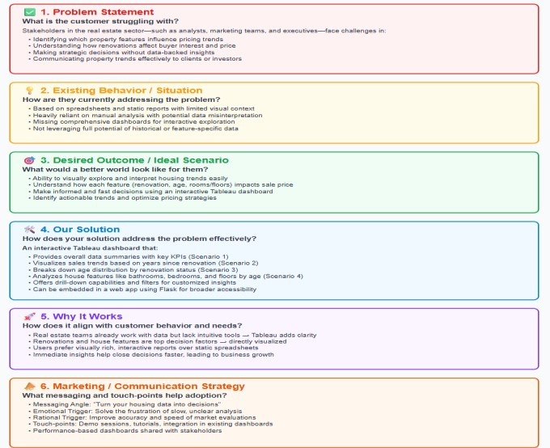

4.2 Proposed Solution

S. No | Parameter | Description
 | Problem Statement (Problem to be solved) | The housing market often lacks clarity regarding how property renovations impact sales prices over time. Buyers and sellers struggle to assess the return on investment for renovations due to the absence of clear data analytics. This limits effective decision-making and market efficiency.
2. | Idea / Solution description | Our project addresses this issue by visualizing total sales in relation to the number of years since a house was renovated. Using Tableau, we created a histogram that displays how recently renovated properties correlate with various sales price ranges. This visualization enables stakeholders to identify patterns and trends in buyer preferences and renovation impact.
3. | Novelty / Uniqueness | This solution stands out by offering an interactive, visual data analysis centered around the renovation timeline— a variable rarely explored in depth in traditional market reports. It brings actionable insights to the forefront using clear, user-friendly dashboards, making the data more accessible to both experts and laypeople.
4. | Social Impact / Customer Satisfaction | he solution empowers homebuyers with valuable insights into how renovation age affects home value, leading to more informed purchasing decisions. It also helps sellers and agents time renovations effectively to increase profits. Overall, it supports transparency, enhances consumer trust, and contributes to better housing policy and urban planning.
5. | Business Model (Revenue Model) | The solution can be monetized through a subscriptionbased model targeting real estate agencies, property investors, and developers. Additional income streams include custom dashboard development, real-time market reporting, and integration services with existing property listing platforms or CRMs.
6. | Scalability of the Solution | This model can be extended to include multiple variables such as location, square footage, number of bedrooms, or neighborhood crime rates. It can also scale geographically to analyze real estate markets across different cities or countries. With integration into national real estate databases, it can provide ongoing, large-scale market intelligence.

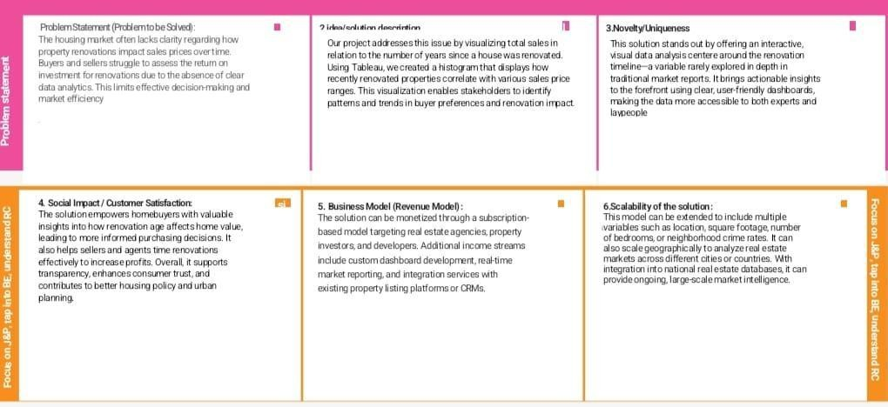

4.3 Solution Architecture
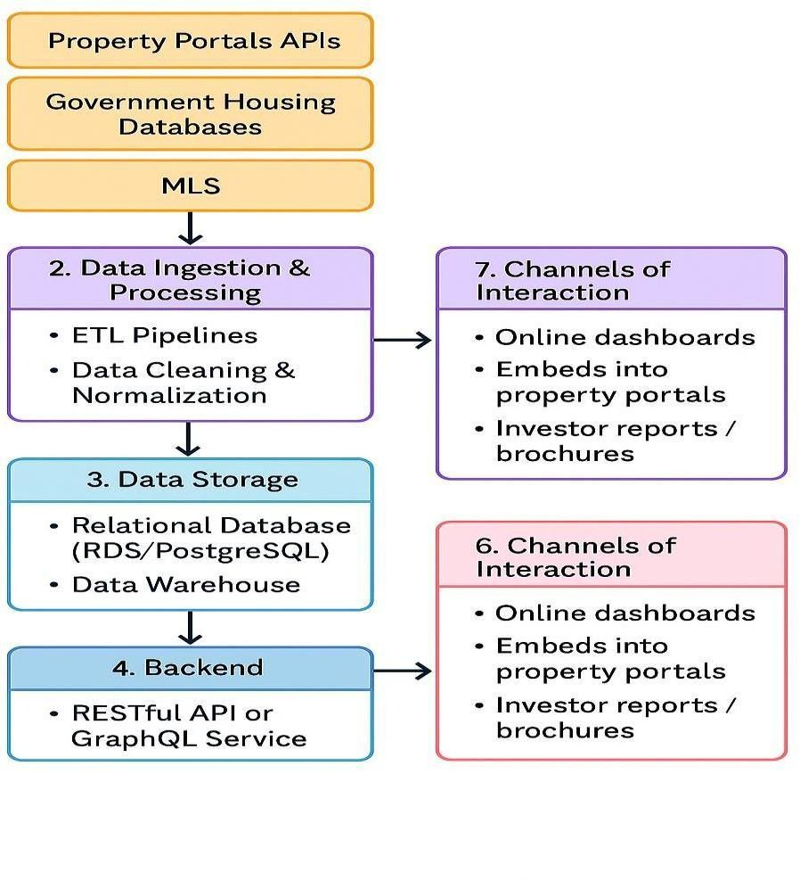

5. PROJECT PLANNING & SCHEDULING

5.1 Project Planning

Product Backlog, Sprint Schedule, and Estimation

Sprint | Functional  Requirement (Epic) | User  Story  Number | User Story / Task | Story  Point s | Priority | Team Members
Sprint-1 | Data  Collection &  Overview | USN-1 | As a stakeholder, I want to collect and transform housing market data to create a comprehensive dataset overview. | 1 | High | Team  Member -2
Sprint-1 | Data Analysis  Setup | USN-2 | As a real estate analyst, I want to load housing data into Tableau for visualization and analysis. | 2 | High | Team  Member -2
Sprint-1 | Data  Preprocessing | USN-3 | As a user, I want to clean and prepare housing data including sales prices, renovation years, and house features. | 2 | High | Team  Member -3
Sprint-2 | Renovation  Impact  Analysis | USN-4 | As a stakeholder, I want to visualize total sales  by years since renovation to understand renovation impact on pricing. | 3 | High | Team  Member -4
Sprint-2 | Age  Distribution  Analysis | USN-5 | As a real estate analyst, I want to create a pie chart showing house age distribution by renovation status. | 3 | Medium | Team  Member -4
Sprint-2 | Feature-  Based  Analysis | USN-6 | As a marketing team member, I want to analyze house age distribution by number of bathrooms, bedrooms, and floors. | 3 | High | Team  Member -4
Sprint-2 | Dashboard  Creation | USN-7 | As an executive stakeholder, I want an interactive dashboard combining all visualizations for strategic decision making. | 5 | High | Team  Member -3
Sprint-2 | Story  Development | USN-8 | As a company executive, I want a Tableau story that presents insights in a narrative format for presentations. | 5 | Medium | Team  Member -3

Project Tracker, Velocity & Burndown Chart

Sprint | Total  Story  Points | Duratio n | Sprint  Start  Date | Sprint End Date  (Planned) | Story Points  Completed | Sprint  Release  Date
Sprint-1 | 8 | 5 Days | 16 June  2025 | 20 June 2025 | 5 | 20 June  2025
Sprint-2 | 18 | 5 Days | 21 June  2025 | 25 June 2025 | 19 | 25 June  2025

Burndown Chart

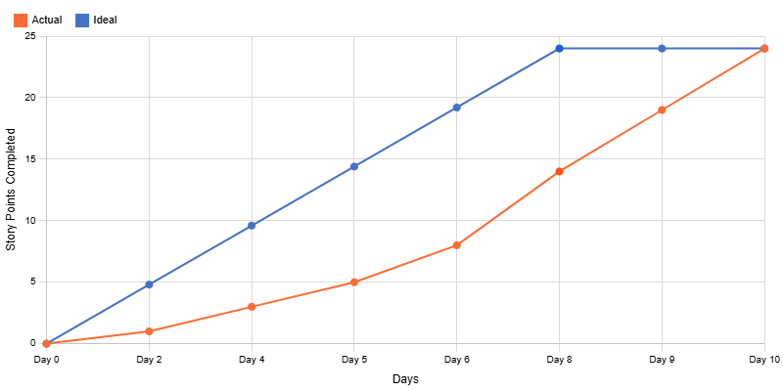

6. FUNCTIONAL AND PERFORMANCE TESTING

6.1 Performance Testing

Project team shall fill the following information in model performance testing template.
S.No. | Parameter | Screenshot / Values
1. | Data Rendered | Data contains 33 fields and 21609 rows  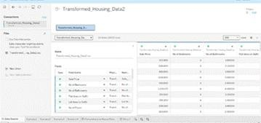
2. | Data Preprocessing | Identified 11 duplicate rows , removed unnecessary columns like  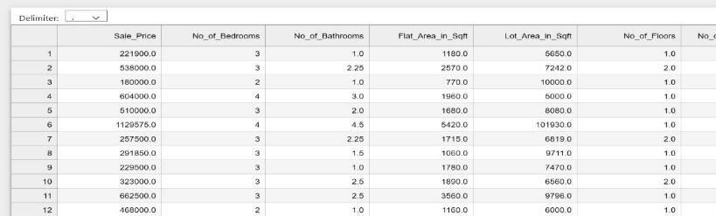  zipcodes, no missing or null values.

3. | Utilization of Filters | For scenario – 1  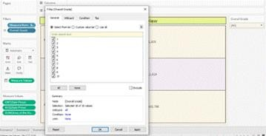  For scenario – 2  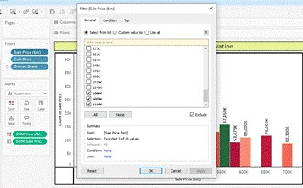  For scenario – 3  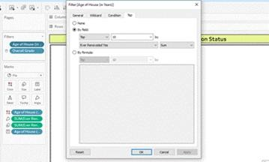

For scenario – 4

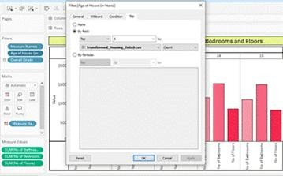
4. | Calculation fields Used | 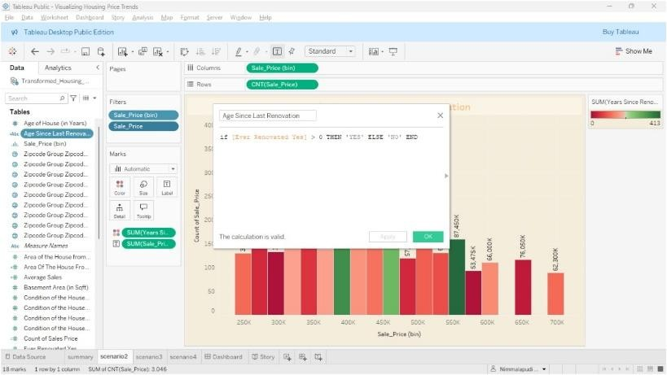
5. | Dashboard design | No of Visualizations / Graphs – 4  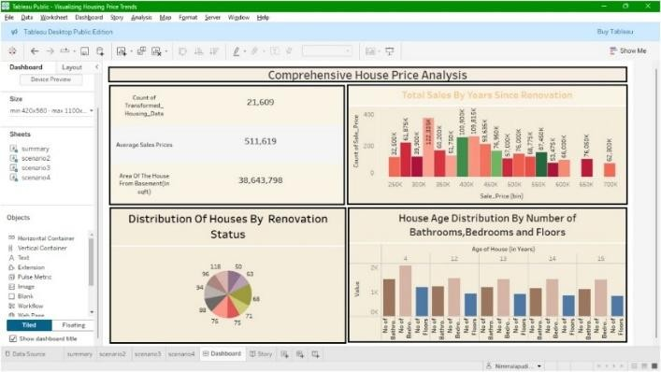  Dashboard Link : https://public.tableau.com/views/VisualizingHousingPriceTrends/Das hboard?:language=en-  US&:sid=&:redirect=auth&:display_count=n&:origin=viz_share_link
6 | Story Design | No of Visualizations / Graphs – 4  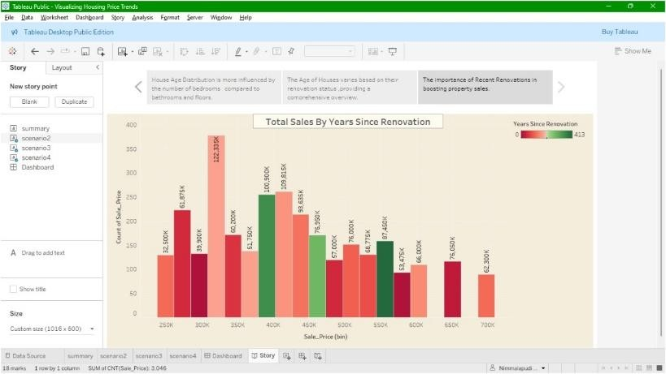  Story link :  https://public.tableau.com/views/VisualizingHousingPriceTrends/Stor y?:language=en-  US&:sid=&:redirect=auth&:display_count=n&:origin=viz_share_link

7. RESULTS

7.1 Output Screenshots

Scenario-1
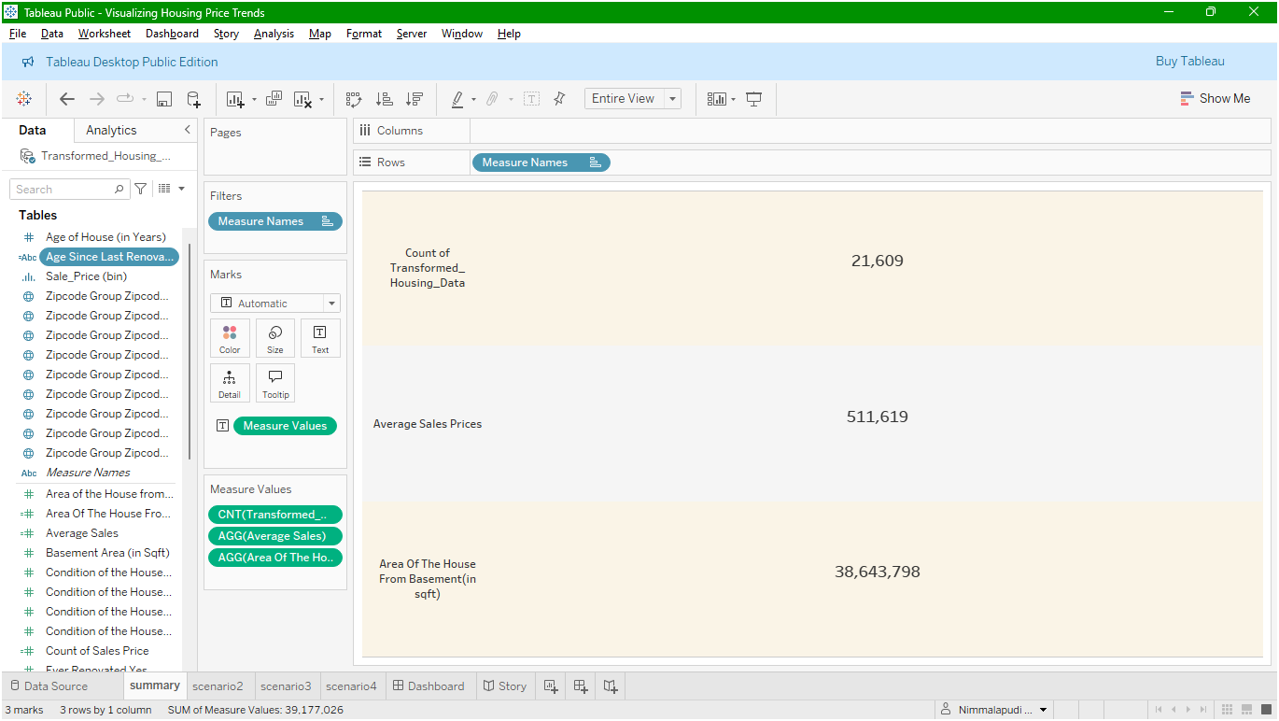

Scenario-2

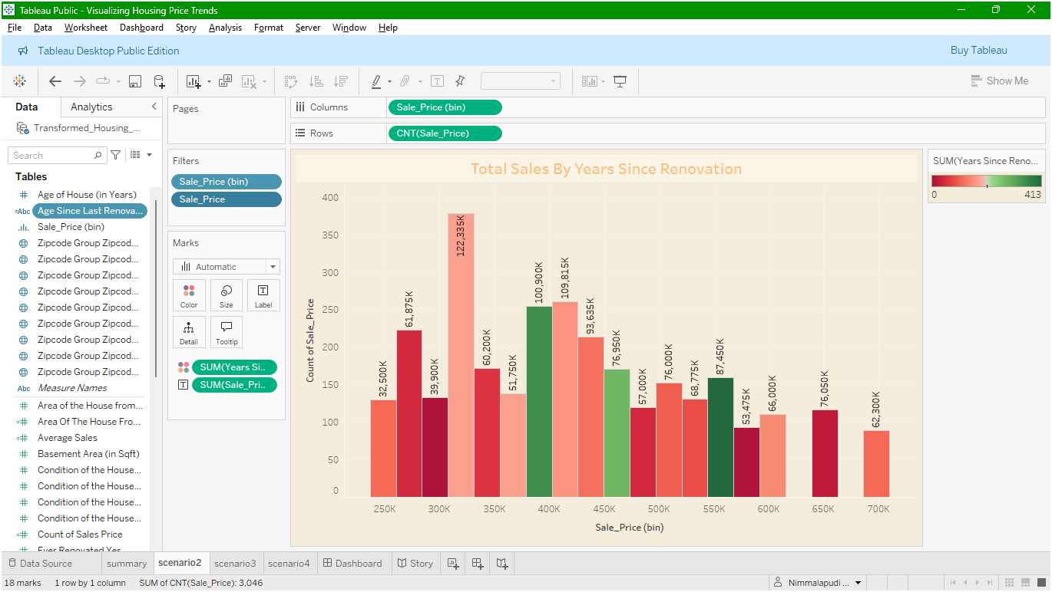
Scenario-3

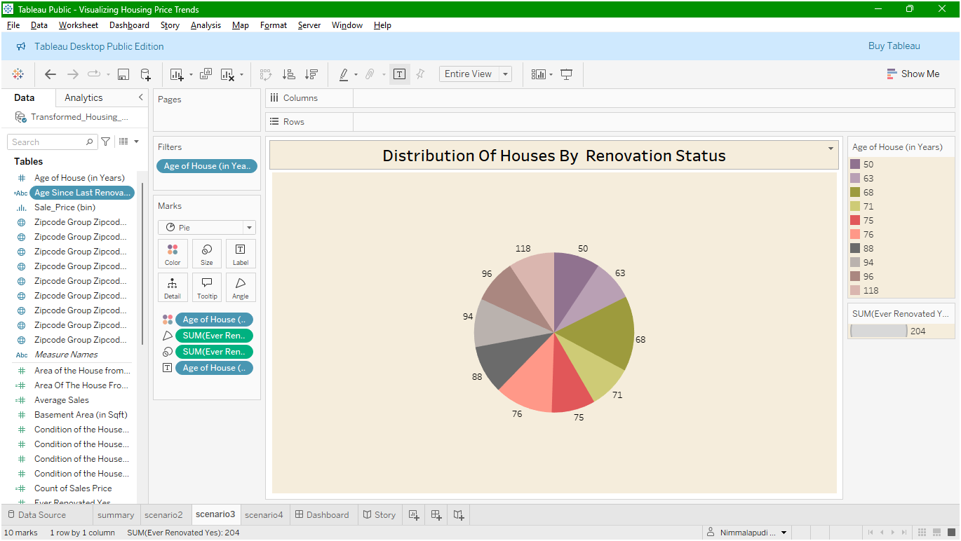

Scenario-4

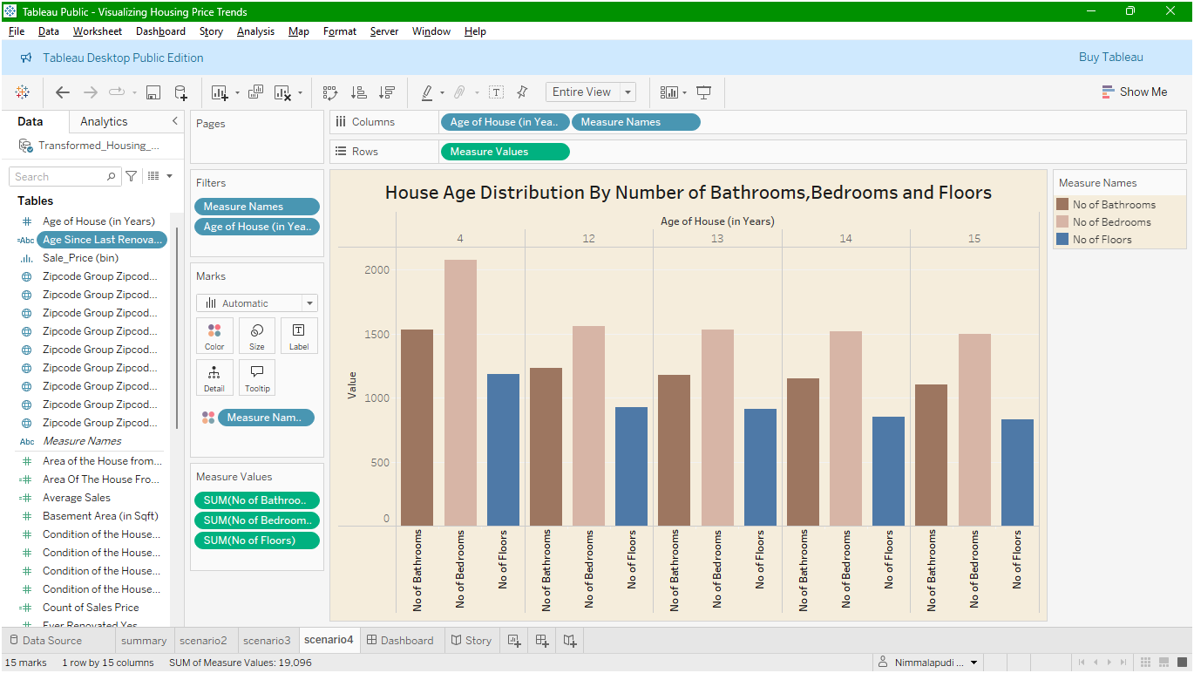

Dashboard
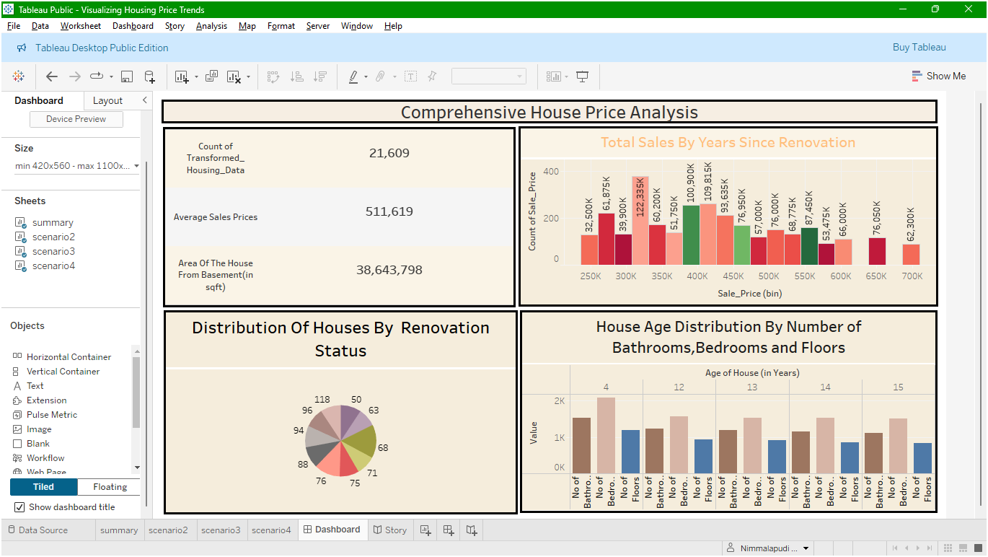

Story

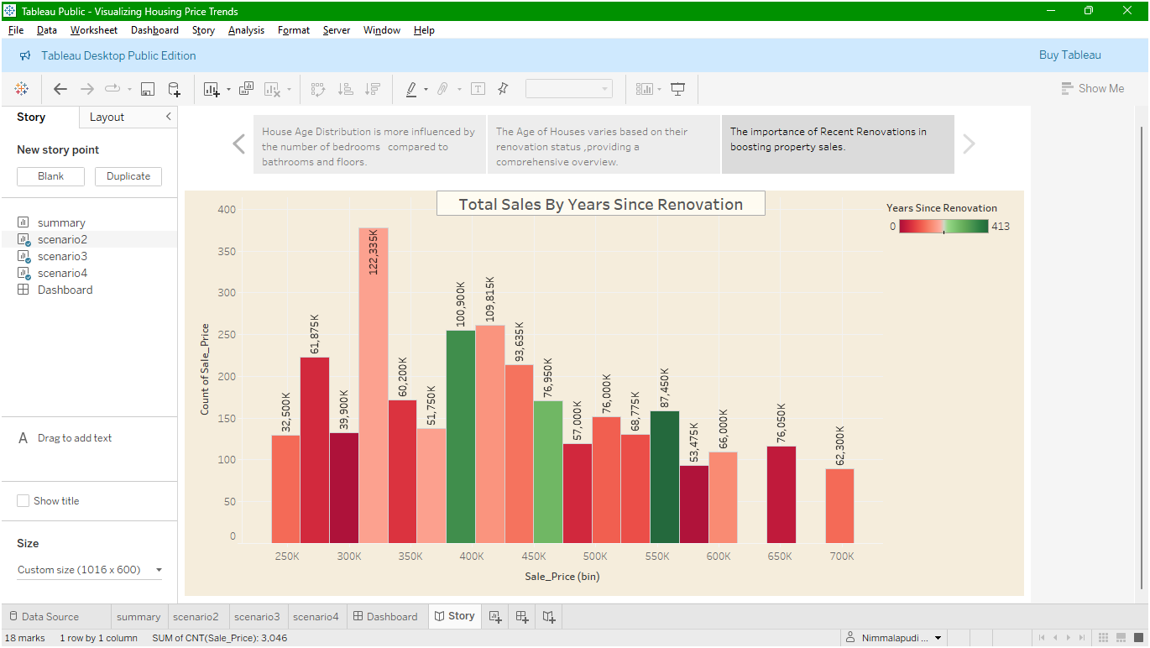

8. ADVANTAGES & DISADVANTAGES

8.1 ADVANTAGES
- Visual Clarity: Tableau enables intuitive, easy-to-understand visualizations for complex housing datasets.

- Interactive Dashboards: Users can filter data dynamically based on features like renovations, age, or number of rooms.

- Business Insights: Helps stakeholders identify trends and patterns that influence pricing strategies and buyer behavior.

- Time-Efficient: Reduces manual analysis through automated and visual insights.

- Storytelling Capability: Tableau’s story feature allows presenting data as step-by-step narratives.

- Non-technical Accessibility: Designed for business users with minimal technical skills.

- Improves Decision Making: Enhances strategic planning through data-driven recommendations.

- Flexible Data Sources: Supports a wide range of formats like Excel, CSV, and cloudbased data.

8.1 DISADVANTAGES

- No Predictive Modeling: Tableau lacks built-in machine learning or forecasting capabilities.

- Dependence on Data Quality: Inaccurate or unclean data can lead to misleading visualizations.

- Limited Data Cleaning: Complex data transformations require external tools like Tableau Prep.

- Performance Issues: Can slow down with very large datasets if not optimized properly.

- Story Limitations: Tableau’s story feature is static and not as flexible as interactive dashboards.

- Cost (for full version): Tableau Creator licenses and cloud solutions may be expensive.

- No Native Real-Time Streaming: Tableau is not ideal for real-time dynamic updates.

- Requires Training: Users need time to become proficient in designing meaningful dashboards.

9. CONCLUSION

This project demonstrates the effective use of Tableau and Tableau Prep Builder to analyze and visualize housing market data in a meaningful and interactive way. By examining patterns related to sale prices, renovations, house age, and structural features, the project reveals key insights that support a deeper understanding of real estate trends.
Through a combination of interactive dashboards and story-driven visualizations, the project transforms raw datasets into easily interpretable insights. It proves how data visualization can enhance clarity, support decision-making, and provide a structured narrative around complex datasets. The approach used ensures the findings are accessible to both technical and non-technical users, making it a valuable asset for real estate data analysis.

10. FUTURE SCOPE

- Add Predictive Analytics: Integrate machine learning to forecast housing prices.

- Use Real-Time APIs: Connect to real estate APIs (like Zillow or Realtor.com) for live data updates.

- Enhance with Maps: Use Tableau’s map visualizations for geospatial housing trends.

- Deploy on Tableau Server: Expand collaboration through server-hosted dashboards.

- Include External Data: Add economic, demographic, or regional data to enrich insights.

- Mobile Dashboards: Optimize dashboards for mobile accessibility.

- Automated Data Refresh: Schedule regular updates from connected data sources.

- Multi-User Interaction: Enable tailored views for different user types like analysts, buyers, or planners.

11. APPENDIX
Dataset Link :
https://www.kaggle.com/datasets/rituparnaghosh18/transformed-housing-data-2

Dashboard Link :
https://public.tableau.com/views/VisualizingHousingPriceTrends/Dashboard?:language= en-US&:sid=&:redirect=auth&:display_count=n&:origin=viz_share_link

Story Link :
https://public.tableau.com/views/VisualizingHousingPriceTrends/Story?:language=enUS&:sid=&:redirect=auth&:display_count=n&:origin=viz_share_link

Project Demo Link :
https://drive.google.com/file/d/1T0GZEivxXbg9HlnctpyagDtSkV0laL02/view?usp=sharing

