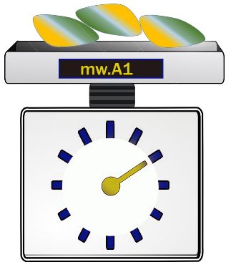**Introduction**

wm.A1 is a freeware software developed in Python, designed to run on Microsoft

Windows systems. It is compatible with nearly all Windows operating systems and has

minimal requirements. The executable file size is less than 1.56 MB, while the supporting folder size is 22 MB. The tool features a main module that provides all necessary options, and the results are displayed on an easy-to-use interface

**Instruction manual**

You can download m.A1 from website.

To install the software, users can download .exe file Github or Codeocen.

<https://github.com/aziz1sh1/mw.A1/blob/main/mwa1.exe>

<https://codeocean.com/capsule/8104884/tree/v1>

Supporting folded, with instruction is available in below mention link

<https://github.com/aziz1sh1/mw.A1/tree/main/_internal>

The software consists of a single executable file named "wm.A1.exe" and a supporting folder called "_internal." To run the program, double-click the opaque icon. Make sure to place the "wm.A1.exe" file outside the "_internal" folder. Double-click the opaque icon to run this file. Put wm.A1.exe file and folder _internal together. You must put exe file outside the ¬ _internal

wm.A1 is designed to be free of viruses and bugs, and it is released under the MIT License. If you encounter any issues with your operating system while installing, you may need to temporarily disable your antivirus software and then re-enable it after the installation is complete.

Muhammad Aziz

Aziz1sh@hotmail.com