Name:Abdulaziz Aburawi

Student Number:200348236

**Title: Socket Chatroom**

In this project I have use python to develop a chatroom using a Socket. The idea of it is to have a client side and a server side to communicate between two or more clients. The server needs to accept the connection from the client. At this point the user is displayed by IP address. In the program it allows users to us user names. After that the server will display in coming messages that have been collected.

To run the program:

1.Lucht he Server.py and run. You will get a screen that looks like this:

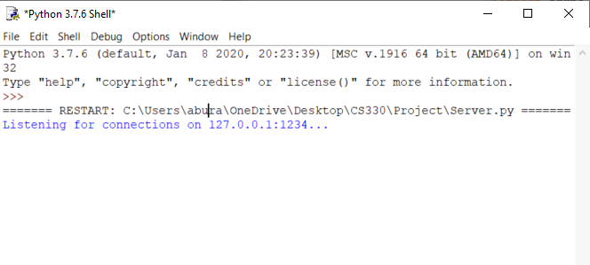

2.Lunch Client.py and run it. You will get a screen that looks like this:

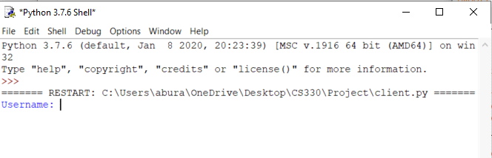

3.Select a user name. For demonstration reason I have choose the name DOOM as shown below.

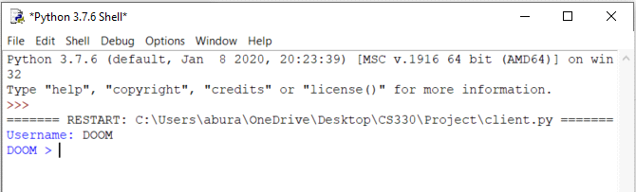

4.Now we can see the commutation between the client and the sever.

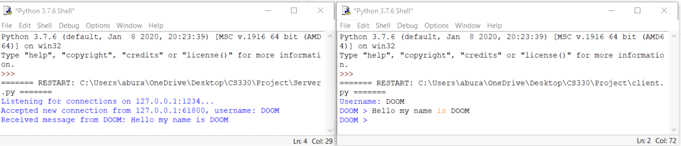

**Challenges**

The Challenges that I have found was the fact that I had to work on this project during a very though times. It was very hard for me to work on my project that I have originally choose. I hade no choose but to change the topic, I had no where to work, and so much is going on to in my place concentrate.

**To reproduce** this project, it is very simple as I have provided links to the videos that helped me. You can us any language you like.

References:

<https://pythonprogramming.net/server-chatroom-sockets-tutorial-python-3/>

<https://pythonprogramming.net/client-chatroom-sockets-tutorial-python-3/>

[https://www.youtube.com/watch?v=CV7_stUWvBQ HYPERLINK "https://www.youtube.com/watch?v=CV7_stUWvBQ&feature=emb_title"& HYPERLINK "https://www.youtube.com/watch?v=CV7_stUWvBQ&feature=emb_title"feature=emb_title](https://www.youtube.com/watch?v=CV7_stUWvBQ&feature=emb_title)

[https://www.youtube.com/watch?v=ytu2yV3Gn1I HYPERLINK "https://www.youtube.com/watch?v=ytu2yV3Gn1I&t=3s"& HYPERLINK "https://www.youtube.com/watch?v=ytu2yV3Gn1I&t=3s"t=3s](https://www.youtube.com/watch?v=ytu2yV3Gn1I&t=3s)