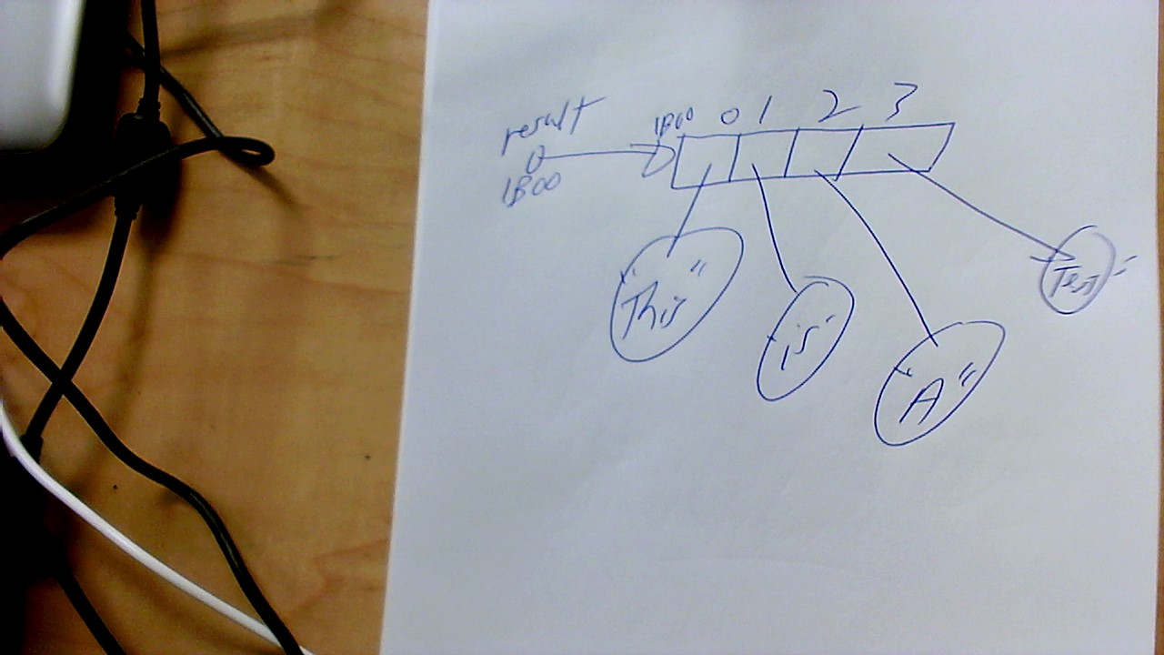

Comparable - compareTo - only One way to sort!

Comparator - compare - can do sorting in more than one way if use more than

one comparator.