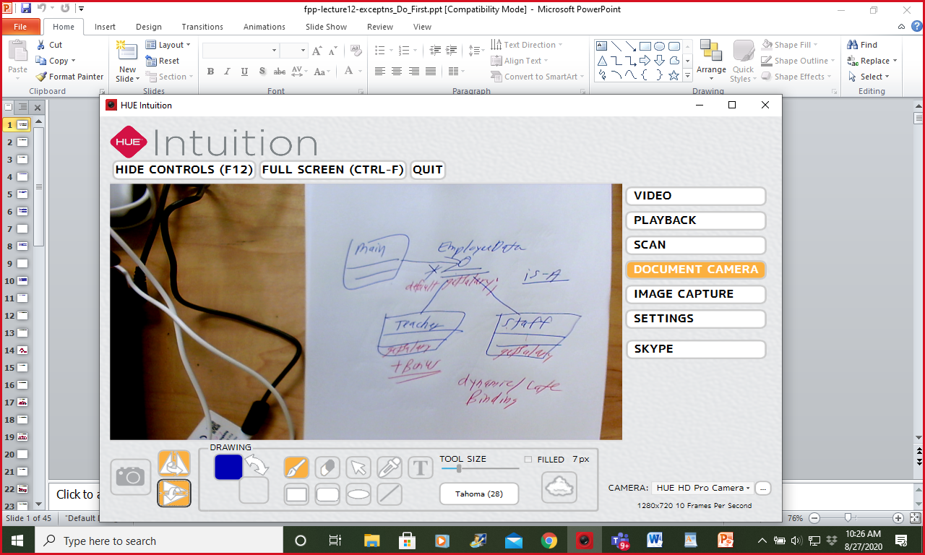

**Checked Exceptions**

All Exceptions EXCEPT the **RuntimeException**

Compiler insists that you do something! Two choices :

1) ignore it (throws)

2) try … catch …

**Unchecked Exceptions**

**RuntimeException**

**Integer.parseInt(myString) // “422” “hello”**

**m1 -> m2 throws -> m3 throws or try … catch …**

void m1()

return;