Debugging :

1) White-box

2) System.out.println 98 percent

3) Debugger

SOP (“at 3 j = “ + j + “ sum = “ + sum) //get ALL variables you need

for ( …

SOP (“at 1 j = “ + j + “ sum = “ + sum) //get ALL variables you need

{

If ( …

SOP (“at 2 j = “ + j + “ sum = “ + sum) //get ALL variables you need

}

}

SOP (“at 4 j = “ + j + “ sum = “ + sum) //get ALL variables you need

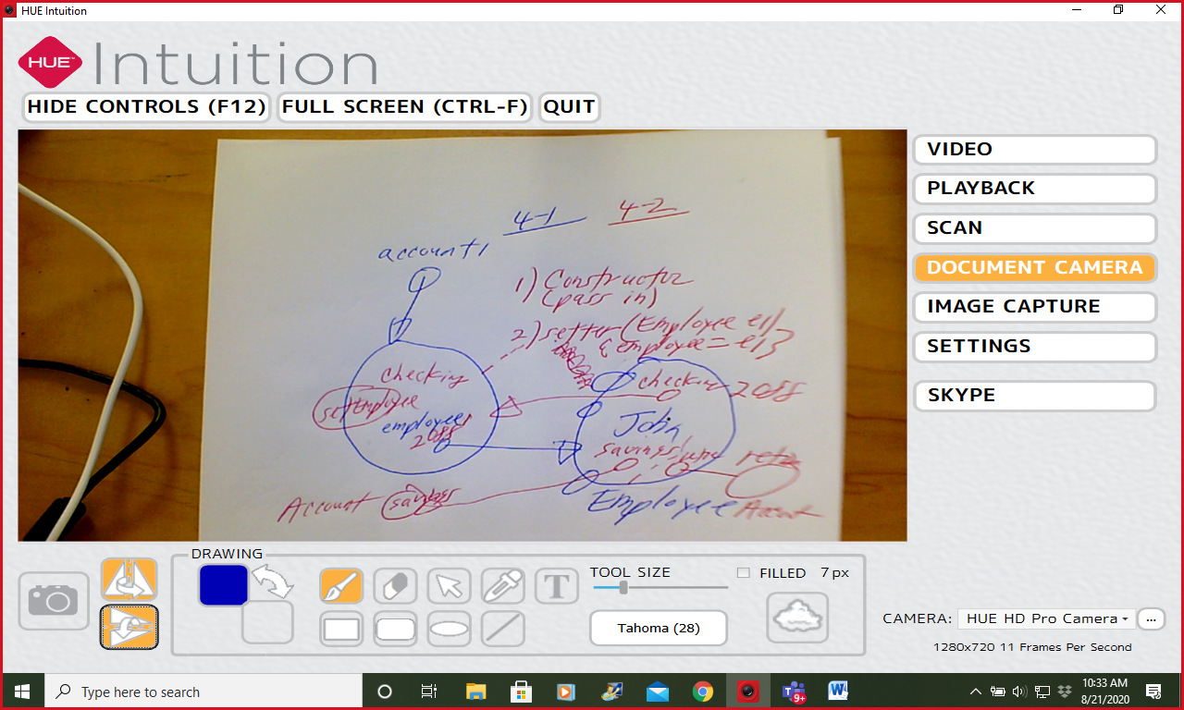

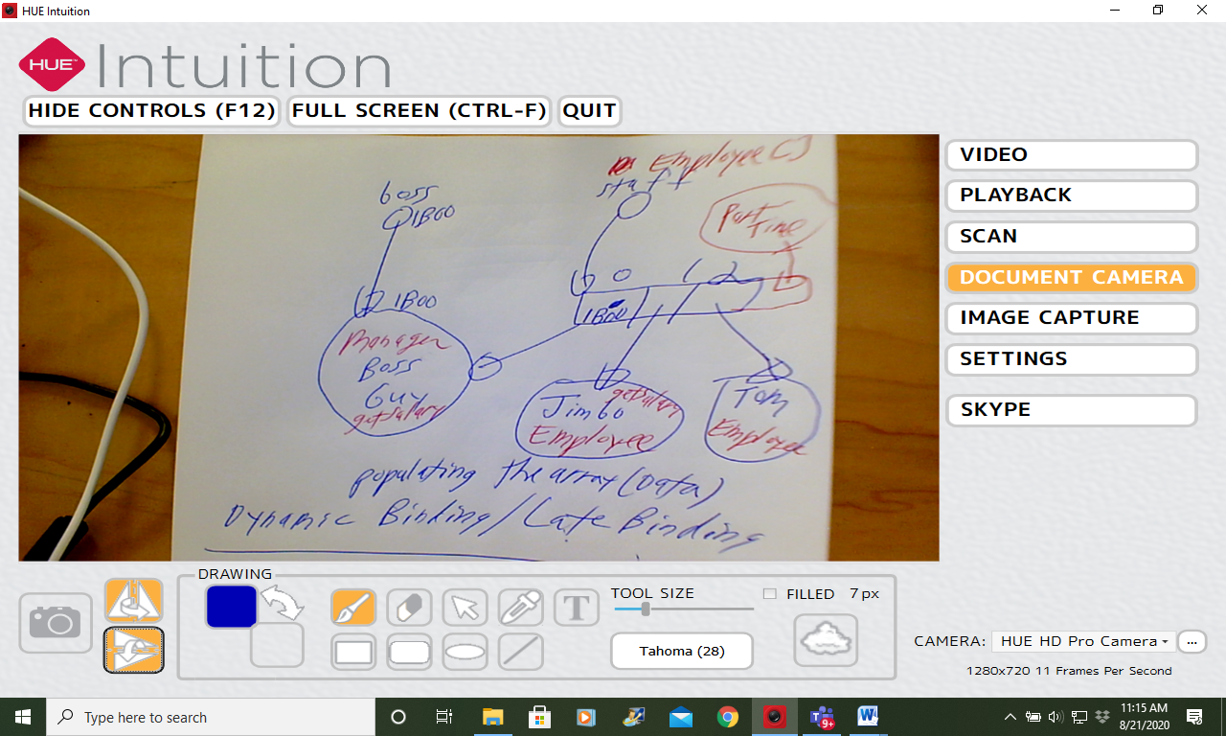

setSalary (double aSalary)

salary = aSalary

addTen ()

{ salary += 10

Overriding child and a parent Same arguments

Overloading you have only One class. Different argumnents

access modifiers

private, <package level>, protected, public