Lesson 10

Binary Search Trees

- The fundamental operations on a BST are:
public boolean find(Object val)
public void insert(Object val)
public boolean remove(Object val)
public void print()

A Binary Search Tree
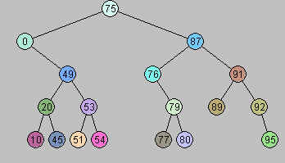

Sample Code

public class MyBST {
/** The tree root. */
private BinaryNode root;

public MyBST() {
root = null;
}
/**
* Prints the values in the nodes of the tree
* in sorted order.
*/
public void printTree( ) {
if( root == null )
System.out.println( "Empty tree" );
else
printTree( root );
}
private void printTree( BinaryNode t ){
if( t != null ){
printTree( t.left );
System.out.println( t.element );
printTree( t.right );
} // An INORDER Traversal
}
//Assume the data in the Node is an Integer.

public void insert(Integer x) {
if (root == null) {
root = new Node(x, null, null);
return;
}

Node n = root;
boolean inserted = false;

while(!inserted){
if(x.compareTo(n.element)<0) {
//space found on the left
if(n.left == null){
n.left = new Node(x,null,null);
inserted = true;
}
//keep looking for a place to insert (a null)
else {
n = n.left;
}
}
else if(x.compareTo(n.element)>0){
//space found on the right
if(n.right==null){
n.right = new Node(x,null,null);
inserted = true;
}
//keep looking for a place to insert (a null)
else {
n = n.right;
}
}
}

}

private class BinaryNode {

// Constructors
BinaryNode( Integer theElement ){
this( theElement, null, null );
}

BinaryNode( Integer element,
BinaryNode left,
BinaryNode right ){
this.element = element;
this.left = left;
this.right = right;
}
private Integer element;// The data in the node
private BinaryNode left; // Left child
private BinaryNode right; // Right child
}
}

