Programming Exercise 7-1

Write the Swing code necessary to produce the following screen.
Use the default layout manager.

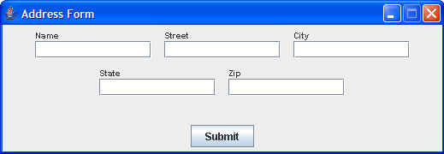

Add an appropriate ActionListener so that, when a user clicks the Submit button…
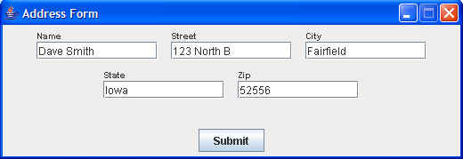

the data that has been entered into the GUI fields is output to the console in the following format:

Dave Smith
123 North B
Fairfield, Iowa 52556

