Programming Exercise 7-2

Write the Swing code necessary to create the following screen.
Use the default Layout Manager.

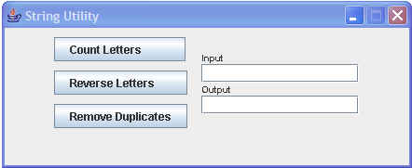

Create the necessary ActionListeners so that, when Count Letters is clicked, the number of characters in the Input field is placed in the Output field,

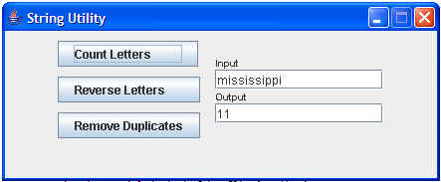

and, when Reverse Letters is clicked, the letters in the input area are reversed and placed in the output area,

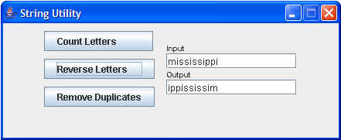

and, when the Remove Duplicates is clicked, the duplicate letters are removed and the result is placed in the output area.

