UML — Factory Method (Character System)
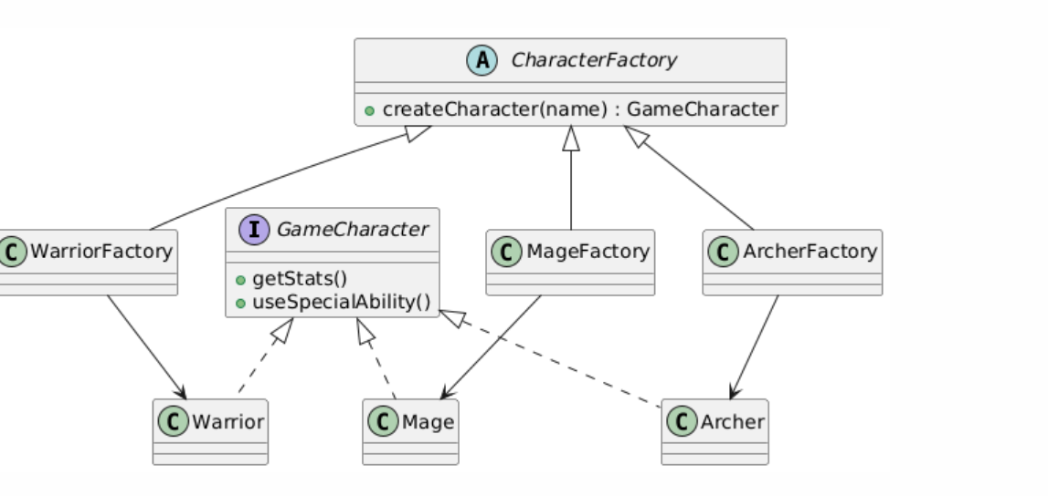
UML — Abstract Factory (Equipment System)
