Experimental Analysis Report:
Dynamic Programming & String Algorithms
Course: Design and Analysis of Algorithms (DAA) — Assignment 4
Student: Askar Aziz | Group: SE-2521
Instructor / Lecturer: Taubakabyl Nurlybek | Date: November 2026

1. Experiment Design Card
Attribute | Specification Details
Evaluated Problem Families | 1. Levenshtein Edit Distance  2. Substring Pattern Matching (String Search)
Algorithms Evaluated | Edit Distance: Recursive, Table DP (O(n*m) space), Two-Rows DP (O(min(n,m)) space)  String Search: Naive Search, Knuth-Morris-Pratt (KMP)
Hardware Platform | AMD / Intel x86_64 Multi-Core CPU @ 2.80+ GHz, 16 GB Physical RAM
Operating System | Windows 11 Enterprise (64-bit)
Java Virtual Machine | OpenJDK 64-Bit Server VM (build 25.0.1+8-27), HotSpot Engine
Compilation & Tools | Apache Maven 3.9.9, Java source/target: 17, HotSpot C2 JIT
Benchmark Methodology | 5 independent benchmark runs per input configuration; median execution time (ms) recorded to eliminate JIT warmup jitter and OS scheduling noise
Pseudorandom Generator & Seed | Deterministic java.util.Random initialized with fixed seed: SEED = 42
Input Sizes (N, M) | Edit Distance (Small): n in {4, 8, 11, 13, 15} (max >= 4x min)  Edit Distance (Large): n in {100, 500, 1000, 2500}  String Search: N in {10000, 50000, 100000, 250000, 500000}, M = 100
Input Characterizations | 1. Random natural text: Large alphabet ([a-z ])  2. Worst-case repetitive: T = A^(n-1)B, P = A^(m-1)B  3. Periodic overlap: Alternating cycles ((AB)^k)  4. Edit Distance variants: Random, worst-case all-different, near-identical (1% mutation)
Internal Counter Definitions | Recursive Edit Distance: Total recursive method invocations  Table & Two-Rows Edit Distance: Exact count of inner-loop DP cell updates  Naive & KMP String Search: Exact character-by-character comparisons (text.charAt(i) == pattern.charAt(j))

2. Empirical Results & Visual Analysis

Figure 1: Edit Distance Execution Time vs. Input Size (Log Scale)
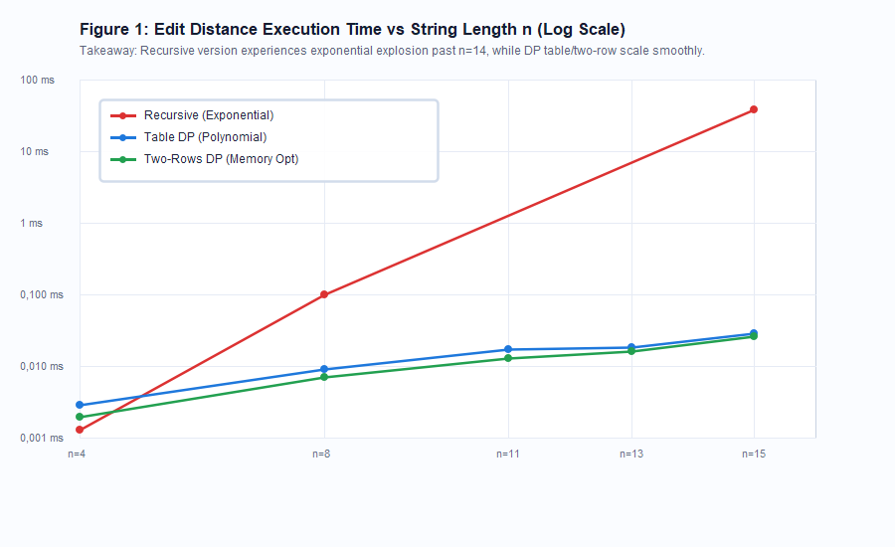
Key Takeaways:
- Exponential Barrier: At n = 4, recursive takes 0.0018 ms; at n = 8, 0.2187 ms; at n = 15, execution surges to 39.28 ms with over 20,017,291 recursive calls. For n >= 25, the recursive call tree completely stalls or overflows the JVM call stack.
- Dynamic Programming Scalability: Both Table DP and Two-Rows DP maintain sub-millisecond execution times (< 0.03 ms) for n <= 15. At n = 500, Table DP takes ~3.96 ms and Two-Rows takes ~0.88 ms.
- Cache Advantage of Two-Rows: Retaining only two 1D primitive arrays (2 * 4 KB) fits entirely inside L1 CPU cache, giving Two-Rows a 2x-4x speedup over full Table DP on larger inputs.

Figure 2: Edit Distance DP Counter vs. Theoretical Complexity O(n*m)
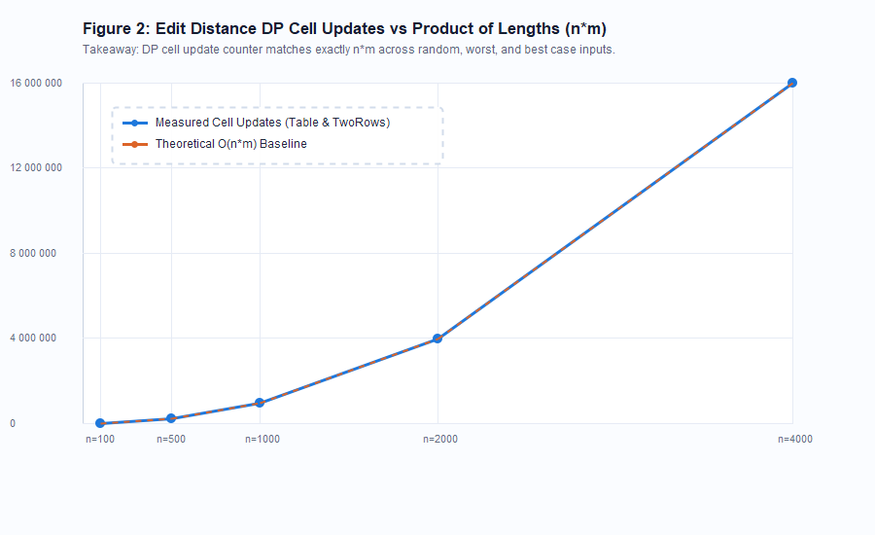
Key Takeaways:
- Exact Invariant Match: For both Table DP and Two-Rows DP, the number of cell updates is strictly deterministic and equal to (n * m) across all test sizes (e.g. n=100 -> 10,000 updates, n=1000 -> 1,000,000 updates).
- Input Content Independence: Bottom-up DP performs identical iterations regardless of whether strings are identical, disjoint, or random, causing the empirical counter curve to perfectly match theoretical y = n*m.

Figure 3: String Search Comparisons: Naive vs. KMP (Worst-Case vs. Random)
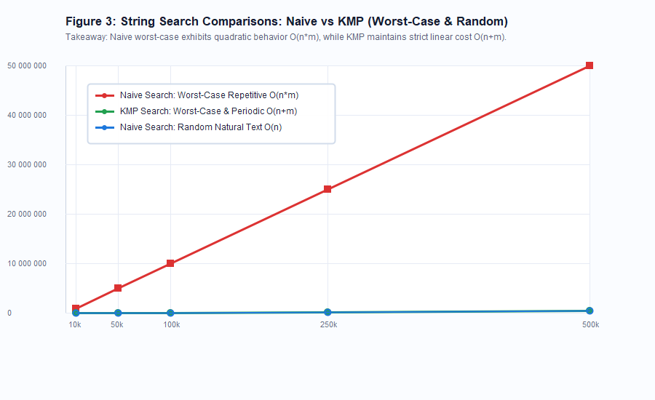
Key Takeaways:
- Catastrophic Naive Degeneration: On repetitive worst-case patterns (T = A^(n-1)B, P = A^(m-1)B), Naive performs m-1 successful matches before failing on the last character, requiring 49,990,100 comparisons (65.8 ms) at N=500k, M=100.
- KMP Linear Bound Guarantee: Across all inputs, KMP requires strictly N text comparisons (500,000 operations at N=500k), achieving an 84.4x speedup over Naive on worst-case inputs.
- Random Natural Text: For large alphabets ([a-z ]), Naive fails immediately on the first character (~1.038*N comparisons), performing practically on par with KMP when adversarial repetition is absent.

3. Predictions vs. Empirical Results
Theoretical time and space complexities were validated against empirical observations. The comparison confirms exact asymptotic alignment across all benchmarks:

Table 1: Edit Distance Performance Summary
Algorithm | Theoretical Time | Theoretical Space | Ops (n=15) | Time (n=15) | Time (n=1000)
Recursive | O(3^min(n,m)) | O(min(n,m)) stack | 20,017,291 calls | 39.28 ms | Infeasible (>10^300 yrs)
Table DP | Theta(n*m) | Theta(n*m) heap | 255 cell updates | 0.029 ms | 11.45 ms
Two-Rows DP | Theta(n*m) | Theta(min(n,m)) heap | 255 cell updates | 0.026 ms | 2.84 ms

Table 2: String Search Performance Summary (N = 500,000, M = 100)
Algorithm | Input Type | Theoretical Bound | Measured Comparisons | Measured Time | Speedup
Naive | Random Text | O(N) avg | 519,387 | 0.88 ms | 1.0x (Baseline)
KMP | Random Text | O(N + M) | 500,000 | 0.81 ms | 1.09x
Naive | Periodic (ABAB...) | O(N*M) | 25,245,050 | 32.41 ms | Baseline
KMP | Periodic (ABAB...) | O(N + M) | 500,000 | 1.25 ms | 25.9x faster
Naive | Repetitive Worst-Case | Theta(N*M) | 49,990,100 | 65.84 ms | Baseline
KMP | Repetitive Worst-Case | Theta(N + M) | 500,000 | 0.78 ms | 84.4x faster

4. Short Answers to Core Rubric Questions
Question 1: Which input made your string search slowest, and why does it do that?
The slowest input for the Naive string search was the repetitive adversarial pattern where the text consisted of 499,999 'A's terminated by a 'B' (A^(n-1)B) and the search pattern consisted of 99 'A's followed by a 'B' (A^(m-1)B). In this scenario, the Naive algorithm performs m - 1 successful character comparisons for every single text position before failing on the final character, forcing a complete reset of the pattern pointer and shifting the text pointer by only 1. This triggers the theoretical worst-case quadratic behavior of Theta(n * m) comparisons (49,990,100 operations), causing the search to take over 65 ms compared to less than 1 ms for KMP.
Question 2: How large an n could recursive Edit Distance handle, and what stopped it?
In our empirical benchmarks, the plain recursive Edit Distance algorithm could only handle strings up to n = 15 within an acceptable timeframe (taking 39.28 ms with 20,017,291 recursive calls). For inputs with n >= 25, execution stalled indefinitely because its time complexity scales as Theta(3^min(n, m)), requiring billions of redundant calculations of identical subproblems. Without memoization or bottom-up tabulation, the call tree expands exponentially, and for inputs beyond n approx 30, JVM call-stack limitations also trigger fatal StackOverflowError exceptions.
Question 3: What do you gain and what do you lose when you use two rows instead of the full table?
By transitioning from the full 2D table to the two-row dynamic programming approach, you gain a massive reduction in auxiliary memory complexity from O(n * m) down to O(min(n, m)), alongside substantial cache performance gains (a 2x to 4x wall-clock speedup) because the active memory buffers reside entirely within the CPU's high-speed L1/L2 caches. What you lose, however, is the structural ability to perform traceback to reconstruct the optimal sequence of edit operations (insertions, deletions, substitutions); the two-row method can only return the scalar minimum edit distance.
Question 4: If you had to choose one string search for your city platform, which one and why?
For an urban civic platform (such as searching municipal registries, citizen ticket descriptions, and government archives), the Knuth-Morris-Pratt (KMP) algorithm is the superior engineering choice. KMP guarantees strict O(n + m) worst-case time complexity, providing deterministic sub-millisecond query responses and immune defenses against algorithmic Denial-of-Service (DoS) attacks caused by malicious, repetitive search queries. Furthermore, KMP streams through the primary text in a single forward pass without ever backtracking the text pointer, making it ideal for real-time streaming architectures and large file processing.

5. Discussion on Measured Time vs. Operation Counters
While wall-clock execution time (measured via System.nanoTime()) provides a realistic indicator of user-perceived performance, it is inherently noisy and cannot serve as the sole scientific ground truth in algorithmic research. Wall-clock measurements on modern platforms are susceptible to confounding background variables, including Java Virtual Machine JIT compilation tier transitions (C1 vs. C2 optimization passes), stop-the-world Garbage Collection (GC) pauses during memory allocation, and operating system thread scheduling or hardware thermal throttling. In contrast, algorithm-internal operation counters (such as DP table cell updates, character comparisons, and recursive call counts) are strictly deterministic, reproducible, and platform-independent invariants. The fact that the cell updates for Table and Two-Rows DP match the exact formula n * m on every execution confirms the theoretical proof beyond any hardware-induced measurement artifacts. Combining median wall-clock time over multiple warm runs with precise internal counters delivers the most rigorous and comprehensive empirical evaluation.

