**Analysis of Youth Unemployment in South Korea: Trends, Challenges, and Policy Recommendations**

*Team Seniors*

*May 26, 2025*

### **Introduction**

Youth unemployment in South Korea is a pressing issue with significant implications for the nation's economic and social future. As part of our Big Data Analysis course (IBT4105), our team, Team Seniors, conducted a comprehensive study to analyze youth labor market trends from 2018 to 2024. Our project focuses on unemployment rates, NEET (Not in Education, Employment, or Training) rates, and employment conditions for youth aged 18–35, with comparisons to countries like Japan, China, and the United States. By leveraging data from reputable sources and advanced analytical tools, we aim to identify key challenges and propose actionable policy solutions. This report details our methodology, findings, visualizations, and recommendations, fulfilling the course requirements for a detailed analysis and presentation.

### **Objectives**

The primary objectives of our project are:

* To assess the state of the youth labor market in South Korea post-COVID-19 pandemic.
* To identify structural challenges, such as high NEET rates, non-regular employment, and education-job mismatches.
* To compare South Korea’s youth labor market with those of Japan, China, and the United States to contextualize challenges and successes.
* To propose evidence-based policy recommendations to improve youth employment prospects and address demographic and economic challenges.

### **Data Collection and Processing**

#### **Data Sources**

To ensure a robust analysis, we collected data from multiple reputable sources:

* **KOSIS (Korean Statistical Information Service)** (<https://kosis.kr/eng/>): Provided labor force survey data, including unemployment rates, employment rates, and population statistics by age group.
* **OECD** (<https://www.oecd.org/en/data/indicators/youth-not-in-employment-education-or-training-neet.html>): Supplied data on NEET rates for youth aged 15–29 and tertiary education attainment for ages 25–34.
* **Bank of Korea** (<https://www.bok.or.kr/eng/>): Offered economic indicators, such as GDP growth rates.
* **Ministry of Employment and Labor** (<https://www.moel.go.kr/>): Provided data on policy programs aimed at youth employment.  
   These datasets were downloaded in CSV or Excel formats, covering the period from 2018 to 2024.

#### **Data Processing**

The datasets were processed using Python scripts to create a unified dataset with 24 variables, matching the structure of our final dataset, "Youth_Unemployment_Full_Expanded_SK_2018_2024.xlsx". The processing steps included:

* **Filtering**: Selecting data for the years 2018–2024 and relevant age groups (e.g., 18–35 for unemployment rates, 15–29 for NEET rates).
* **Cleaning**: Handling missing values, standardizing column names, and ensuring data consistency across sources.
* **Calculation**: Estimating the population aged 18–35 by summing proportions of age groups (e.g., 15–19, 20–24) when single-year data was unavailable.
* **Merging**: Combining datasets on the 'Year' column using left joins to retain all years.
* **Advanced Analysis**: Utilizing AI-based tools, such as GPT models, to extract deeper insights and identify patterns in the data.  
   The final dataset included variables such as unemployment rates, NEET rates, income metrics, and economic indicators, enabling comprehensive analysis and visualization.

### **Analysis and Visualizations**

To communicate our findings effectively, we created seven visualizations, each highlighting a specific aspect of the youth labor market in South Korea. Below, we describe each visualization and its key insights.

#### **Population Aged 18–35 in South Korea**

* **Visualization**: A line graph depicting the population of individuals aged 18–35 from 2018 to 2024.
* **Description**: The graph shows a steady decline from approximately 12.25 million in 2018 to 11.25 million in 2024, as illustrated in Figure 1 (insert line graph here).
* **Insight**: This declining trend, often referred to as a "demographic cliff," poses significant challenges for South Korea’s labor market and economic growth. A shrinking youth population may lead to labor shortages and increased pressure on social welfare systems.

#### **Youth Unemployment Rate (18–35)**

* **Visualization**: A bar chart showing the unemployment rate for youth aged 18–35 from 2018 to 2024.
* **Description**: The rate peaked at around 9–10% in 2020 and decreased to approximately 5–6% by 2024, as shown in Figure 2 (insert bar chart here).
* **Insight**: The spike in 2020 likely reflects the economic disruptions caused by the COVID-19 pandemic. The subsequent decline suggests effective recovery measures, such as government interventions or economic rebound.

#### **Youth NEET Rate Over Time**

* **Visualization**: An area chart illustrating the NEET rate for youth aged 15–29 from 2018 to 2024.
* **Description**: The NEET rate peaked at around 20% in 2020 and gradually declined to approximately 17% by 2024, as shown in Figure 3 (insert area chart here).
* **Insight**: The high NEET rate in 2020 indicates significant disengagement during the pandemic, but the downward trend suggests improvements in youth engagement in education or employment.

#### **Non-Regular Employment Rate**

* **Visualization**: A horizontal bar chart displaying the non-regular employment rate for youth from 2018 to 2024.
* **Description**: The rate increased from approximately 35% in 2018 to 38–39% in 2021, then decreased to around 33–34% by 2024, as shown in Figure 4 (insert horizontal bar chart here).
* **Insight**: The high prevalence of non-regular employment indicates job instability among youth, though recent declines suggest progress in improving job quality, possibly due to policy interventions.

#### **Share of 15–29 Employees in Non-Regular Jobs (2021)**

* **Visualization**: A bar chart comparing the percentage of male and female youth aged 15–29 in non-regular jobs in 2021.
* **Description**: The chart shows 39% of young males and 45% of young females in non-regular jobs, as illustrated in Figure 5 (insert bar chart here).
* **Insight**: The higher rate among females highlights gender disparities in employment stability, necessitating targeted policies to ensure equal opportunities.

#### **Youth Employment by Sector**

* **Visualization**: A stacked bar chart showing the distribution of youth employment between services and manufacturing sectors from 2018 to 2024.
* **Description**: The chart indicates a shift from services-dominated employment to manufacturing-dominated employment, particularly noticeable from 2021 onward, as shown in Figure 6 (insert stacked bar chart here).
* **Insight**: This shift may reflect economic policies promoting manufacturing or technological advancements creating new job opportunities in this sector.

#### **Comparative Youth Unemployment Rates**

* **Visualization**: A line graph comparing youth unemployment rates (ages 15–24) in South Korea, China, Japan, and the United States from 2018 to 2024.
* **Description**: South Korea’s rate fluctuated between 6–8%, peaking in 2020, while Japan maintained the lowest rate (around 4–5%), China the highest (up to 14%), and the US showed volatility (8–12%), as shown in Figure 7 (insert line graph here).
* **Insight**: South Korea’s youth unemployment rate is higher than Japan’s but more stable than China’s or the US’s, suggesting opportunities to learn from Japan’s policies.

**Table 1: Summary of Key Visualizations and Insights**

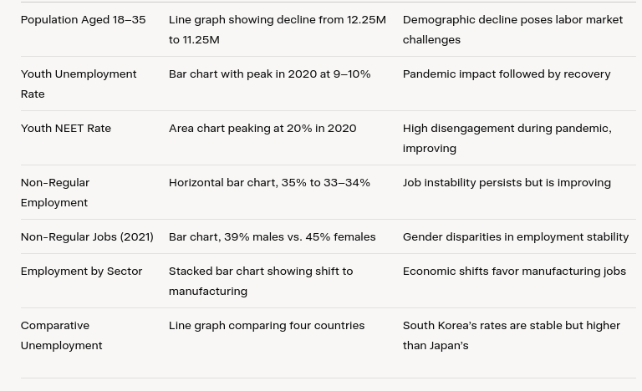

### 

### **Key Findings**

Our analysis reveals several critical insights into South Korea’s youth labor market:

* **Declining Youth Population**: The population aged 18–35 decreased from 12.25 million in 2018 to 11.25 million in 2024, signaling a demographic challenge that could lead to labor shortages.
* **Pandemic Impact and Recovery**: Both unemployment and NEET rates peaked in 2020 due to the COVID-19 pandemic but have since declined, indicating effective recovery measures.
* **High NEET Rates**: South Korea’s NEET rate remains high (17.5% in 2024), ranking among the highest in OECD countries, with 45% of NEETs being college graduates, highlighting an education-job mismatch.
* **Precarious Employment**: Non-regular employment is prevalent, with 33–34% of youth in such jobs in 2024, and females are disproportionately affected (45% vs. 39% for males in 2021).
* **Sectoral Shifts**: A growing trend of youth employment in manufacturing suggests economic or policy-driven changes.
* **International Comparison**: South Korea’s youth unemployment and NEET rates are higher than Japan’s but show different patterns compared to China and the US, offering opportunities for cross-country learning.

### **Policy Recommendations**

Based on our findings, we propose the following policy recommendations to address the identified challenges:

* **Strengthen Vocational Education and Training**: Enhance programs to align skills with industry needs, reducing the education-job mismatch. For example, expand vocational training in emerging sectors like technology and green industries.
* **Promote Permanent Employment**: Offer incentives, such as tax benefits or subsidies, to companies that convert non-regular positions to permanent ones, improving job stability for youth.
* **Targeted Support for NEET Youth**: Develop programs offering counseling, training, and job placement services to re-engage NEET youth in education or employment.
* **Address Gender Disparities**: Enforce equal opportunity laws and provide mentorship programs to support female youth in accessing stable employment.
* **Foster Entrepreneurship**: Provide funding, training, and mentorship to encourage youth entrepreneurship, creating new job opportunities and stimulating economic growth.
* **Adapt to Demographic Changes**: Implement strategies to mitigate the effects of a declining youth population, such as promoting immigration or family-friendly policies to boost birth rates.

### **Conclusion**

This project provides a comprehensive analysis of youth unemployment in South Korea, highlighting key trends, challenges, and potential solutions. By leveraging data from [KOSIS](https://kosis.kr/eng/), [OECD](https://www.oecd.org/en/data/indicators/youth-not-in-employment-education-or-training-neet.html), and other sources, we created a unified dataset and generated insightful visualizations. Our findings underscore the need for targeted policies to address high NEET rates, non-regular employment, and demographic decline. The proposed recommendations aim to create a more inclusive and dynamic labor market for South Korean youth. Future research could explore the effectiveness of implemented policies or investigate regional disparities within South Korea to further refine these strategies.