Modul praktikum metode numerik 6

Tgl :

Matlab untuk matematika

|  |  |  |  |
| --- | --- | --- | --- |
| Nama | FATHURRAHMA NUR AZIZ |  | **Judul praktikum** |
| Nim | 20113694 | **PNL Metode Bisection (Metode BagiDua)** |
| Kelas | 20IF07 |

**

* Metode regulasi false merupakan cara yg paling sederhana untuk mengaproksimasi akar persamaan Non-Linier. Caranya :
* Cara kerja metode ini hampir sama dengan metode bisection, langkahnya :

1. Mulailah dengan interval [a, b] yg memuat akar f(x) = 0
$x_{n+1 }=\frac{a_{n}f\left(b_{n}\right)-b_{n}f(a_{n})}{f\left(b_{n}\right)-f(a_{n})}$

2. Cek f(a).f(b)<0 maka an+1 = an dand bn+1=Xn atau Cek f(a).f(b)>0 an+1 = Xn dand bn+1=bn
3. Ambil a1 : = a dan b1 : = b
4. Untuk n = 1, 2,…, bangunlah barisan (pn), (an+1) dan (bn+2) sbb:

Modifikasi program bisection di bawah agar bisa di gunakan untuk metode regulasi false di atas

Contoh Program 2 :

% Author - Ambarish Prashant Chandurkar

%The Regula Falsi Method

clc;

close all;

clear all;

syms x;

f=log(x)-x+3; %Enter the Function here

n=input('Enter the number of decimal places:');

epsilon = 10^-(n+1)

x0 = input('Enter the 1st approximation:');

x1 = input('Enter the 2nd approximation:');

for i=1:100

f0=vpa(subs(f,x,x0)); %Calculating the value of function at x0

f1=vpa(subs(f,x,x1)); %Calculating the value of function at x1

y=x1-((x1-x0)/(f1-f0))*f1; %[x0,x1] is the interval of the root

err=abs(y-x1);

if err<epsilon %checking the amount of error at each iteration

break

end

f2=vpa(subs(f,x,y));

if (f1)*(f2)<1

x0=y; %taking the next interval as[x0,x1] = [y,x1]

x1=x1;

else

x0=x0; %taking the next interval as[x0,x1] = [x0,y]

x1=y;

end

end

y = y - rem(y,10^-n); %Displaying upto required decimal places

fprintf('The Root is : %f \n',y);

Scilab

clear ; close ; clc ;

*// C o e f f i c i e n t s o f p ol yn omi al i n i n c r e a s i n g o r d e r o f*

power o f x

A = [-2 -1 1];

x1 = 1 ;

x2 = 3 ;

fx = poly (A, ’ x ’ , ’ c ’ );

for i = 1:15

printf ( ’ I t e r a t i o n No . %i nn ’ ,i);

fx1 = horner (fx ,x1);

fx2 = horner (fx ,x2);

x0 = x1 - fx1 *(x2 -x1)/( fx2 -fx1)

printf ( ’ x0 = %f nn ’ ,x0);

fx0 = horner (fx ,x0);

if fx1 * fx0 < 0 then

x2 = x0 ;

else

x1 = x0 ;

end

end

**Soal**

**# tentukan nilai akar dari persamaan dari $f\left(x\right)=x^{3}-x-1$, dengan keakuratan 0,0000001, max iterasi 100 kali, bandingkan dengan hasil perhitungan dari metode bisection , dan berikan kesimupulan.**

#### Copas disini proses, hasil, dan grafik pengerjaannya :

**Regula False :**

**Script :**

%regula false fathurrahman nur aziz

clc;

close all;

clear all;

syms x;

f=input('Masukan Persamaan: ');

%f=log(x)-x+3; %Enter the Function here

epsilon=input('Masukan Toleransi error: ');

a = input('Masukan pendekatan pertama: ');

b = input('Masukan pendekatan kedua: ');

l = input('Masukan maksimal iterasi: ');

for i=1:l

fa=vpa(subs(f,x,a)); %Calculating the value of function at a

fb=vpa(subs(f,x,b)); %Calculating the value of function at b

y=b-((b-a)/(fb-fa))*fb; %[a,b] is the interval of the root

fprintf('iteration %d',i);

fprintf(' => ');

fprintf('fa = %.10f | ',fa);

fprintf('fb = %.10f | ',fb);

fprintf('y = %.10f\n',y);

err=abs(y-b);

if err<epsilon %checking the amount of error at each iteration

break

end

f2=vpa(subs(f,x,y));

if (fb)*(f2)<1

a=y; %taking the next interval as[a,b] = [y,b]

b=b;

else

a=a; %taking the next interval as[a,b] = [a,y]

b=y;

end

end

y = y - rem(y,epsilon); %Displaying upto required decimal places

fprintf('Akarnya adalah : %.10f \n',y);

ezplot(f);

grid;

hold on;

plot(y,0,'.');

**Hasil :**

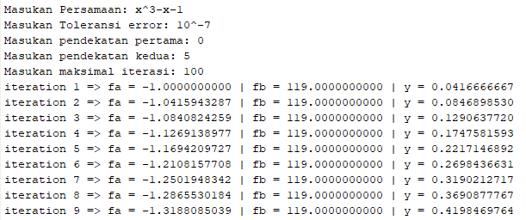

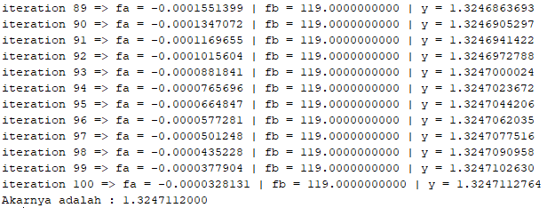

**Grafik :**

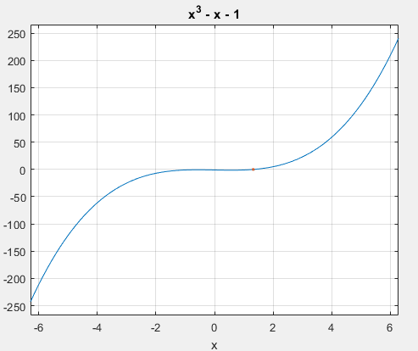

**Bisection :**

**Script :**

%bisection fath

clc;clear;

syms x;

p=input('input equation = ');

a=input('input a = ');

b=input('input b = ');

ezplot(p);

grid;

fa=subs(p,x,a);

fb=subs(p,x,b);

c=(a+b)/2;

fc=subs(p,x,c);

err=input('input error tolerantion = ');

fprintf('error tolerantion = %f \n\n',err);

i=1;

while abs(fc)>err

if (fa*fc)<0

b=c;

else

a=c;

end

fa=subs(p,x,a);

fb=subs(p,x,b);

c=(a+b)/2;

fc=subs(p,x,c);

fprintf('iteration %d',i);

i=i+1;

fprintf(' => ');

fprintf('fa = %f | ',fa);

fprintf('fb = %f | ',fb);

fprintf('c = %f\n',c);

end

hold on;

plot(c,0,'.');

**Hasil :**

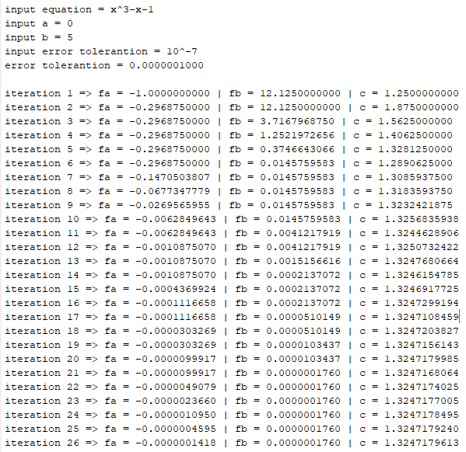

**Grafik :**

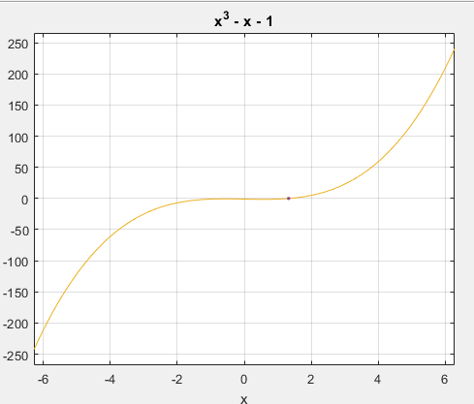

|  |  |  |
| --- | --- | --- |
|  | **bisection** | **False position** |
| **Nilai f(a) pada iterasi terakkhir** | **-0.0000001418** | **-0.0000328131** |
| **Nilai f(b) pada iterasi terakkhir** | **0.0000001760** | **119.0000000000** |
| **Jumlah iterasi** | **26** | **100** |
| **Nilai Root** | **1.3247179613** | **1.3247112000** |