Examen

Mohamed aziz hajlaoui gr6

Ex 2 :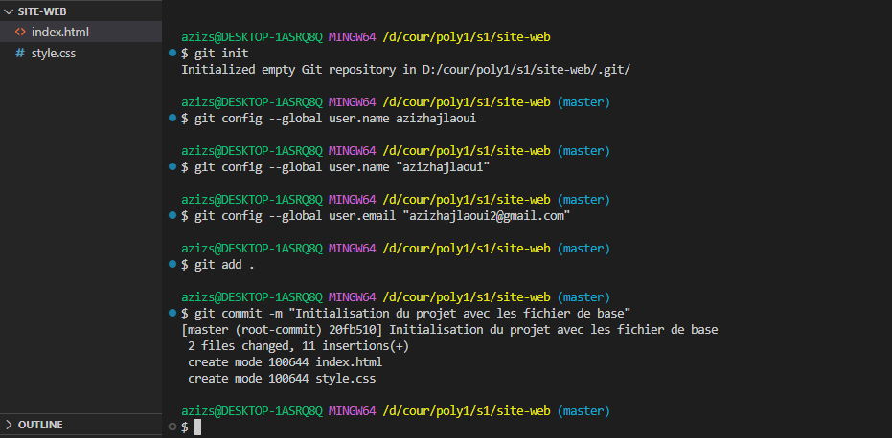1 et 2

3-et 4-

