|  |  |  |  |  |  |  |  |
| --- | --- | --- | --- | --- | --- | --- | --- |
|  |  |  |  |  |  |  |  |
|  |  |  |  | PANITIA | | |  |
|  |  |  | UJIAN SEMESTER | : | **UTS** |  |
|  |  |  | SEMESTER | : | **GENAP** |  |
|  |  |  | TAHUN AKADEMIK | : | **2019 / 2020** |  |
|  |  |  |  |  |  |  |
|  |  |  |  |  |  |  |
|  | NIM | : |  |  | | |  |
|  | NAMA MAHASISWA | : |  |  | | |  |
|  | SMT / JURUSAN | : |  |  | | |  |
|  | HARI / TGL | : |  |  | | |  |
|  | MATA KULIAH | : |  |  | | |  |
|  | DOSEN PENGAMPU | : |  |  | | |  |
|  |  |  |  |  |  |  |  |

*\****NB.** Jawaban harus di tulis tangan pada kertas kemudian di foto / *capture* dan di tempel/ di masukan pada lembar jawaban ini !

Contoh:

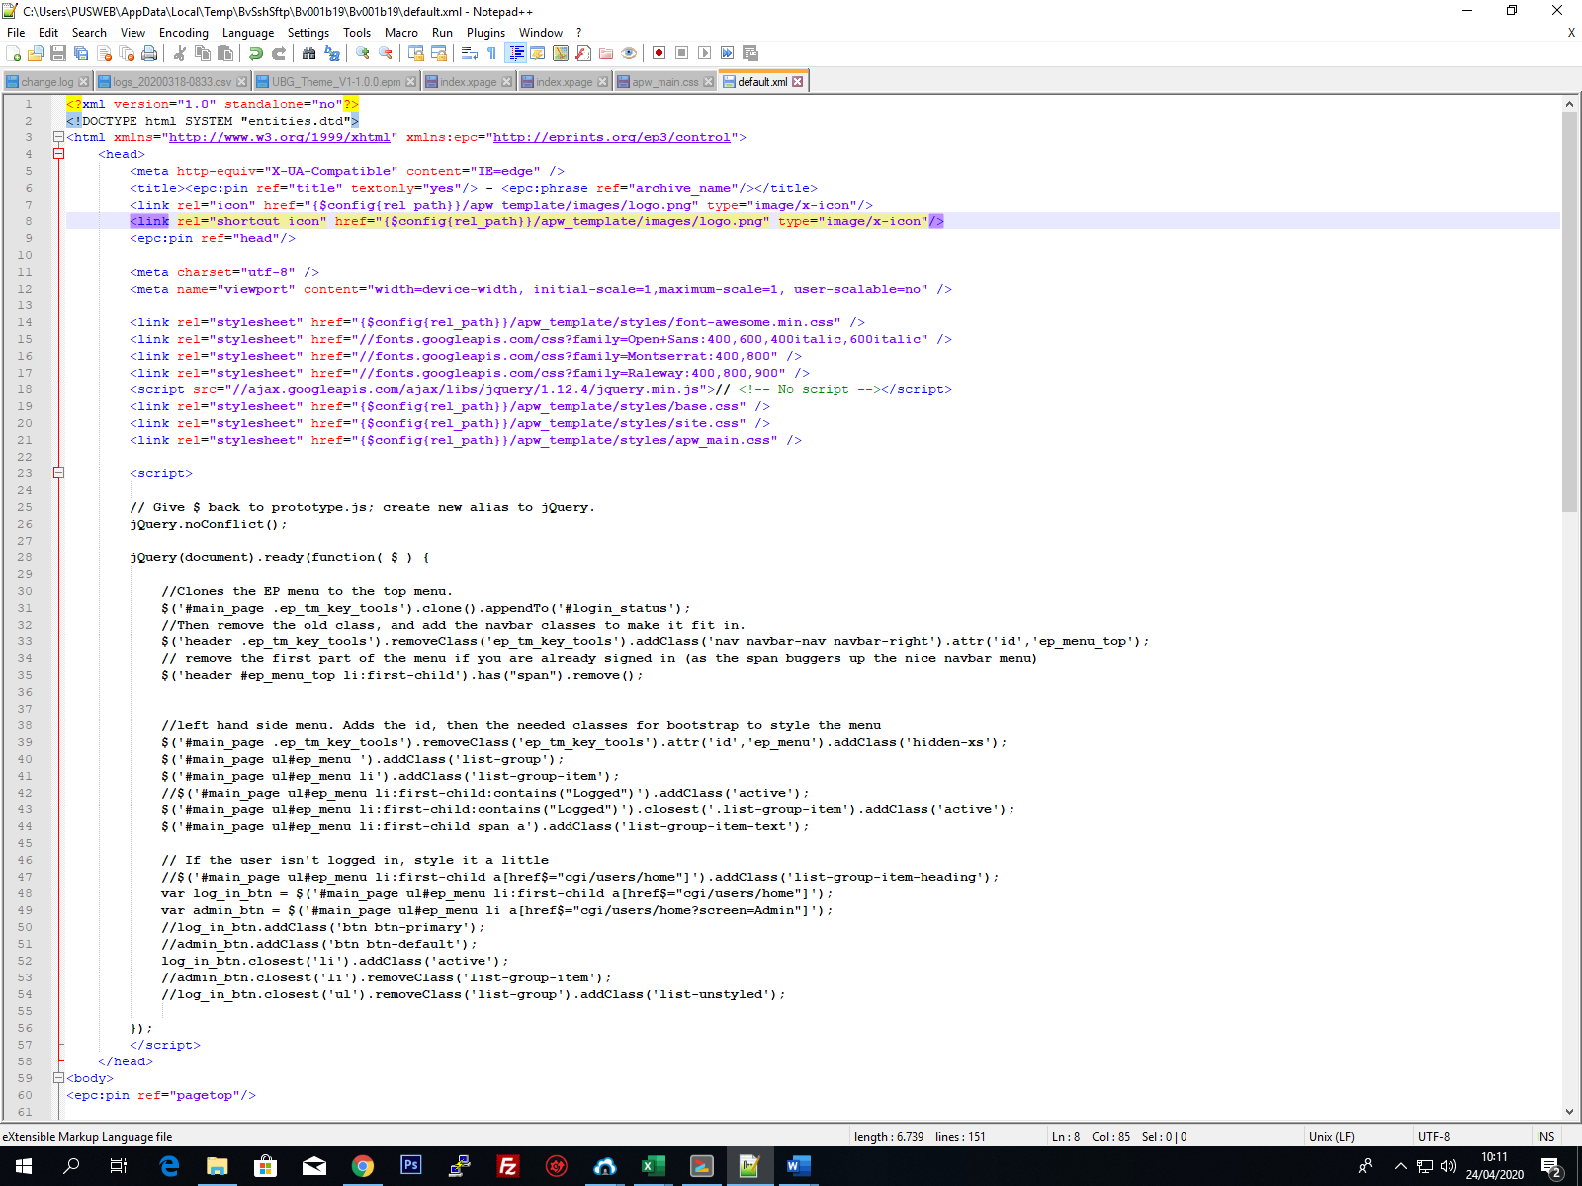

ATAU

