# **Introduction**

The aim of this study is to predict the impact of climate change in Egypt using machine learning methods.

Machine learning is a type of artificial intelligence that allows computers to learn from data and make predictions or decisions without being explicitly programmed to do so and it has been widely used in various fields, including climate science.[1]

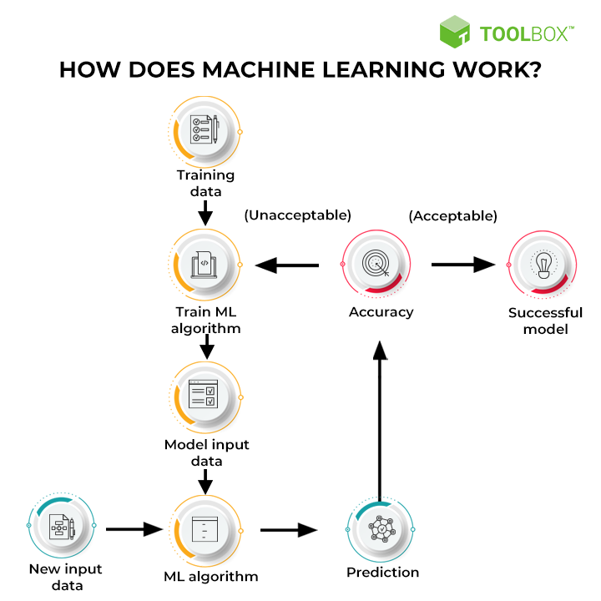

Figure 1: How does Machine Learning Work

<https://pimages.toolbox.com/wp-content/uploads/2022/04/04094749/5-6.png>

# **Data**

We obtained data from the World Bank Climate Change Knowledge Portal.[2] Before conducting our analysis, we performed some basic preprocessing on the data. Data preprocessing is an integral step in Machine Learning as the quality of data and the useful information that can be derived from it directly affects the ability of our model to learn; therefore, it is extremely important that we preprocess our data before feeding it into our model.[3] Although the dataset was already in good shape due to its approved source, we still filled in any missing values by calculating the minimum, maximum, and mean values for each variable and using these values to fill in any missing data. Additionally, we removed any observations that were completely empty.

Our dataset included independent variables such as **minimum temperature, maximum temperature, mean temperature, CO2 levels,** and **precipitation**. These factors were used to predict the impact of climate change. Our target variables included **sea level (measured in millimeters), wheat yield (measured in metric tons), rice yield (measured in metric tons), cotton yield (measured in metric tons),** and **mortality under 5 years (measured as the number of deaths per 1000 births)** these outcomes were the focus of our predictions.

Figure 7: Dataset and the code for reading it in Python.

Figure 8: Basic Statistics about the dataset.

# **Methods**

In this study, we used several machine learning methods from the scikit-learn library to predict the impact of climate change in Egypt. These methods are algorithms that can be learned from data and make predictions. We used a variety of regression models to evaluate our predictions and understand the relationship between our target variables and independent variables.

scikit-learn is a popular open-source library for machine learning in Python [4]. It provides a wide range of tools for data analysis and modeling, including classification, regression, clustering, and dimensionality reduction. scikit-learn is built on top of other widely used libraries such as NumPy, SciPy, and matplotlib. Our focus is on regression models because our dataset contains continuous variables (numerical values).

Furthermore, scikit-learn provides a consistent interface for its machine learning algorithms. This makes it easy to switch between different algorithms and compare their performance. scikit-learn also provides tools for model selection and evaluation, data preprocessing, and feature extraction.

We used several machine learning methods in our analysis, including Linear Regression [6], Ridge Regression [7], LassoLars [8], Random Forest Regression [9], and Tweedie Regressor [10]. These methods were chosen for their ability to handle the specific characteristics of our dataset and the nature of the problem we were trying to solve. Linear Regression is a simple model that assumes a linear relationship between the independent and dependent variables. Ridge Regression is similar to Linear Regression but adds a regularization term to prevent overfitting. LassoLars is another type of regularized Linear Regression that uses a different type of regularization term.

In addition to these methods, we also used Random Forest Regression and Tweedie Regressor. These methods were chosen for their ability to handle the specific characteristics of our dataset and the nature of the problem we were trying to solve. Because we were dealing with multiple outputs (responses), we used the MultiOutputRegressor from scikit-learn [11] for better modeling. MultiOutputRegressor is a meta-estimator that extends single-output regression methods to multi-output problems. It works by fitting one regressor per target variable and making predictions for each target variable independently.

One of the methods we used in our analysis is called LASSO (Least Absolute Shrinkage and Selection Operator) [5]. LASSO is a regression method that can be used to predict a numerical value, such as sea level, based on several input variables, such as temperature, CO2, and precipitation. LASSO works by fitting a linear regression model to the data with an added constraint that the sum of the absolute values of the coefficients must be less than a certain value. This constraint has the effect of shrinking some coefficients towards 0, effectively excluding some input variables from the model. The strength of this constraint is controlled by a tuning parameter called λ.

The advantage of using LASSO is that it can automatically select which input variables are most important for making predictions. This can help to simplify the model and improve its interpretability. As λ increases, more coefficients are shrunk towards 0. When λ is 0, LASSO is equivalent to ordinary least squares regression.

# **Model Evaluation**

The performance of our models was evaluated using appropriate evaluation metrics for regression problems, such as mean squared error or mean absolute error. These metrics measure the difference between the predicted values and the observed values. The results show that LASSO regression performed the best among all the methods we tested.

We found that Lasso Regression worked particularly well for our dataset for most the targets and for some of the other target variables other methods worked better. This model uses a regularization term that encourages the coefficients of less important variables to be set to zero. This can help to prevent overfitting and improve the interpretability of the model.

We also found that some models worked better for some target variables than others. For example, one model might have made accurate predictions for sea level but less accurate predictions for wheat yield.

To evaluate the accuracy of our models, we used several different metrics including Mean Squared Error (MSE), Mean Absolute Error (MAE), R-squared (R2) and Root Mean Squared Error (RMSE).

MAE (Mean Absolute Error): This metric measures the average magnitude of the errors in a set of predictions, without considering their direction. It is calculated as the average of the absolute differences between the predicted and actual values. Mathematically, it is defined as: MAE = 1/n * Σ|yi - ŷi| where n is the number of observations, yi is the actual value and ŷi is the predicted value. A lower MAE value indicates better model performance.[15]

MSE (Mean Squared Error): This metric measures the average squared magnitude of the errors in a set of predictions. It is calculated as the average of the squared differences between the predicted and actual values. Mathematically, it is defined as: MSE = 1/n * Σ(yi - ŷi)^2 where n is the number of observations, yi is the actual value and ŷi is the predicted value. A lower MSE value indicates better model performance.[16]

RMSE (Root Mean Squared Error): This metric measures the standard deviation of the residuals (prediction errors). It is calculated as the square root of the MSE. Mathematically, it is defined as: RMSE = sqrt(MSE). A lower RMSE value indicates better model performance.[17]

R^2 (Coefficient of Determination): This metric represents the proportion of the variance in the dependent variable that is predictable from the independent variable(s). It provides a measure of how well observed outcomes are replicated by the model. Mathematically, it is defined as: R2 = 1 - SSres/SStot where SSres is the sum of squared residuals and SStot is the total sum of squares. An R^2 value of 1 indicates that the model perfectly fits the data, while an R^2 value of 0 indicates that the model does not explain any of the variance in the data.[18]

|  |  |  |  |  |
| --- | --- | --- | --- | --- |
| Model | MAE | MSE | RMSE | R^2 |
| Ridge | ***1.85*** | **18.91** | **4.35** | **0.47** |
| Lasso | *1.80* | 19.28 | 4.39 | 0.36 |
| Tweedie Regressor | *1.99* | 29.96 | 5.47 | 0.40 |
| Lasso Lars | *1.80* | 19.28 | 4.39 | 0.36 |
| Linear Regression | *1.73* | 17.70 | 4.21 | 0.58 |
| Random Forest Regressor | *1.15* | 9.96 | 3.16 | 0.86 |

Figure 2: Model Evaluations (Lower the numbers indicate better accuracy)

Figure 3: Bar-chart of Model Evaluations

# **Technologies**

We used the Python programming language and the scikit-learn library to implement our models.[12] We also used Jupyter Notebook as our programming environment.[13] In addition to scikit-learn, we used several other libraries including numpy for numerical computing, pandas for data manipulation and analysis, matplotlib for data visualization and seaborn for statistical data visualization.[14]

By using machine learning and regression analysis together, we were able to develop a robust methodology for predicting the impacts of climate change on Egypt. This approach allowed us to make accurate predictions and to understand the underlying factors that are driving these changes.

# **Conclusion**

In conclusion, our study demonstrates the potential of machine learning methods for predicting the impact of climate change in Egypt on sea level, crop yields, and child mortality. Further research is needed to refine and improve our models and to explore the use of additional data sources and machine learning methods.

In simpler terms, we used data on temperature, CO2 levels, and precipitation to make predictions about how climate change will affect sea levels, crop yields, and child mortality in Egypt. We then used statistical methods to evaluate the accuracy of these predictions.

# **Code**

Figure 4: Code behind Model Evaluation

Figure 5: Code behind for one of the Models (Lasso Regression)

Figure 6: Code behind creating Excel file in python for further analysis

# **References**

[1] <https://en.wikipedia.org/wiki/Machine_learning>, <https://www.ipcc.ch/report/ar5/wg1/>

[2] add the link

[3] [Introduction to Data Preprocessing in Machine Learning | by Dhairya Kumar | Towards Data Science](https://towardsdatascience.com/introduction-to-data-preprocessing-in-machine-learning-a9fa83a5dc9d)

[4] <https://scikit-learn.org/stable/>

[5] LASSO: <https://scikit-learn.org/stable/modules/generated/sklearn.linear_model.Lasso.html>

[6] Linear Regression: <https://scikit-learn.org/stable/modules/generated/sklearn.linear_model.LinearRegression.html>

[7] Ridge Regression: <https://scikit-learn.org/stable/modules/generated/sklearn.linear_model.Ridge.html>

[8] LassoLars: <https://scikit-learn.org/stable/modules/generated/sklearn.linear_model.LassoLars.html>

[9] Random Forest Regression: <https://scikit-learn.org/stable/modules/generated/sklearn.ensemble.RandomForestRegressor.html>

[10] Tweedie Regressor: <https://scikit-learn.org/stable/modules/generated/sklearn.linear_model.TweedieRegressor.html>

[11] MultiOutputRegressor: <https://scikit-learn.org/stable/modules/generated/sklearn.multioutput.MultiOutputRegressor.html>

[12] Python: <https://www.python.org/>

[13 ] Jupyter Notebook: <https://jupyter.org/>

[14] numpy: <https://numpy.org/> , pandas: <https://pandas.pydata.org/>, matplotlib: <https://matplotlib.org/>, seaborn: <https://seaborn.pydata.org/>

[15] MAE (Mean Absolute Error): <https://scikit-learn.org/stable/modules/generated/sklearn.metrics.mean_absolute_error.html>

[16] MSE (Mean Squared Error): <https://scikit-learn.org/stable/modules/generated/sklearn.metrics.mean_squared_error.html>

[17] RMSE (Root Mean Squared Error): <https://www.statisticshowto.com/probability-and-statistics/regression-analysis/rmse-root-mean-square-error/>

[18] R^2 (Coefficient of Determination): <https://scikit-learn.org/stable/modules/generated/sklearn.metrics.r2_score.html>