Given the parameters of this project, as a team the most important decision was how to organize the thirteen variables. Near all thirteen variables have multiple levels to them (i.e., the total population is divided into male and female and then by various age ranges), meaning that the visualization needs to accommodate all of these levels. The simplest solution would be to have a drop down menu, and once one of the thirteen variables was selected another drop down menu would show the various levels that variable has. However, drop down menus can cover up a lot of area on the screen, and scrolling through all of the levels/options can be a tedious task, especially if the user is unsure of exactly what levels/options s/he is looking for. Thus, we concluded that an accordion style side menu (located on the left side of the screen) with all thirteen variables would be best (see Figure 1). 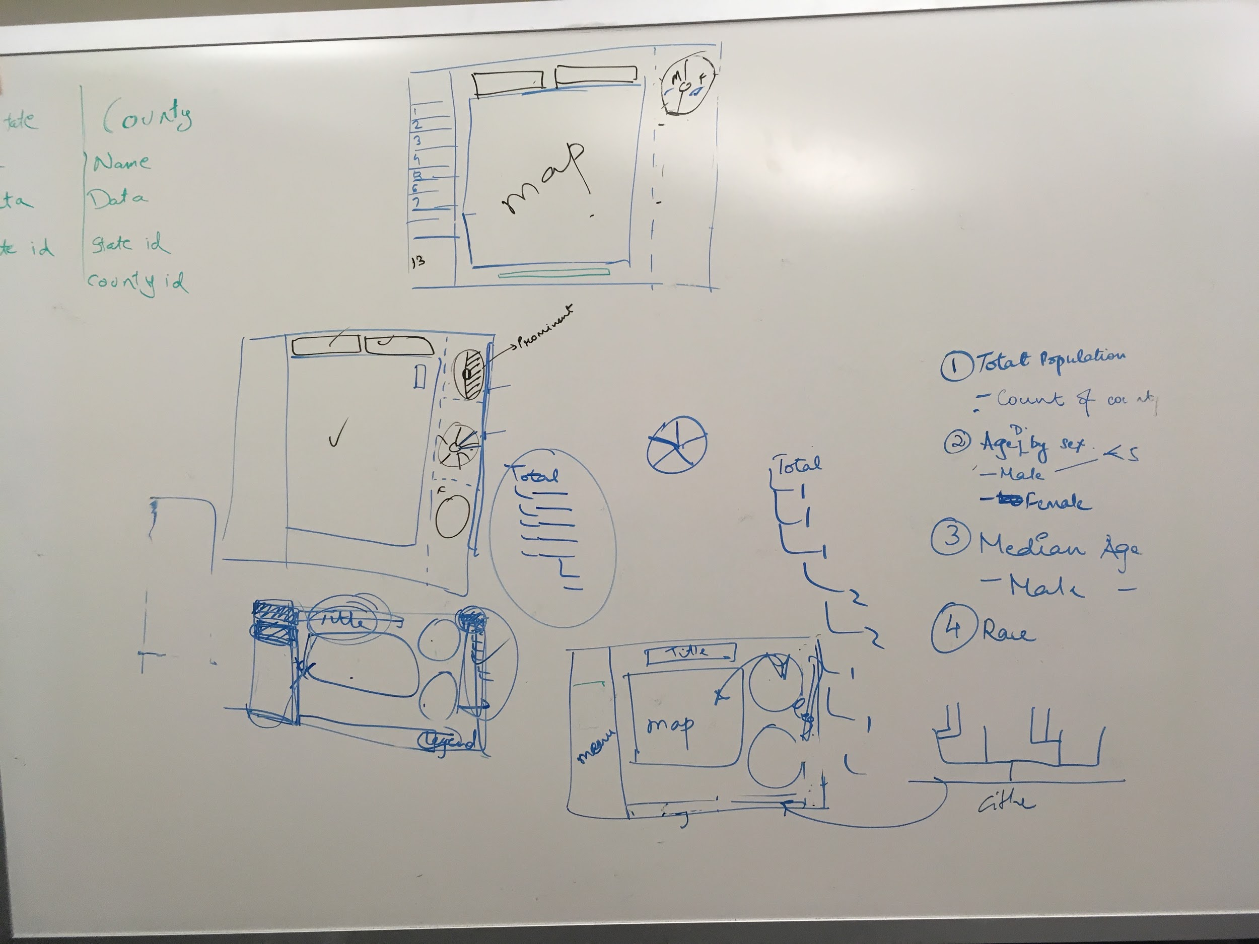

Figure 1

After that selection, the next question would be how to organize the other levels so that the visualization can display them. There were several variables to consider, such as the selection of state or county, and the potential other levels/options that the variables have. We decided that the map alone was not enough to show the visualizations and their levels properly. Taking into consideration about which graphs and/or maps would best represent the data, a donut chart was decided upon, with a ‘reset button in the middle - or hole - of the donut. We decided that the number of donut charts should equal the number of levels each variable would have. For example, the total population can be broken down into a ‘total’, then by ‘gender’, then by ‘sex’, and so on. The main chlorgraphic map would change according to the donut chart selected (i.e., if ‘male’ is selected, the total male population displays on the main chlorgraphic map, and a new donut charge will appear under the original donut chart, as shown in Figure 2). 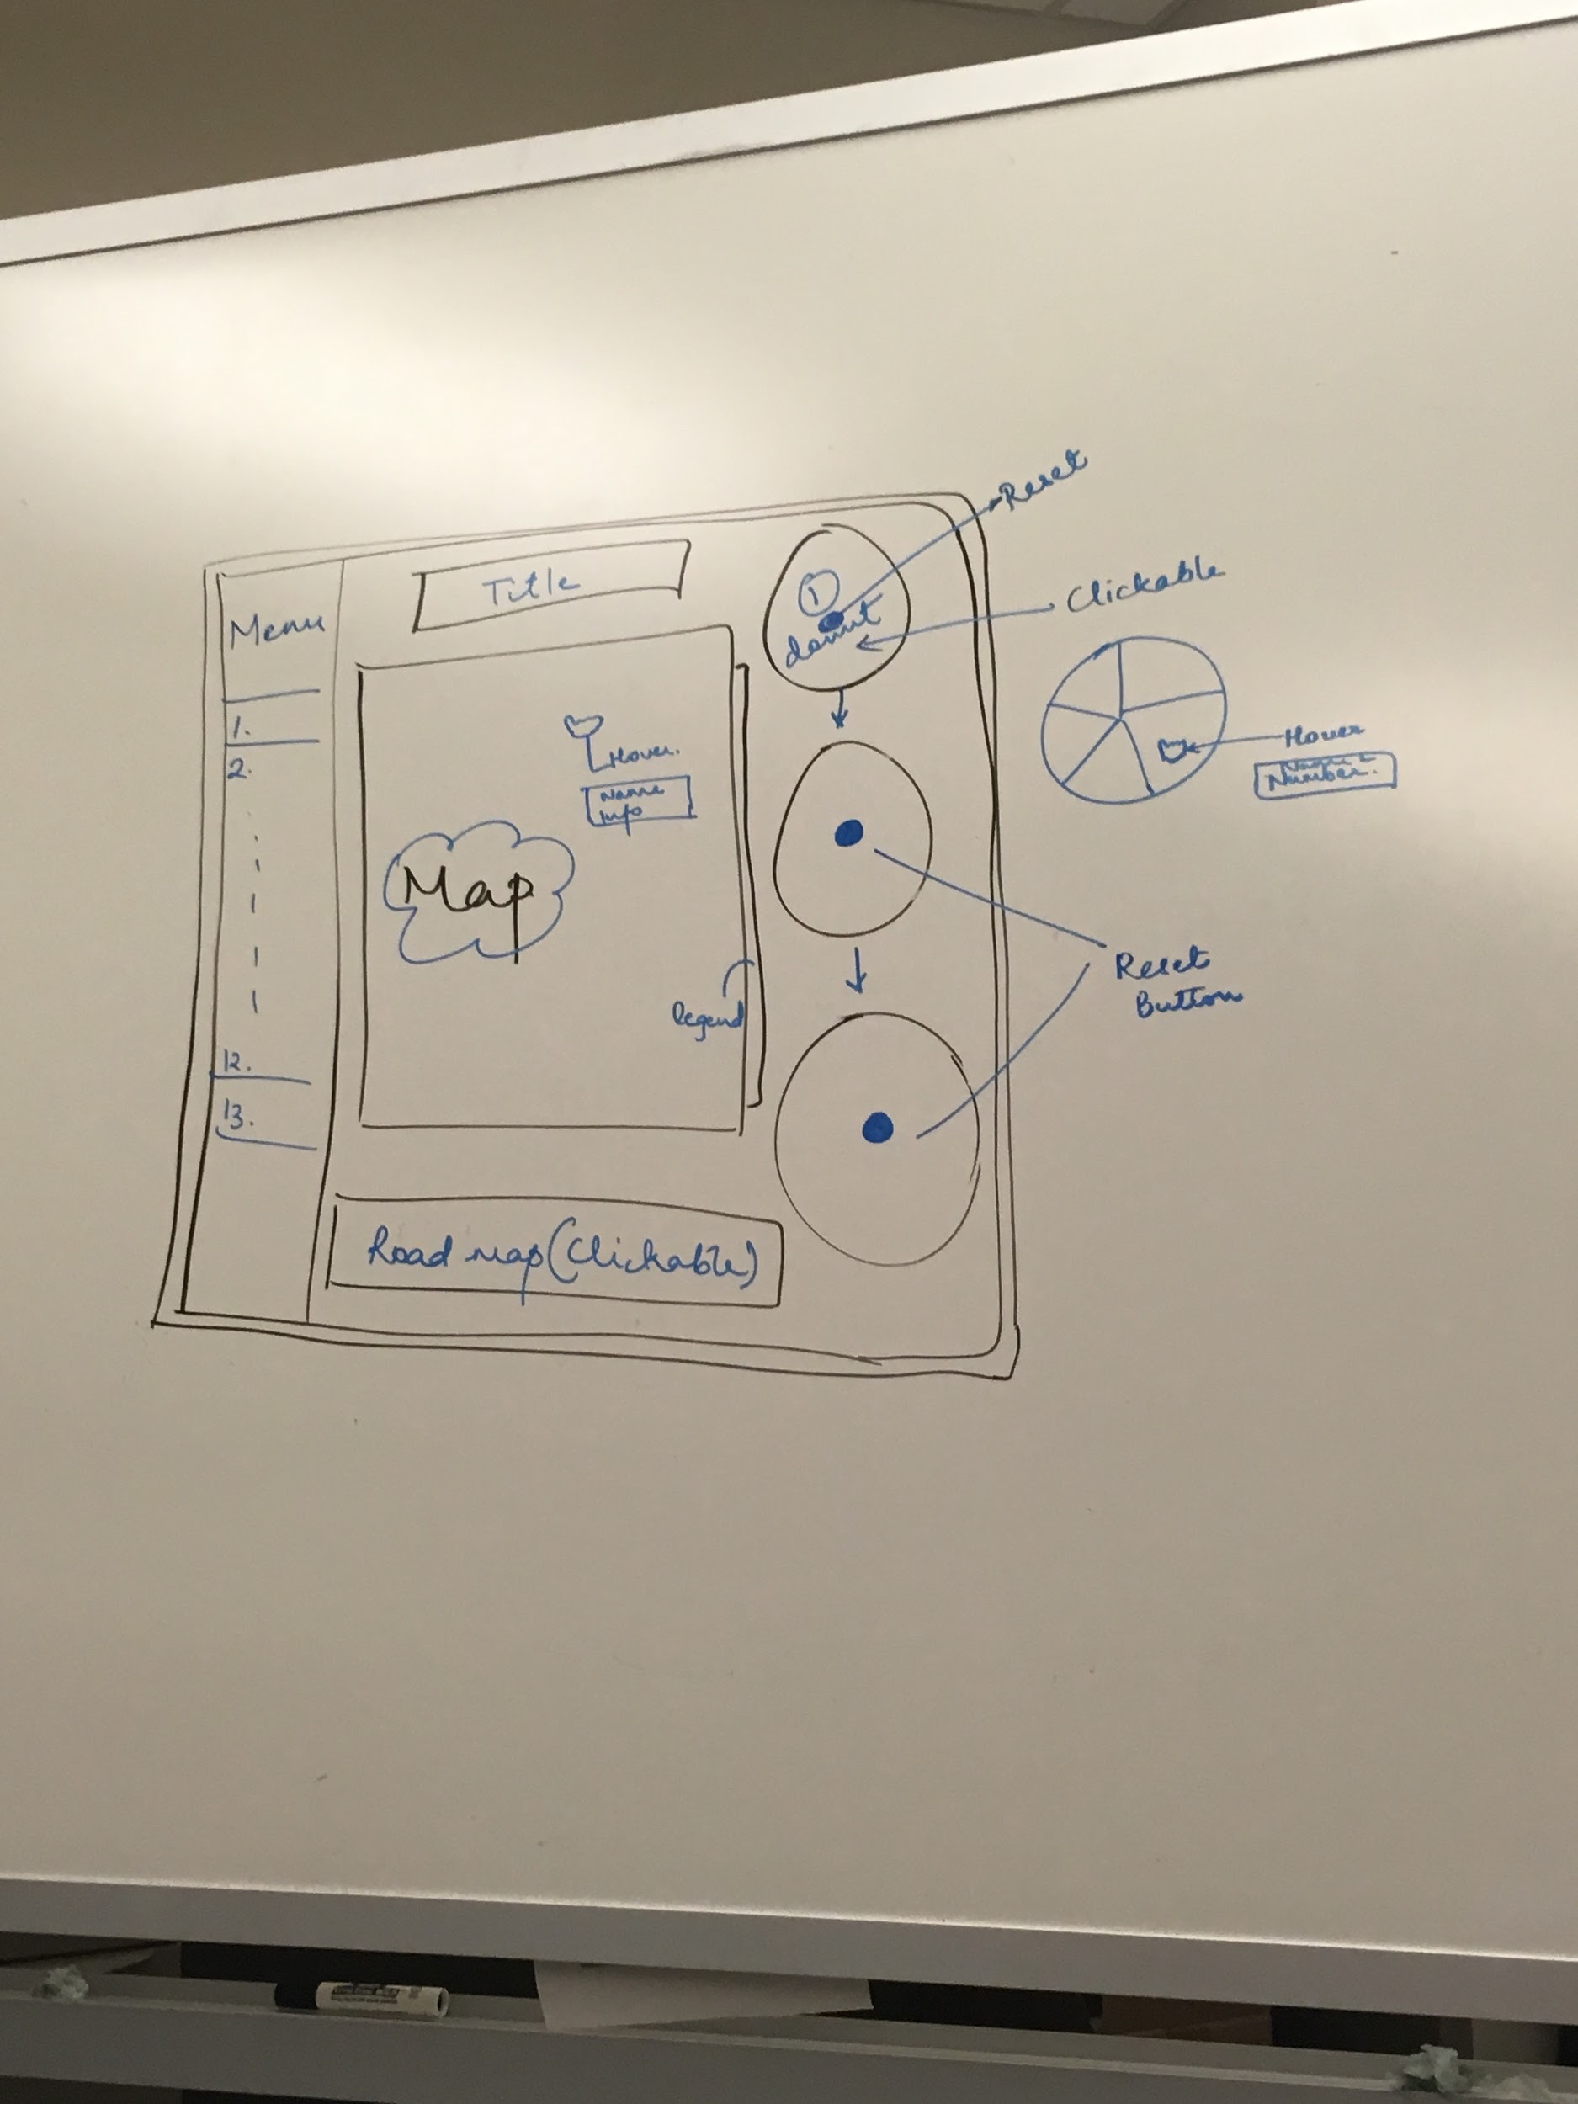

Figure 2.

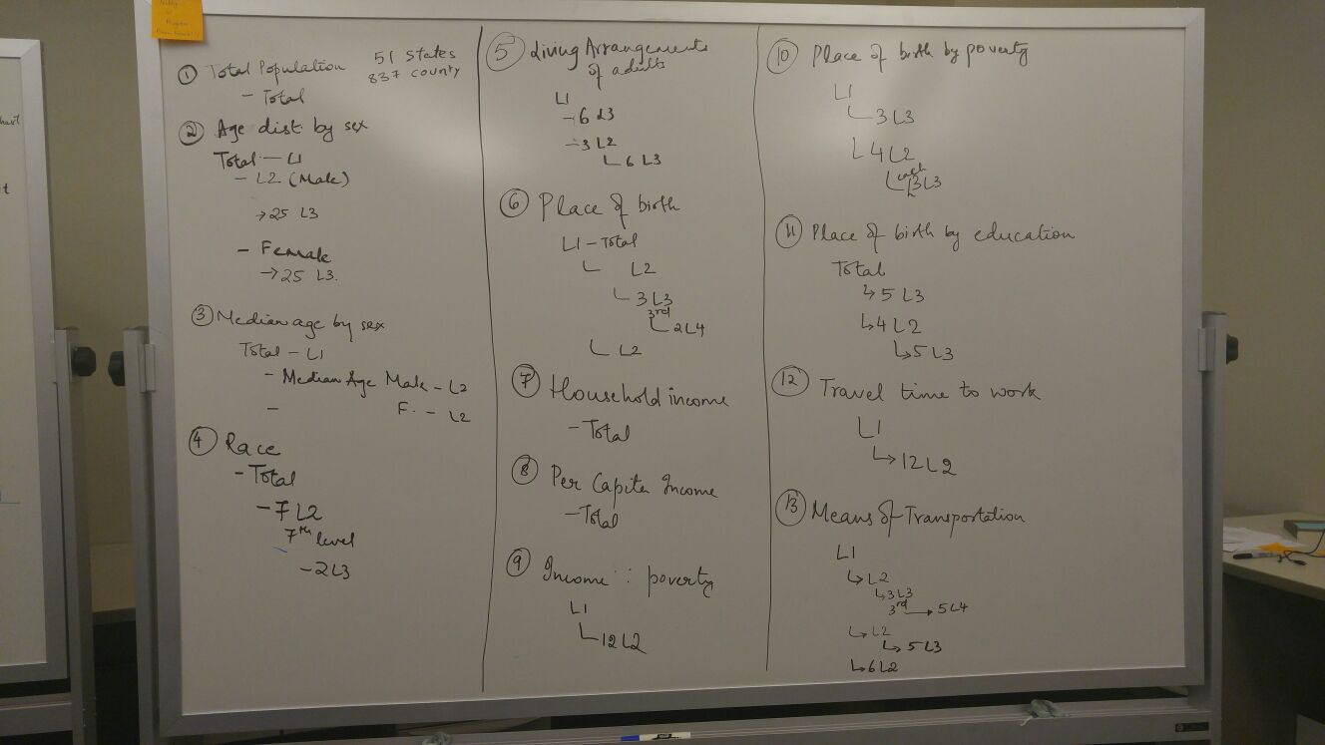During our next meeting the following week, we decided to go into details about the breakdown of how all 13 variables fit in together. Looking more closely at the 13 variables, we noticed that there was not a system in place for how the variables were organized. For example, some variables had a couple of first levels, but others went straight into a second level or third level (i.e., one level could be a “total” data set, but others go straight into a second level data set such as race categories). As demonstrated in Figure 3, we carefully went through all data sets and variables and organized them according to how many levels were in each variable, as well as which subset variables were in each level. After organizing the data, we looked into how the data would be organized into our visualization. We settled that the various pie charts that would appear on the screen will show the various levels that are selected (i.e., the first pie chart will show the first level, the second pie chart will show the selected first level broken down into the corresponding second levels, and so on and so forth). The anticipated visualizations of these levels are depicted in Figure 4. The sketches in Figure 4 are visual representations of the same text based information shown in Figure 3. It is important to note that there are several visualizations of the data; one is the chronolograph of the states and counties, which is the main visualization displayed on the middle of the webpage. Next are the pie charts that will be displayed on the bottom of the screen. These pie charts are meant to display what variables are related to the total amount, as many of the 13 variables have a total, or they can be broken down into displaying the total. Next are the other charts, such as the bar graphs. These appear when a particular state or county is selected under a given variable. These graphs make it easier to see actual amounts and statistics of the variable that cannot be easily gained from a pie chart. In addition to these graphs, there is an option to compare a selected state or county with another state or county via a ‘+’ button on the side of the bar chart modals. This is to make it easier to compare one selection with another selection if the user finds the information on the modal interesting. In addition to these graphs, there is a scatterplot view a correlation of two independent variables. The thirteen variables each have their own levels of variables, and the scatterplot can look at these two independent variables and see how they are correlated. Last but not least, there was a requirement to have at least eight of the thirteen variables viewed side by side in a chorographic map. We addressed this requirement by having 8 small maps of the country divided by states or counties on a separate screen of the website. 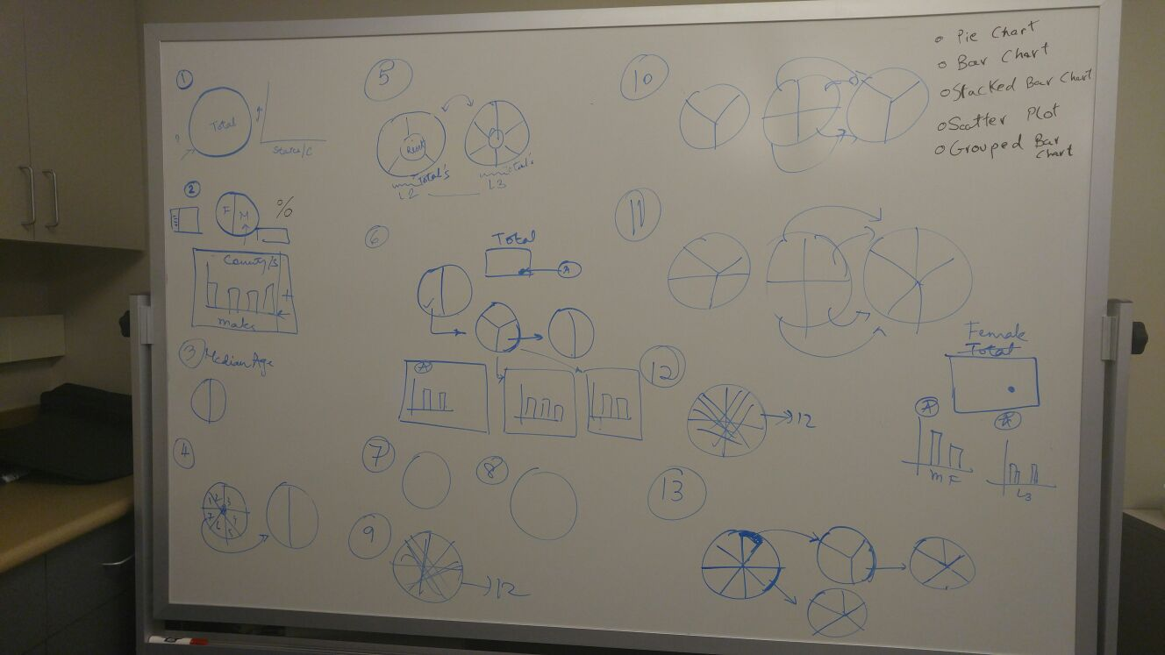The user can pick one of the eight variables to view in one of the eight maps and see, on a broad scale of the country, how they interact with each other.

Figure 3.

Lastly there was the color scheme to think about. Since there was a lot of variables and a lot of sub-levels with variables to display, there was a major concern with how to display the data via colors. Learning what we have in class, ideally different shapes or curves would be the best design options. However, given the numerous levels and variables that this project required, colors seemed to be the only option that can address all of them. Thus, we looked into how the color wheel looked; there are usually six to twelve main colors that are easily distinguishable width each other, as shown in Figures 5 and 6. However, there are many ‘sub’ colors that are not completely saturated or different in luminance. We decided that we would use as many of the the non saturated colors for the first and second levels of each variable, and then if needed we will expand our color pallette to different saturations of one color. We kept each variable a consistent color within the next pie chart if it was selected. For example, for Total Population had two levels in it, Male and Female. Within each of the two genders, different blues - and saturation of blues if needed - were displayed if that variable was chosen. An example is shown in Figure 7. 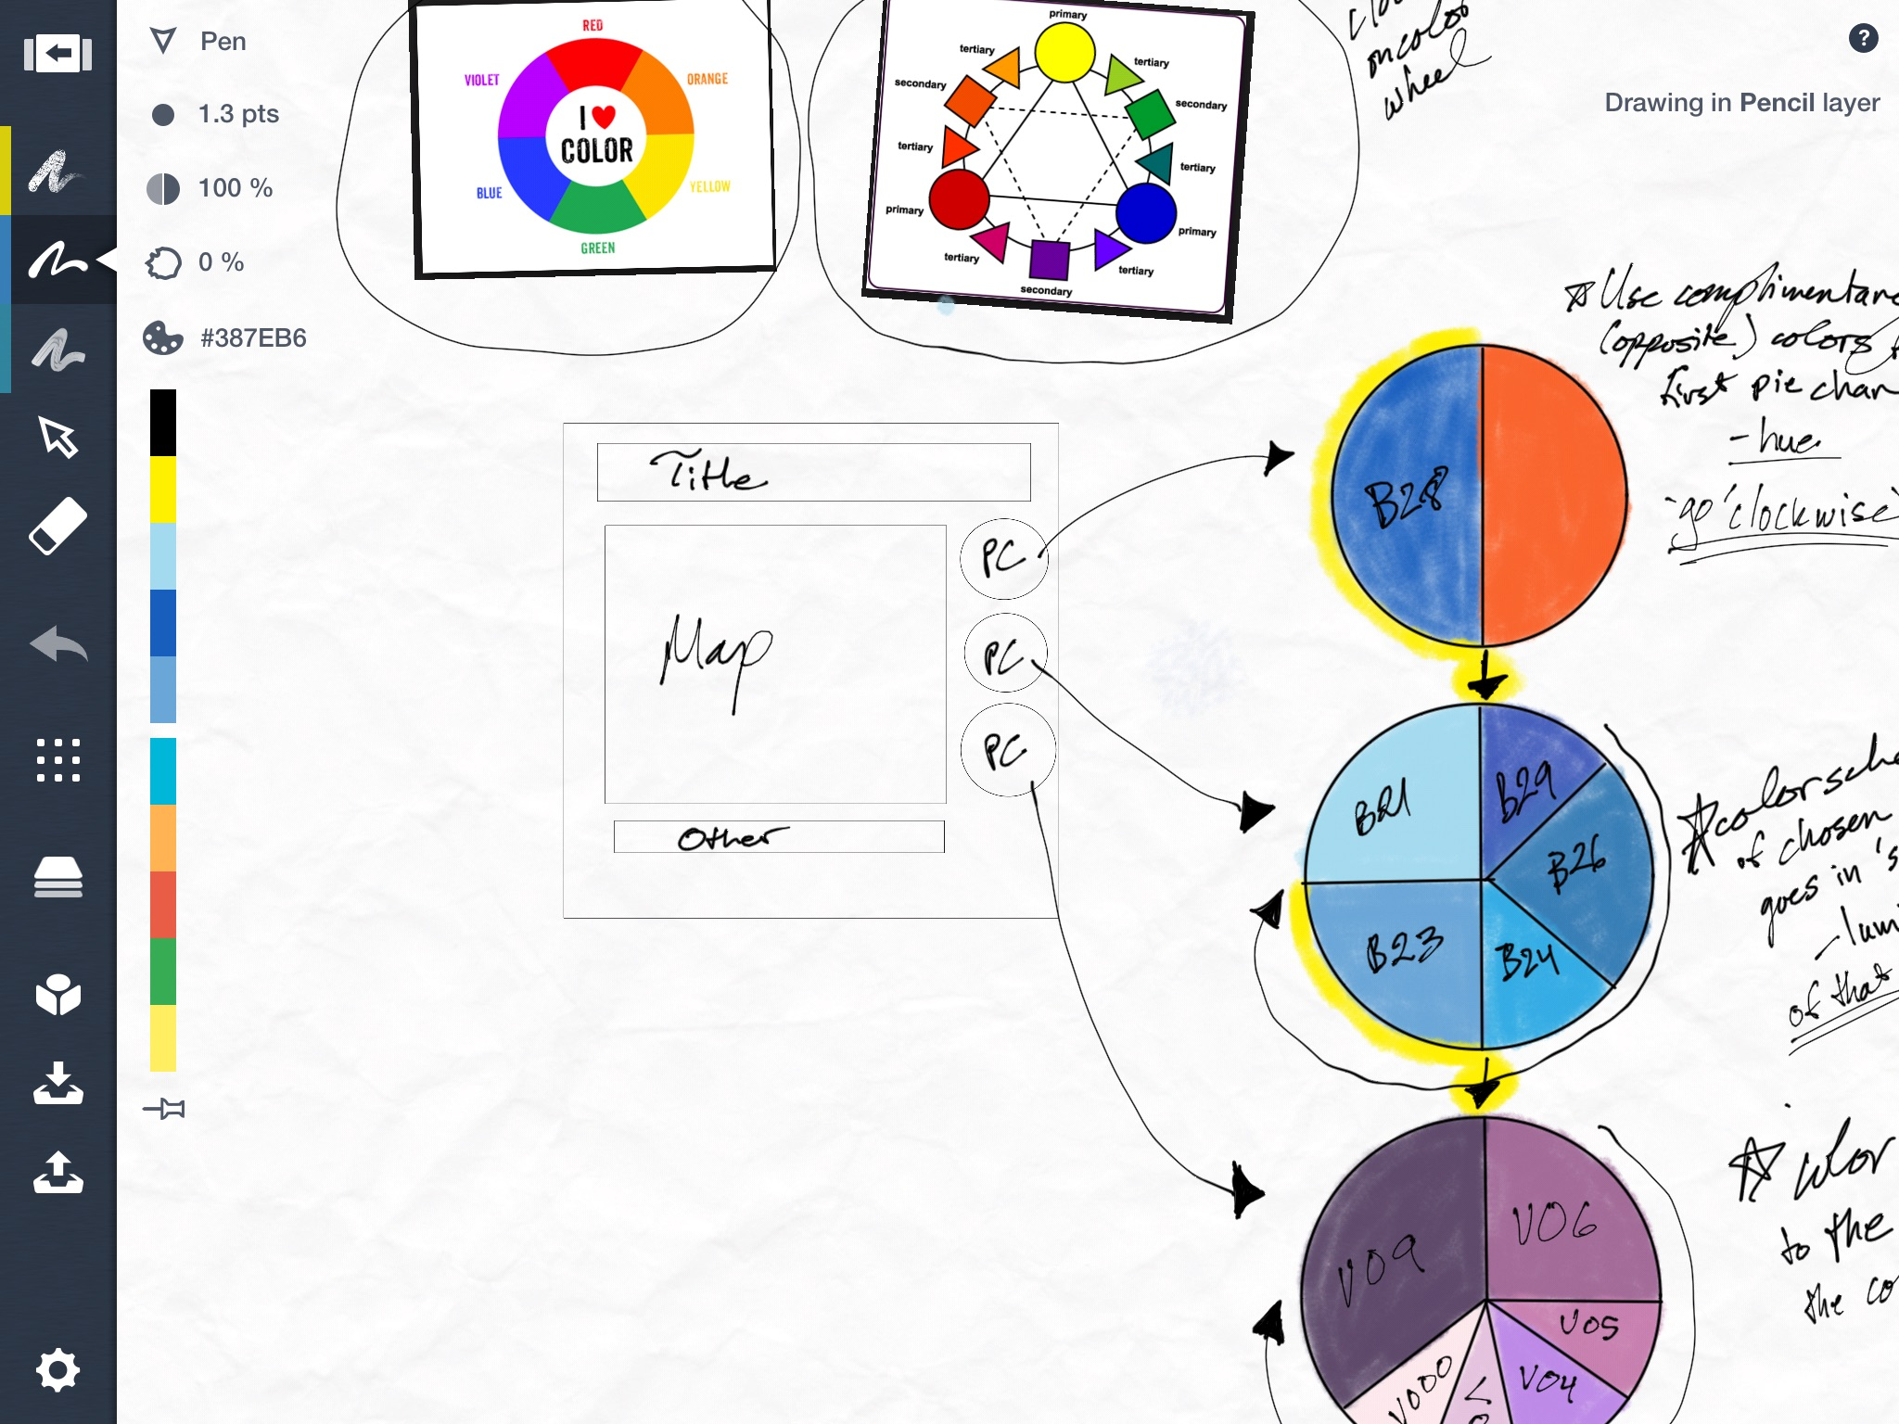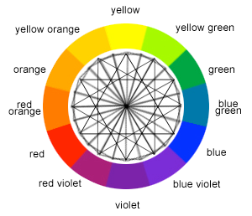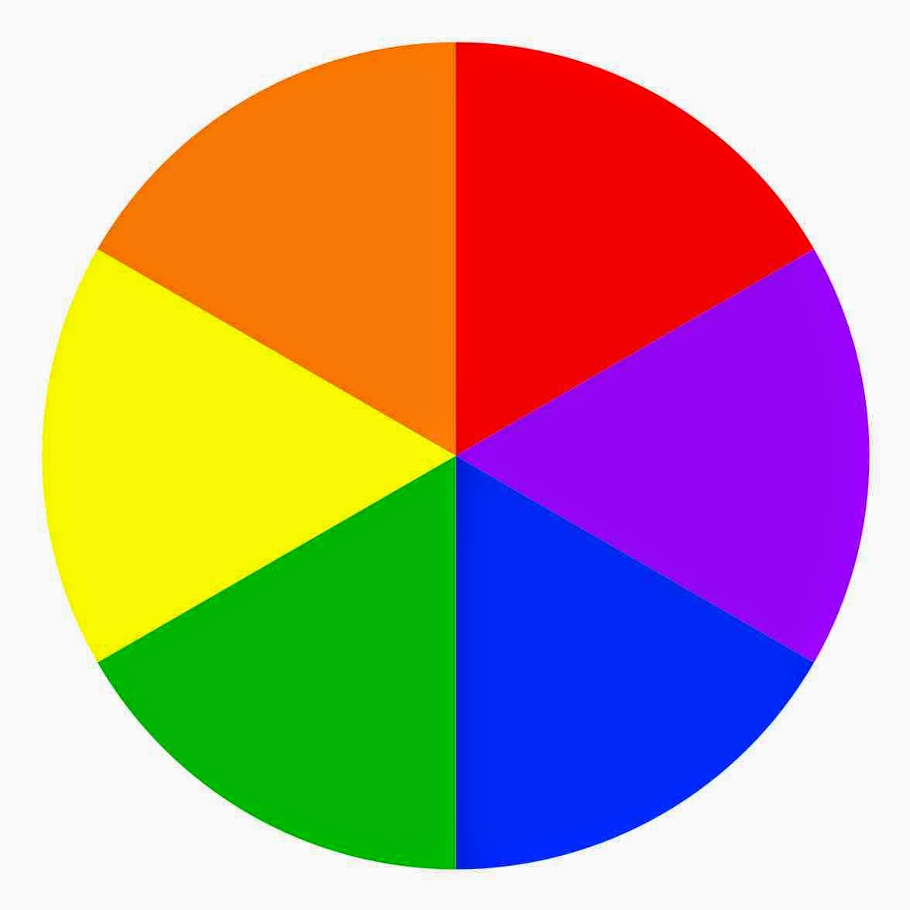

Figure 4.

Figure 6.

Figure 5.

Figure 7.