|  |
| --- |
| **Project:**  **node-js -csv-proj** |
|  |  |
|  | A nice project with a nice description |
|  |  |
|  | --- |
|  | ## Requirements |
|  |  |
|  | For development, you will only need Node.js and a node global package, Yarn, installed in your environement. |
|  |  |
|  | ### Node |
|  | - #### Node installation on Windows |
|  |  |
|  | Just go on [official Node.js website](https://nodejs.org/) and download the installer. |
|  | You can find more information about the installation on the [official Node.js website](https://nodejs.org/) and the [official NPM website](https://npmjs.org/). |
|  |  |
|  | If the installation was successful, you should be able to run the following command. |
|  |  |
|  | $ node --version |

nodeapp.js file will convert from CVS to JSON format for easy compute:

as shown in screen shot below:

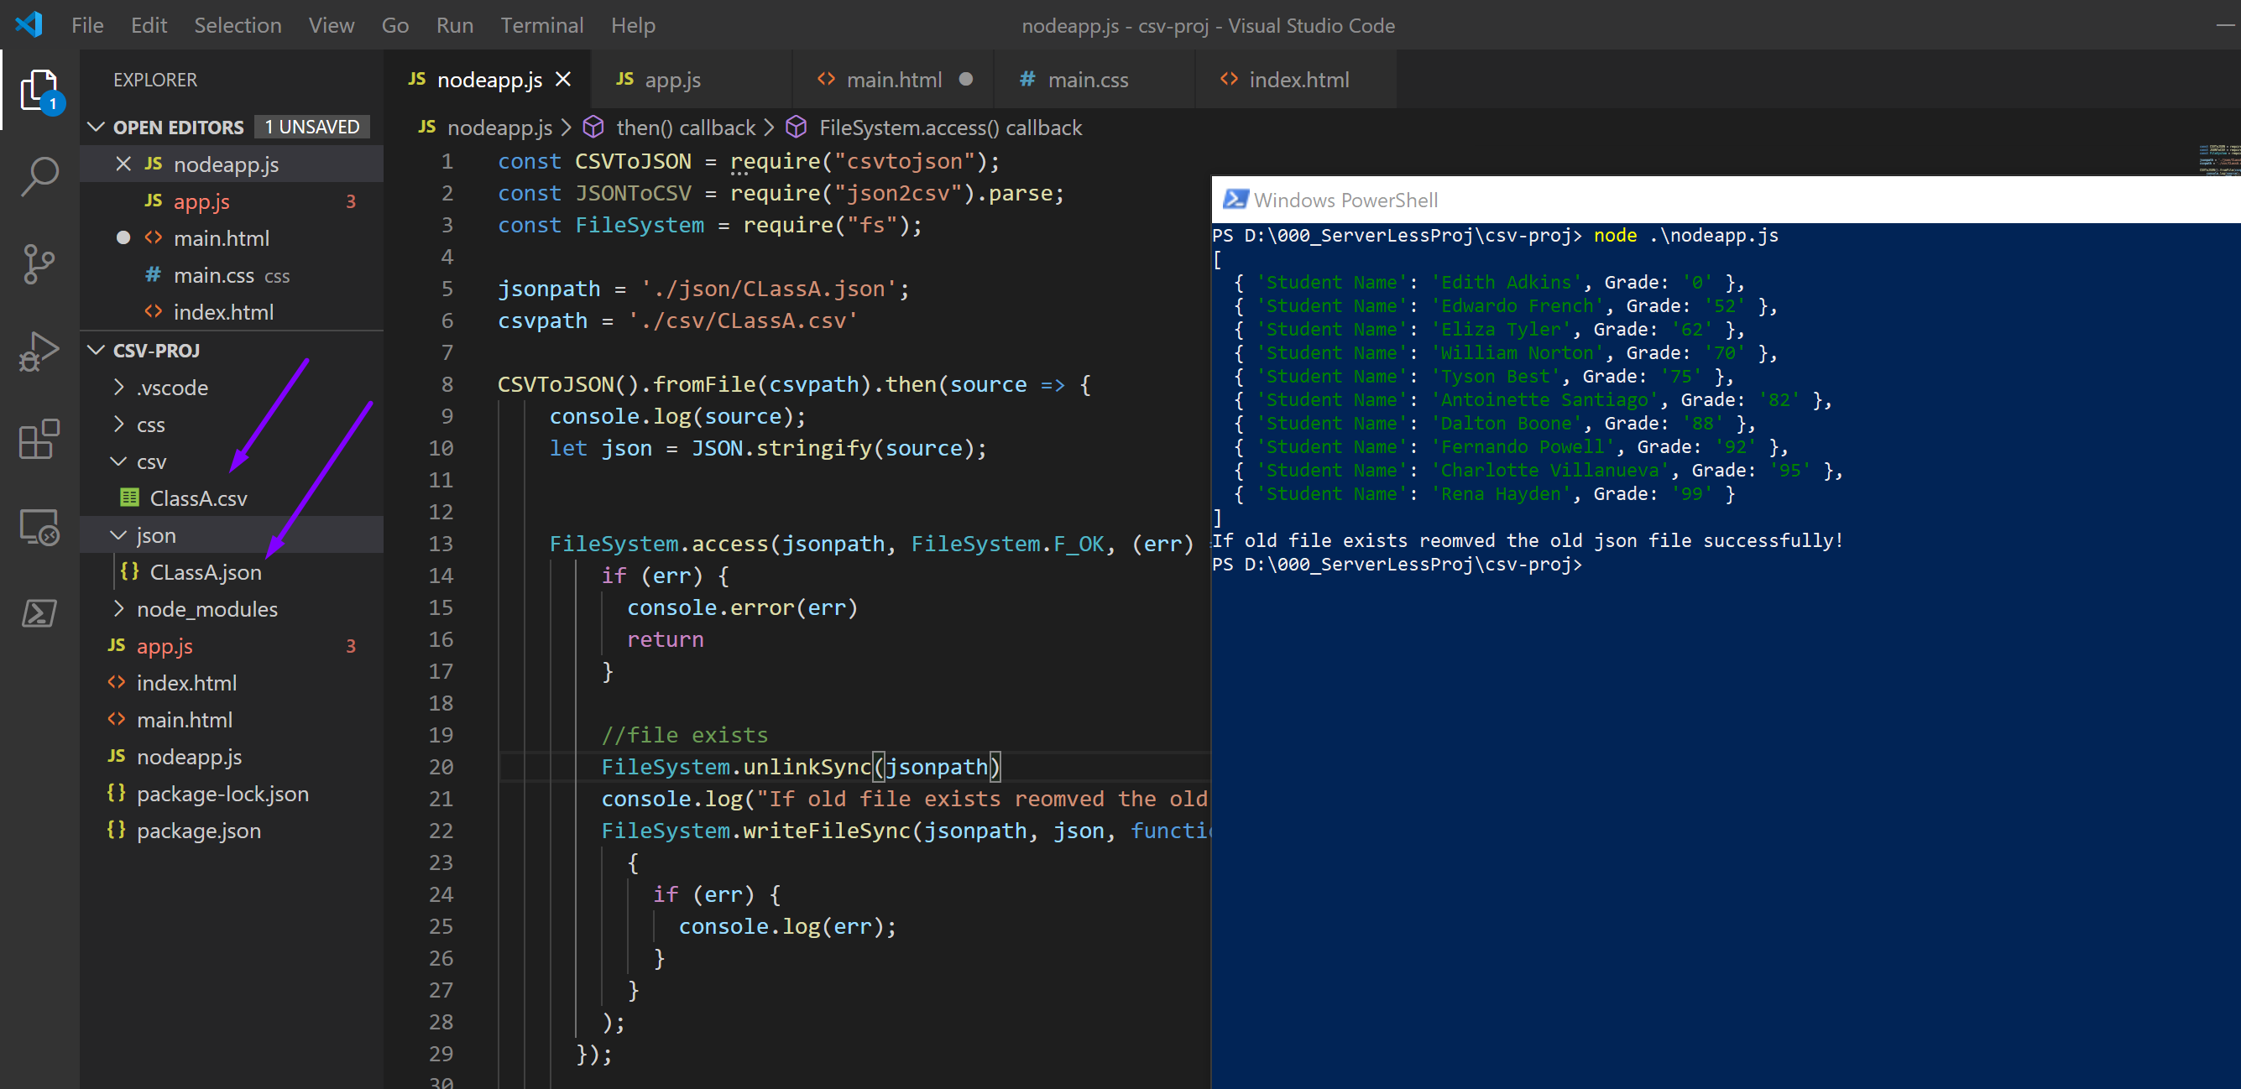 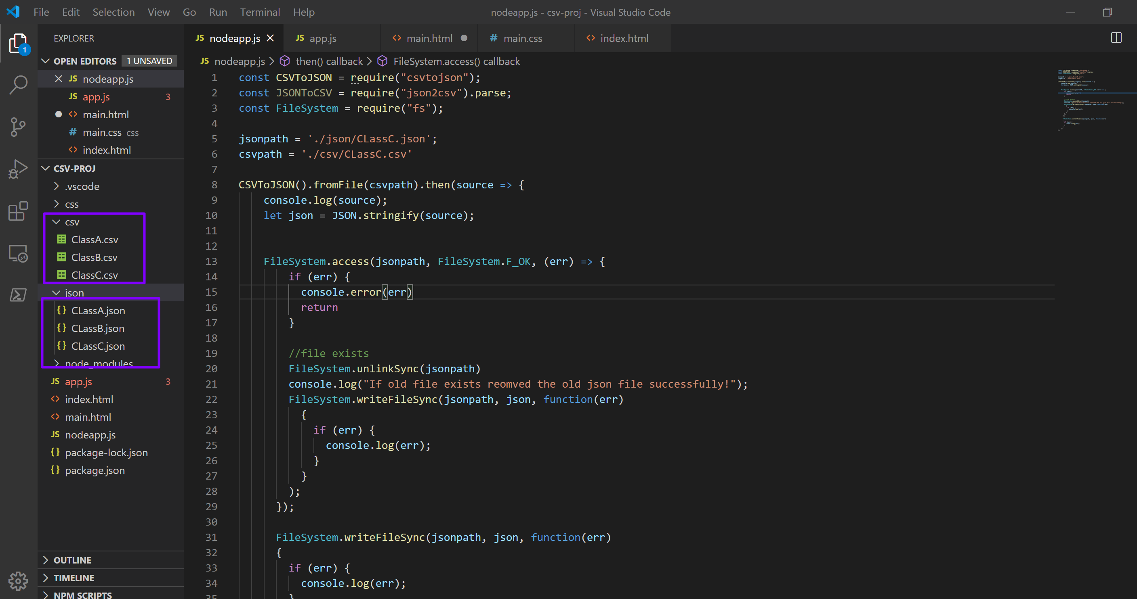

After convertion Json format:

Open main.html page from live server as shown below:

