**Name**: Muhammad Aziz **Professor**: Dr. Usman.

**Roll** #: 16l-6344 **T.A**: Mam Sofia.

**Digital Image Processing**

**Project I**

**Part II**

**P2.1:**

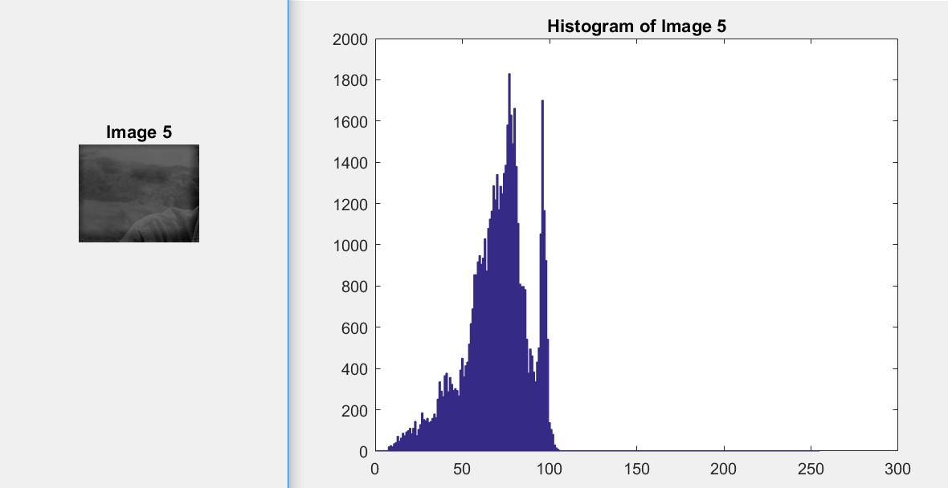

**The image has a poor contrast, with a very narrow dynamic range of intensities, as we can see in this image the histogram is skewed to the values between 0 and 110.**

**P2.2**

**After Applying Contrast Stretching the range get scattered resulting an enhanced picture shown below.**

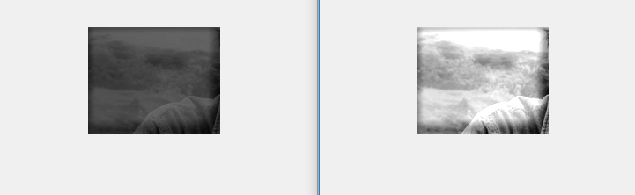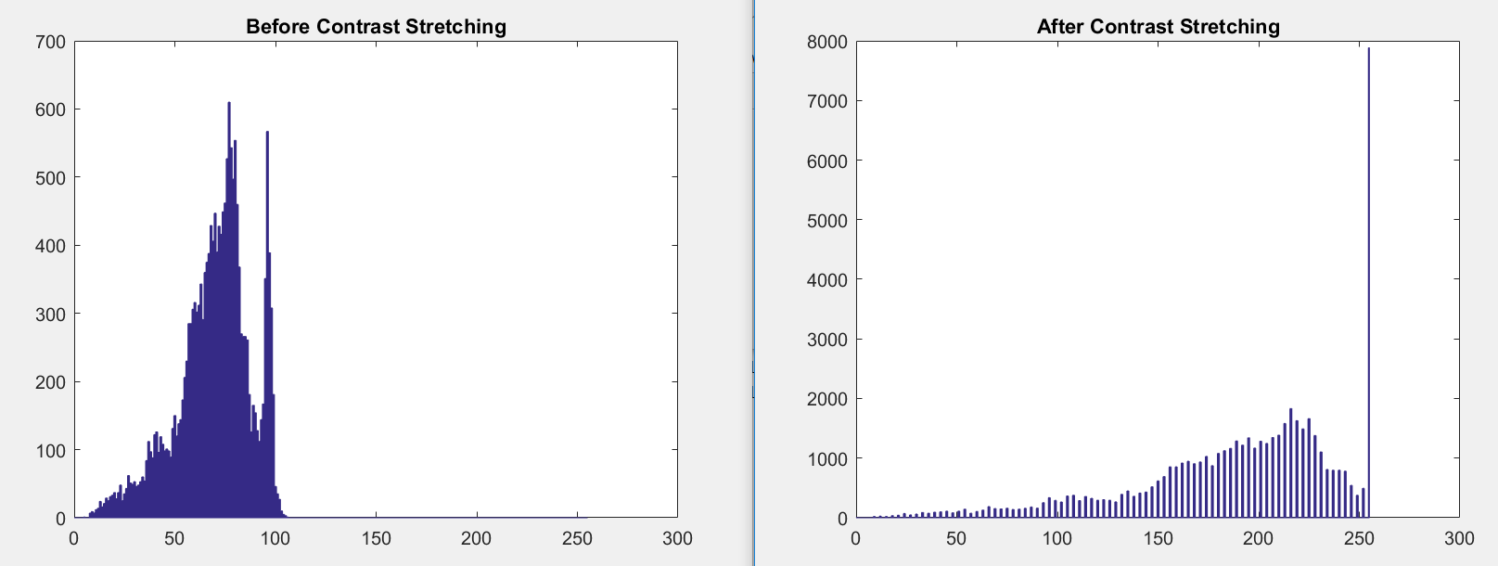

**P2.3**

* **Read image**
* **Define array (1 column and 256 rows) of zeros.**
* **Collect the frequency of each intensity (Using Loop).**
* **Calculate Probabilities by dividing each element of array by total pixels(Rows * Cols)**

**P2.4**

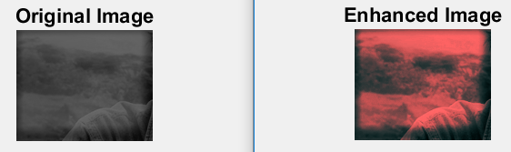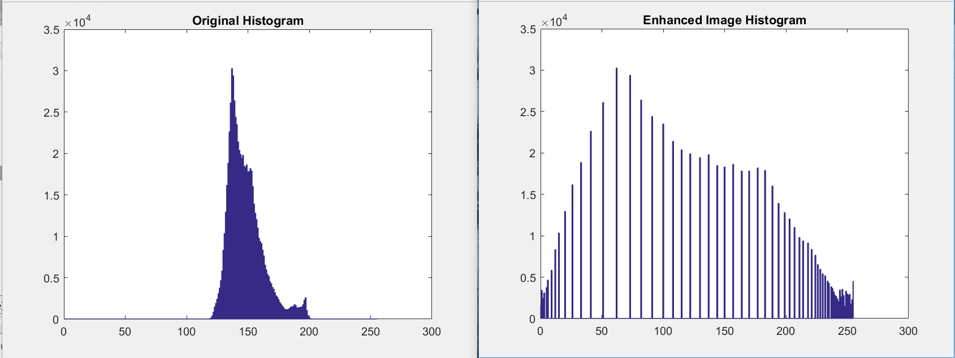

**Minimum intensity value is zero and it’s right because when you’re applying contrast stretching you’re basically stretching the skewed range of intensities to 0-255.**

**P2.5- Contrast Stretching**

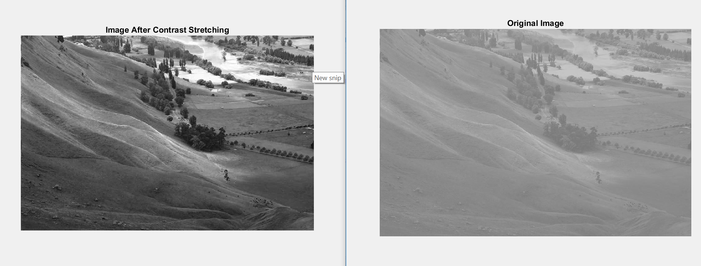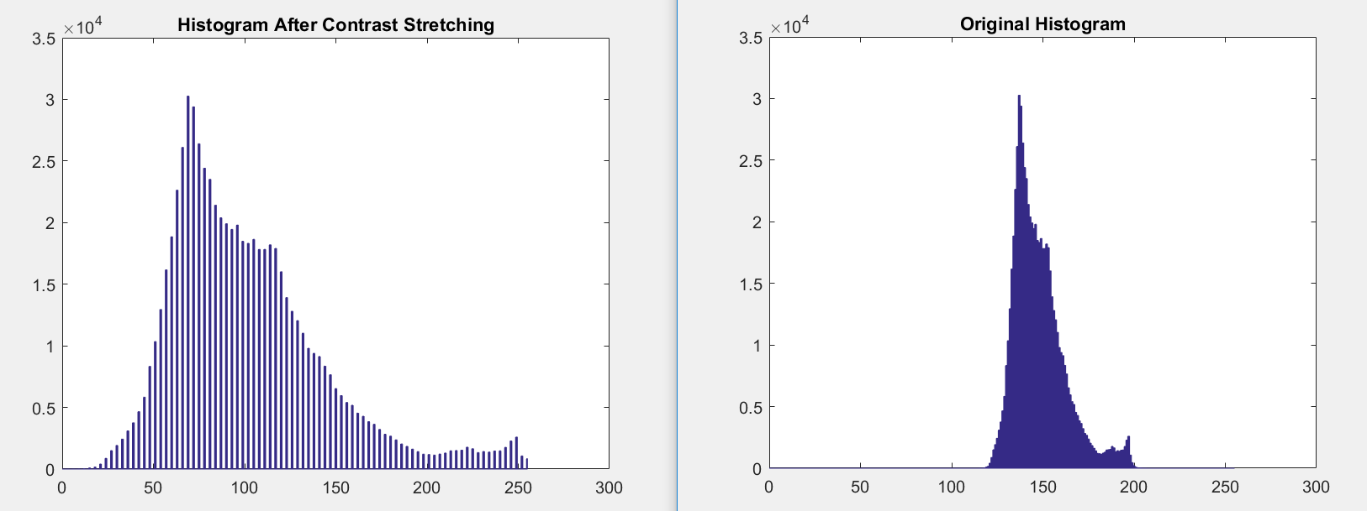

**Histogram equalization:**

