Q1)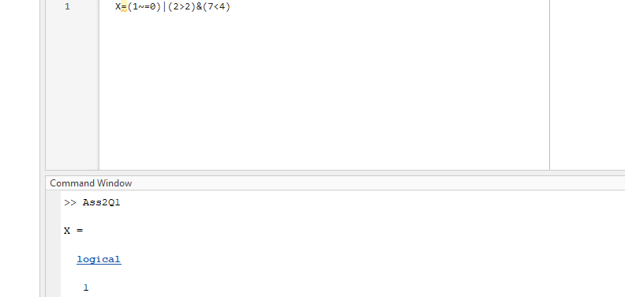



A ~= B returns a logical array with elements set to logical 1 (true) where arrays A and B

are not equal; otherwise, the element is logical 0 (false). The test compares both real

and imaginary parts of numeric arrays. ne returns logical 1 (true) where A or B

have NaN or undefined categorical elements and that’s why the answer is logical 1 = true but here it asks about the value of X which is 1

Q2)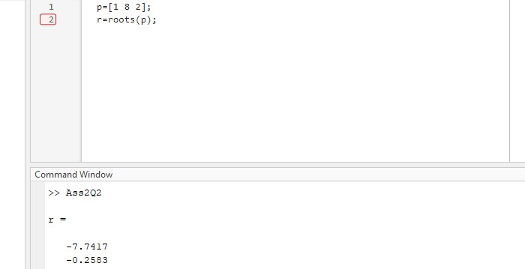

r = roots(p) return the roots of the polynomial represented by p as a column vector.

Input p is a vector containing n+1 polynomial coefficients, starting with the coefficient of xn.

A coefficient of 0 indicates an intermediate power that is not present in the equation.

For example, p = [1 8 2] represents the polynomial x^2 + 8x -2

Q3)

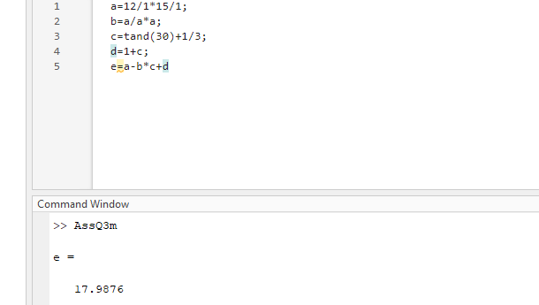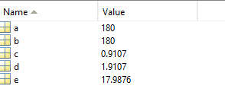

It is basically variables and were substitutes in an equation to get the value of e

As a = 180 , b = 180 , c = which is the tangent of (30) added by 1 divided by 3 as tand([X](https://uk.mathworks.com/help/matlab/ref/tand.html#bth4dgd-X)) returns the tangent of the elements of X, which are expressed in degrees which is 0.9107 and then d is 1 + c (0.9107 ) = 1.9107 and then e which we substitute the values e = (180) – (180)*0.9107+1.9107 = 17.9876

**Q.4.**

Initial vector n=   
 Formula:

For first iteration:

=

=

For 2nd iteration:

=

=

For 3rd iteration:

For 4th iteration:

=

=

For 5th iteration:

=

=

For 6th iteration:

=

=

For 7th iteration:

=

=

**Q5)**

Denote the variable

Then the linear equation that fits the data can be given by

Where,

Here, N = Total Number of Observation (data point)

Construct a table of value as shown below:

|  |  |  |  |  |
| --- | --- | --- | --- | --- |
|  |  |  |  |  |
|  | 0 | 1.15 | 0.00 | 0 |
|  | 1 | 2.32 | 2.32 | 1 |
|  | 2 | 3.32 | 6.64 | 4 |
|  | 3 | 4.53 | 13.59 | 9 |
|  | 4 | 5.56 | 22.60 | 16 |
|  | 5 | 6.97 | 34.85 | 25 |
|  | 6 | 8.02 | 48.12 | 36 |
|  | 7 | 9.23 | 64.61 | 49 |
| **SUM** | **28** | **41.19** | **192.73** | **140** |

From the table;

Use the table values to obtain the values of and.

So,

And

Required line of best fit will be:

Where,

So, option (C) gives the nearest approximation.

Q6

|  |  |
| --- | --- |
|  |  |
| 1 | 5.12 |
| 3 | 3 |
| 6 | 2.48 |
| 9 | 2.34 |
| 15 | 2.18 |

When

Corresponding normal equation we.

|  |  |  |  |  |
| --- | --- | --- | --- | --- |
|  |  |  |  |  |
| 1 | 5.122 | 1.6332 | 1 | 1.6332 |
| 3 | 3 | 1.0986 | 9 | 3.2958 |
| 6 | 2.48 | 0.9083 | 36 | 5.4498 |
| 9 | 2.34 | 0.8502 | 81 | 7.6518 |
| 15 | 2.18 | 0.7793 | 225 | 11.6895 |
|  |  |  |  |  |

Slope formula

=

Intercept formula

=

**Q7):**

Given equation

We can write as:

|  |  |  |  |  |
| --- | --- | --- | --- | --- |
|  |  |  |  |  |
| 1 | 5.12 | 1 | 5.12 | 1 |
| 3 | 3 | 0.33 | 1 | 0.111 |
| 6 | 2.48 | 0.166 | 0.4133 | 0.0277 |
| 9 | 2.34 | 0.111 | 0.26 | 0.0123 |
| 12 | 2.18 | 0.0666 | 0.14533 | 0.0044 |
|  | **15.12** | **1.677** | **6.93866** | **1.1557** |

a =

**Q8)**

Given

|  |  |  |  |
| --- | --- | --- | --- |
|  | 0.5 | 1 | 1.5 |
|  |  |  |  |

Construct a divided difference table as shown below:

|  |  |  |  |
| --- | --- | --- | --- |
|  |  | First Order | Second Order |
| 0.5 | -0.09420 |  |  |
|  |  | -0.69976 |  |
| 1 | -0.44408 |  | -223346 |
|  |  | -2.93322 |  |
| 1.5 | -1.91069 |  |  |

Now, the Newton’s divided difference formula is:

Here,

Thus, for

=

=

Thus,

**Q9)**

Using langrage’s interpolation:

|  |  |  |
| --- | --- | --- |
|  |  |  |
|  | 2 | 8 |
|  | 3 | 42.79399 |
|  | 7 | 962.9227 |

Using larynges, inter pollution formula

For

=

Q10)

Solution: we choose first 3 points to find velocity approximation that close to 18s.

Using langrage’s interpolation

=

=

At

**=**