

**LAB-02**

**Title: Intermediate level DDL and Simple DML statements.**

**Name: Azizul Abedin Azmi**

**ID: 2022-1-60-130**

**Section: 02**

**Course Code: CSE302**

**Course Title: (Database Systems)**

**Date: 27/08/2024**

**Course Instructor:**

**Mahmuda Rawnak Jahan**

**Lecturer**

**Department of Computer Science and Engineering**

**Lab Task # 01 (Schema Definition):**

**Write SQL statements to create the following tables with the given constraints.**

1. account  
   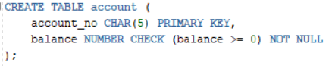  
   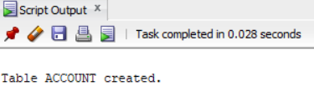
2. customer  
   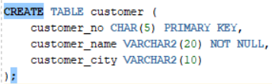  
   
3. depositor  
   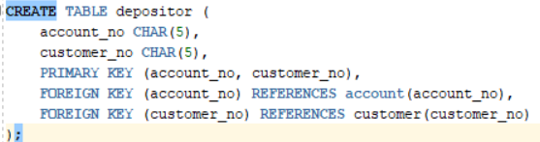  
   

**Lab Task # 02 (Schema Modification):**

**After executing each of these SQL statements execute the command – desc <table_name> to confirm the**

**changes.**

1. Write SQL statement to add a new attribute ‘date_of_birth’ (date type) in customer table.  
     
   
2. Write SQL statement to drop the attribute ‘date_of_birth’ from customer table.  
     
   
3. Write SQL statement to rename the attribute account_no, customer_no from depositor table to a_no and c_no, respectively.  
   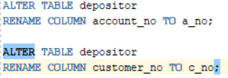  
   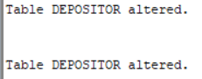
4. Write SQL statements to add two foreign key constraints ‘depositor_fk1’ and ‘depositor_fk2’ which identifies a_no and c_no as a foreign key.

**Lab Task # 03 (Inserting Records into Tables):**

**Write appropriate SQL statements to insert the records as shown below.**

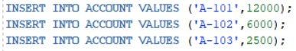  
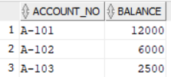

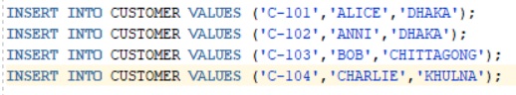

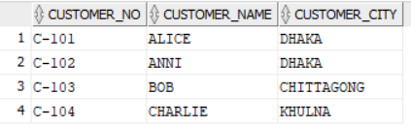

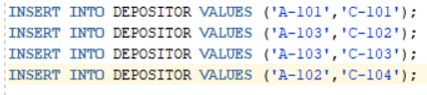

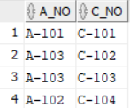

**Lab Task # 04 (Queries):**

1. **Display customer name and customer city only.  
     
   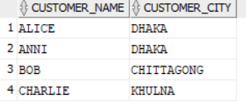**
2. **Display the unique customer city. No repetitions are allowed.  
     
   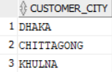**
3. **Find account numbers with balance more than 7000.  
     
   **
4. **Find customer number and customer name who live in Khulna.  
   **



1. **Find customer number and customer name who do not live in Dhaka.  
   **

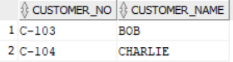

1. **Find customer name and customer city who have accounts with balance more than 7000.  
   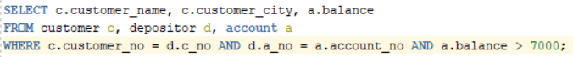  
   **
2. **Find customer name and customer city who have accounts with balance more than 7000 and do not**

**live in Khulna.  
**



1. **Find account number and balance for those accounts which belong to a customer with id ‘C-102’.  
   **



1. **Find all account number and balance for those accounts which belong to customers of Dhaka and**

**Khulna city.  
  
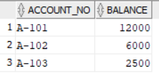**

1. **Find the customer who have no accounts. [Result of this query will be empty for this dataset.**

