Customer and Revenue Analysis
UK online giftware retailer, December 2010 to December 2011
ShadowFox Data Analyst Internship, Intermediate Level
Prepared by: Azizul Abedin Azmi
azmi00121@gmail.com | github.com/azizulabedinazmi | azizulabedinazmi.is-a.dev

1. Executive summary
The business sold £10.00M of goods across 19,771 orders to 4,333 identified customers in 38 countries over one year. Revenue runs at roughly £0.5M to £0.75M a month from January to August, then climbs sharply into November. The more important story is who produces it: a small group of repeat buyers carries the business.
- Revenue is highly concentrated. The top 10% of customers produce 60% of revenue and the top 20% produce 74%. The bottom half of customers produce 8%.
- A Champions group does most of the work. 912 customers (21% of the base) generate 66% of revenue. They order about 11 times a year.
- Repeat buying is the business. 65% of customers ordered more than once, and those repeat customers account for 94% of revenue. In 2011, returning customers made 80% of revenue from identified customers.
- Most new customers do not return. Only about 20% of a month's new customers order again the following month, and the figure stays near 25% six months later. New customers are being brought in, but most do not come back.
- The business is highly seasonal. September to November brought in 38% of revenue. November alone was 2.2 times the average month from January to August.
- There is a recoverable pool of lapsed buyers. 641 customers who ordered several times before have been silent for about 154 days. They spent £734K with the business before going quiet.
Main recommendations: protect and reward the Champions, run a win-back campaign aimed at At Risk and high-value quiet customers, add a second-order incentive for new customers, and build the Q4 plan (stock, staffing, campaigns) from August. Details are in section 7.

2. Business question and data
Business question: where does revenue come from, how well does the company keep its customers, and which actions would grow revenue most?
Supporting questions:
- How does revenue move over time, and how seasonal is it?
- How concentrated is revenue across customers and products?
- How many customers come back, and how quickly do they drop off?
- Which customer segments matter most, and which are at risk?
- Which products and countries drive the business?
Item | Detail
Source | Online Retail dataset (UCI Machine Learning Repository), read from a public GitHub mirror
Period | 2010-12-01 to 2011-12-09
Raw size | 541,909 order lines, 8 columns
Grain | One row = one product line on one invoice
After cleaning | 522,537 sales lines, 19,771 invoices, 3,908 products, 4,333 identified customers
Customer field | CustomerID is missing on about 25% of lines. These lines are kept for revenue, product and country analysis, but excluded from customer analysis. Identified customers account for 85% of revenue.
Currency | Pounds sterling (£). The retailer is UK based.

3. Data cleaning and preparation
Every change is recorded in docs/cleaning_log.csv and reproduced by scripts/clean_online_retail.py. The main steps:
Issue found | Action taken | Rows affected
Exact duplicate lines (identical in every column) | Removed repeats and kept the first. Same invoice, product, quantity, price and time is most likely a double entry. | 5,268
Cancellation invoices (InvoiceNo starts with 'C') | Moved to cancellations.csv. Revenue analysis uses completed sales; cancellations are reported separately as a return rate. | 9,251
Non-product lines (postage, manual, bank charges, Amazon fees, gift vouchers) | Removed. These are not products and would distort product and revenue analysis. | 2,356
Quantity <= 0 or UnitPrice <= 0 on non-cancelled invoices (stock write-offs, adjustments, free items) | Removed. They carry no sales revenue. | 2,493
StockCode has several spelling variants of its description | Used the most common description for each StockCode. | 6,784
Duplicates revealed after standardising descriptions | Removed (same invoice, product, quantity, price, time). | 2
Missing CustomerID (guest or untracked orders) | Kept in sales_all.csv for revenue, product and country analysis. Excluded from sales_customers.csv because customer behaviour cannot be tracked without an ID. | 131,388
Orders of 10,000+ units that the same customer cancelled in full (MEDIUM CERAMIC TOP STORAGE JAR x74,215, PAPER CRAFT , LITTLE BIRDIE x80,995) | Removed both the sale and its cancellation. They are one reversed transaction worth 245,653 in revenue that was never kept. Leaving them in would make a cancelled order the #2 product. | 2

Three decisions are worth explaining:
- Cancellations. Lines whose invoice number starts with C are returns. They were removed from revenue and analysed on their own, so revenue figures show completed sales only.
- Order-and-cancel pairs. Two orders of more than 70,000 units were cancelled in full by the same customer. Left in, one of them would have shown up as the second best-selling product at £168K, when it earned nothing. Both the sale and the cancellation were removed.
- Non-product lines. Postage, manual adjustments, bank charges, Amazon fees and gift vouchers are not products. Removing them keeps product and revenue analysis honest.

4. Metrics used and why
Metric | Definition | Why it matters
Revenue | Quantity x UnitPrice, completed sales only | Size and trend of the business
Orders and customers | Distinct InvoiceNo; distinct CustomerID | Separates more buyers from bigger baskets
Average order value | Revenue / orders | Basket size; the median is shown too because a few huge orders skew the mean
Repeat purchase rate | Customers with 2+ orders / all customers | Basic loyalty measure
Revenue concentration | Share of revenue from top 1%, 10%, 20% of customers | How exposed the business is to a few accounts
Cohort retention | Share of customers first seen in a month who order again N months later | Whether new customers stick
RFM segments | Recency (days since last order), Frequency (orders), Monetary (revenue); each scored 1 to 5 by quintile | Groups customers by value and risk so each group gets a different action
Cancellation rate | Value of cancelled lines / revenue | Revenue leakage

5. Findings

5.1 Revenue trend and seasonality
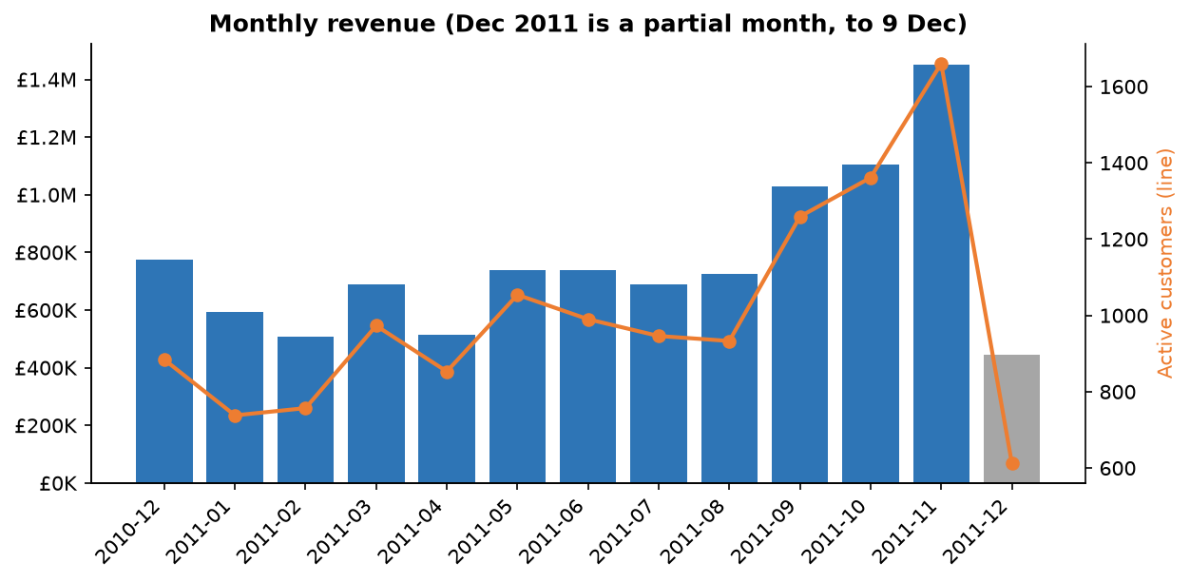
What the data shows. Revenue sits between £508K and £776K a month from December 2010 to August 2011, then rises to £1.03M in September, £1.10M in October and £1.45M in November. The number of active customers rises with it, so the peak is driven by more buyers, not only bigger orders. December 2011 is a partial month (data stops on 9 December) and should not be read as a fall.
Likely reason. Items with Christmas-themed names make up only 5% of revenue, but 80% of their sales fall in September to November. The business sells giftware to customers who are stocking up before the holidays, and trade buyers order early.
What to do. Plan Q4 from August: secure stock for the best sellers, schedule warehouse and support staff, and start campaigns in late August, ahead of the September jump rather than during it.

5.2 When customers order
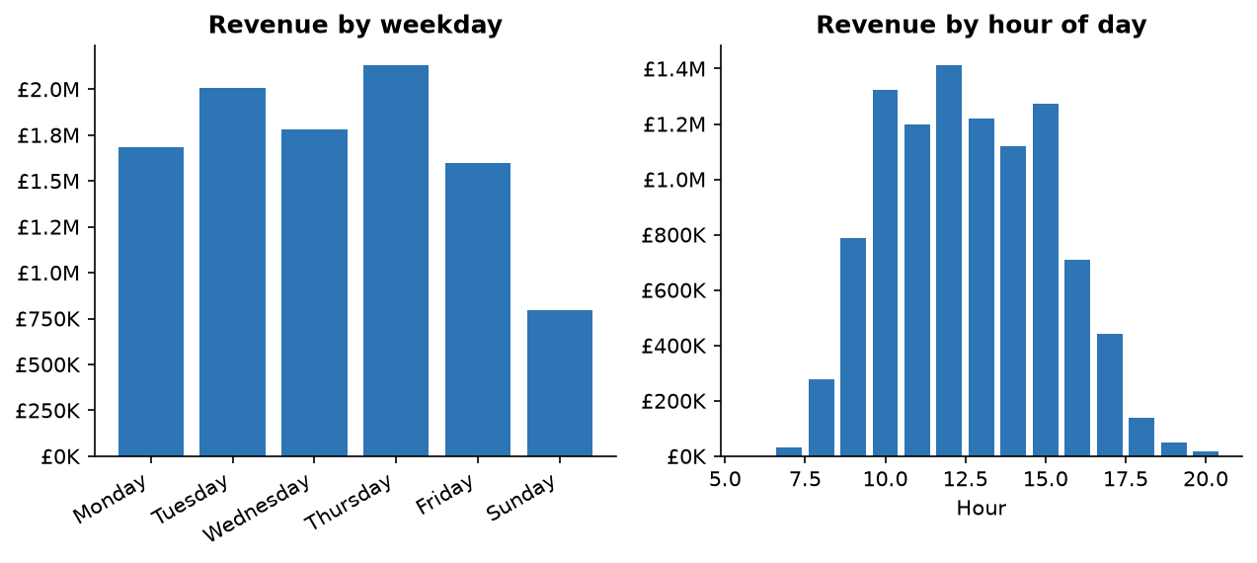
What the data shows. 75% of revenue is placed between 10:00 and 15:59. Thursday and Tuesday are the strongest days and Sunday is 8% of revenue. No orders are recorded on Saturdays.
Likely reason. This is a working-hours pattern, which fits trade and business buyers more than consumers. The Saturday gap may be a trading rule or a gap in how the data was recorded. The data cannot say which, so it is worth confirming with the business before acting on it.
What to do. Schedule emails and promotions for Tuesday to Thursday mornings, and keep customer support staffed over the 10:00 to 16:00 window.

5.3 Countries
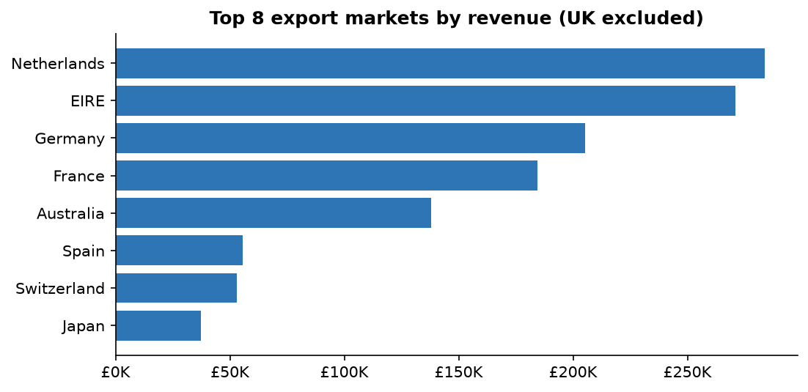
What the data shows. The United Kingdom is 85% of revenue. Export markets add 15%, led by the Netherlands (£284K), EIRE (£271K), Germany (£205K) and France (£184K). The customer counts behind these figures differ sharply: EIRE's revenue comes from only 3 customers, the Netherlands and Australia from 9 each, while Germany has 94 and France 87.
Likely reason. The Netherlands, EIRE and Australia are essentially a handful of large accounts. Germany and France are broader markets with many smaller buyers.
What to do. Manage EIRE, the Netherlands and Australia as key accounts, because losing one buyer would remove a large share of that market. Germany and France are better candidates for market-level marketing, since the customer base is already broad.

5.4 Revenue concentration
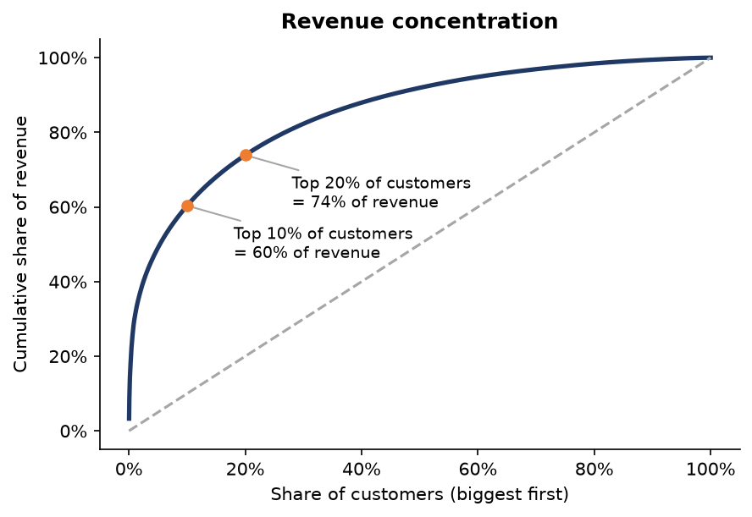
What the data shows. The top 1% of customers (43 accounts) produce 30% of revenue, the top 10% produce 60%, and the top 20% produce 74%. This is steeper than the usual 80/20 rule.
Likely reason. Average order value is £506 but the median is £302, so a few very large orders pull the average up. Combined with orders placed during working hours (section 5.2), this suggests many customers are businesses buying to resell. The dataset has no customer-type field, so this is an inference, not a measured fact.
What to do. Losing one top account costs far more than losing many small ones. Give the top 1% to 10% a named account owner and watch their order gaps closely.

5.5 Repeat purchase behaviour
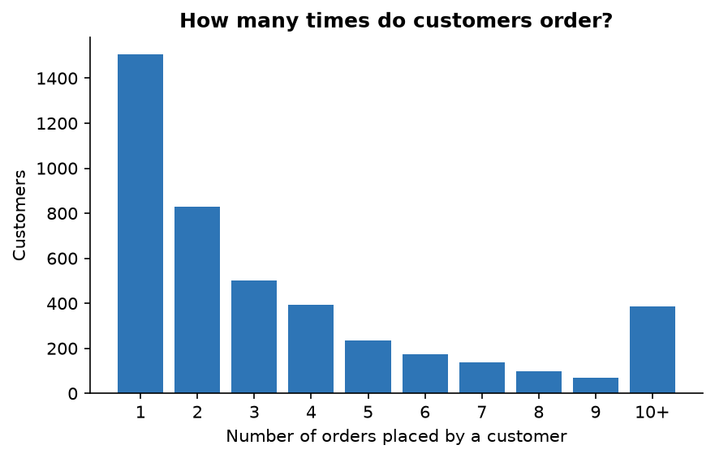
What the data shows. 65% of customers ordered more than once. The average customer ordered 4.2 times, but the median is 2, so many customers order once or twice while a smaller group orders very often. Repeat customers produce 94% of revenue, and returning customers have a higher average order (£485) than customers on their first order month (£402).
Likely reason. Customers who come back also buy more each time, which is the usual sign of trust and familiarity building up.
What to do. The cheapest growth comes from turning one-time buyers into second-time buyers.

5.6 Retention by cohort
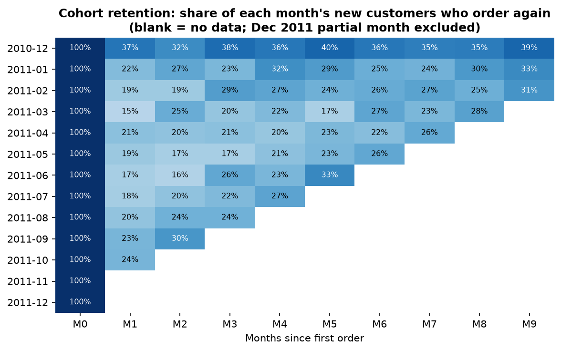
What the data shows. On average, 20% of a month's new customers order again in the next month, 23% are active three months later and 25% six months later. The rate does not fall steadily. It stays flat or rises a little, which means customers who return do so in bursts. The December 2010 row is higher (37% in month 1) because the data starts that month, so those customers were already established and are not truly new. It is excluded from the averages above.
Likely reason. Customers reorder on their own cycle, probably restocking, not on a monthly rhythm. A one-month retention figure alone would make the business look worse than it is.
What to do. Measure retention over 3 to 6 months, and time follow-up messages to the customer's own ordering gap rather than to a fixed calendar.
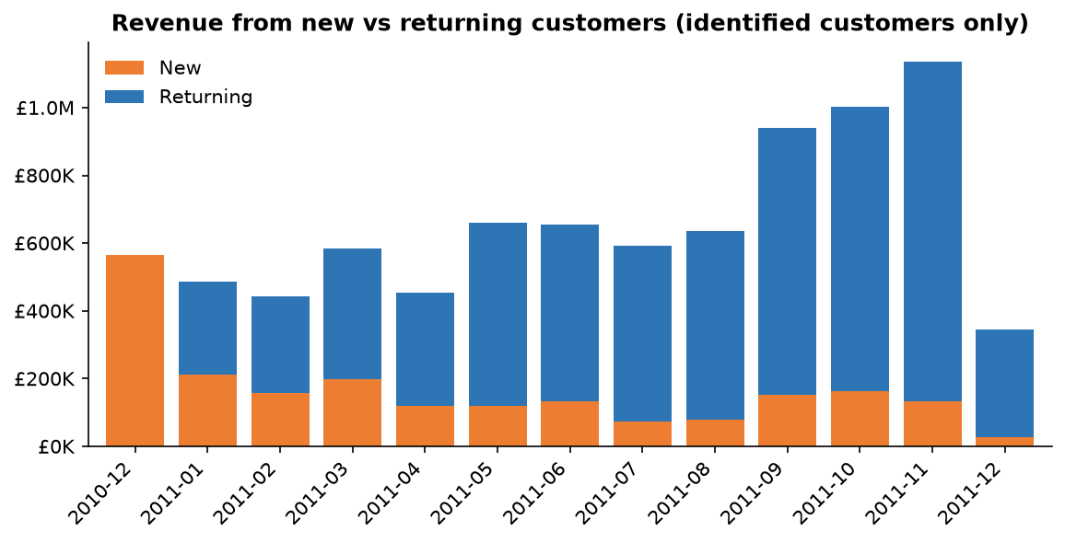
Returning customers supply about 80% of monthly revenue during 2011, and their share grows through the year. Revenue growth into November came mostly from existing customers ordering more. New-customer revenue stayed between £72K and £197K a month from February to November.

5.7 Customer segments (RFM)
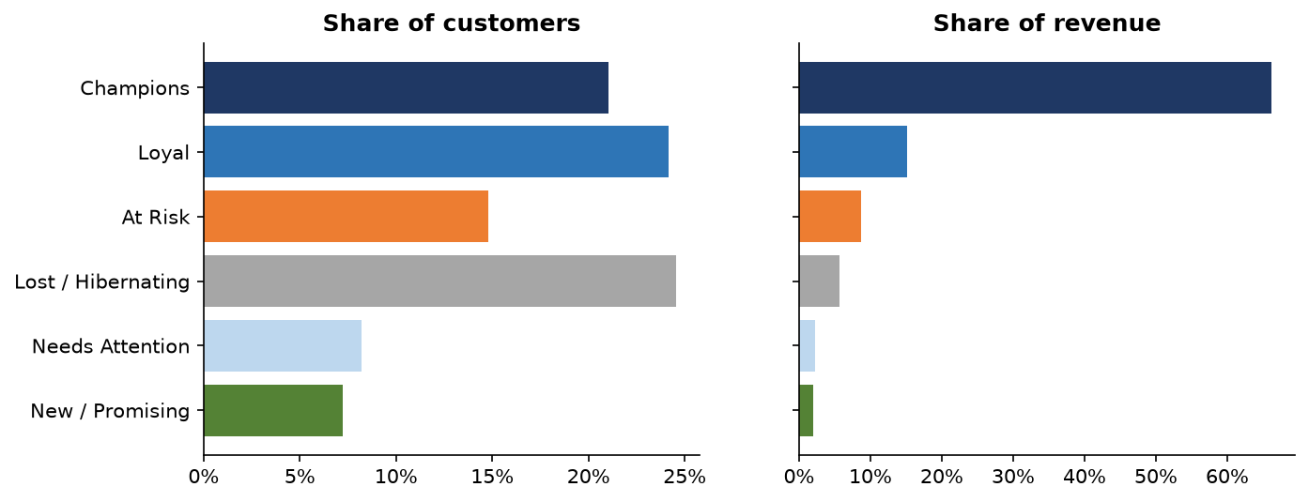
Segment | Meaning | Customers | % of customers | % of revenue | Avg days since order | Avg orders | Avg spend
Champions | Recent, frequent, high spend (R, F, M all 4 or 5) | 912 | 21% | 66% | 12 | 11.4 | £6,165
Loyal | Order regularly and recently | 1,047 | 24% | 15% | 33 | 3.7 | £1,232
At Risk | Ordered often before, quiet for months | 641 | 15% | 9% | 154 | 3.4 | £1,144
Lost / Hibernating | Few orders, long silence | 1,064 | 25% | 6% | 218 | 1.1 | £454
Needs Attention | Middling on every score | 356 | 8% | 2% | 54 | 1.2 | £537
New / Promising | Recent, but only 1 or 2 orders | 313 | 7% | 2% | 18 | 1.2 | £548

What the data shows. Champions are 21% of customers and 66% of revenue, each spending about £6,165 a year. At Risk customers are 15% of the base. They placed about 3.4 orders each before going quiet for roughly 154 days. Separately, 246 customers in the top two spend bands have not ordered in over 90 days, and they spent £535K before going quiet.
Likely reason. A customer who used to order every few weeks and has been silent for five months has either moved to a competitor, changed what they sell, or been missed by the business. The data cannot say which. It does show that this group was valuable and is now inactive.
What to do. Run a targeted win-back effort with a personal message first, before offering any discount. Recovering a modest share of the £734K these customers brought in is a realistic first target.

5.8 Products
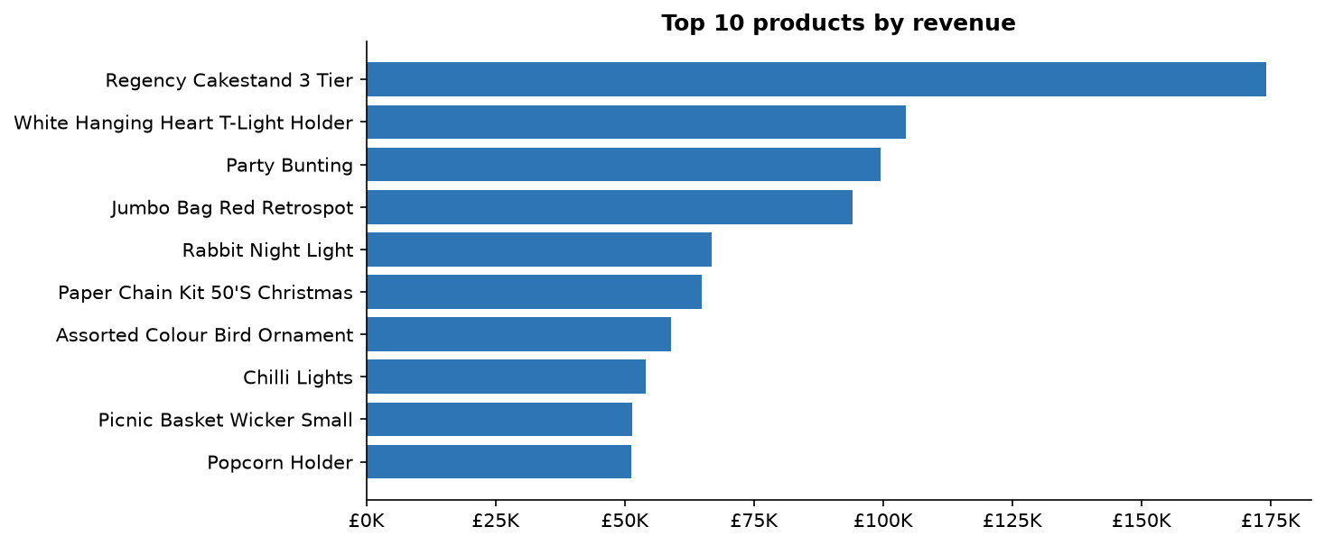
What the data shows. The top 10 products make up 8% of revenue and the top 10% of the 3,908 products make up 61%. The best seller is the Regency Cakestand 3 Tier (£174K). Product revenue is spread widely rather than resting on a few items.
Likely reason. The catalogue is wide, with nearly 4,000 products, so no single item dominates. This is a description of the pattern; the data does not say why.
What to do. Keep the long tail for variety, but make sure the top few hundred products are never out of stock, especially before September.

5.9 Cancellations
Cancelled lines are worth £230K, or 2.3% of revenue. The worst month for cancellations (April 2011) reached 6.5%. Ten customers account for 34% of the cancelled value. This is a low rate and is not the priority. It is still worth checking whether the same few accounts cancel repeatedly.

6. Why these patterns are happening: summary
- Concentration. The pattern of heavy repeat ordering, large baskets and working-hours orders points to a trade customer base. In a trade business, a relatively small number of reliable accounts naturally carry the revenue.
- Seasonality. Gift and homeware buyers stock up before the holidays, and trade buyers order earlier than consumers would.
- Weak early retention. Many one-time customers are probably trying the business or placing a single stocking order. Without a prompt, there is no prompt to return. The data has no marketing information, so this is untested.
These are reasoned explanations from the patterns in the data. The dataset has no information about customer type, marketing activity, prices or competitors, so they should be tested with the business before large investments are made.

7. Recommendations
# | Action | Evidence | How | How to measure
1 | Protect the Champions | 912 customers produce 66% of revenue. | Assign account owners to the top 10%. Alert the team when a top customer's gap since last order is longer than usual. Offer early access to new lines. | Champion count; their average orders per year
2 | Win back lapsed high-value customers | 641 At Risk customers spent £734K before going quiet; 246 high spenders have been silent over 90 days. | Personal outreach to the highest spenders first, then a templated message. Ask why they stopped ordering. Test a small incentive on one half only. | Reactivation rate; revenue from reactivated customers
3 | Get a second order from new customers | Only about 20% of new customers order again the next month. | Send a follow-up 2 to 3 weeks after the first order with best sellers and a modest incentive on the second order. Test it against a control group. | Share of new customers who place a second order within 90 days
4 | Build the Q4 plan from August | September to November is 38% of revenue. November is 2.2x a normal month. | Forecast demand by product, order stock by July and August, schedule staff, and launch campaigns before the September jump. | Stock-outs on top products; Q4 revenue vs plan
5 | Time communication to when customers buy | 75% of revenue is ordered between 10:00 and 16:00, and Tuesday to Thursday are strongest. | Send emails on Tuesday to Thursday mornings. Keep support staffed in the 10:00 to 16:00 window. | Email-to-order conversion by weekday
6 | Handle exports by market type | Exports are 15% of revenue. EIRE rests on 3 customers, the Netherlands and Australia on 9 each; Germany and France have 94 and 87. | Key-account management for EIRE, the Netherlands and Australia. Market-level marketing for Germany and France. | Revenue per export account; number of active buyers per country

8. Limitations
- One year of data from one retailer. Seasonality is based on a single holiday season, so it cannot be separated from growth in the business.
- About 25% of order lines have no CustomerID. Customer findings cover only the identified customers, who account for 85% of revenue.
- December 2011 is a partial month. It is shown in grey and left out of averages.
- The first cohort (December 2010) contains existing customers because the data starts there, so it is excluded from average retention.
- RFM segment boundaries are quintile-based and somewhat arbitrary. Customers near a boundary could fall into either segment. The segments are for prioritising action, not exact classes.
- The dataset has no customer type, marketing, price or cost information. Profit cannot be calculated, so every 'value' in this report is revenue, not profit.
- Reasons given for the patterns are inferences from the data and have not been tested.

9. Reproducing this work
All code is in the repository. Run from the 02-intermediate folder:
python scripts/clean_online_retail.py
python analysis/analyze_online_retail.py
python analysis/build_report.py
Tables behind every chart are in analysis/analysis_tables.xlsx.

