Assignment-13

Part 1 : Laravel Installation

Here I install Laravel first step I just go Laravel official document and see here installation guide with composer global requirement below I share screen short

Here I run -- composer global require laravel/installer

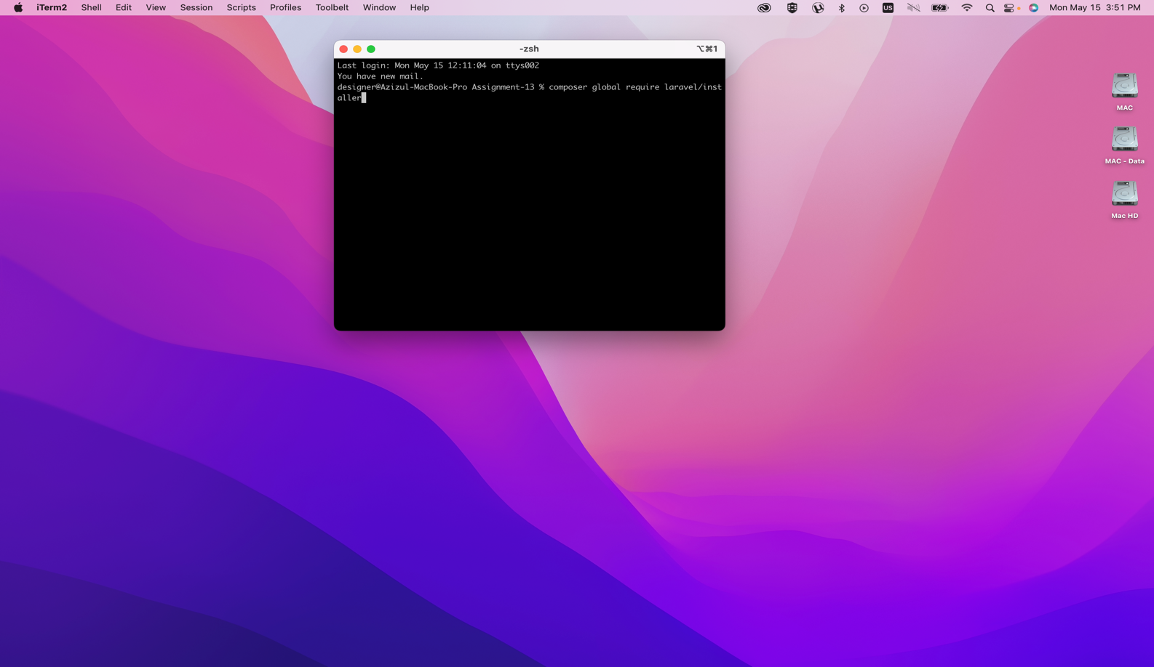

2nd: code I run “laravel new assignment-13”

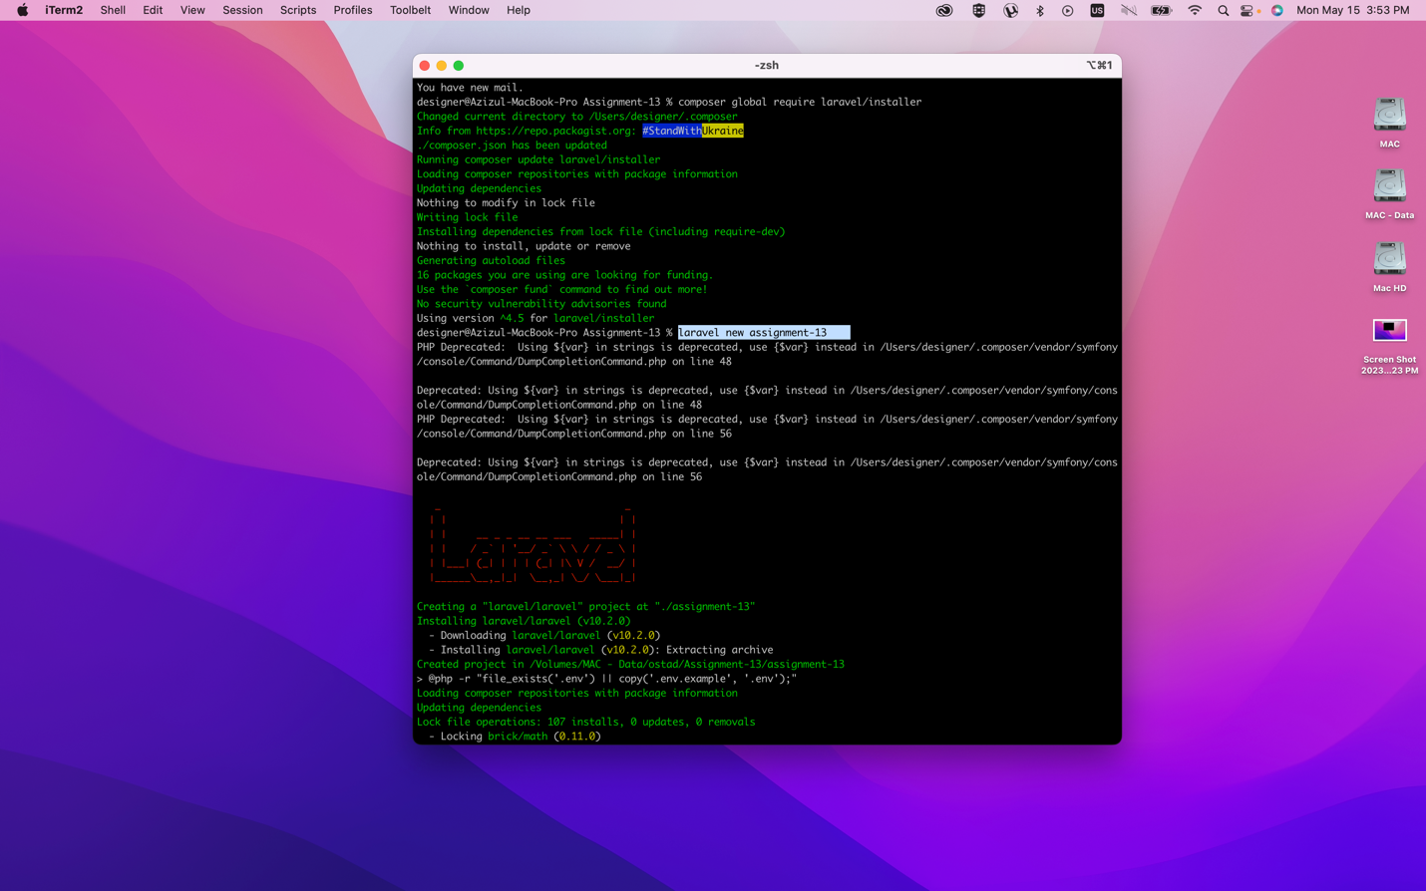

3. than in run -- “cd assignment-13”

4. than -- “run php artisan serve”

5. than come in browser below I share screen short

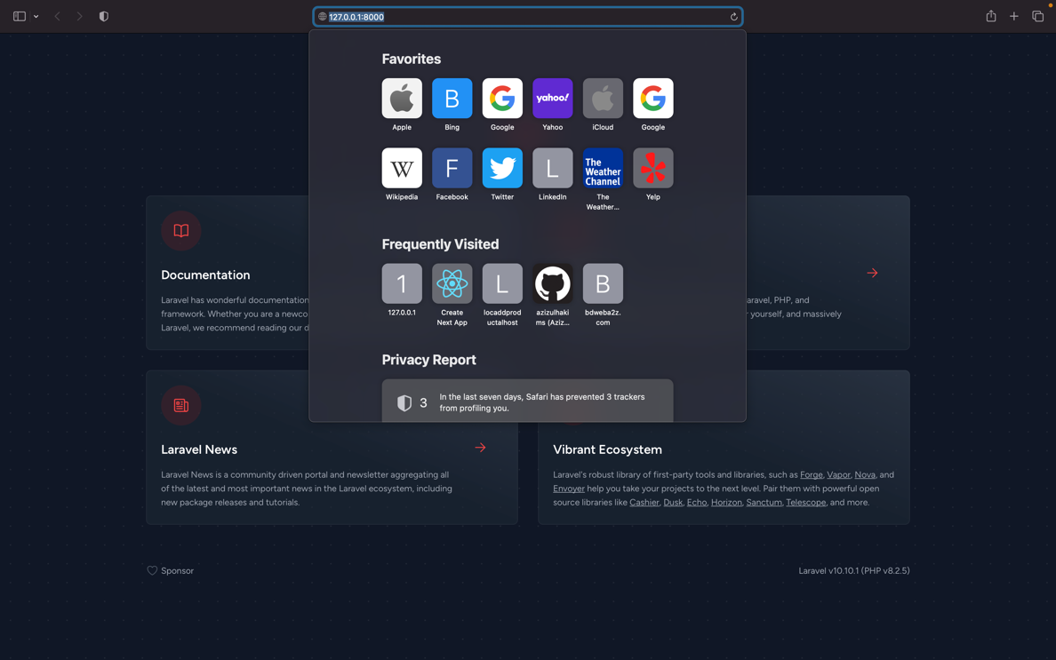

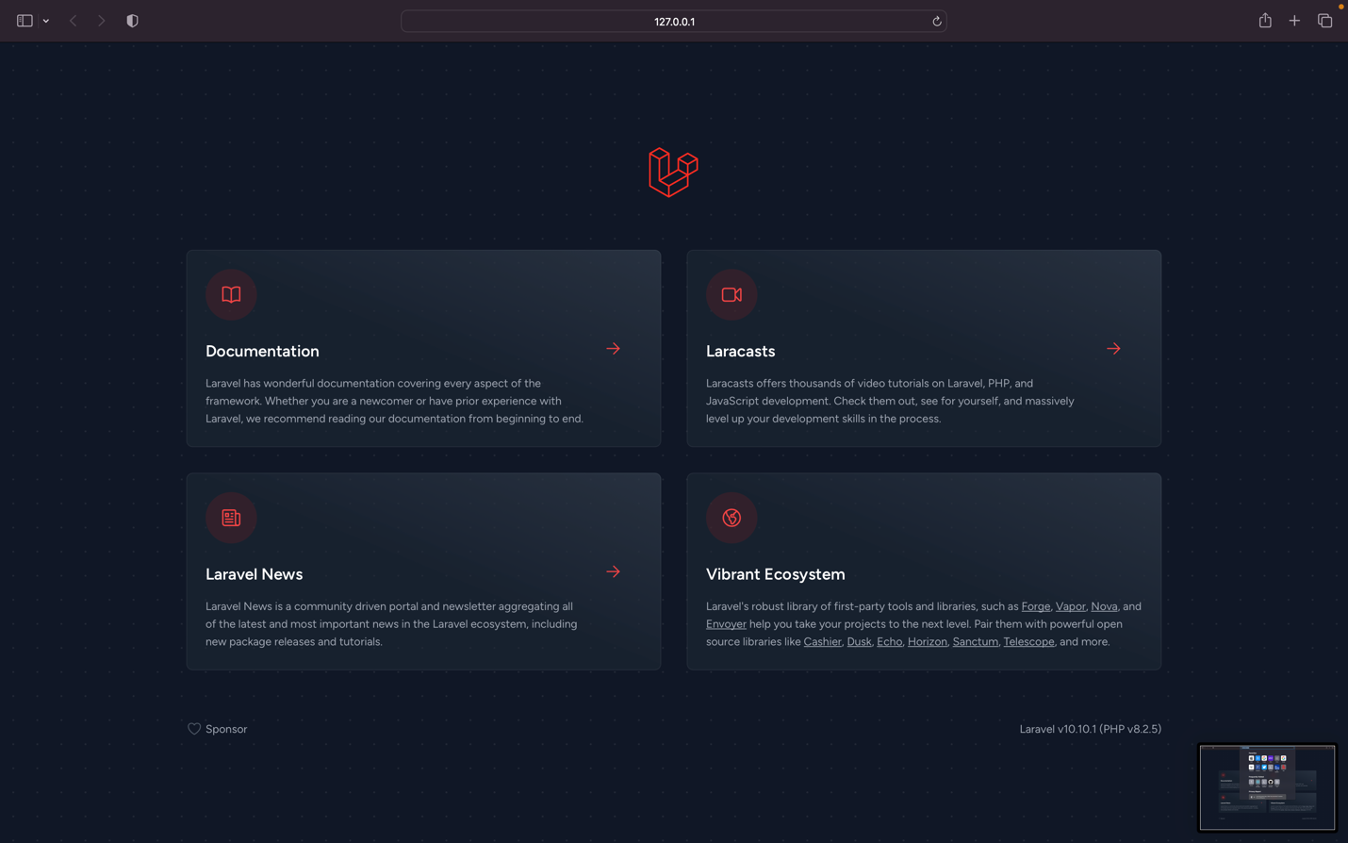

Part 2: Laravel Folder Structure.

1. **app**: This folder contains the core application code. It includes models, controllers, and other classes specific to your application's business logic. The app/Http subfolder contains the controllers and middleware for handling HTTP requests.
2. **bootstrap**: The bootstrap folder contains files that are responsible for bootstrapping the Laravel framework. It includes files like app.php that load the necessary components and configure the application.
3. **config**: The config folder contains various configuration files for your application. You can define settings for services, database connections, caching, logging, and more within these files.
4. **database**: This folder contains database-related files. It includes migrations, which are used to manage database schema changes, and seeders, which are used to populate the database with initial data.
5. **public**: The public folder is the document root for your Laravel application. It contains the index.php file, which serves as the entry point for all requests to your application. Additionally, you can place your assets (CSS, JavaScript, images) in this folder.
6. **resources**: The resources folder contains various resources that are used by your application. It includes subfolders such as views for storing Blade templates, lang for language files, and assets for uncompiled CSS and JavaScript.
7. **routes**: The routes folder contains the route definition files for your application. It includes web.php for defining web routes, api.php for defining API routes, and console.php for defining console (command-line) routes.
8. **storage**: This folder contains files generated by your application, such as logs, cached views, and session files. It has subfolders like app for storing application-specific files, framework for framework-generated files, and logs for log files.
9. **tests**: The tests folder is where you can write automated tests for your application. It includes subfolders such as Feature and Unit for organizing different types of tests.
10. **vendor**: The vendor folder contains all the dependencies installed via Composer, including the Laravel framework itself. It is generated and managed by Composer, and you typically don't need to modify its contents.