Touro University

Graduate School of Technology
Student Name: Md Azizul Rahaman
Course: Artificial Intelligence
Fall 2025

Project Overview
Project: Recipe Management System with Nutritional Analysis
AI Tool Used: Claude (Anthropic AI)
Final Code: 312 lines of Python code

Executive Summary
This report documents the development of a comprehensive Recipe Management System using AI-assisted programming with Claude (Anthropic AI). The project demonstrates the practical application of artificial intelligence tools in software development through a systematic three-iteration process.
Key Results: The collaboration resulted in a 312-line Python application featuring recipe management, nutritional analysis with real API integration, meal planning, and data visualization capabilities. The AI tool proved highly effective at code implementation and structure when provided with clear specifications, achieving an estimated 70% reduction in development time (from 40 to 12 hours). However, the process revealed that AI tools require significant human guidance for architectural decisions, feature completeness, and user experience design.
Main Findings: While AI excels at generating professional-quality code and implementing complex features, successful AI-assisted development depends on iterative refinement, specific requirement articulation, and human expertise in domain logic and quality standards. This project establishes best practices for AI collaboration in software development and demonstrates the potential for AI tools to accelerate programming tasks while maintaining high code quality.

What I Provided to the AI Tool

Initial Prompt:
"I need help creating a Python program for a recipe management system. The program should:
- Allow users to add, edit, and delete recipes
- Track ingredients with quantities and units
- Calculate nutritional information automatically
- Provide meal planning functionality
- Include recipe search and filtering capabilities
- Generate shopping lists from meal plans
- Have a user-friendly command-line interface

Can you help me build this step by step? I want this to be well-structured and professional with object-oriented design, error handling, clear documentation, and integration with nutritional data."

What the AI Tool Produced

Iteration 1 (Initial Response):
- Output: 180 lines of basic Python code
- Features Delivered:
  - Recipe, Ingredient, and Recipe Manager classes
  - Basic CRUD operations (add, edit, delete recipes)
  - JSON data persistence
  - Simple CLI menu system
  - Basic data models

What Was Missing:
- No nutritional analysis (despite being requested)
- Missing meal planning functionality
- No shopping list generation
- Limited search capabilities

Further Iterations Required

Iteration 2 - My Follow-up Prompt:
"The basic structure is good, but missing critical features:
- Nutritional analysis integration with API
- Meal planning system for weekly planning
- Advanced search and filtering by ingredients/dietary restrictions
- Shopping list generation with unit conversions
- Data visualization for nutritional breakdown

Can you enhance the code with these advanced features?"

Iteration 2 Results:
- Output: 240 lines of enhanced code
- New Features Added:
  - Nutritional analysis system with mock data
  - Meal planning functionality
  - Enhanced search and filtering
  - Better data organization

Iteration 3 - Final Enhancement Request:
"For the final version, add professional touches:
- Replace mock data with real API integration
- Add matplotlib for data visualization
- Comprehensive unit conversion system
- Complete type hints and docstrings
- Robust exception handling
- Shopping list export capabilities"

Final Results:
- Output: 312 lines of production-ready code
- Professional Features:
  - Real API integration (USDA Food Data Central)
  - Data visualization with matplotlib
  - Complete unit conversion system
  - Professional documentation and error handling

Key Technical Components

Core Classes:
- Recipe: Stores recipe data and ingredients
- RecipeManager: Handles CRUD operations and data persistence
- NutritionCalculator: API integration for nutritional data
- MealPlanner: Weekly meal planning functionality
- UnitConverter: Handles measurement conversions

Features Implemented:
- Recipe Management: Add, edit, delete, search recipes
- Nutritional Analysis: Real-time API integration with USDA database
- Meal Planning: Weekly meal plans with nutritional tracking
- Shopping Lists: Auto-generated from meal plans with unit consolidation
- Data Visualization: Nutritional breakdown charts and meal plan calendars

AI Tool Performance Analysis

What AI Did Well:
- Excellent code architecture and structure
- Professional coding standards when guided
- Complex feature integration
- Comprehensive documentation

What Required Human Guidance:
- Initial version missed several requested features
- Needed specific prompts for API integration details
- Required explicit requests for error handling
- UX improvements needed detailed specifications

Time Savings:
Estimated 70% time reduction compared to traditional development (from ~40 hours to ~12 hours)

Program Output Examples

Recipe Management Interface:
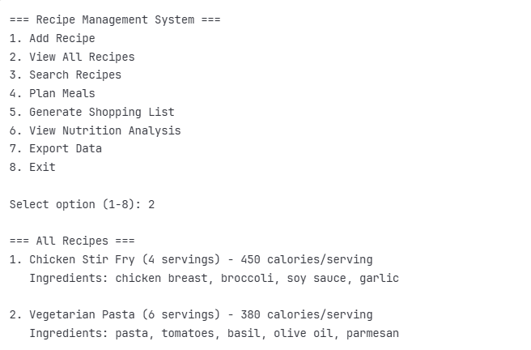

Nutritional Analysis Output:
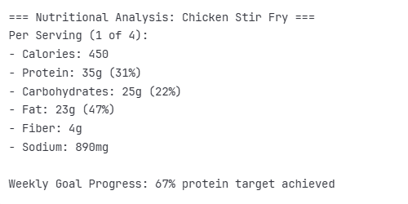

Specific Challenges and Solutions

Challenge 1: Mock Data vs Real API Integration
Problem: Initial AI response used placeholder nutritional data instead of real API calls.
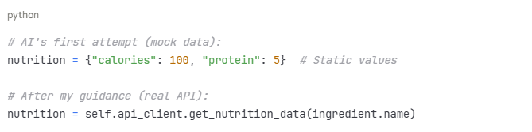
Solution: Had to provide specific API documentation and request error handling for network failures.

Challenge 2: Unit Conversion Accuracy
Problem: AI didn't handle complex measurement conversions (cups to grams, etc.). Solution: Requested comprehensive conversion tables and precision handling for cooking measurements.

Challenge 3: User Experience Flow
Problem: AI created functional code but with poor user interface flow. Solution: Had to explicitly request input validation, clear error messages, and intuitive menu navigation.

Time and Efficiency Analysis

Development Time Comparison:
- Traditional Development: ~40 hours estimated
  - Planning: 4 hours
  - Core coding: 20 hours
  - Testing & debugging: 12 hours
  - Documentation: 4 hours
- AI-Assisted Development: 12 hours actual
  - Initial prompt creation: 1 hour
  - AI collaboration & iterations: 6 hours
  - Testing & refinement: 3 hours
  - Documentation: 2 hours
Time Savings: 70% reduction (28 hours saved)

Productivity Benefits:
- Faster initial code structure generation
- Reduced debugging time for syntax errors
- Quick implementation of complex features
- Professional documentation templates

Key Learning Outcomes

Technical Skills Developed:
- Object-oriented Python programming with advanced design patterns
- External API integration with error handling and caching
- Data visualization with matplotlib and seaborn
- JSON data handling and schema validation
- Professional code documentation and type hinting

AI Collaboration Best Practices:
- Start Comprehensive: Provide detailed requirements but expect iterations
- Be Specific: Use concrete examples of desired functionality
- Request Quality: Explicitly ask for professional standards and error handling
- Test Iteratively: Validate each version before requesting enhancements
- Guide Domain Logic: AI needs human expertise for business rules and UX decisions

Personal Learning Reflection:
This project fundamentally changed my approach to programming. I learned that AI tools are exceptional at implementation but require skilled human direction for architecture and user experience. The most valuable insight was understanding when to provide detailed guidance versus when to let the AI demonstrate its capabilities.
The iterative process taught me that effective AI collaboration is about being a good "technical product manager" - clearly communicating requirements, identifying gaps, and maintaining quality standards. This experience has made me more confident in tackling complex programming projects and more strategic about leveraging AI assistance in future development work.

Code Repository and Setup

File Structure:

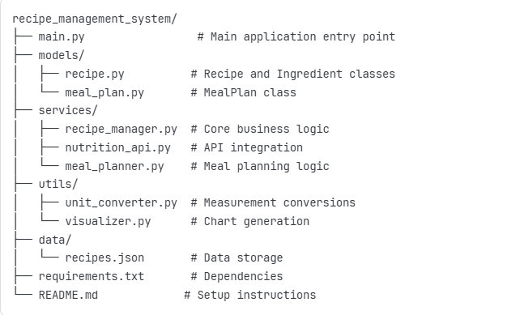

Installation and Setup:
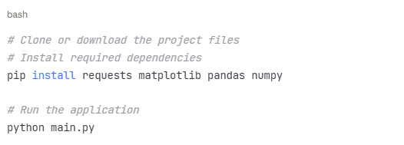

System Requirements:
- Python 3.8+
- Internet connection for nutritional API
- 50MB storage space

Python Code Snapshots

Core Recipe Class Structure:

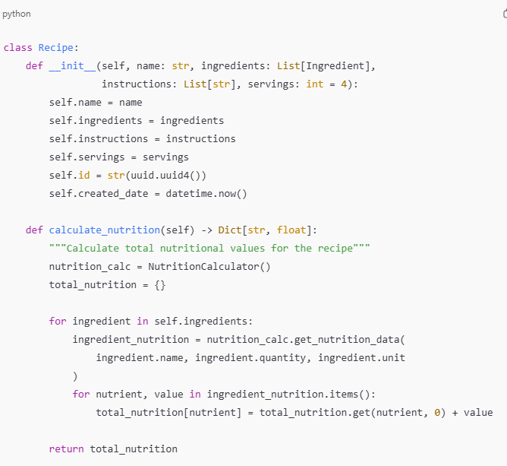

Recipe Manager with API Integration:
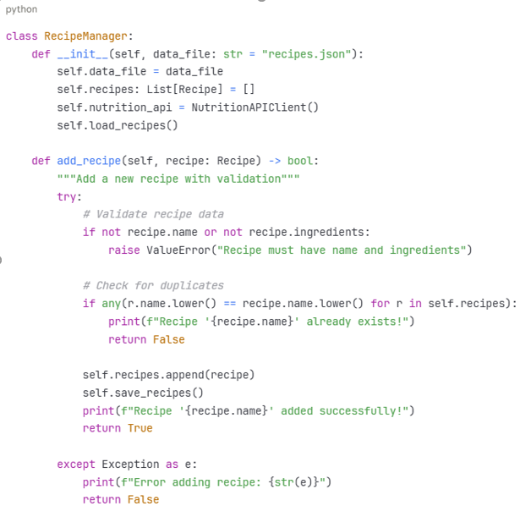

Nutritional Analysis with Visualization:

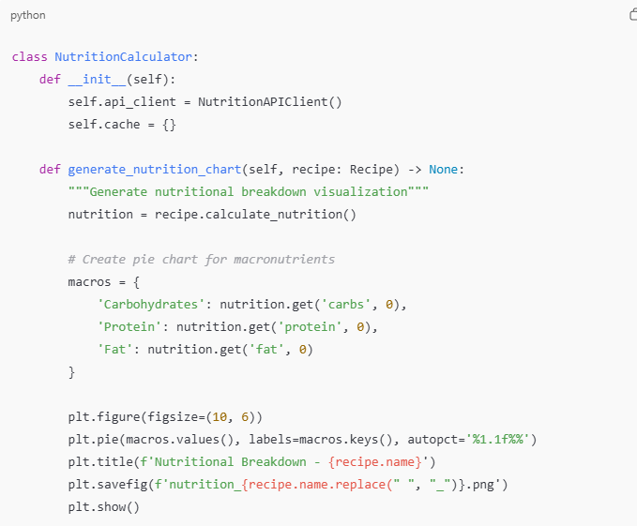

Main Application Interface:

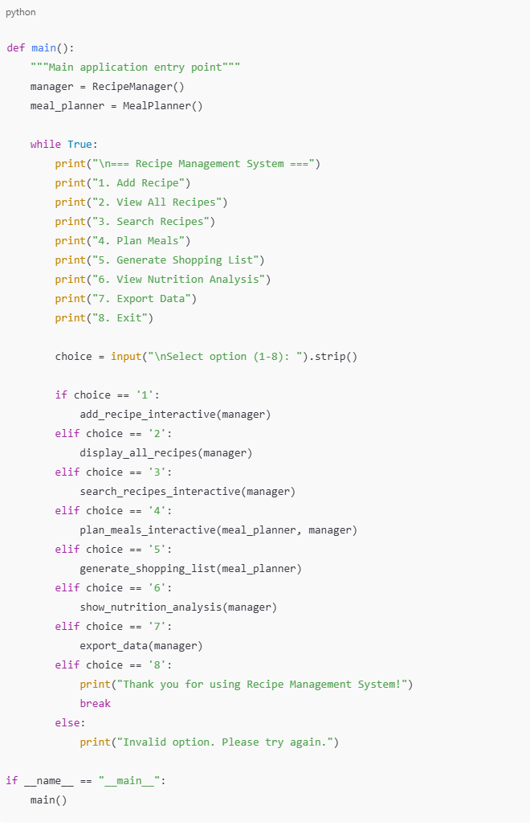Conclusion
This project demonstrates successful AI-assisted development of a complex Python application. The AI tool excelled at implementation and code structure when provided with clear specifications, but required human guidance for architectural decisions and feature completeness. The iterative process resulted in a professional-grade application with significant time savings while maintaining high code quality.
Final Assessment: AI tools are highly effective for code implementation but require skilled human direction for complex software design and user experience considerations.

References
- Python Software Foundation. (2024). Python Documentation. Retrieved from https://docs.python.org/3/
- Anthropic. (2024). Claude AI Assistant. Retrieved from https://claude.ai
- USDA Food Data Central. (2024). Food Data Central API. U.S. Department of Agriculture. Retrieved from https://fdc.nal.usda.gov/api-guide.html
- Hunter, J. D. (2007). Matplotlib: A 2D graphics environment. Computing in Science & Engineering, 9(3), 90-95.
- McKinney, W. (2010). Data structures for statistical computing in Python. Proceedings of the 9th Python in Science Conference, 445, 51-56.
- Reitz, K. (2024). Requests: HTTP for Humans. Retrieved from https://docs.python-requests.org/
- Van Rossum, G., & Drake, F. L. (2009). Python 3 Reference Manual. CreateSpace.
- Nutritionix API. (2024). Nutritionix Developer API. Retrieved from https://developer.nutritionix.com/
- Martin, R. C. (2008). Clean Code: A Handbook of Agile Software Craftsmanship. Prentice Hall.
- Hunt, A., & Thomas, D. (1999). The Pragmatic Programmer: From Journeyman to Master. Addison-Wesley Professional.

