**Enterprise Application Development**

**(Class-Tasks File)**



**Submitted By**

**Name: Azka Noreen**

**Roll no: BSEF19M502**

**Submitted To:**

**Engr. Fiaz Khan**

**Punjab University College of Information Technology**

**University of the Punjab**

**EAD Home Task#1**

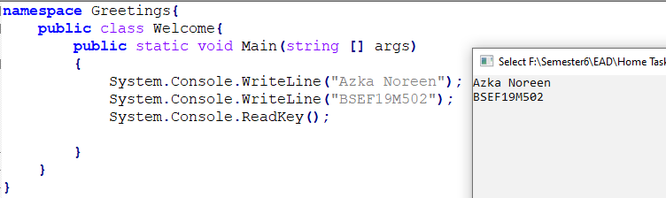

**EAD Home Task#2**

**Some Famous Personalities**

**Konrad Zuse**

Konrad Ernst Otto Zuse was a German civil engineer, pioneering computer scientist, inventor and businessman. His greatest achievement was the world's first programmable computer; the functional program-controlled Turing-complete Z3 became operational in May 1941.Plankalkül was the first high-level computer programming language to be designed.

**John Mauchly**

John Mauchly, in full John William Mauchly, (born August 30, 1907, [Cincinnati](https://www.britannica.com/place/Cincinnati), [Ohio](https://www.britannica.com/place/Ohio-state), U.S.—died January 8, 1980, Ambler, Pennsylvania), American physicist and engineer ,he designed [ENIAC](https://en.wikipedia.org/wiki/ENIAC), the first general-purpose electronic [digital computer](https://en.wikipedia.org/wiki/Digital_computer), as well as [EDVAC](https://en.wikipedia.org/wiki/EDVAC), [BINAC](https://en.wikipedia.org/wiki/BINAC) and [UNIVAC I](https://en.wikipedia.org/wiki/UNIVAC_I), the first commercial computer made in the [United States](https://en.wikipedia.org/wiki/United_States).

**John Warner Backus**

He directed the team that invented and implemented [FORTRAN](https://en.wikipedia.org/wiki/Fortran), the first widely used [high-level programming language](https://en.wikipedia.org/wiki/High-level_programming_language), and was the inventor of the [Backus–Naur form](https://en.wikipedia.org/wiki/Backus%E2%80%93Naur_form) (BNF), a widely used notation to define [formal language](https://en.wikipedia.org/wiki/Formal_language) [syntax](https://en.wikipedia.org/wiki/Syntax).

**Martin Richards**

Martin Richards  (born 21 July 1940) is a British [computer scientist](https://en.wikipedia.org/wiki/Computer_scientist) known for his development of the [BCPL](https://en.wikipedia.org/wiki/BCPL) [programming language](https://en.wikipedia.org/wiki/Programming_language)[[3]](https://en.wikipedia.org/wiki/Martin_Richards_(computer_scientist)#cite_note-3) which is both part of early research into [portable](https://en.wikipedia.org/wiki/Software_portability) [software](https://en.wikipedia.org/wiki/Software), and the ancestor of the [B programming language](https://en.wikipedia.org/wiki/B_(programming_language)) invented by [Ken Thompson](https://en.wikipedia.org/wiki/Ken_Thompson) in early versions of Unix and which [Dennis Ritchie](https://en.wikipedia.org/wiki/Dennis_Ritchie) in turn used as the basis of his widely used [C programming language](https://en.wikipedia.org/wiki/C_(programming_language)).

**Ken Thompson**

Kenneth Lane Thompson (born February 4, 1943) is an American pioneer of [computer science](https://en.wikipedia.org/wiki/Computer_science). Thompson worked at [Bell Labs](https://en.wikipedia.org/wiki/Bell_Labs) for most of his career where he designed and implemented the original [Unix](https://en.wikipedia.org/wiki/Unix) operating system. He also invented the [B programming language](https://en.wikipedia.org/wiki/B_(programming_language)),

**Dennis Ritchie**

Dennis MacAlistair Ritchie (September 9, 1941 – c. October 12, 2011) was an American [computer scientist](https://en.wikipedia.org/wiki/Computer_science).[[1]](https://en.wikipedia.org/wiki/Dennis_Ritchie#cite_note-NYTimes-1) He created the [C programming language](https://en.wikipedia.org/wiki/C_(programming_language)) and, with long-time colleague [Ken Thompson](https://en.wikipedia.org/wiki/Ken_Thompson), the [Unix](https://en.wikipedia.org/wiki/Unix) [operating system](https://en.wikipedia.org/wiki/Operating_system) and [B programming language](https://en.wikipedia.org/wiki/B_(programming_language)).[[1]](https://en.wikipedia.org/wiki/Dennis_Ritchie#cite_note-NYTimes-1) Ritchie and Thompson were awarded the [Turing Award](https://en.wikipedia.org/wiki/Turing_Award) from the [ACM](https://en.wikipedia.org/wiki/Association_for_Computing_Machinery) in 1983, the [Hamming Medal](https://en.wikipedia.org/wiki/IEEE_Richard_W._Hamming_Medal) from the [IEEE](https://en.wikipedia.org/wiki/Institute_of_Electrical_and_Electronics_Engineers) in 1990 and the [National Medal of Technology](https://en.wikipedia.org/wiki/National_Medal_of_Technology) from [President Bill Clinton](https://en.wikipedia.org/wiki/Bill_Clinton) in 1999.

**Alan Kay**

Alan Curtis Kay is an American computer scientist. He has been elected a Fellow of the American Academy of Arts and Sciences, the National Academy of Engineering, and the Royal Society of Arts. He is best known for his pioneering work on object-oriented programming and windowing graphical user interface design

**Bjarne Stroustrup**

Bjarne Stroustrup is a Danish computer scientist, most notable for the invention and development of the C++ programming language. He is a visiting professor at Columbia University, and works at Morgan Stanley as a managing director in New York.

**James Gosling**

James Gosling, often referred to as "Dr. Java," OC is a Canadian computer scientist, best known as the founder and lead designer behind the Java programming language

**Anders Hejlsberg**

Anders Hejlsberg is a Danish software engineer who co-designed several programming languages and development tools. He was the original author of Turbo Pascal and the chief architect of Delphi. He currently works for Microsoft as the lead architect of C# and core developer on TypeScript.

**EAD Home Task#3**

**Main.cs**

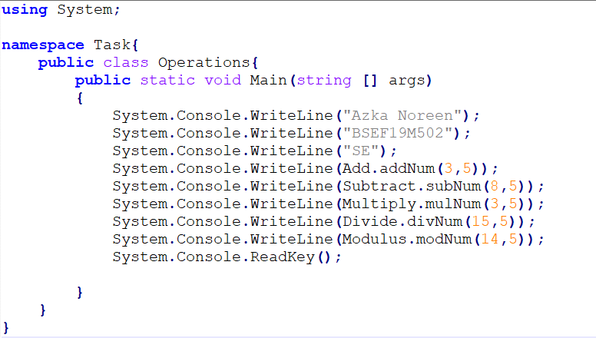

**add.cs**

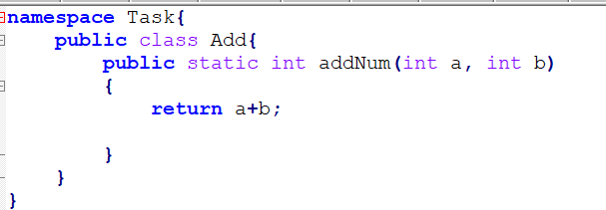

**sub.cs**

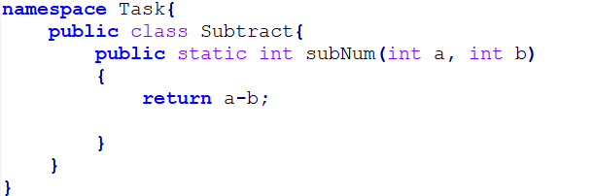

**mul.cs**

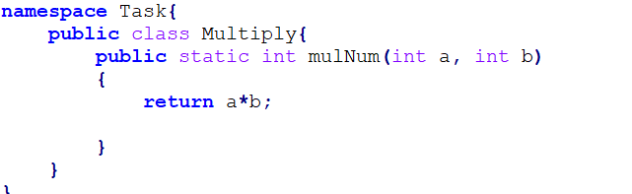

**div.cs**

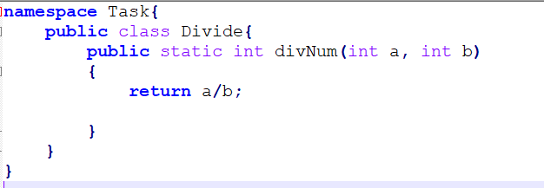

**mod.cs**

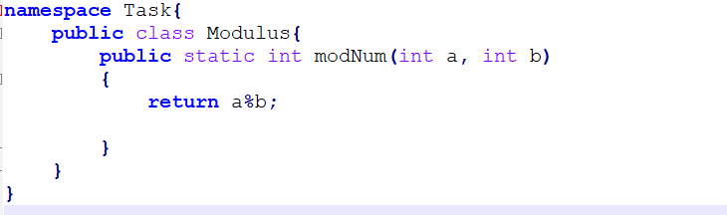

**Before compiling**

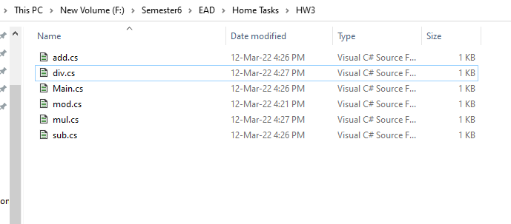

**Compilation**

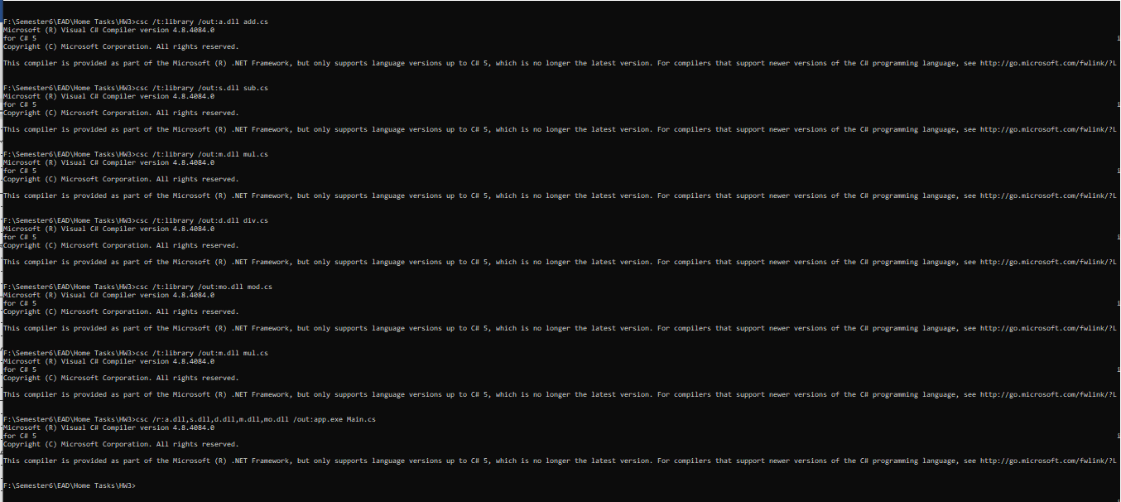

**After compilation**

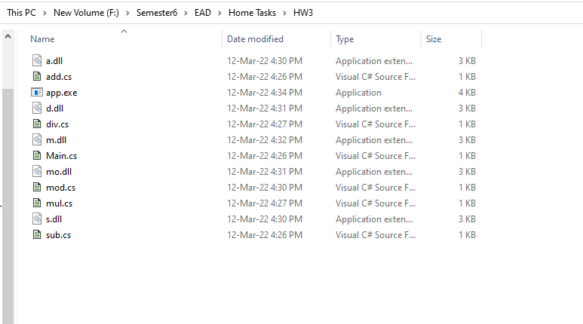

**Output:**

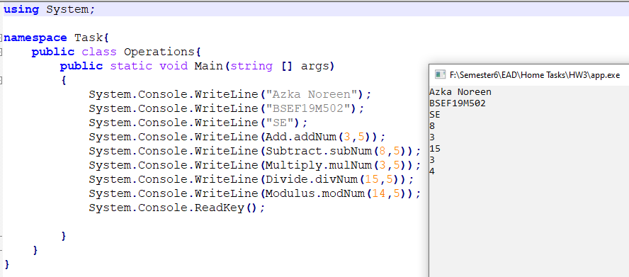

**EAD Home Task#4**

**Name Space**

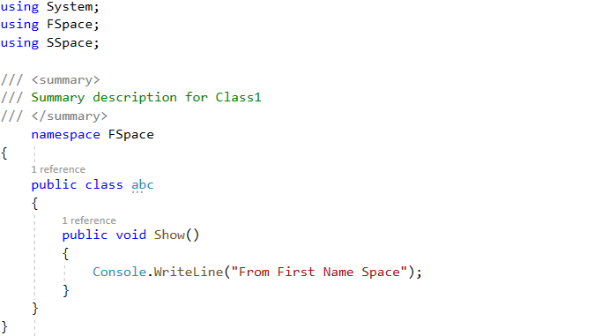

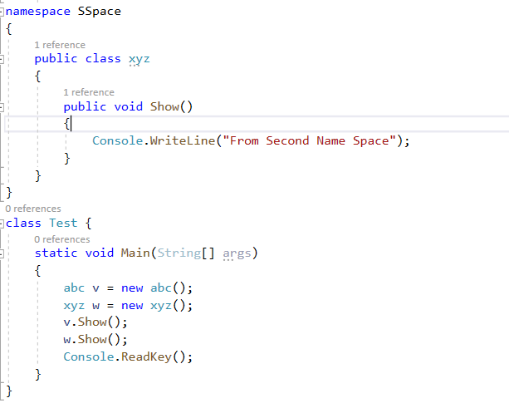

**Output**

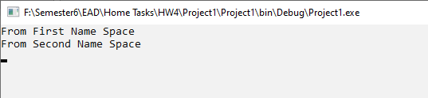

**Nested Name Space(1)**

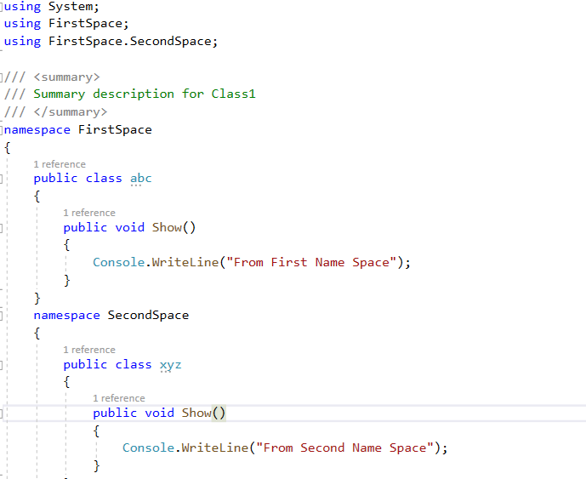

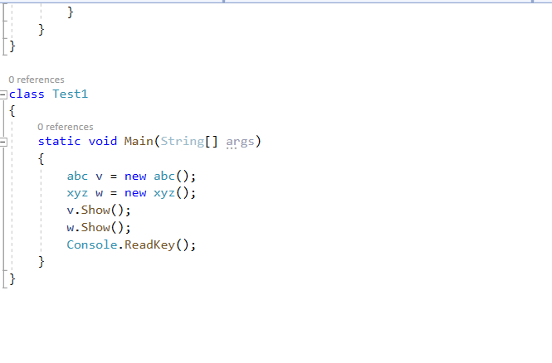



**Nested Name Space(2)**

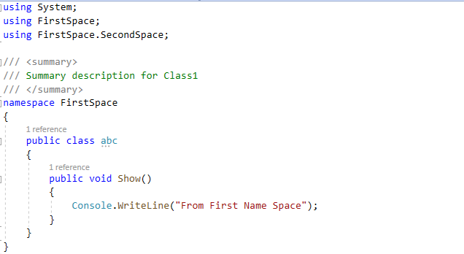

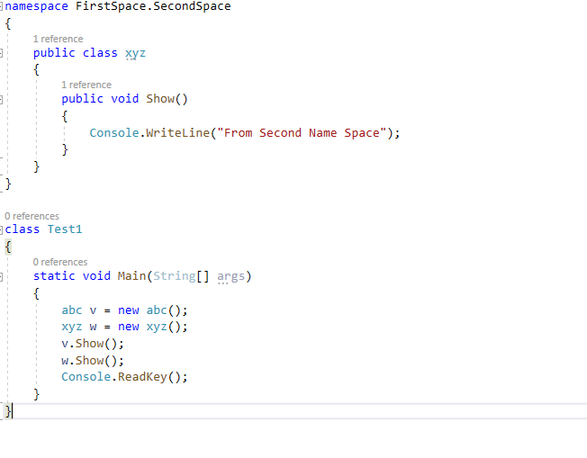



**Boxing and Unboxing**

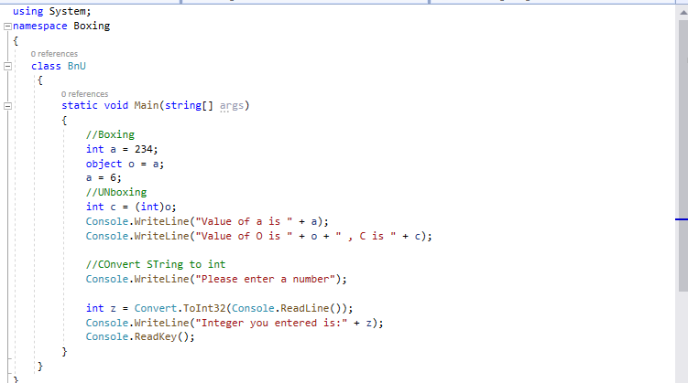

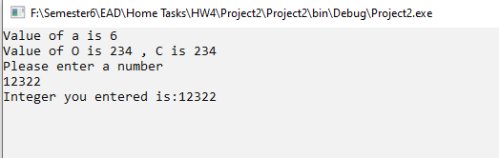

**EAD Home Task#5**

**Business Object**

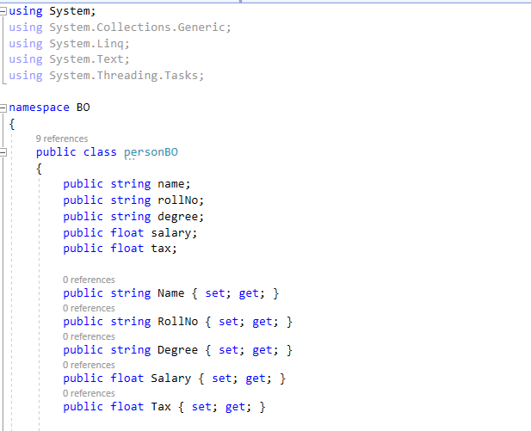

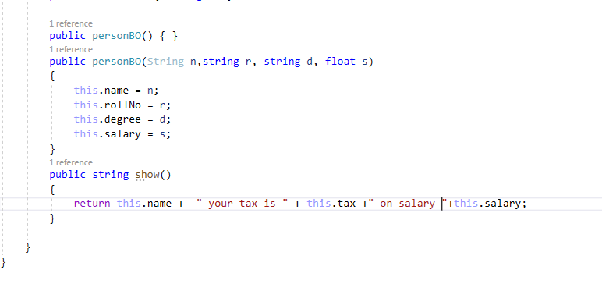

**DATA ACCESS LAYER  
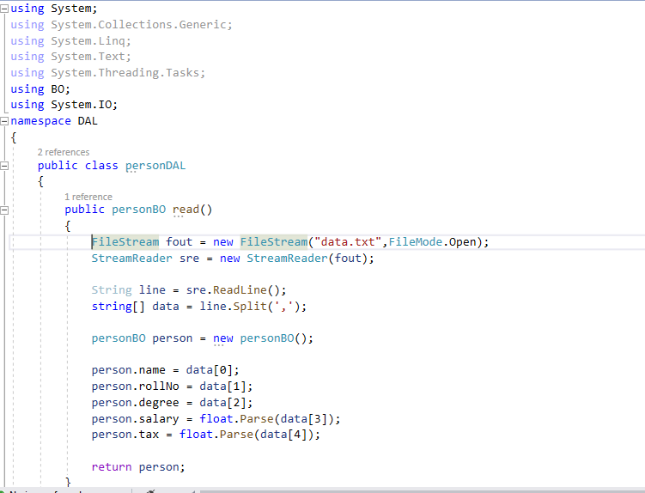**

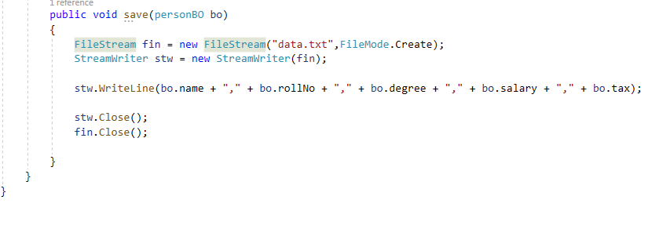

**Business Logic Layer**

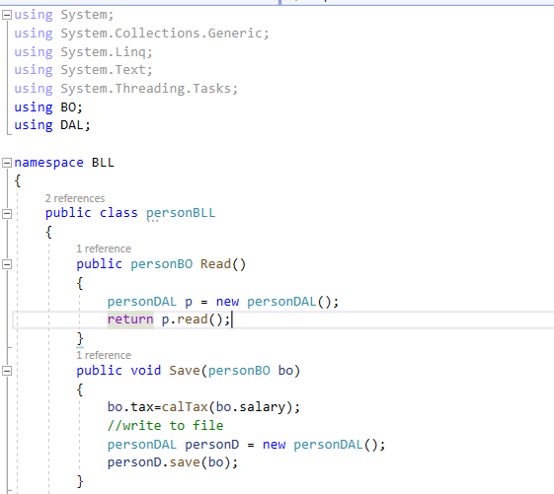

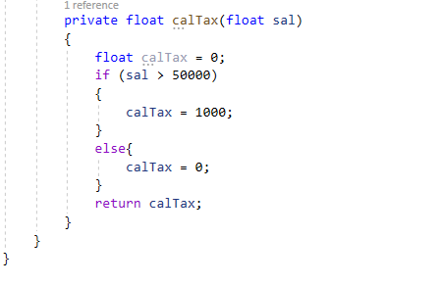

**VIEW**

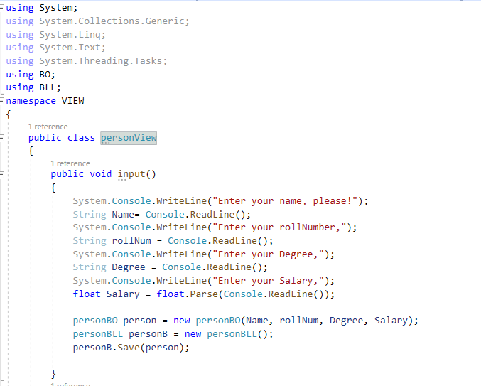

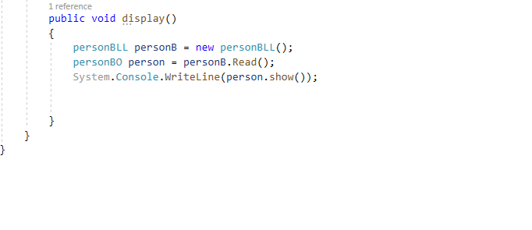

**Main program**

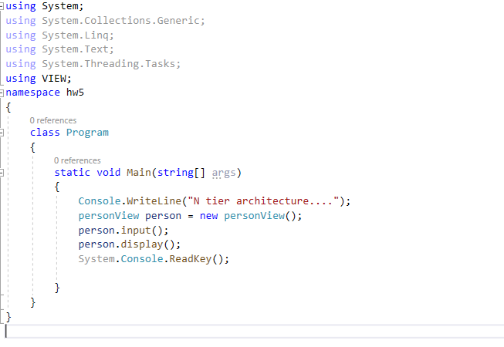

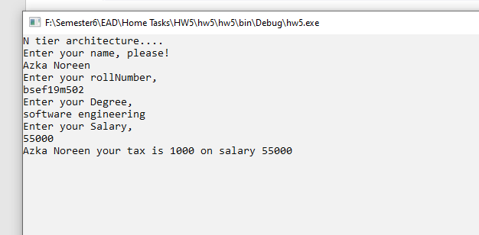

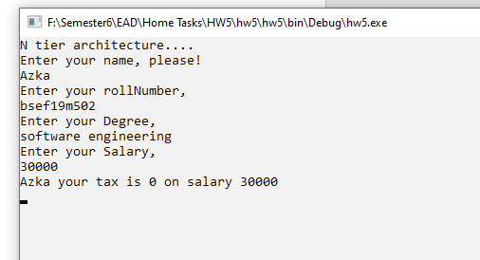

**EAD Home Task#6**

**Connected Model**

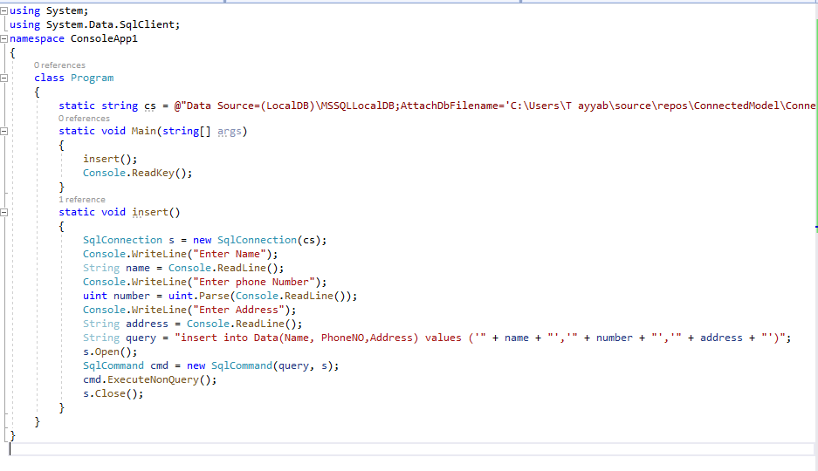

Database after execution:

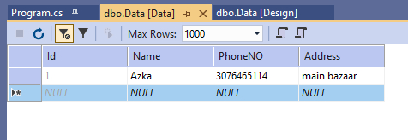

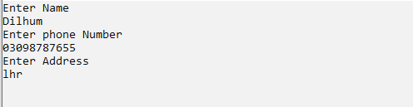

Database after execution:

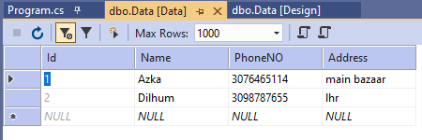

**EAD Home Task#7**

**BSEF19M502-AZKA NOREEN**

**WPF**

# **Text to Speech**

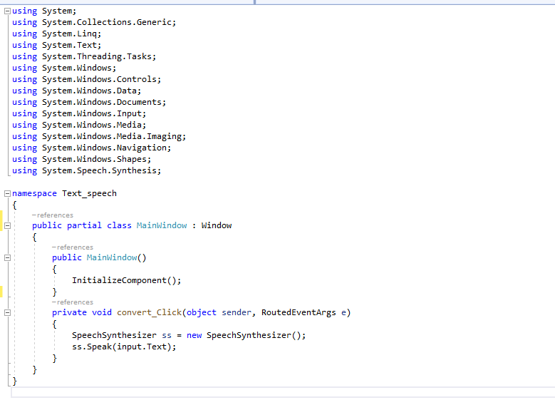

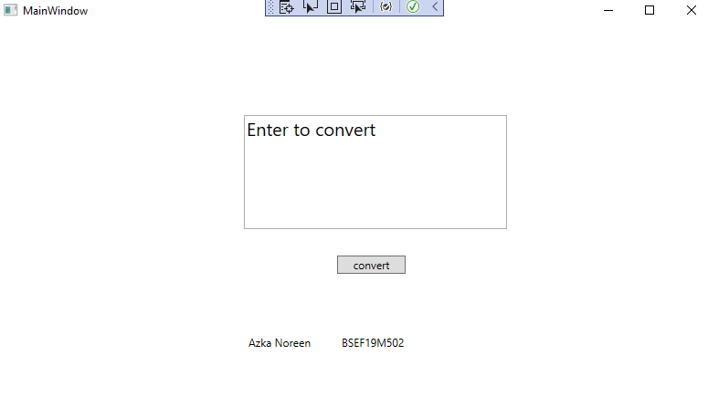

# **Message Box**

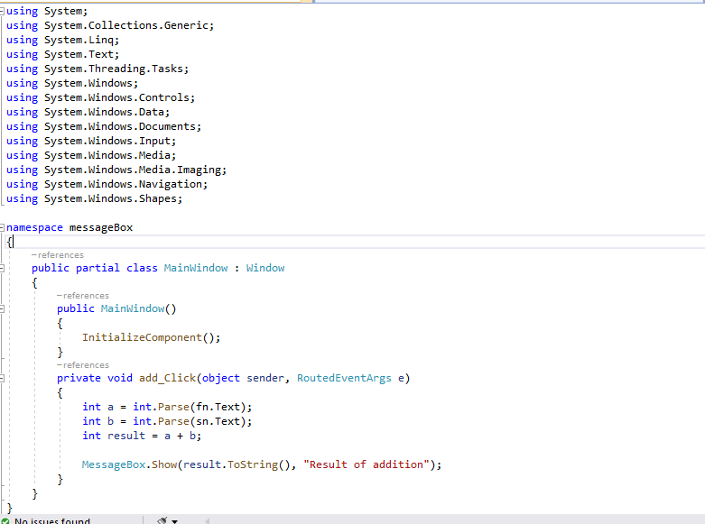

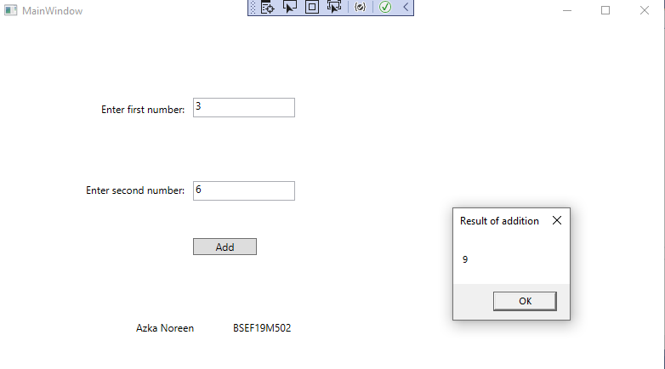

# **Web browser**

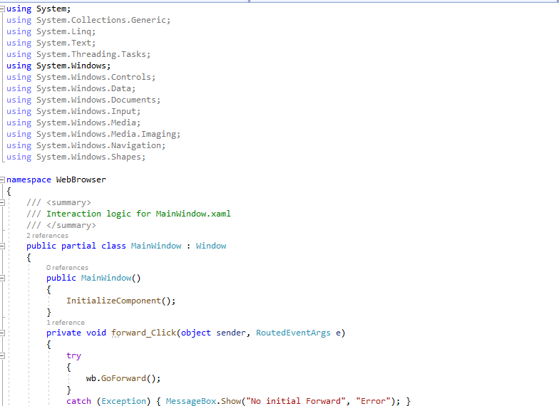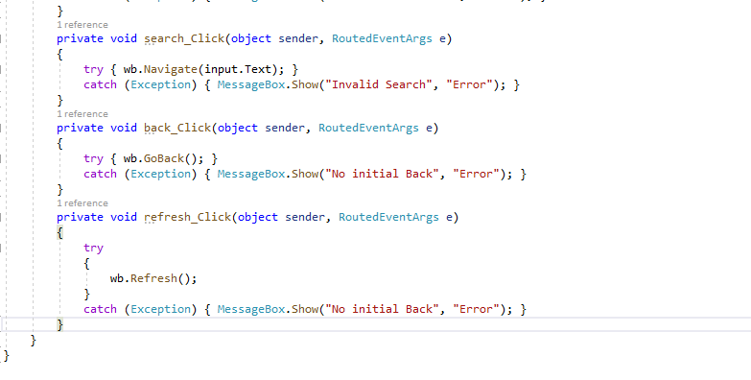

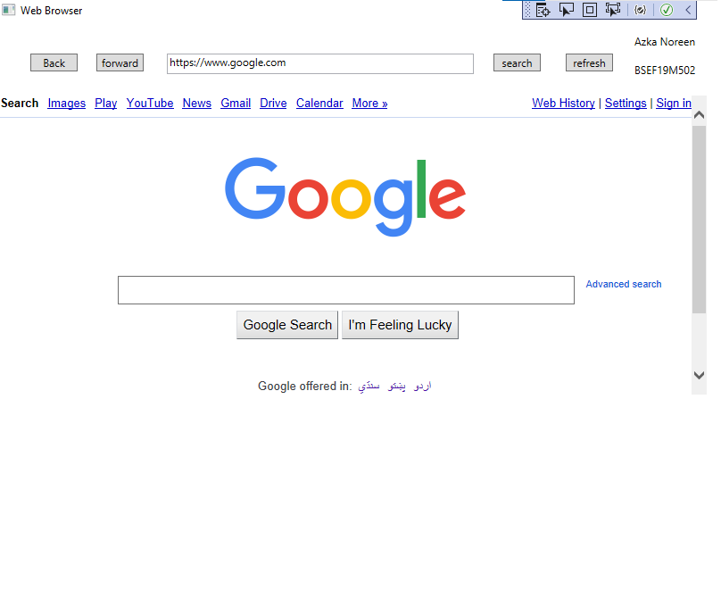

# **Calculator**

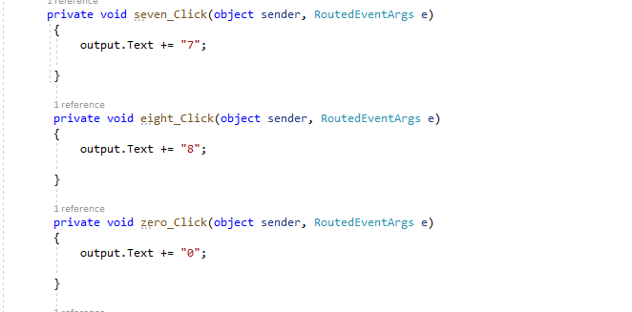 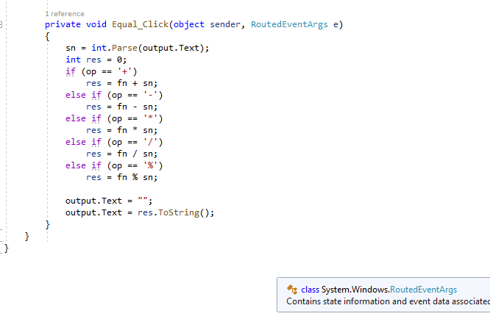 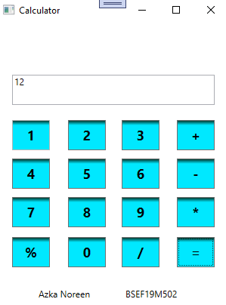

**EAD Home Task#8**

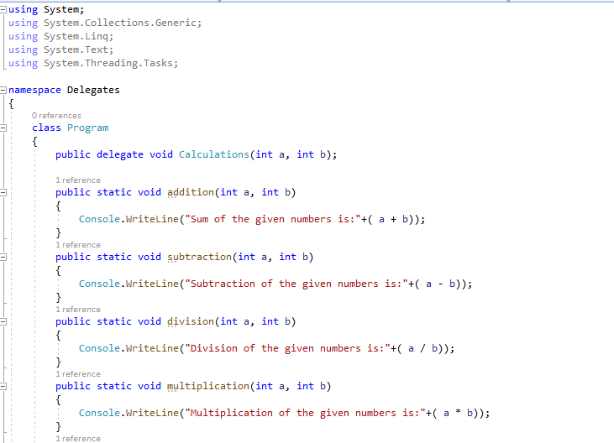

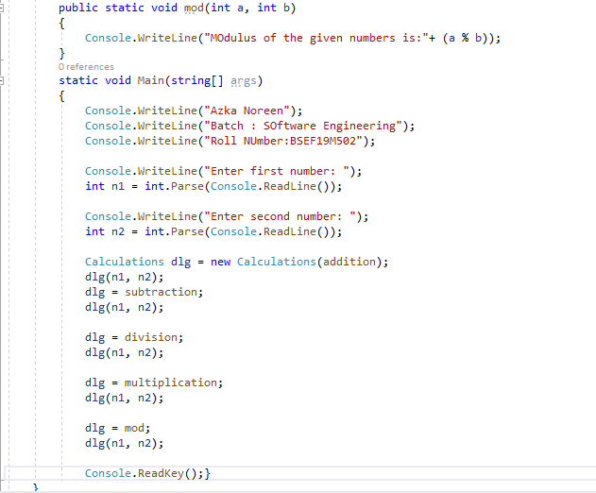

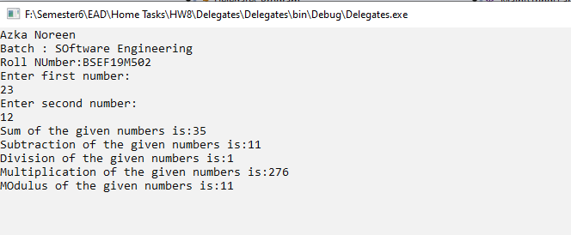

**EAD Home Task#09**

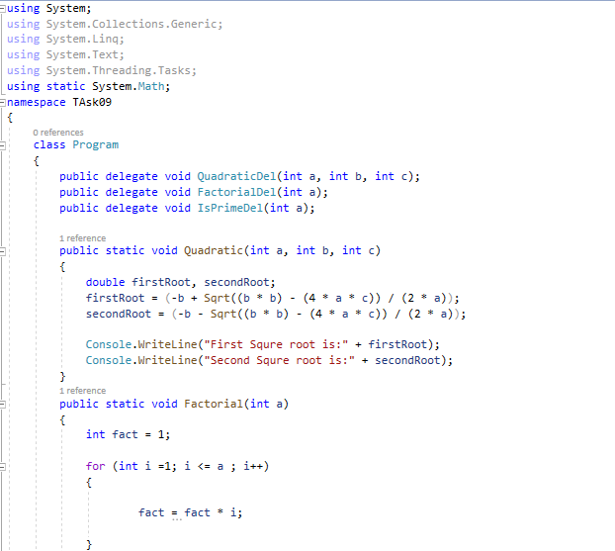 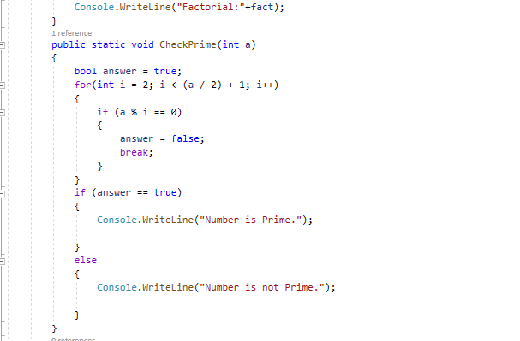

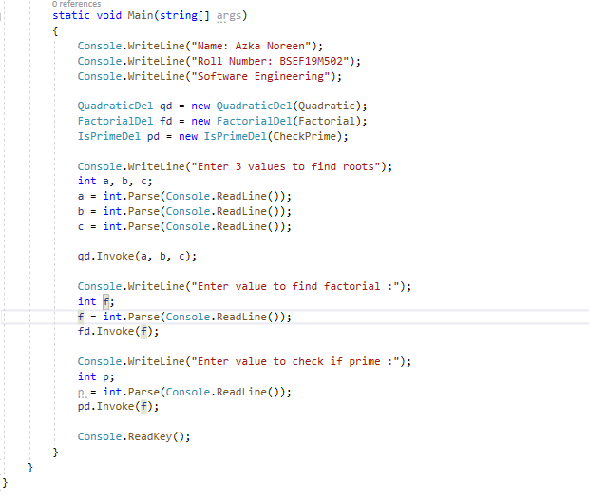

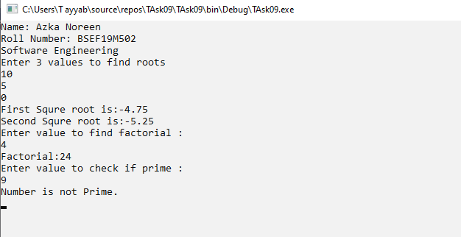

**EAD Home Task#10**

**Task 1:**

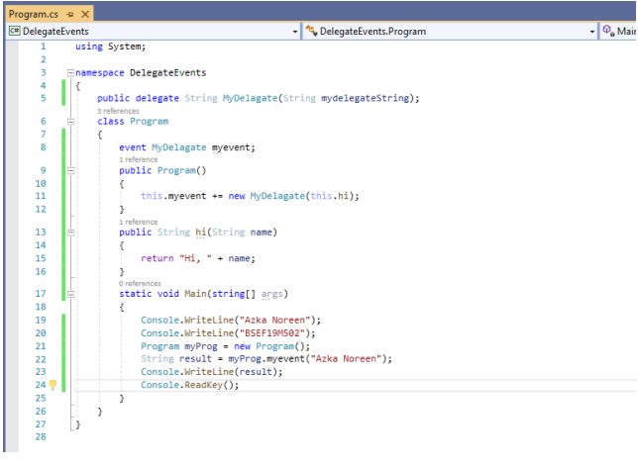

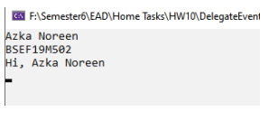

**Task 2:**

