

**Name: Azka Noreen**

**Roll no: BSEF19M502**

**Subject: EAD**

**Topic: Connected Model**

**Program: Software Engineering**

**Section: Morning**

**Batch: F19**

**Submitted to: Sir Fiaz**

**Punjab University College of Information Technology**

**University of the Punjab**

# **Task 01**

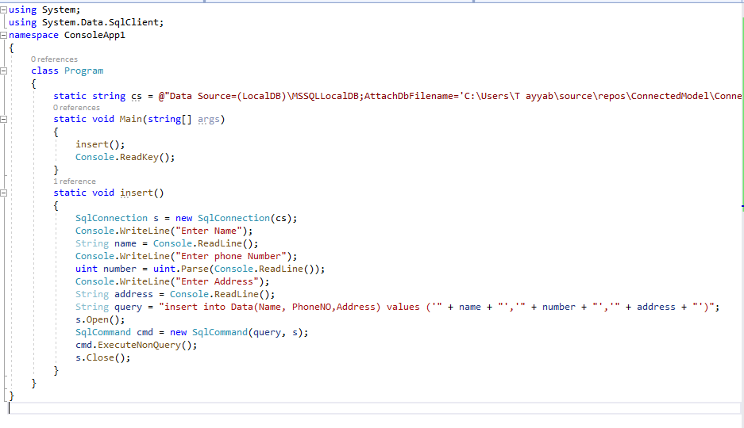

Database after execution:

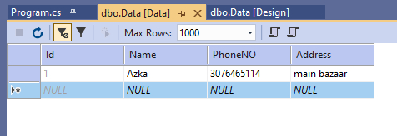

: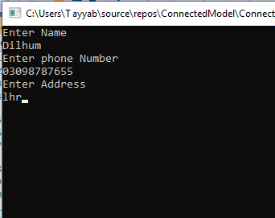

Database after execution:

