# National_University_of_Computer_and_Emerging_Sciences_logo.png

# GROUP MEMBERS:

1. 19I-0597 AZKA ALI
2. 19I-0733 ZAIN HAFEEZ
3. 19I-1975 HAMMAD HAMEED

## SECTION: C

## INSTRUCTOR: MS. SABA RASHEED MALIK

# Machines Specification:

1. struct LinkedList specifies the circular linked list of machines.

Each node contains the following components:

string data\_1, key\_val;

int machine\_ip;

avl\_node avl\_p;

DLL rt;

1. functions related to machines:
2. void assign\_machine\_id(int\* machine\_id, int s)

assigns ids to machines

1. void insert(int ins\_id, string data\_1\_id, string value, int s, int\* machine\_id, int id\_space, int machine\_entry)
2. void display(int n) prints the machine’s data
3. long long polynomialRollingHash

this function performs the hashing algorithm.

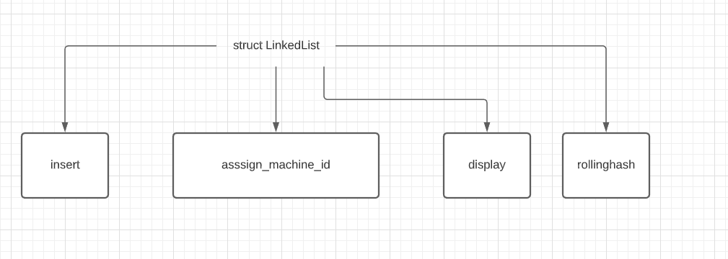

# AVL Tree:

Data on AVL tree is inserted from machines

1. It has a root node named avl\_node\* root
2. The utility functions linked with avl tree are:
3. Height: to calculate height with respect to a given node
4. Diff : to calculate height difference between left and right subtree
5. Balance: to balance whenever an imbalance exists using one of the following functions:
6. ll\_rotation
7. rr\_rotation
8. lr\_rotation
9. rl\_rotation
10. insert function: to insert new nodes
11. display functions: namely: display, inorder,postorder,preorder.

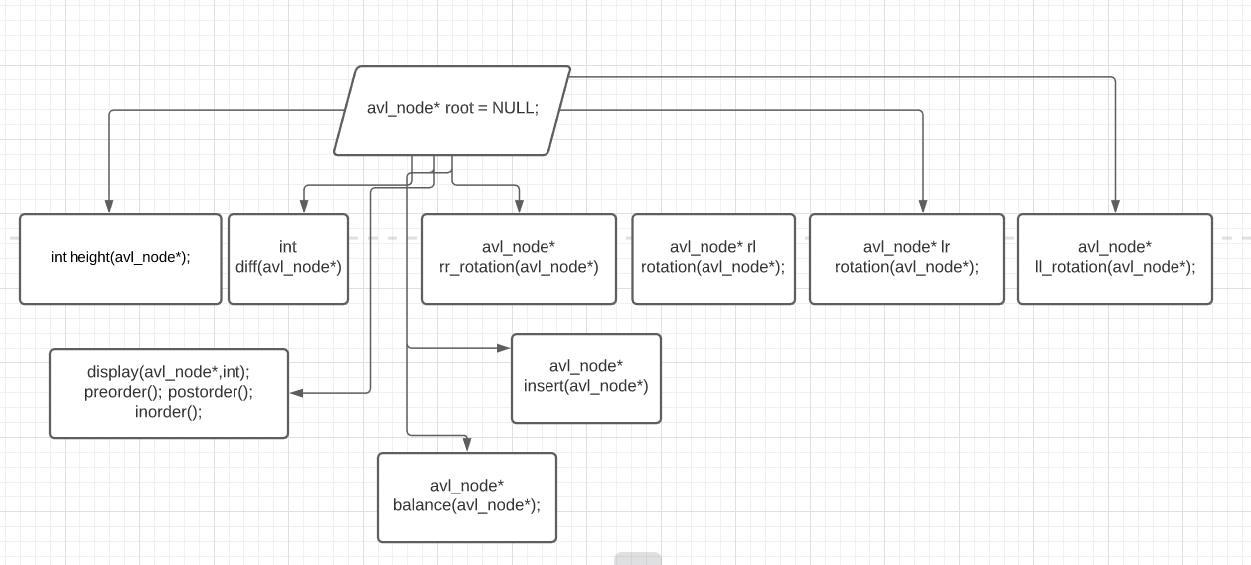

# Class DLL:

Class dll maintains the functionality of routing tables and contains a utility function to insert data:

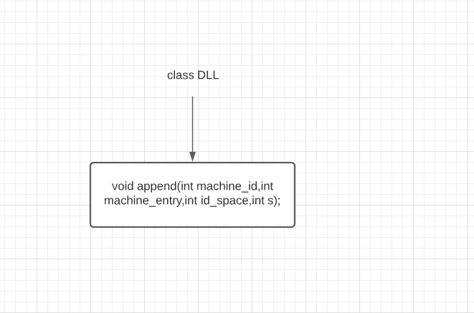

# CLASS DIAGRAM:

