AI Ethics & Responsible Usage Declaration
I hereby declare that:
- The dataset used in this assignment is properly cited and ethically sourced.
- I have analyzed potential biases present in the dataset and model.
- I have considered privacy implications related to the data used.
- I understand the responsible and ethical usage of the developed system/model.
- This work adheres to institutional guidelines on ethical AI practices.

Dataset Details:
Source: NSE Historical Data (National Stock Exchange of India)
Type of Data: Public Stock Market Time-Series Data (Daily Historical Closing Prices)
Contains Personal/Sensitive Data? (Yes/No): No
If Yes, describe anonymization steps: Not Applicable

Identified Bias (if any):

The model may exhibit model bias due to its reliance on historical price data alone, without considering external factors such as market news, economic conditions, or company-specific events. Additionally, ARIMA assumes that past patterns will continue into the future, which may not always hold true in volatile stock markets. As a result, the model may produce stable forecasts even when real-world prices experience sudden changes, leading to potential underestimation of variability.

Responsible Usage Statement:
This project is developed for academic purposes to demonstrate the application of time series analysis and ARIMA modeling on stock price data. The results are intended for learning and analytical understanding only, and should not be used for real-world financial or investment decision-making.

Student Details:
Student Name: Azka Dalvi
UIN: 242A001
Course: Artificial Intelligence & Data Science
Date: 19/04/2026
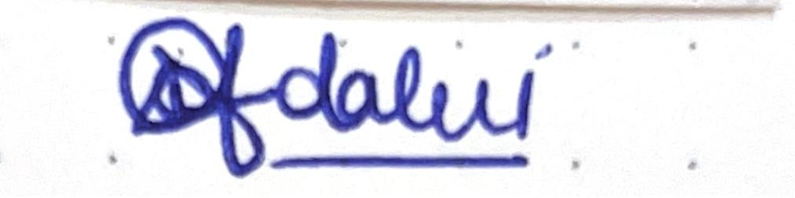
Signature:

