Trust the Report or Check the Artifact? Provenance-Aware Oversight of Falsely Independent Reports in Multi-Agent LLM Systems - Full Technical Report
Mochamad Azmi Rizkulloh. Swarm Alignment Hackathon, 6-8 November 2026 (main track: Track 4, Multi-Agent Oversight and Control; supporting tests for Tracks 1-3).

Abstract
Multi-agent LLM systems can produce reports that look independent while sharing or copying evidence. We ask what an overseer must inspect to notice: the reports, the artifacts, or a provenance record of how the reports were made. We built a controlled testbed in which real LLM agents (Gemma 4 31B) write evidence reports from the author's own course materials, while a controller creates scenarios with known ground truth for three separate targets: copying, non-independent evidence, and a false provenance claim. Honest twin sources, near-duplicates and a no-source control keep similarity from being mistaken for misconduct. Over 5 replicates (410 pooled test scenarios, thresholds set at a 5% false-alarm target on disjoint topics), an LLM reading reports only recovered 38% of copies, and only 6% of paraphrased copies that falsely claimed independence. Research similarity formulas used alone (STP, STP-AR, MOI, RCC-v3.3, Argon) were close to chance (AUROC 0.48 to 0.65). Checking claims against the cited source raised AUROC to 0.99, and adding a hash-chained provenance ledger gave recall 1.00 and Brier 0.001 with a complete log, degrading gracefully as events were removed. Results rest on one generator model, instructed agents and a controller-written ledger, so the ledger results are an upper bound.

1. Research background and problem
Multi-agent LLM systems are usually supervised through what agents say about themselves. A report can claim independent evidence while the content was copied from another agent, or while both agents used the same document. Identical content does not prove copying, because honest agents can cite different publications with the same text. The problem is therefore to decide what an overseer must inspect, and which signals separate copying, shared evidence and false provenance claims.

2. Objectives, research questions, contributions
- RQ1: Does reading reports suffice to detect copying, non-independent evidence and false provenance claims?
- RQ2: Do research similarity formulas (STP, STP-AR, MOI, RCC-v3.3, Argon) improve oversight over lexical and embedding baselines?
- RQ3: Do claim-versus-cited-source checks and a provenance ledger improve detection, and how does the ledger degrade when events are missing?
- RQ4: Which monitors raise false alarms on honest twin sources and on a no-source control?
Contributions: a controlled testbed with real LLM agents on course texts; three separately labelled targets; a monitor comparison with Brier scores and cluster-aware intervals; an audited pipeline (an earlier scripted-bot pilot exposed a hash non-determinism bug and an honest-twin control that lowered the original claim).

3. Related work
AI control evaluates trusted monitoring of untrusted models (Greenblatt et al., 2024). Multi-agent risk taxonomies (Hammond et al., 2025) and failure taxonomies (Cemri et al., 2025) motivate inter-agent oversight; secret collusion studies hidden coordination (Motwani et al., 2024). Attribution evaluation (Rashkin et al., 2021; Gao et al., 2023) relates claims to cited sources. Agent infrastructure (Chan et al., 2025) motivates identifiers and attribution; tamper-evident logging (Crosby and Wallach, 2009) motivates the hash chain. Collective bias in LLM populations (Ashery et al., 2025) shows that group behaviour can differ from individual behaviour. References marked VERIFIED or PARTIAL in 01_SOURCE_AUDIT/LITERATURE_CANDIDATES.md are the only ones used.

4. System architecture
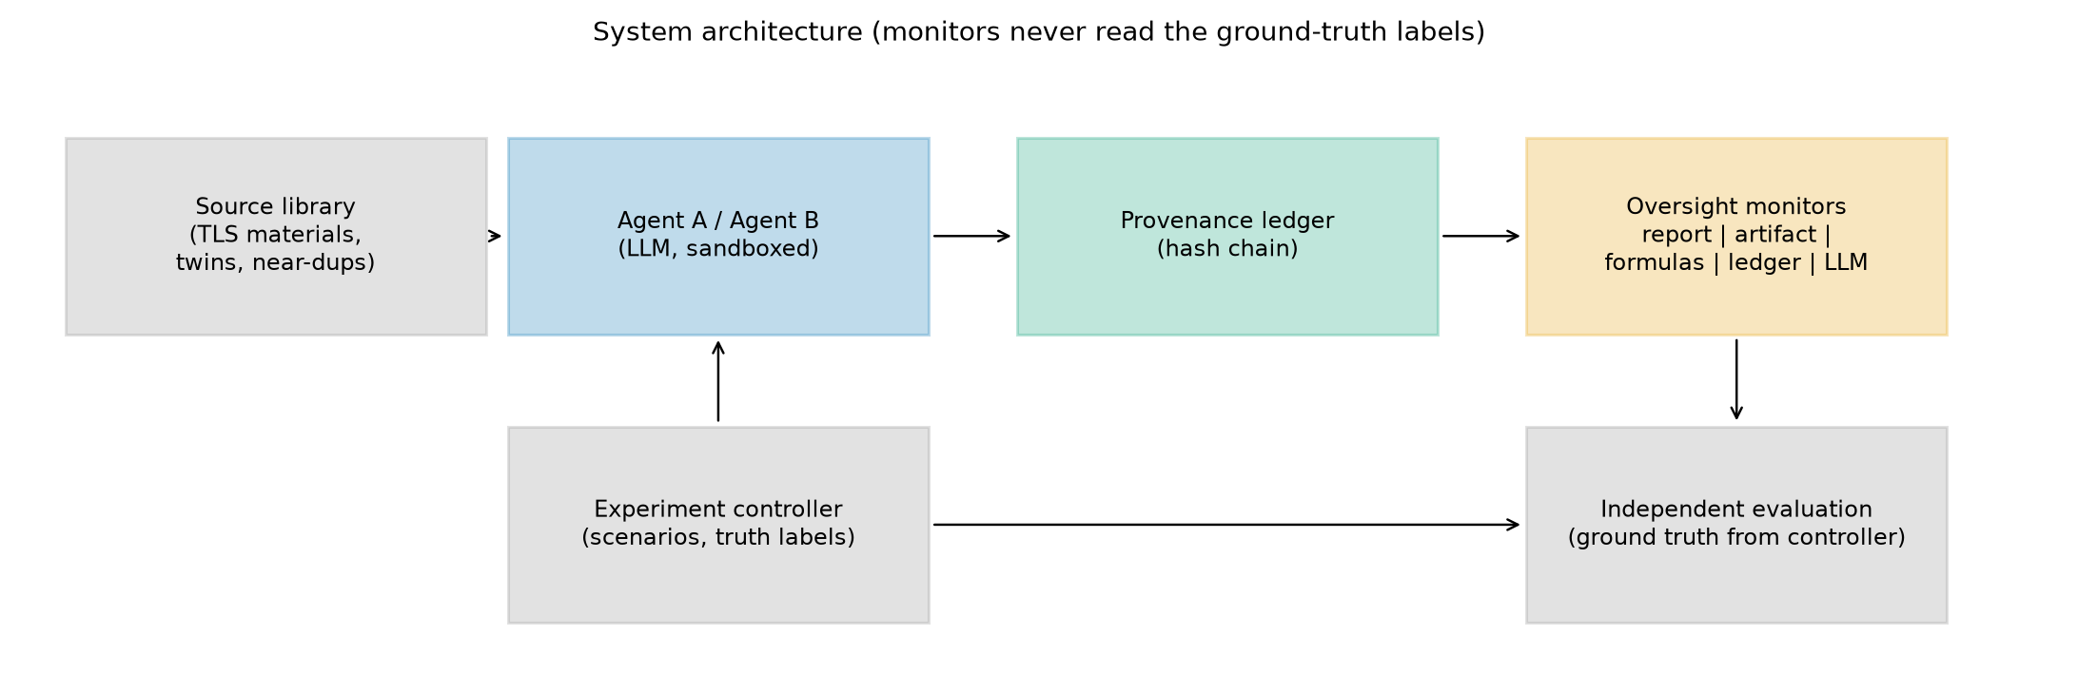
System architecture: the controller builds scenarios and holds the ground truth; monitors never read the labels.

5. Experimental environment and GPU
Measured device: NVIDIA GeForce RTX 3050 Laptop GPU, 4096 MiB, driver 610.74, PyTorch 2.6.0+cu124 (the brief assumed an RTX 2060). Embeddings (embeddinggemma-2:740m, 768-d) ran on the local GPU through Ollama 0.40.14 (utilisation mean 5%, peak 89%, VRAM peak 1.6 GB, maximum temperature 60 C, no thermal events). The agents and LLM monitors (Gemma 4 31B, remote Ollama cloud) did not use the local GPU. Formulas, ledger and statistics ran on the CPU. See 02_GPU_ENVIRONMENT/GPU_EXECUTION_REPORT.md.
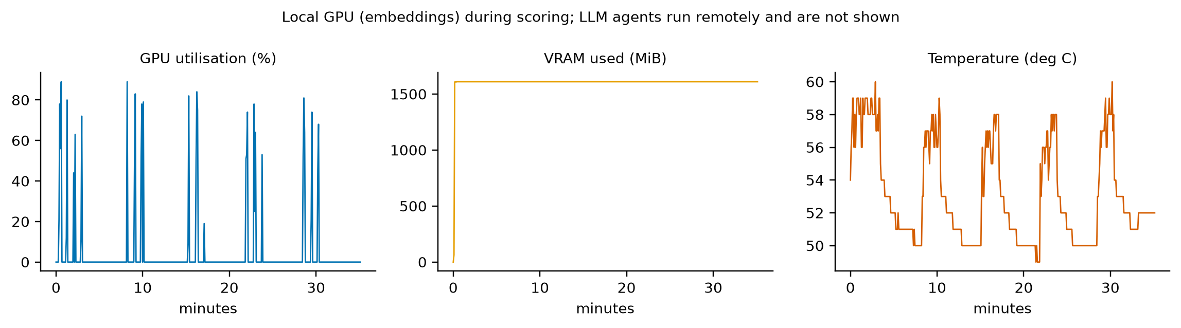
Local GPU during scoring (embeddings only).

6. Agent selection and bot inventory
The earlier 69-bot inventory was audited (BOT_REGISTRY.csv): 22 are briefs only, 17 and 13 are rule-based tool modules, 10 are orchestration modules, 4 hand off to external models and 3 need an external API; 3 are candidate tool or evaluator modules and none is an LLM agent. Selection used capability and relevance criteria, not test performance. In this study the agents are Gemma 4 31B instances with separate contexts (same model, so independence of the agents is limited to context), and the oversight roles (provenance, formula analysis, oversight) are software components.

7. Mathematical formulas
Sentence embeddings U_A, U_B (claims) and W_A, W_B (method sentences) are unit vectors. g(X) is the geometric median (Weiszfeld iteration). Frozen preexisting formulas:
STP(A,B) = clip[0,1] < g(U_A)/|g(U_A)| , g(U_B)/|g(U_B)| > (1)
STP-AR = STP / (1 + k sigma_boot), k = 2, sigma_boot = sd of STP over B = 25 bootstrap resamples (2)
MOI(A,B) = clip[0,1] < mu(W_A), mu(W_B) >, mu(W) = mean(W)/|mean(W)|; S_base = 0.5 STP-AR + 0.5 MOI (3)
RCC: SER = exp(-sum p_i ln p_i), p_i = nu_i / sum nu_l (eigenvalues of X X^T); kappa = exp(-10 m), m = clip((SER/n - 1/n)/(1 - 1/n)) (4)
gamma = 1/(1 + exp(-20 (kappa - 0.85))), lambda = 0.5 gamma, c = normalise((1 - lambda) g + lambda a), RCC(A,B) = cos(c_A, c_B) (5)
a = normalise(sum alpha_i x_i), alpha_i = 0.9 beta_i + 0.1/n, beta = softmax((r - max r)/tau), r_i = <x_i, g>, tau = max(0.05, 1.4826 MAD(r)) (6)
Argon F42 (embedding triage) and F44 (claim-evidence audit) are called through a hash-checked adaptor. Decision rule and calibration:
theta = Q0.95 { s_i : y_i = 0, i in calibration }, y_hat = 1[s > theta] (7)
p = sigma(w^T z + b), z_k = (x_k - mu_k)/s_k, (w,b) = argmin -sum [y ln p + (1-y) ln(1-p)] + |w|^2/(2C) (calibration only) (8)
Brier = (1/N) sum (p_i - y_i)^2, BSS = 1 - Brier / Brier_ref, Brier_ref = (1/N) sum (pi_cal - y_i)^2 (9)
MCC = (TP TN - FP FN) / sqrt((TP+FP)(TP+FN)(TN+FP)(TN+FN)), CI95 = [q0.025, q0.975] of 1000 cluster-bootstrap resamples (10)
STRICT-GAP and the superseded RCC versions were not tested (see FORMULA_REGISTRY.csv); Argon calibration F35 (ECE) is planned, not run.

8. Dataset and source provenance
Sources: 109 definition-and-explanation texts from the author's course materials (13 biology topics, anthropology, geography, social studies, mathematics), eight evenly spaced sentences each, plus 44 honest twins and 22 near-duplicates (175 sources). The texts are the author's AI-assisted drafts. Calibration and test scenarios use disjoint topic domains. Frozen corpora and SHA-256 are in data/. The 184-book corpus of the earlier pilot was not used for LLM runs because book text is not sent to remote services.
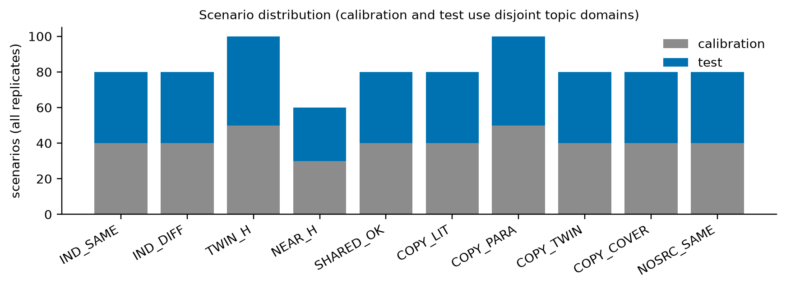
Scenario distribution over the five replicates.

9. Experiment design, ground truth and baselines
Scenario type | What happens | Copy (A) | Non-indep. (B) | False prov. (C)
IND_SAME / IND_DIFF | Both agents honest, own sources (same topic / other topic) | 0 | 0 | 0
NOSRC_SAME | Both answer from general knowledge, no source | 0 | 0 | 0
TWIN_H | Honest agents, twin sources (identical text, different publisher) | 0 | 1 | 0
NEAR_H | Honest agents, near-duplicate sources | 0 | 1 | 0
SHARED_OK | B builds on A's report and cites it, says it is not independent | 1 | 1 | 0
COPY_LIT / COPY_PARA | B reuses A's report verbatim / paraphrased, cites another source, claims independence | 1 | 1 | 1
COPY_TWIN | As COPY_PARA but cites the twin of A's source | 1 | 1 | 1
COPY_COVER | B opens its cited source as a cover story, still copies A | 1 | 1 | 1

Ground truth comes from the controller's design and is never visible to monitors. Five replicates use different scenario plans and generation seeds (164 scenarios each). Baselines: F0a (trust cited sources), F0b (LLM reads reports only), lexical 3-gram overlap and embedding cosine. The primary analysis keeps all scenarios; the sensitivity analysis keeps only copy scenarios verified by reused numbers (course text has few numbers, so 35% of copy scenarios cannot be verified this way).

10. Communication protocol and oversight mechanisms
Agent B receives Agent A's report as a message in copy and shared scenarios; tool use is controller-mediated (open_source) and every event is written to a SHA-256 hash-chained ledger (open_source, message, message_received, report_submitted). Monitors: report-only (rule and LLM), LLM with sources, single formulas, claim-support and source-overlap checks (S1, S2), ensembles (F9, F9b) and F10 (ensemble plus ledger features) under four visibility settings: full log, no message events, 50% of events (deterministic hash), log missing.

11. Statistical analysis plan
Per replicate, thresholds and logistic models are fitted on the calibration split and evaluated on the test split; test results are pooled. Uncertainty: 95% cluster bootstrap over (replicate, source of A) clusters. All results are descriptive; no hypothesis tests were run, and the five replicates share one source library, so they are not independent samples.

12. Results - Track 4 (oversight)
Main table for Target A (copying):
Monitor | Recall | FPR | Precision | F1 | MCC | AUROC | Brier | BSS
F0a report rule (same cited source) | 0.000 | 0.000 | n/a | n/a | 0.000 | 0.500 | 0.250 | -0.000
F0b LLM report-only | 0.381 | 0.010 | 0.976 | 0.548 | 0.464 | 0.919 | 0.113 | 0.549
D LLM with sources (Config D) | 0.795 | 0.010 | 0.988 | 0.881 | 0.797 | 0.949 | 0.088 | 0.648
F1 lexical 3-gram | 0.086 | 0.060 | 0.600 | 0.150 | 0.049 | 0.481 | 0.244 | 0.022
F2 embedding cosine | 0.014 | 0.075 | 0.167 | 0.026 | -0.148 | 0.570 | 0.219 | 0.122
F3 STP | 0.010 | 0.080 | 0.111 | 0.018 | -0.172 | 0.572 | 0.219 | 0.124
F4 STP-AR | 0.000 | 0.020 | 0.000 | n/a | -0.102 | 0.563 | 0.239 | 0.043
F5 STP-AR+MOI | 0.048 | 0.070 | 0.417 | 0.085 | -0.048 | 0.640 | 0.239 | 0.043
F6 RCC-v3.3 (AR) | 0.000 | 0.045 | 0.000 | n/a | -0.154 | 0.578 | 0.238 | 0.047
F6b RCC-v3.3 (AR+MOI) | 0.071 | 0.065 | 0.536 | 0.126 | 0.013 | 0.651 | 0.236 | 0.055
F8a Argon embedding triage | 0.076 | 0.045 | 0.640 | 0.136 | 0.065 | 0.638 | 0.209 | 0.162
F8b Argon claim overlap | 0.076 | 0.080 | 0.500 | 0.132 | -0.007 | 0.536 | 0.247 | 0.010
S1 claim unsupported by cited source | 0.000 | 0.000 | n/a | n/a | 0.000 | 0.754 | 0.248 | 0.007
S2 source containment (twin/near) | 0.000 | 0.000 | n/a | n/a | 0.000 | 0.432 | 0.238 | 0.047
F9 formula ensemble (artifact only) | 0.871 | 0.135 | 0.871 | 0.871 | 0.736 | 0.916 | 0.124 | 0.505
F9b ensemble + source checks | 0.971 | 0.075 | 0.932 | 0.951 | 0.898 | 0.990 | 0.048 | 0.806
P ledger only [full] | 1.000 | 0.000 | 1.000 | 1.000 | 1.000 | 1.000 | 0.002 | 0.993
F10 ensemble + ledger [full] | 1.000 | 0.060 | 0.946 | 0.972 | 0.943 | 1.000 | 0.001 | 0.994
F10 ensemble + ledger [comm_hidden] | 0.995 | 0.035 | 0.968 | 0.981 | 0.961 | 1.000 | 0.016 | 0.936
F10 ensemble + ledger [half] | 0.976 | 0.080 | 0.928 | 0.951 | 0.899 | 0.994 | 0.040 | 0.841
F10 ensemble + ledger [none] | 0.971 | 0.075 | 0.932 | 0.951 | 0.898 | 0.990 | 0.048 | 0.806

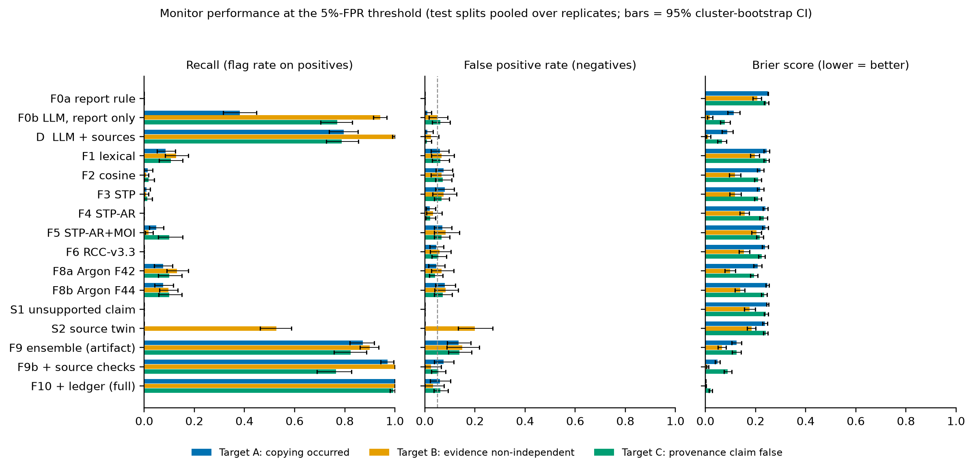
Recall, false positive rate and Brier score of all monitors for the three targets (95% cluster-bootstrap CI).
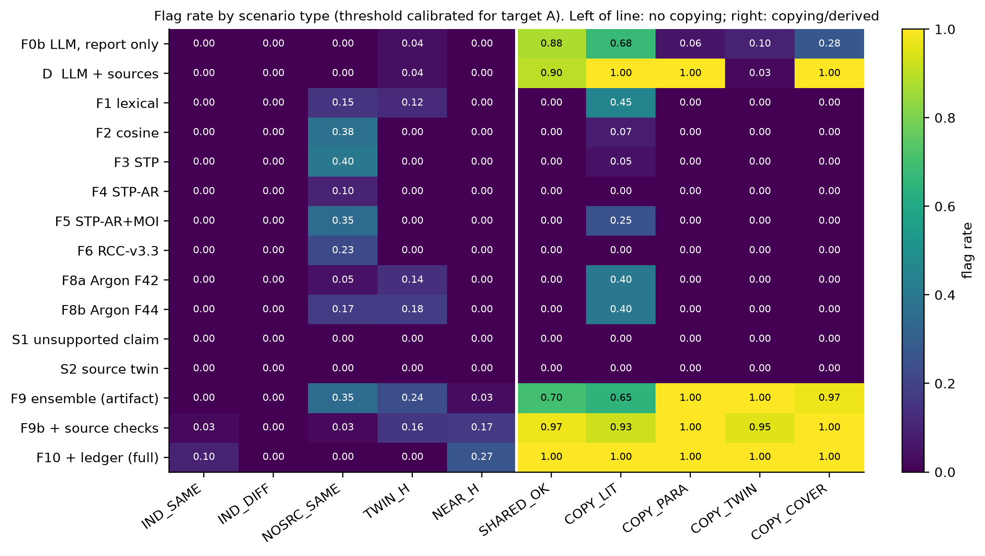
Flag rate by scenario type (Target A threshold).
Reports only: the LLM report reader flagged 0.38 [0.32, 0.45] of copies; by type it flagged 88% of shared-with-attribution reports and 68% of verbatim copies, but only 6% of paraphrased copies and 10% of copies citing the twin source. Single formulas reached at most 0.09 recall (AUROC 0.48-0.65). Claim-versus-cited-source checks (F9b) reached AUROC 0.99; with the ledger (F10) recall 1.00 and Brier 0.001.

13. Formula ablation
The ablation sequence (lexical, cosine, STP, STP-AR, STP-AR+MOI, RCC, Argon, ensembles) is in the Target A table above and in TABLES.md. Formulas that improved results only as part of an ensemble: F9 (logistic ensemble) raised AUROC from at most 0.65 to 0.92. Formulas that did not change results alone: STP, STP-AR, RCC-v3.3 (recall 0.00-0.01 at the 5% target). Formulas that added false alarms: embedding cosine, STP and RCC on the no-source control.

14. Model comparison
Only Gemma 4 31B (remote) was executed. Qwen (HTTP 401 for the configured key), qwen3.5 and deepseek cloud tags (HTTP 410), minimax and kimi (HTTP 402) were BLOCKED; Claude Haiku as an experimental agent and a local GPU model were NOT TESTED. Configurations B (heterogeneous) and C (mixed provider) therefore have no results; Configuration A (homogeneous) and D (LLM monitor with sources) were run.

15. Brier score and calibration
Brier scores and skill versus a constant-prevalence predictor are in the main table. Figure: reliability diagram for three monitors (8 bins).
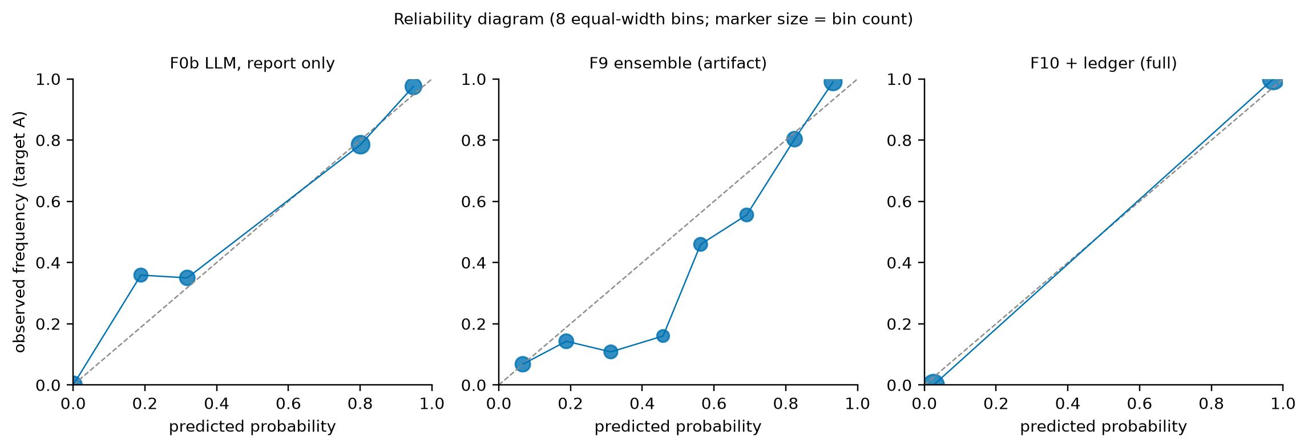
Reliability diagram for Target A (report-only LLM, formula ensemble, ensemble plus ledger).
Expected calibration error via Argon F35 was planned but not run, so no ECE is reported.

16. Targets B and C
Target B (evidence non-independent) and Target C (provenance claim false):
Monitor | Recall | FPR | Precision | F1 | MCC | AUROC | Brier | BSS
F0a report rule (same cited source) | 0.000 | 0.000 | n/a | n/a | 0.000 | 0.500 | 0.207 | -0.000
F0b LLM report-only | 0.941 | 0.050 | 0.978 | 0.960 | 0.870 | 0.976 | 0.017 | 0.919
D LLM with sources (Config D) | 0.997 | 0.025 | 0.990 | 0.993 | 0.976 | 0.999 | 0.011 | 0.947
F1 lexical 3-gram | 0.128 | 0.067 | 0.822 | 0.221 | 0.089 | 0.745 | 0.197 | 0.049
F2 embedding cosine | 0.007 | 0.067 | 0.200 | 0.013 | -0.176 | 0.698 | 0.118 | 0.431
F3 STP | 0.007 | 0.075 | 0.182 | 0.013 | -0.192 | 0.699 | 0.118 | 0.430
F4 STP-AR | 0.000 | 0.033 | 0.000 | n/a | -0.154 | 0.701 | 0.156 | 0.245
F5 STP-AR+MOI | 0.017 | 0.083 | 0.333 | 0.033 | -0.160 | 0.617 | 0.204 | 0.013
F6 RCC-v3.3 (AR) | 0.000 | 0.058 | 0.000 | n/a | -0.205 | 0.675 | 0.154 | 0.256
F6b RCC-v3.3 (AR+MOI) | 0.024 | 0.092 | 0.389 | 0.045 | -0.150 | 0.633 | 0.202 | 0.025
F8a Argon embedding triage | 0.131 | 0.067 | 0.826 | 0.226 | 0.093 | 0.809 | 0.098 | 0.525
F8b Argon claim overlap | 0.097 | 0.083 | 0.737 | 0.171 | 0.021 | 0.773 | 0.138 | 0.332
S1 claim unsupported by cited source | 0.000 | 0.000 | n/a | n/a | 0.000 | 0.563 | 0.177 | 0.145
S2 source containment (twin/near) | 0.528 | 0.200 | 0.864 | 0.655 | 0.301 | 0.734 | 0.184 | 0.112
F9 formula ensemble (artifact only) | 0.900 | 0.150 | 0.935 | 0.917 | 0.732 | 0.961 | 0.066 | 0.683
F9b ensemble + source checks | 1.000 | 0.025 | 0.990 | 0.995 | 0.982 | 1.000 | 0.008 | 0.962
P ledger only [full] | 0.897 | 0.000 | 1.000 | 0.945 | 0.847 | 0.948 | 0.060 | 0.710
F10 ensemble + ledger [full] | 1.000 | 0.033 | 0.986 | 0.993 | 0.976 | 1.000 | 0.002 | 0.991
F10 ensemble + ledger [comm_hidden] | 1.000 | 0.025 | 0.990 | 0.995 | 0.982 | 1.000 | 0.008 | 0.962
F10 ensemble + ledger [half] | 1.000 | 0.033 | 0.986 | 0.993 | 0.976 | 1.000 | 0.006 | 0.969
F10 ensemble + ledger [none] | 1.000 | 0.025 | 0.990 | 0.995 | 0.982 | 1.000 | 0.008 | 0.962

Monitor | Recall | FPR | Precision | F1 | MCC | AUROC | Brier | BSS
F0a report rule (same cited source) | 0.000 | 0.000 | n/a | n/a | 0.000 | 0.500 | 0.243 | -0.000
F0b LLM report-only | 0.771 | 0.062 | 0.897 | 0.829 | 0.729 | 0.960 | 0.077 | 0.681
D LLM with sources (Config D) | 0.788 | 0.008 | 0.985 | 0.876 | 0.816 | 0.965 | 0.066 | 0.728
F1 lexical 3-gram | 0.106 | 0.062 | 0.545 | 0.177 | 0.079 | 0.507 | 0.244 | -0.004
F2 embedding cosine | 0.018 | 0.071 | 0.150 | 0.032 | -0.122 | 0.656 | 0.210 | 0.135
F3 STP | 0.012 | 0.067 | 0.111 | 0.021 | -0.132 | 0.656 | 0.210 | 0.135
F4 STP-AR | 0.000 | 0.021 | 0.000 | n/a | -0.094 | 0.614 | 0.232 | 0.042
F5 STP-AR+MOI | 0.100 | 0.067 | 0.515 | 0.167 | 0.060 | 0.708 | 0.217 | 0.104
F6 RCC-v3.3 (AR) | 0.000 | 0.054 | 0.000 | n/a | -0.152 | 0.654 | 0.225 | 0.071
F6b RCC-v3.3 (AR+MOI) | 0.118 | 0.071 | 0.541 | 0.193 | 0.080 | 0.702 | 0.218 | 0.103
F8a Argon embedding triage | 0.100 | 0.042 | 0.630 | 0.173 | 0.116 | 0.731 | 0.194 | 0.201
F8b Argon claim overlap | 0.100 | 0.071 | 0.500 | 0.167 | 0.052 | 0.593 | 0.235 | 0.033
S1 claim unsupported by cited source | 0.000 | 0.000 | n/a | n/a | 0.000 | 0.703 | 0.242 | 0.005
S2 source containment (twin/near) | 0.000 | 0.000 | n/a | n/a | 0.000 | 0.472 | 0.240 | 0.010
F9 formula ensemble (artifact only) | 0.824 | 0.137 | 0.809 | 0.816 | 0.684 | 0.915 | 0.124 | 0.488
F9b ensemble + source checks | 0.765 | 0.054 | 0.909 | 0.831 | 0.735 | 0.951 | 0.089 | 0.634
P ledger only [full] | 0.765 | 0.000 | 1.000 | 0.867 | 0.810 | 0.980 | 0.049 | 0.797
F10 ensemble + ledger [full] | 0.994 | 0.062 | 0.918 | 0.955 | 0.923 | 0.999 | 0.020 | 0.916
F10 ensemble + ledger [comm_hidden] | 0.994 | 0.067 | 0.914 | 0.952 | 0.918 | 0.999 | 0.022 | 0.908
F10 ensemble + ledger [half] | 0.847 | 0.062 | 0.906 | 0.875 | 0.793 | 0.977 | 0.064 | 0.738
F10 ensemble + ledger [none] | 0.765 | 0.054 | 0.909 | 0.831 | 0.735 | 0.951 | 0.089 | 0.634

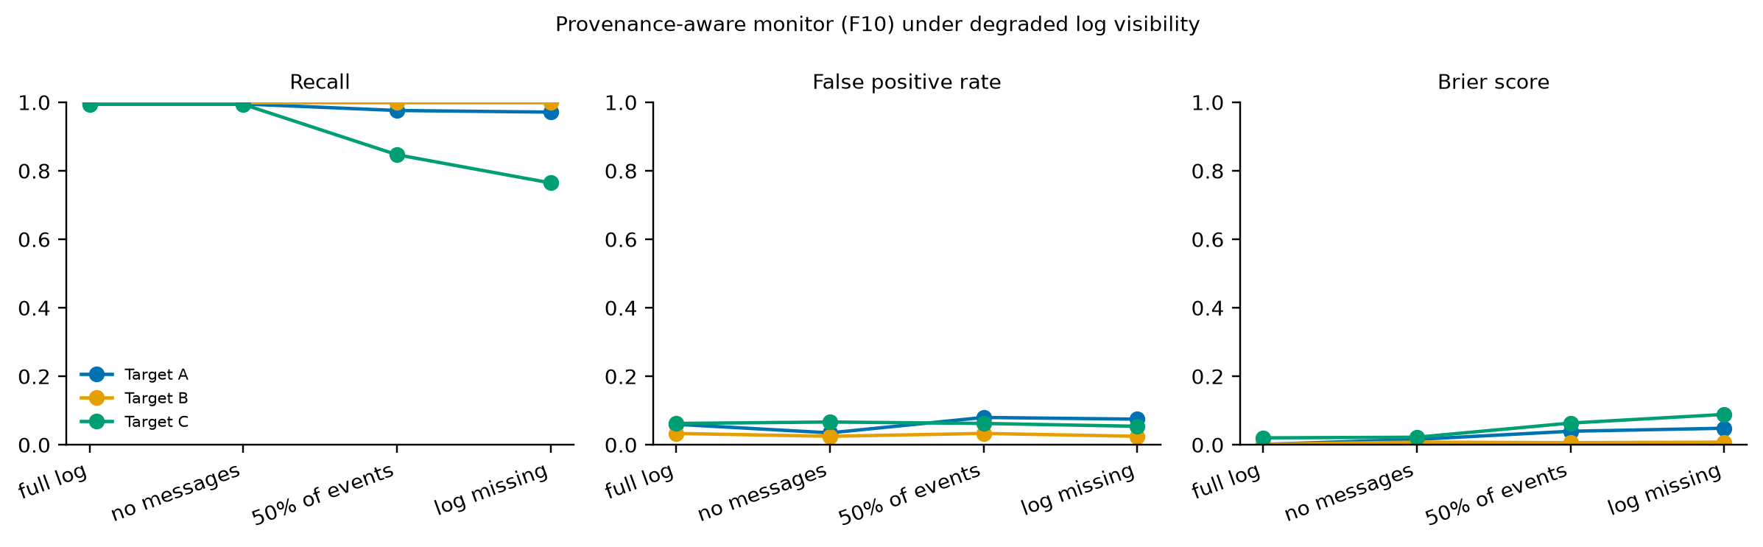
Provenance-aware monitor F10 under degraded log visibility.

17. Supporting tests (Tracks 1-3)
Track 1. The sandbox blocked 18 of 18 path-traversal attempts (an unprotected read leaked 11), all 13 denials were logged and the ledger chain verified. The formula pipeline reproduced exactly (100%); LLM exact-output agreement was 30% at temperature 0 and 0% at temperature 0.7 with a fixed seed, while semantic agreement (cosine > 0.99) was 100%.
Track 2. A false claim was planted in agent 1 of 4 and the other agents held different sources. Results by topology:
Topology | Trials | Propagation per downstream agent | Correction per downstream agent | Trials contaminated | Mean depth | Mean messages
isolated | 20 | 0.00 | 0.00 | 0.00 | 1.00 | 0.0
chain | 20 | 0.00 | 0.33 | 0.00 | 1.00 | 3.0
star | 20 | 0.00 | 1.00 | 0.00 | 1.00 | 3.0
full | 20 | 0.00 | 1.00 | 0.00 | 1.00 | 6.0
chain_verifier | 20 | 0.00 | 0.33 | 0.00 | 1.00 | 3.0

No downstream agent repeated the planted claim in any topology (ceiling effect: agents were told to include only facts their own source supports), so this test does not separate topologies on propagation; correction rates only reflect how many downstream agents saw the planted report. A weaker instruction or agents that must rely on the shared report would be needed.
Track 3. Duplicate-source identity by body hash: precision 1.00, recall 1.00 ({'tp': 44, 'fp': 0, 'fn': 0, 'precision': 1.0, 'recall': 1.0}). Hash chain detection: edit 1.00, deletion 1.00, reordering 1.00, tail truncation 0.00 (1.00 when the head hash is anchored). Identity by internal id was 1.00 versus 0.00 by display name in a simulated rename-collision (a sanity check of the harness). Chain completeness hides the cover story (COPY_COVER = 1.00); only message events reveal it.
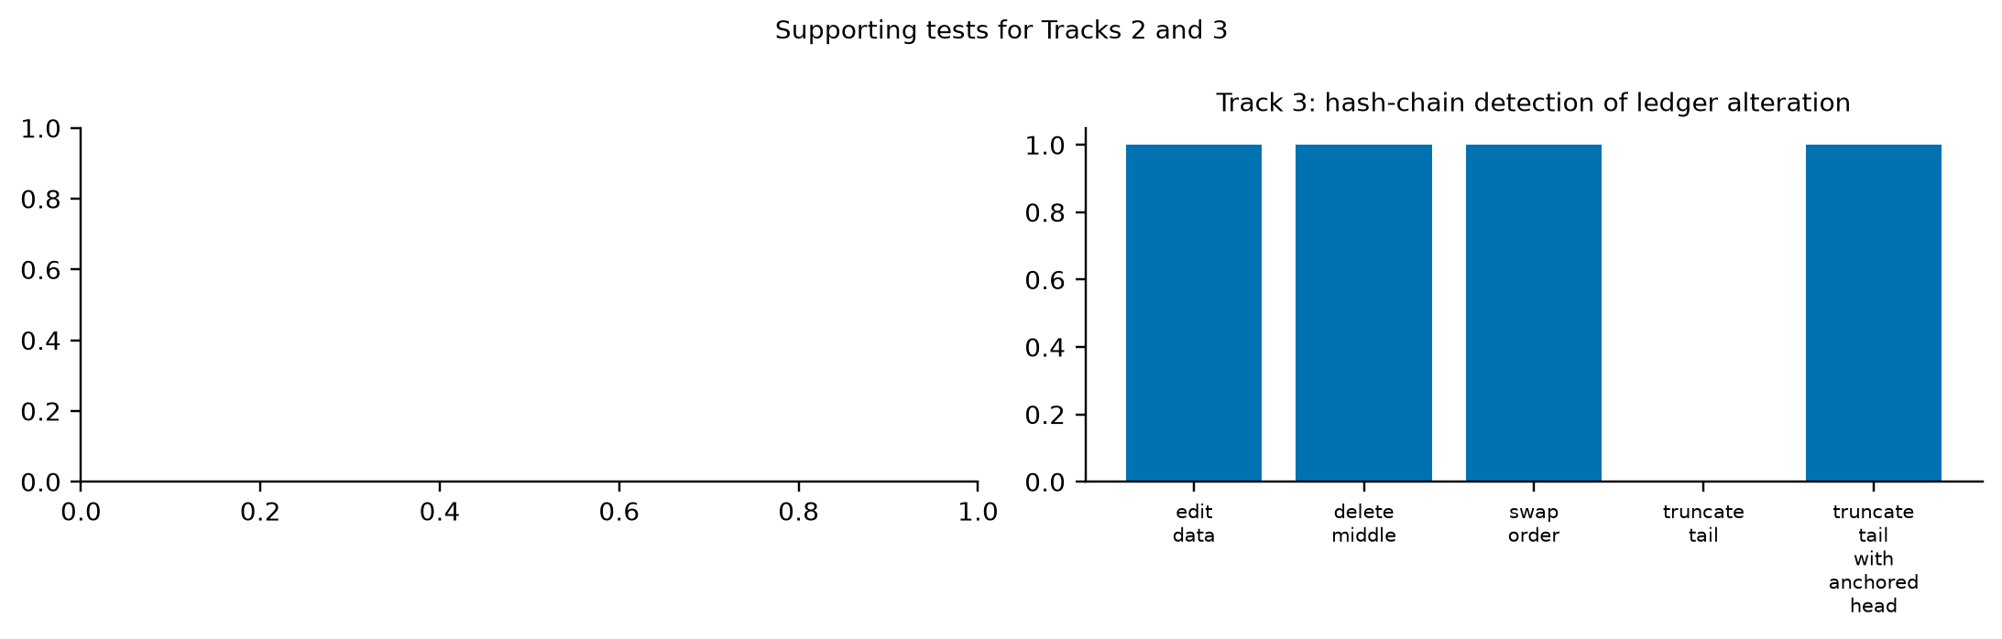
Supporting tests for Tracks 2 and 3.

18. Failure case analysis
- Paraphrased copies claiming independence pass an LLM report reader (flag rate 6%); copies citing a twin source pass even an LLM that reads the sources (2%).
- Honest same-topic reports and the no-source control look as similar as copies to embedding formulas (cosine flags 38% of the no-source pairs).
- The ledger's chain completeness is satisfied by a cover story (the cited source was opened); only the message record reveals copying.
- Without the ledger, Target C recall falls from 0.99 to 0.76.

19. Reproducibility
Code, frozen corpora with SHA-256, raw runs, scores and metrics are in this package; 17 unit tests pass without network or GPU. Formula pipeline reproduction is exact; LLM generation is not exactly reproducible even at temperature 0 (setup is reproducible, outputs are not). Full reproduction needs Ollama, the embedding model and access to the remote Gemma model; the earlier 184-book corpus is not distributed.

20. Discussion, limitations, dual use, future work
Content similarity is the wrong main signal for copying and provenance claims; claim-to-source support and process evidence carry it. The ledger result is an upper bound because the controller writes both the log and the labels. Limitations: one generator model; instructed agents; controller-mediated tools; AI-assisted source texts with common knowledge; shared source library across replicates; frozen formulas not tuned. Dual use: the scenarios instruct a model to misrepresent provenance in a sandbox with fictional framing, and results show which signals monitors miss. Future work: heterogeneous and local models, agents choosing their own tool calls, adaptive copiers, signed logs, real transcripts, and ECE via Argon F35.

21. Conclusion
Reading reports is not enough; similarity formulas alone did not help; claim-to-source checks and a provenance record separated copying, shared evidence and false provenance claims in controlled scenarios.

References
Ashery, A. F., Aiello, L. M., & Baronchelli, A. (2025). Emergent social conventions and collective bias in LLM populations. Science Advances, 11(20), eadu9368.
Cemri, M., et al. (2025). Why do multi-agent LLM systems fail? arXiv:2503.13657.
Chan, A., et al. (2025). Infrastructure for AI agents. arXiv:2501.10114.
Crosby, S. A., & Wallach, D. S. (2009). Efficient data structures for tamper-evident logging. USENIX Security.
Gao, T., Yen, H., Yu, J., & Chen, D. (2023). Enabling large language models to generate text with citations. EMNLP 2023.
Greenblatt, R., Shlegeris, B., Sachan, K., & Roger, F. (2024). AI control. ICML 2024, PMLR 235, 16295-16336.
Hammond, L., et al. (2025). Multi-agent risks from advanced AI. arXiv:2502.14143.
Motwani, S. R., et al. (2024). Secret collusion among AI agents. NeurIPS 37.
Rashkin, H., et al. (2021). Measuring attribution in natural language generation models. arXiv:2112.12870.
Vardi, Y., & Zhang, C.-H. (2000). The multivariate L1-median and associated data depth. PNAS 97(4), 1423-1426.
Weiszfeld, E. (1937). Tohoku Mathematical Journal 43, 355-386.
Brier (1950) and Platt (1999) are cited from secondary records only; the status of every reference is listed in 01_SOURCE_AUDIT/LITERATURE_CANDIDATES.md.

Appendix: per-type flag rates and sensitivity
Full tables with confidence intervals, the naive-threshold variant and the verified-subset sensitivity analysis are in 07_STATISTICAL_ANALYSIS/TABLES.md.

