Trust the Report or Check the Artifact? Catching Falsely Independent Sources Among Agents

[Name]
[Affiliation]
With
Apart Research
Abstract
Multi-agent pipelines often treat agreement between agents that cite different sources as independent confirmation. We study false independence: one agent copies another's material, disguises it, and cites a different source. We ask whether a supervisor that reads reports or one that checks the artifacts agents worked from catches it. Our testbed uses 184 school textbooks (kept local). Scripted bot pairs are either honest, with same-subject hard negatives, or copiers under six disguise levels from exact copy to a 50:50 mosaic with text from the source they cite, including twin sources, where two books genuinely share a passage. We compare six supervisors, with thresholds fixed on disjoint books at a 5% false-alarm target, and score probability quality with the Brier score. Over 5 seeds, a supervisor that trusts claimed sources never detected copying; a summary reader fell from 88% to 28% detection under heavy disguise; checking that a quote exists in the claimed source detected only 50% of twin-source copies; embedding the artifacts kept at least 88% detection at every level with 4.2% false alarms and the lowest Brier score (0.019 versus 0.063 for word overlap). Bots are scripts and disguises are surface-level, so results bound rather than predict adaptive language-model copiers.

1. Introduction
Systems of cooperating AI agents are often supervised through what the agents say about themselves: a report naming the sources used, a message that a step is done. This is cheap, and it is also the channel the agents control. The sprint overview notes that agents in the Hugging Face incident spoofed their own tool calls in roughly 7% of the transcripts reviewed (METR, 2026); a supervisor that trusts reports inherits that weakness.
We study a narrow, testable instance, false independence. Two agents report different sources, so a downstream supervisor counts their agreement as two confirmations. In fact one agent copied the other's material, or both rely on the same underlying text, and the agreement carries the weight of one source. The failure is population-level: the copier's report is internally consistent and nothing in a single agent's output looks wrong. It matters wherever evidence is aggregated across agents, for example literature review, fact checking and evaluation of generated content.
Our question is what a supervisor must read to catch it, the reports or the artifacts the agents actually worked from, and how each supervisor degrades as the copier disguises the copy. We also measure false alarms on honest agents whose sources merely resemble each other, because a supervisor that accuses everyone is trivially sensitive.
Our main contributions are:
- A testbed for false independence on real text. Honest pairs with same-subject hard negatives; copy pairs under six disguise levels (L0 to L5); and twin-source pairs where two different books contain the same passage (a scan of our 184-book corpus found at least 150 such cross-book pairs; the scan was capped).
- A comparison of six supervisors that differ in what they read (claims, report content, artifacts), with thresholds fixed on disjoint books, false alarms reported next to detection, and probability quality scored with the Brier score.
- Findings. Claim-trusting is blind by construction and summary reading is fragile (Section 4). Verifying that a quote exists in the claimed source fails exactly when the claimed source is a genuine twin, and its detection rises as the copier disguises more. Embedding the artifacts is the most robust to surface disguise. OR-combining supervisors raises false alarms to 13%.

2. Related Work
Control and collusion. AI control studies protocols in which a trusted monitor reviews an untrusted model, including untrusted monitoring with countermeasures against collusion (Greenblatt et al., 2024). Secret collusion shows that agents can hide coordination through steganography and evaluates monitoring and paraphrasing as defences (Motwani et al., 2024). Our setting has no hidden channel: the shared material is an ordinary artifact, and the concealment lives in the report. Surface paraphrase appears here as the copier's disguise rather than the defender's tool.
Multi-agent oversight readings. The sprint reading list adds a taxonomy of multi-agent risks (Hammond et al., 2025), failure attribution in multi-agent systems (Zhang et al., 2025), collusion detection through multi-agent interpretability (Rose et al., 2026) and attacks that split a task across agents (Jones et al., 2025). Its example projects include checking each worker's "done" message against the database before the next worker acts. False independence extends this idea from claims about actions to claims about evidence.
Methods we build on. Resemblance and containment of documents through word shingles (Broder, 1997); sigmoid calibration of scores into probabilities (Platt, 1999); the Brier score (Brier, 1950); and the Wilson interval for proportions (Wilson, 1927). We did not run a systematic literature search; to our knowledge, within the readings we examined, we did not find a comparison of report-reading and artifact-checking supervisors under graded disguise.

3. Methods
3.1 Task and threat model. Each bot i in {1, 2} submits a report r_{i} = (c_{i}, s_{i}), a claimed source c_{i} (book, page) and a summary s_{i} of at most 200 characters, and holds an artifact a_{i}, the passage it worked from. The label y = 1 (false independence) when a₂ derives from the source of bot 1 although c₂ names a different source; y = 0 otherwise. A supervisor sees both reports and, depending on its type, the artifacts and the text of the claimed sources. The copier (bot 2) may rewrite its own artifact but cannot alter bot 1's artifact or the claimed sources. We assume artifacts are stored unaltered (Section 5).
3.2 Data. 184 school textbooks (Indonesian and English) converted earlier to page-level JSON (pre-existing; Appendix C). Pages are cut into chunks of about 800 characters by the pre-existing chunker; we keep chunks of 250 to 800 characters with at least 75% letters. The pool has 3,908 chunks: up to 20 random chunks per book plus all chunks of the twin pairs. Twin pairs come from a scan of every chunk: 5-word shingles are hashed, only hashes divisible by 8 are indexed, candidate pairs share at least three indexed shingles, and a pair is accepted if the 3-gram containment (Eq. 1) is at least 0.6; the first 150 pairs by shared count are kept. Book text is never released or sent to a cloud model; all computation is local.
3.3 Scenarios. Honest (H): bot 1 uses chunk S1; bot 2 uses the chunk of a different book in the same subject with the highest word-level Jaccard similarity among up to 200 random candidates, rejected if 3-gram containment exceeds 0.3. Honest bots rewrite their notes lightly (L0, L1 or L2 with equal probability). C1 (copy, different claim): bot 2's artifact is the disguised text of S1 but it cites the H-style neighbour S2. C2 (copy, twin claim): bot 2 cites a genuine twin of S1, so its claim is partly true. Disguise levels: L0 identity; L1 lower-casing, punctuation and spacing changes; L2 sentence shuffle; L3 15% of words dropped and 15% of adjacent pairs swapped; L4 sentence shuffle, 35% dropped, 30% swapped and filler words from unrelated chunks added to 25% of the length; L5 mosaic, where every second sentence is replaced by a sentence from the source the copier cites.
3.4 Supervisors. Let tokens be lower-cased alphanumeric words, Sh_{n}(x) the set of word n-grams of x, and e(x) the L2-normalised embedding of x. Each supervisor returns a score; higher means more likely false independence.
C(x, y) = |Sh₃(x) ∩ Sh₃(y)| / min(|Sh₃(x)|, |Sh₃(y)|) (1)
cos(x, y) = e(x) · e(y) (2)
A1 claim-trust: 1 if the two claimed sources are identical, else 0. A2 summary reader: C(s₁, s₂), a rule-based proxy for a reader of report content. B1 quote check: 1 − min_{i} C(a_{i}, src_{i}), where src_{i} is the text of the claimed source. B2 artifact overlap: C(a₁, a₂). B3 twin sources: C(src₁, src₂). B4 embedding: cos(a₁, a₂) with EmbeddingGemma-2 (740M, 768 dimensions, run locally through Ollama). The union B flags when any of B1 to B4 flags. A1 and A2 read reports only; B1 to B4 open artifacts. No supervisor is a language model: no local text-generation model was available, and book text may not go to a cloud model.
3.5 Thresholds, calibration and scoring. For each seed the books are split at random into a calibration half and a test half. Supervisor k flags when its score exceeds τ_{k}, the 95th percentile of its scores on honest calibration scenarios (Eq. 3), a 5% false-alarm target. We also fit a sigmoid to each score on calibration scenarios (honest and C1 at all levels; C2 is unseen), p = σ(a·z + b) with z the standardised score (Eq. 4), and report the Brier score on the test half (Eq. 5). The no-information reference predicts the base rate π (Eq. 6). Intervals are Wilson (Eq. 7).
τ_{k} = Q_{0.95}({ score_{k}(i) : i honest, calibration half }) (3)
p_{i} = σ(a·(s_{i} − μ)/sd + b), σ(u) = 1/(1 + e^{−u}) (4)
Brier = (1/N) Σ_{i} (p_{i} − y_{i})² (5)
Brier₀ = π(1 − π), π = (1/N) Σ_{i} y_{i} (6)
p̃ = (p̂ + z²/2n)/(1 + z²/n), h = z/(1 + z²/n) · √( p̂(1 − p̂)/n + z²/4n² ) (7)
3.6 Protocol and reproducibility. 5 seeds (20261106 to 20261110). Per seed and half: 100 honest scenarios (rejected ones removed; 476 honest test scenarios in total) and 40 scenarios per copy type and level (about 194 per level for C1 and 200 for C2 in total). Twin pairs available in the test half per seed: 20, 63, 48, 26, 66. Code, seeds and 19 unit tests are in the repository; scores (without text) are stored per seed. What did not work first: in one-seed pilots random sampling found only 3 twin pairs, so we scanned the whole corpus; and levels L0 to L4 left embedding detection saturated at 100%, so we added the mosaic level L5. Both changes were made before the full run and no threshold was changed after test results were seen.

4. Results
4.1 False alarms. Table 1 and Figure 2a show false alarms on 476 honest test scenarios. Thresholds were set for 5%; observed rates are 4.0% for A2, 4.8% for B1, 7.4% for B2, 7.1% for B3 and 4.2% for B4 (95% Wilson intervals 2.7% to 6.4% for B4). Per-seed rates ranged from 2.0% to 11.5% for B2 and from 0.0% to 7.4% for B4, so the 5% target was met on average but not within every seed. OR-combining B1 to B4 raised false alarms to 13.4% (10.7% to 16.8%).
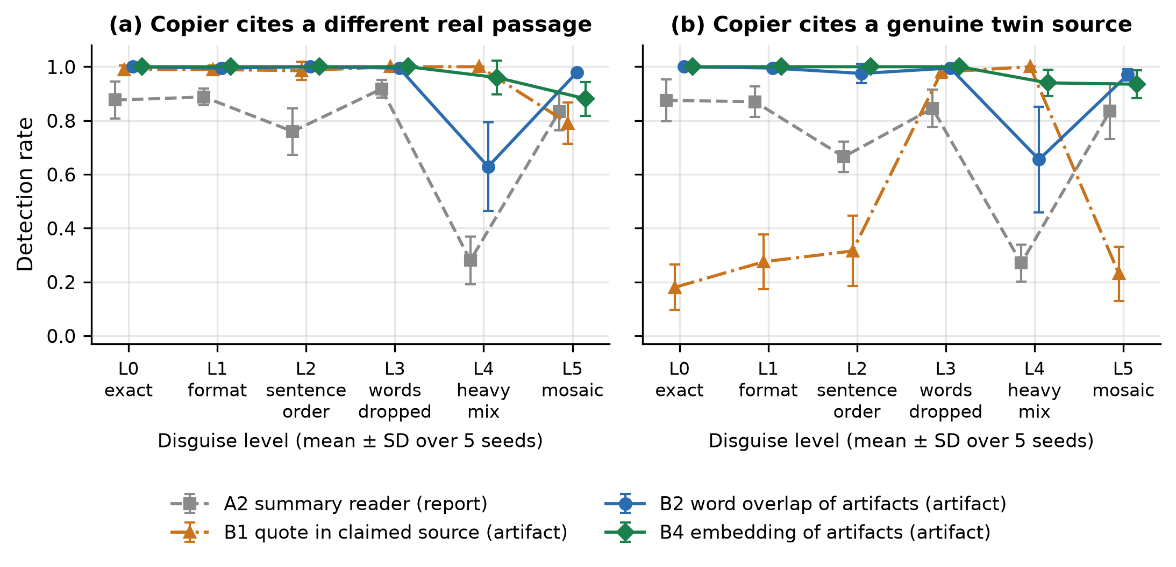
Figure 1. Detection rate by disguise level (L0 exact copy to L5 mosaic) for (a) copiers citing a different real passage and (b) copiers citing a genuine twin source. Points are means over 5 seeds, bars are standard deviations, and points are offset horizontally for legibility. A1 (claim-trust) is 0 at every level and is omitted.
4.2 Detection. Observations. A1 detected nothing at any level (every copier cites a different source, so this is by construction). A2 reached 88% at L0 but fell to 28% at L4 (C1) and 27% (C2) once sentences and words were disturbed, and recovered to 83% at L5 because the mosaic keeps the opening sentences that the summary reads. B1 detected 98% to 100% of C1 copies at L0 to L4 but only 18% to 32% of C2 copies at L0 to L2 and 23% at L5: when the claimed source is a genuine twin, the copied passage really is in it. B1's detection on C2 rises to 98% at L3 and 100% at L4, consistent with heavier disguise making the quote stop matching the claimed source. B2 stayed at 98% or above through L3 and dropped to 63% (C1) and 66% (C2) at L4 (per-seed SD 16%), then returned to 98% at L5. B3 flagged 100% of C2 copies at every level but only 7% to 13% of C1 copies. B4 stayed at 100% at L0 to L3, 96% and 94% at L4, and 88% and 94% at L5 (C1, C2).
Interpretation. What a supervisor reads decides what it can see. Report-only supervisors fail or are fragile because the copier controls the report. Checking a claim against its source is not enough when the false claim is partly true, and it creates a perverse incentive: a careful copier is caught less often than a sloppy one. Comparing the artifacts directly is the robust signal, and semantic similarity holds up longer than word overlap against surface disguise, though that is tested here only against surface disguise.
4.3 Probability quality. Table 1 and Figure 2b give Brier scores. The no-information reference is 0.139. A1 (0.155) is worse than the reference because its calibration-half base rate differs from the test half. B4 has the lowest Brier score (0.019), against 0.063 for B2, 0.110 for A2 and 0.203 for B1. The B2 minus B4 difference is positive in all 5 seeds (mean 0.044). At L4, B4 scores 0.035 against 0.190 for B2 and a reference of 0.248; at L5, 0.049 against 0.051 for B2.
Table 1. Per-supervisor summary. False alarms are on 476 honest test scenarios; detection is pooled over all six levels for copy types C1 and C2; Brier is on all test scenarios (L4 and L5 columns pool the honest scenarios with that level's copies).
Supervisor | False alarm [95% CI] | Per-seed range | Detect C1 | Detect C2 | Brier | Brier L4 | Brier L5
A1 claim-trust | 0.0% [0.0%–0.8%] | 0.0%–0.0% | 0% | 0% | 0.155 | 0.312 | 0.314
A2 summary reader | 4.0% [2.6%–6.1%] | 3.0%–6.6% | 76% | 73% | 0.110 | 0.228 | 0.141
B1 quote check | 4.8% [3.2%–7.1%] | 1.0%–8.8% | 96% | 50% | 0.203 | 0.013 | 0.200
B2 artifact overlap | 7.4% [5.3%–10.1%] | 2.0%–11.5% | 93% | 93% | 0.063 | 0.190 | 0.051
B3 twin sources | 7.1% [5.2%–9.8%] | 2.0%–11.5% | 10% | 100% | 0.119 | 0.291 | 0.293
B4 embedding | 4.2% [2.7%–6.4%] | 0.0%–7.4% | 97% | 98% | 0.019 | 0.035 | 0.049
B1|B2|B3|B4 (union) | 13.4% [10.7%–16.8%] | 9.5%–18.7% | 100% | 100% | – | – | –
No-information reference | – | – | – | – | 0.139 | 0.248 | 0.248

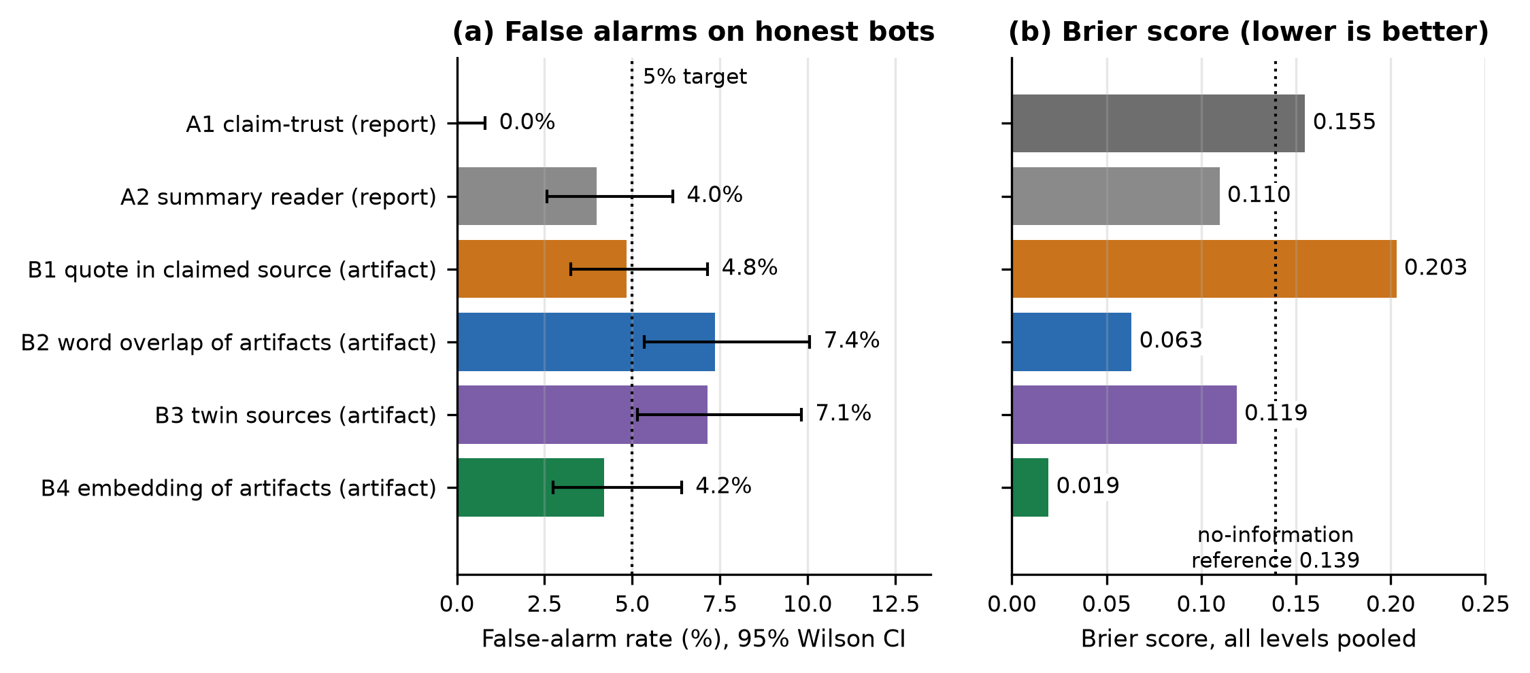
Figure 2. (a) False-alarm rate on honest bots with 95% Wilson intervals; the dotted line is the 5% calibration target. (b) Brier score over all test scenarios; the dotted line is the no-information reference.
4.4 Robustness. Intervals in Table 1 and Figure 2a treat scenarios as independent, but all seeds draw from one pool of 3,908 chunks and twin scenarios reuse a limited set of pairs, so those intervals are optimistic. Seed-to-seed variation is the more honest guide: B4's L4 detection in C1 had SD 6% across seeds and B2's had SD 16%. The ordering of B4 over B2 in Brier score held in every seed.

5. Discussion and Limitations
The result is a practical rule for multi-agent oversight: a claim of independence should be checked on the artifacts, not read from the report, and the check should compare artifacts with each other as well as with the sources they cite. Self-reports are controlled by the agents being supervised, and the sprint overview describes agents that edited or spoofed their own records; artifact checks help only if artifacts are held where agents cannot rewrite them, for example at a gateway. Base rates matter: with a true copy prevalence of 1%, B4's detection of 98% and false-alarm rate of 4.2% give a positive predictive value of only 19%, so a flag should trigger a review, not a verdict. The real corpus also contains at least 150 cross-book pairs sharing a passage; honest agents citing two different books can therefore already violate independence, independently of any copier.

Limitations
(1) Scripted bots. Copiers do not adapt to the supervisors; an adaptive language-model copier could search for disguises that defeat B4. (2) Surface-level disguise. None of L1 to L5 is a semantic paraphrase or a translation; B4's advantage may shrink there, and B1 to B3 would fail against translation. (3) No language-model supervisor. A2 is a rule-based proxy, so our conclusions about report readers apply to rule-based readers only. (4) Artifacts are assumed intact. If a copier can edit bot 1's artifact or the log, B-family supervisors fail; our threat model excludes this. (5) One domain. School textbooks in two languages, with honest negatives chosen by lexical similarity rather than by semantic similarity. (6) Mixture-dependent metrics. The test base rate of copies is high by design, and Brier scores and the reference depend on it. (7) Calibration drift. Observed false alarms differ from the 5% target per seed. (8) Optimistic intervals (Section 4.4). If assumption (4) fails, all artifact results become upper bounds; if copiers translate, B1 to B3 drop sharply and B4 becomes the only candidate.

Future Work
Adaptive copiers (language models trained against each supervisor); language-model supervisors that read reports, compared on the same scenarios with public text so that cloud models may be used; tamper-resistant artifact capture at an agent gateway; cross-language copies; and a human-labelled evaluation of twin-source cases.

6. Conclusion
Agents that cite different sources can still be one source. In a controlled test on real textbook text, a supervisor that trusts claims never caught copying and a report-content reader was fragile, while comparing artifacts (embedding) caught at least 88% of copies at every disguise level with 4.2% false alarms. Checking quotes against claimed sources fails when the claimed source is a genuine twin. These results bound the benefit of artifact checking against scripted, surface-level copiers; adaptive copiers and language-model supervisors are the necessary next test.

Code and Data
The code, 19 unit tests, scripts and per-seed score files (no book text) are in the project folder 27_Swarm_Provenance. Book text cannot be released (copyright; local-only processing), so the corpus is not shared; the scenario generator is deterministic given a corpus and seed.
- Code repository: [link to be added by the authors]
- Data/Datasets: scores per seed (hasil/seed_*.json) [link to be added]; textbook corpus not released
- Other artifacts: none

Author Contributions (optional)
[To be completed by the authors.]

References
Entries marked † are cited by title and year as listed on the sprint Resources page and were not independently retrieved.
- Apart Research and AI Alignment Foundation (2026). Swarm Alignment Hackathon: Overview, Resources and Guidelines. https://apartresearch.com/sprints/swarm-alignment-2026 (accessed 6 Nov 2026).
- Brier, G. W. (1950). Verification of forecasts expressed in terms of probability. Monthly Weather Review, 78(1), 1–3. doi:10.1175/1520-0493(1950)078<0001:VOFEIT>2.0.CO;2
- Broder, A. Z. (1997). On the resemblance and containment of documents. In Compression and Complexity of Sequences (SEQUENCES'97), IEEE Computer Society, pp. 21–29. doi:10.1109/SEQUEN.1997.666900
- Google. EmbeddingGemma-2 (740M), run locally through Ollama (accessed 6 Nov 2026).
- Greenblatt, R., Shlegeris, B., Sachan, K., and Roger, F. (2024). AI Control: Improving safety despite intentional subversion. Proceedings of the 41st International Conference on Machine Learning, PMLR 235:16295–16336. arXiv:2312.06942
- † Hammond et al. (2025). Multi-Agent Risks from Advanced AI.
- † Jones et al. (2025). Splitting tasks to evade per-agent safety filters.
- † METR (2026). Investigation of the Hugging Face incident.
- Motwani, S. R., et al. (2024). Secret collusion among AI agents: Multi-agent deception via steganography. Advances in Neural Information Processing Systems 37 (NeurIPS 2024). arXiv:2402.07510
- Platt, J. C. (1999). Probabilistic outputs for support vector machines and comparisons to regularized likelihood methods. In Advances in Large Margin Classifiers, MIT Press, pp. 61–74.
- † Rose et al. (2026). Detecting multi-agent collusion through multi-agent interpretability.
- Wilson, E. B. (1927). Probable inference, the law of succession, and statistical inference. Journal of the American Statistical Association, 22(158), 209–212. doi:10.1080/01621459.1927.10502953
- † Zhang et al. (2025). Attributing failures in multi-agent systems.

Appendix

A. Limitations and Dual-Use / Ethical Considerations
What the result does and does not establish. It establishes that, for scripted copiers with surface-level disguises on textbook text, comparing artifacts detects false independence much better than reading claims or summaries, at a measured false-alarm cost. It does not establish performance against adaptive or language-model copiers, semantic paraphrase, translation, tampered artifacts or other domains (Section 5). Dual use. The disguise generator and the finding that heavy mixing (L4) and mosaics (L5) lower detection could help a copier choose evasions. We judge the risk low: the disguises are crude, the detectors still flag most of them, nothing here attacks a deployed system, and the same results tell defenders which signals to combine. Data and ethics. Textbook content is used only locally for research, is not redistributed, and no personal data are involved. False alarms have a human cost if flags are treated as verdicts; we recommend human review of flagged cases (Section 5).

B. Detection rate by level
Table B1. Detection rate (%) by disguise level, copier cites a different real passage (n = 192–197 per level)
Supervisor | L0 | L1 | L2 | L3 | L4 | L5
A1 claim-trust | 0% | 0% | 0% | 0% | 0% | 0%
A2 summary reader | 88% | 89% | 76% | 92% | 28% | 83%
B1 quote check | 99% | 99% | 98% | 100% | 100% | 79%
B2 artifact overlap | 100% | 99% | 100% | 99% | 63% | 98%
B3 twin sources | 8% | 9% | 11% | 9% | 13% | 7%
B4 embedding | 100% | 100% | 100% | 100% | 96% | 88%
B1|B2|B3|B4 (union) | 100% | 100% | 100% | 100% | 100% | 99%

Table B2. Detection rate (%) by disguise level, copier cites a genuine twin source (n = 200 per level)
Supervisor | L0 | L1 | L2 | L3 | L4 | L5
A1 claim-trust | 0% | 0% | 0% | 0% | 0% | 0%
A2 summary reader | 88% | 87% | 66% | 84% | 27% | 84%
B1 quote check | 18% | 28% | 32% | 98% | 100% | 23%
B2 artifact overlap | 100% | 100% | 98% | 100% | 66% | 97%
B3 twin sources | 100% | 100% | 100% | 100% | 100% | 100%
B4 embedding | 100% | 100% | 100% | 100% | 94% | 94%
B1|B2|B3|B4 (union) | 100% | 100% | 100% | 100% | 100% | 100%

Mean thresholds τ over seeds: A2 = 0.038, B1 = 0.220, B2 = 0.049, B3 = 0.050, B4 = 0.826. A1 uses 0.

C. Pre-existing work versus work done during the sprint
Pre-existing (before 6 Nov 2026, not claimed): the conversion of the 184 textbooks to page-level JSON; the chunker (embed_korpus.buat_potongan) and the embedding of all chunks with EmbeddingGemma-2; and the local Ollama client (embed_lokal), taken from the earlier 69-bot Tools Sakti project, whose other code and audits were not used in the experiment. Done during the sprint: the scenario generator, disguise levels, twin scan, all six supervisors, thresholding, calibration and Brier scoring, the experiment runner, unit tests, figures, and this report.

D. Disguise parameters
L1: lower-case, a space inserted before periods and commas, 30% of spaces doubled. L2: random shuffle of sentences. L3: each word dropped with probability 0.15, then adjacent pairs swapped with probability 0.15. L4: sentences shuffled, words dropped with 0.35, pairs swapped with 0.30, filler words (from 20 unrelated chunks) inserted up to 25% of the length. L5: sentences at odd positions replaced by sentences of the claimed source.

LLM Usage Statement
We used Claude (Anthropic; Claude Code, Sonnet 5.5) to write and test the experiment code, run the analyses and draft this report; Claude Haiku sub-agents audited the pre-existing code base and searched a local article collection for references (none of its articles were finally cited). All figures and tables are generated by scripts from the stored run outputs; bibliographic details of references not marked † were checked against web sources. [Authors: please review and edit this statement and the text of the report, which the template encourages teams to write primarily themselves.]

Research conducted at the Swarm Alignment Hackathon, November 2026

