Discussion

26/08/2021

KENNY

- Features

- Additional vs Core

- Hook up Database

- Optional: Unit Testing

OKA

- SQL Alchemy

- Design from database point of view

- 1 class per table

- Use SQL Alchemy to manipulate database

- Optional separate class for some operations

- The class methods contain SQL Alchemy stuff

- Features

- Additional vs Core

19/08/2021

hey sorry for the late reply

21:36

i think this is a great tool to use

21:37

its looks very clear with regards to the objects attributes and methods

21:37

regarding the class diagram, shouldnt the method that exist in parent class, not be declared in child class?

22:11

transaction can also be declared as an object just like customer

22:13

i tried the staruml diagram

22:29

its hard for me to understand how to use it

22:29

here are some of the things i would like to add with regards to customer and transactions

22:29

customer

22:29

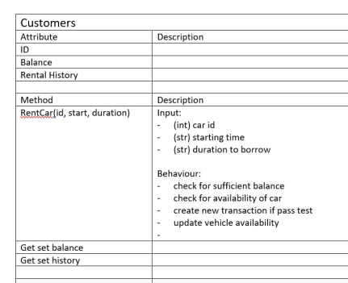

transactino

22:30

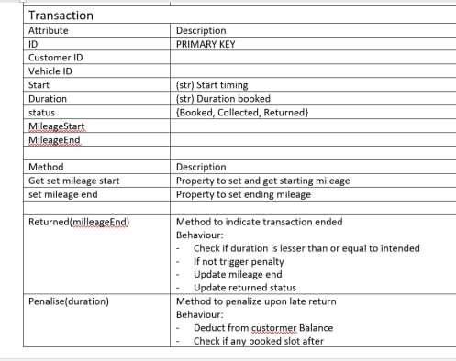

I think you're right... I'll check that first. I know if we are overriding, it should be there.

22:34

Azmi

regarding the class diagram, shouldnt the method that exist in parent class, not be declared in child class?

Ya, StarUML is an awesome tool. Learn it, it will be useful for your software documentation

22:35

Azmi

i think this is a great tool to use

im trying to list down requirements for our app. Was thinking that it would help us craft our methods and objects better

22:35

currently i have this

22:35

1.User needs to be able to choose vehicle from a date and duration

2.User needs to be able to rent from available vehicles

3.User needs to be able to cancel bookings

4.User needs to be able to make payment using inapp balance

5.User needs to be able to top up to balance

22:35

Ya, it isn't straight forward. So I'm thinking about how it's going to be done

22:35

Azmi

transaction can also be declared as an object just like customer

so from these requirement (can list more) we can choose the attributes and methods that we need

22:37

Azmi

1.User needs to be able to choose vehicle from a date and duration 2.User needs to be able to rent f...

mayb can do app requirement also haha but it feels like it should match

22:37

Azmi

1.User needs to be able to choose vehicle from a date and duration 2.User needs to be able to rent f...

Wow! A wallet! I liked this idea!

22:37

Azmi

Photo, customer

Demerit points! Good idea also!

22:38

Azmi

Photo, transactino

I think this can be a separate table

22:38

Alkaff Paiya

Demerit points! Good idea also!

ya can be seperate and attach a customer id to it

22:38

mayb return on time can get better rates next haha

22:38

Ya, your ideas are good.

22:38

Azmi

im trying to list down requirements for our app. Was thinking that it would help us craft our metho...

Vouchers! Another possible feature!

22:39

Azmi

mayb return on time can get better rates next haha

im having trouble thinking of the thinking process, or the things we need to lay down first before starting to code

22:39

yes interesting!

22:40

Alkaff Paiya

Vouchers! Another possible feature!

And that reminds me, a separate table that can do a point system to claim vouchers?

22:40

Damn! It's getting complicated!

22:40

Coming Thursday is consultation. We still haven't booked any slots with Oka and Kenny

22:41

ok we can book first

22:41

then try to work something out before

22:41

At least showing them these diagrams will be good. I though of start coding after the consultations

22:42

presentation in 3 weeks

22:42

sounds great

22:42

Alkaff Paiya

At least showing them these diagrams will be good. I though of start coding after the consultations

i think the documentation should be solid first then we can start code

22:42

so we are clear of the functionality of the app

22:43

Yup, from consultation to presentation, there's 2 weeks. It should be enough to code.

22:43

Yup, this is important. StarUML has the functionality to export an almost full fletched HTML document as Documentations. Just need to click export. But to make the documentation work, there's lots of behind the scenes work

22:44

Azmi

i think the documentation should be solid first then we can start code

oh i remember oka wants a markdown doc for documentation right

22:44

22:44

mayb tmrw i will try and find again

22:44

if i see wrongly

22:45

Did he specify markdown?

22:45

but we can insert the uml diagram in markdown right

22:45

Ok, worst case copy paste the HTML and properly format the the markdown.

22:45

And markdown supports many HTML tags, so I think it will be quite convenient.