**GO/CuO Nanohybrid Based Carbon Dioxide Gas Sensor with Arduino Detection Unit**

**Nagesh Bhat1, Momin Ashraf1, Krishnaraja Acharya1, Naveen Kumar J. R.1,2, Shrinivasa Mayya D.2, Prasad P.1,2, Vinaya B. Koradoor3, Adarsh D. P.4 Shareefraza J. Ukkund1,2\***

1Department of Biotechnology, P. A. College of Engineering, Mangaluru, Karnataka, India.

2Department of Nano Technology, Srinivas Institute of Technology, Mangaluru, Karnataka, India.

3College of Engineering and Technology, Srinivas University, Mangaluru, Karnataka, India.

4Department of EEE, Channabasaveshwara Institute of Technology, Tumkur, Karnataka India

4Project Coordinator, Bioinnovation Centre, Bangalore, Karnataka-560100, India

*Corresponding Author: Shareefraza J. Ukkund Email: [shareef@sitmng.ac.in](mailto:shareef@sitmng.ac.in)

**Abstract:**

A gas sensor is a device that detects the presence of gases in a specific area. This research work demonstrates the effectiveness of gas sensor based on Graphene oxide (GO), and Copper oxide (CuO) semiconductor nanomaterials for the detection of carbon dioxide. GO and CuO were prepared by modified Hummer’s method and precipitation method using CuCl2 as precursor, respectively. These materials are made into a hybrid using poly(vinyl alcohol) (PVA) / poly(vinyl pyrrolidone) (PVP) polymer solutions of low concentrations and are spin coated onto the pattern etched copper clad substrate. The sensor is tested using source measurement unit (SMU) to obtain the change in the resistance of the sensor in open air and in carbon dioxide environment. The fabricated sensor with Arduino microcontroller detection unit showed a good sensing response of 60%.

**Key Words:** Copper oxide nanomaterial, Graphene oxide nanomaterial, Nanohybrid, Sensing response, Sensors.

**1. Introduction**

Sensors are a basic component in nature which can be seen anywhere in and around us. There are a number of natural sensors in nature which are made up of molecules or cells and can particularly detect the measurands towards which they are sensitive. Specialized cells sensitive to light, motion, temperature, magnetic fields, gravity, humidity, moisture, vibration, pressure, electrical fields, sound, biomolecules, toxins etc. are present in nature [1], [2]. A sensor is a device, unit or a system which is designed to analyse the changes or the processes happening in and around its components and directs the detected data to other device such as electronic devices or computer [3].

Zaaba et al. [4] demonstrated graphene oxide synthesis by modified Hummer’s method. Robinsonet et al. [5] experimented on graphene oxide as an active material for high-performance molecular sensors**.** Naik et al. [6] demonstrated room-temperature humidity sensing device using graphene oxide (GO) thin films produced by chemical exfoliation. Papamatthaiou et al. [7] experimented on GO, a functionalized form of graphene, which has enhanced sensing properties as it’s defects further enhanced the chemical interaction with the gas molecules. Graphene-based hybrids were demonstrated by Meng et al. [8], as chemi-resistive gas sensors with high sensitivity and selectivity. Li et al. [9] have investigated on the GO for humidity sensing. Taylor et al. [10] reported their study on nanostructured GO gas sensors. Park et al. [11] have demonstrated their work on tuning of GO synthesis process. Balashov et al. [12] worked on kinetic characteristics of SAW humidity sensor. Bannova et al. [13] experimented on graphite oxide for gas sensing.

Tanvira et al. [14] have published their work regarding the low temperature effects on CO2 sensing. Kshirsagar et al. [15] demonstrated the preparation the CuO nanoparticles by inexpensive sol-gel method and studied development in critical heat flux. Chand et al. [16] synthesised of CuO nanoparticles by sol-gel method. Phiwdang et al. [17] prepared CuO by precipitation method using different precursors. Mirmotallebi et al. [18] have published their work on reduced graphene oxide for hydrogen sulfide gas sensing. In this work three-dimensional reduced graphene oxide (3D-rGO) structures decorated with CuO particles (GCu) are synthesized through an effortless and scalable method for detection of hydrogen sulfide (H2S) gas.

Basua and Bhattacharyya [19] have reported a review paper on recent developments in gas sensors. In this work graphene and graphene oxide sensors are studied in accordance with most recent developments. Graphene based gas and vapor sensors concerned in this experiment are Graphene based resistive gas/vapor sensors, Graphene based field effect transistor (FET) gas/vapor sensors, Graphene based surface acoustic wave (SAW) gas/vapor Sensors, Graphene based quartz crystal microbalance (QCM) gas/vapor sensors, Graphene based MEMS gas sensors, Graphene metal oxide hybrid gas sensors. The techniques and methods employed for above sensors are revived in detailed manner. Jin Wu et al. [20] worked on facile, cost-effective and two-step strategy to design a nanoporous graphene (Gr) thin film for improved gas sensing at room temperature. Hyeun Joong Yoon et al. [21] showed preparation of graphene samples concerning designing of polydimethylsiloxane stamps by mixing PDMS and a curing agent in 10:1 ratio and pouring the mixture into a stamp mold for curing. To analyse the performance of the designed graphene device as a CO2 sensor, they calculated its electrical transfer properties upon exposure to CO2 gas at different concentrations. Nauman Bin Tanvira et al. [22] reported their experimentation on CO2 gas sensing with metal oxide nanoparticles.

The GO/CuO nanohybrid have properties such that the sensor made out of it shows high efficiency compared to the sensors made up of individual components. The electrical properties can change drastically due to the binding of two different materials and one can get improved efficiency and sensitivity. In this work we demonstrate a sensor which detects CO2 with expected higher efficiency. The GO/CuO gas sensor is fabricated using copper clad or a printed circuit board. The interdigitated electrode is patterned on either of these boards by chemical etching using FeCl3 and then hybrid is spin coated over it. The sensing property can be studied by using Keithley Source/Measure unit (SMU).

**2. Experimental Procedure**

All the chemicals used for this study were purchased from Meck India Pvt Ltd. The synthesized graphene oxide and copper oxide nanoparticles are characterised by the UV-Vis Spectrophotometry, Scanning Electron Microscopy, and Energy Dispersive X-ray Spectroscopy (EDS) analysis. The efficiency of the gas sensor is determined using Keithleymeter.

**2.1 Preparation of Graphene Oxide**

Graphene oxide (GO) was prepared from graphite powder by using modified Hummer’s method. 2 g of graphite powder, 2 g of NaNO3 and 50 mL of H2SO4 (98%) were mixed in a 500 mL beaker kept in an ice bath (0-6°C) with continuous stirring. The sample mixture was stirred for 2 hours by maintaining same temperature and 6 g of potassium permanganate (KMnO4) was added to the suspension very slowly. The addition rate was controlled carefully to preserve the reaction temperature lower than 10°C. Then the ice bath was removed, and the sample mixture was stirred at 30°C till it became pasty brownish and kept under continuous stirring for 2 hrs. Temperature was raised slowly up to 80°C. Then the mixture was weakened with the slow addition of 100 mL of water. The reaction temperature was increased quickly to 96°C with effervescence, and the colour changes to brownish colour. Further, this solution mixture was weakened by the addition of 200 mL of water under continuous stirring. The solution mixture was finally treated with 8 mL H2O2 to terminate the reaction by the formation of yellowish brown colour. For purification, the mixture was washed by centrifugation and rinsing with 5% HCl and then distilled water for several times. After filtration and then it dried in microwave oven, the Graphene Oxide (GO) was obtained in the powder form.

**2.2 Synthesis of Copper Oxide Nanoparticle**

0.1 M copper (II) chloride solution is prepared by dissolving 4.3 g of CuCl2 in 100 mL distilled water and stirred well until it is dissolved completely. 0.2 M NaOH solution is prepared in 100 mL of distilled water. 50 mL of 0.1 M CuCl2 solution is taken in a beaker and NaOH solution is added drop wise under continuous stirring till the colour of the mixture changes to brown colour. The mixture is then continuously stirred for 30 minutes which results in precipitation. The precipitate is centrifuged and washed several times with distilled water. The particles were obtained by filtration and calcination at 100°C for 30 minutes.

**2.3 Sensor Fabrication**

The schematic representation of GO/CuO gas sensor is given in Figure 1.

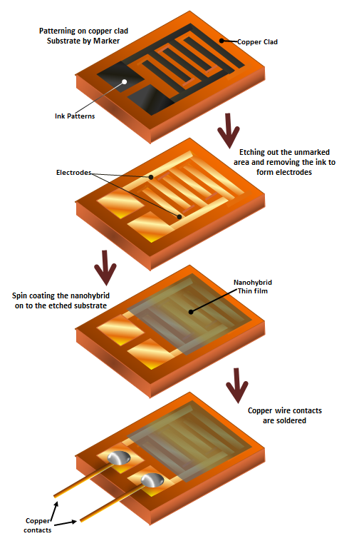

Figure 1: Sensor Fabrication Process.

**2.3.1 Patterning the Copper Clad substrate**

The patterning of copper clad substrate is done with a permanent black ink marker. This marker ink prevents the etching of copper where ever it is required. At first the copper clad which is cut into the required dimensions is washed thoroughly with clean water or Acetone. Then the required pattern of electrodes is drawn on the clad and the ink is allowed to dry properly. Before etching it is necessary to ensure that there are no unmarked areas on the patterned region. The copper is etched with the help of ferric chloride solution. An excess amount of ferric chloride is added into the water and is stirred well for complete dissolution. Precautions are taken while working with the ferric chloride solution.

The pattern marked copper clad substrate is then dipped in the ferric chloride solution for 10-15 minutes till the unmarked copper dissolves completely in the solution. Then the substrate is taken out of the solution and washed with water. The marker ink is then dissolved and removed completely using Acetone or ink remover. Finally, it is checked for any over etching and unremoved copper to make sure the etching is done properly.

**2.3.2 Preparation of the GO/CuO Nanohybrid Coating Solution**

To coat the etched substrate with the GO/CuO nanohybrid, the nanohybrid solution is prepared by considering a ratio for mixing the two materials. To get a uniform, sticky and non-peeling film on the substrate, nanomaterials are dispersed in a polymer solution of PVA/ PVP mixture, containing 80% PVA and 20% PVP. Before making the polymer ratio, both polymer solutions are prepared separately, where both are 10% solution. This proportion is considered because of the high Conductivity of the solution. Then 0.005g of both GO and CuO is dissolved in the 5 ml polymer solution and it is spin coated on the substrate.

**2.3.3 Coating of GO/CuO Nanohybrid on the Patterned Substrate**

The solution is dropped on the substrate in dynamic spinning mode at 100rpm for 100 seconds and then is spun at 2500rpm for about 300 seconds. The film is left for complete drying for few minutes. The coated film is of about 10 micro meters. Finally the electrodes are soldered with copper wires as contacts.

**3. Results and Discussions**

**3.1 UV-Vis Spectrophotometry of Graphene Oxide**

The synthesized and dried GO powder is dispersed in distilled water using ultrasonicator. The ultrasonication results in dispersion GO which consist of several individual layers. The UV absorption spectra of GO depends on some of the factors such as number of graphene layers in dispersed GO layers and the amount of defects and impurities present in them. The UV-Vis spectrophotometry provides the maximum wavelength (λmax) at which the absorption and transmission is high or low. It provides two peaks for both UV and visible region. The peaks depending on the GO synthesised by using modified hummers method showed maximum wavelength for adsorption between 200-400 nm. The UV curve consists of two main peaks, one is for π-π* transition and another is for π*-n transition. Usually π-π* transitions can be observed below 300 nm and π*-n transitions above 300 nm for almost all organic and inorganic materials [23].

The λmax for π-π* transition of GO is obtained at 233.6 nm (Figure 2) for absorption value of 1.132 (a.u.). In π*-n transition region it shows two peaks with absorption of 0.791 and 0.782 (a.u.) at wavelengths 399.2 nm and 353.6 nm respectively. These multiple peaks in the absorbance graph are due to vibronic coupling or due to the electron transitions to higher excited states. This shows that the synthesized GO has good electronic properties with molecular vibrational states.

**3.2 UV-Vis Spectroscopy of Copper Oxide (CuO) Nanoparticles**

The metal oxide nanoparticles show a wide range of UV-Vis spectrum. Copper oxide nanoparticles are dispersed in distilled water with ultra-sonication for a long time for uniform dispersion of the particles, due to the insolubility of CuO nanoparticles in water.

The UV spectrophotometer graph of CuO nanoparticle (Figure 3) shows the λmax for π-π* electron transitionis at 233.6 nm for absorption of 1.309 (a.u.). Whereas, for the π*-n transitions, four high energy peaks are obtained at 497.6, 468.8, 399.2 and 368.0 nm for absorption of 1.598, 1.521, 1.468 and 1.210 (a.u.), respectively. These multiple peaks are the results of allowed multiple higher electronic excitations from ground state to excited state. The UV-Vis spectroscopic results for the CuO nano particles shows that the nano particles exhibit higher electronic transitions and can be semiconducting or conducting in nature. Its absorption is much higher in visible region than the UV region, which indicates that there are plenty of free electrons for the conduction.

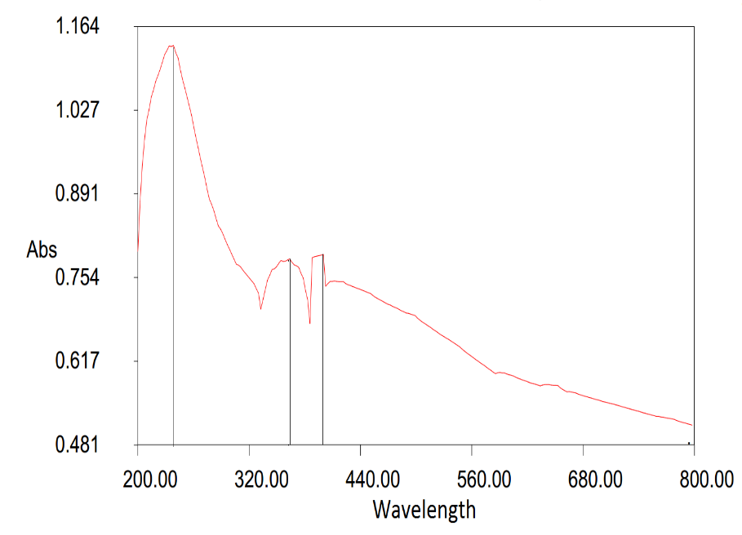

Figure 2: UV-Vis absorption peak for GO.

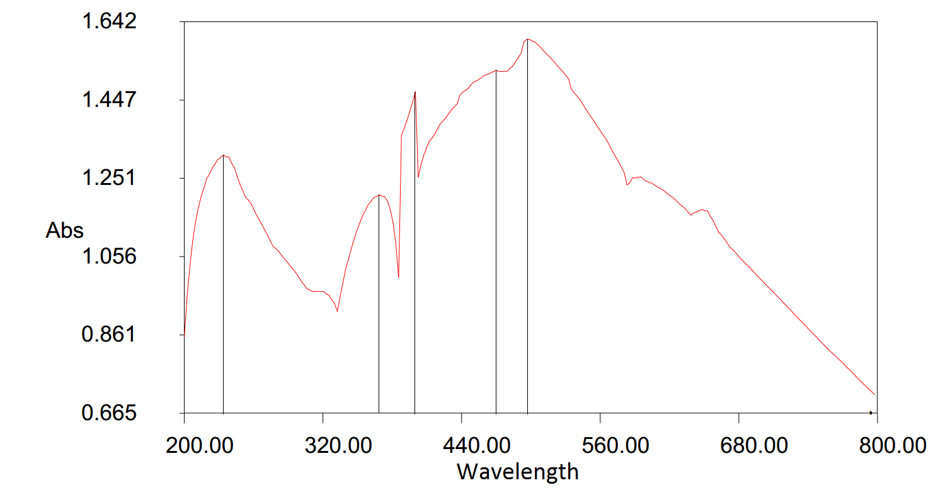

Figure 3: UV-Vis absorption peak for CuO NPs.

**3.3 SEM Characterization of Graphene Oxide**

The SEM images of the synthesized graphene oxide (GO) shows (Figure 4) the sheets of graphene oxide which are stacked together to form GO flakes. The rough thickness range of the stacked GO is 4-8 nm. This stacking is due to the weak forces which upon dispersion by ultrasonication in water or alcohols, provides single GO sheets.

**3.4 SEM Characterization of Copper Oxide Nanoparticles**

The SEM image of CuO nanoparticles is shown in Figure 5. The synthesized CuO nanoparticles by the precipitation method are in a flower like crystal structure. The size of the synthesised CuO nanoparticles is analysed and average particle diameter is found to be 350 nm. This size of CuO nanoparticles is due to the particle agglomeration during synthesis or drying.

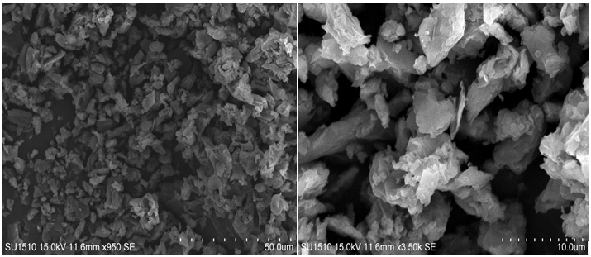

Figure 4: SEM images of graphene oxide sample.

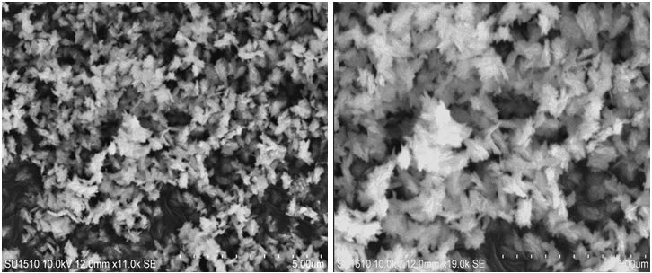

Figure 5: SEM images of copper oxide nanoparticles.

**3.5 EDX of Graphene Oxide**

The graph (Figure 6) shows the amount of element present in the GO sample at a point, in terms of number of atoms present at that point. In the graph, it can be seen that the amount of carbon and oxygen is in higher concentration. There are also some traces of sulphur (S) and potassium (K) in the sample as impurities, which are due to the potassium permanganate and sulphuric acid, which remained in the sample during washing.

**3.6 EDX of Copper Oxide Nanoparticles**

The graph (Figure 7) shows the amount of element present in the CuO nanoparticles at a selected point on the SEM image, which provides number of atoms present at that point. In the graph, amount of copper (Cu) and oxygen (O) for different transition electrons is obtained. Copper and oxygen atoms are in higher concentration with the presence of some amount of carbon (C) in the sample as impurity.

**3.7 Sensor Test Results**

The sensor is tested using the SMU instrument to find out the I-V characteristics and the change in resistance. The resistance of the material is calculated by varying the voltage and measuring the current with respect to it. The SMU unit directly provides the resistance value with the variable current and voltage. It is found that the resistance of the nanohybrid is too high in the order of Mega Ohms (MΩ). Resistance of the material is tested first in the open atmosphere i.e. in air and then in CO2 atmosphere (Figure 8). From the plot given below, we can observe that the resistance of the nanohybrid increased in the presence of CO2 than in air. This data aids in recognizing the presence of CO2 with the help of sensor, with changing material resistance. These values are considered as standard resistance of the sensor and are uploaded in the Arduino System, which measures the change in the resistance in the presence of CO2 gas in the surroundings. The sensitivity/response of a gas sensor are calculated and is found to be 60%.

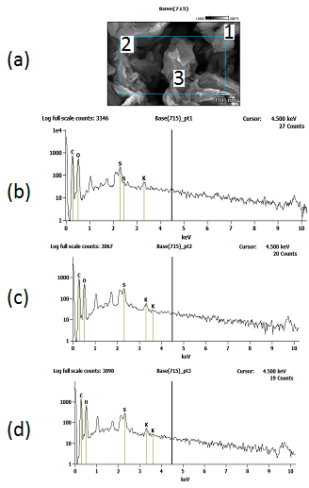

Figure 6: (a) EDX characterisation sample image of graphene oxide, (b) EDX graph showing amount of elements present in GO sample at point 1, (c) EDX graph showing amount of elements present in GO sample at point 2, (d) EDX graph showing amount of elements present in GO sample at point 3

**3.8 Sensor Integration with Arduino Microcontroller**

The fabricated sensor is devised (Figure 9) with Arduino Microcontroller for transduction and gas concentration detection. The transduction from the chemical response by the sensor is due to the principle of voltage divider. The sensor is considered as unknown resistor and a 55kΩ known resistor. The voltage given to the circuit divides the voltage between two resistors, i.e. the sensor and the resistor, current and voltage in the sensor is measured with respect to the known resistance. Then the resistance is converted to the gas concentration in terms of PPM.

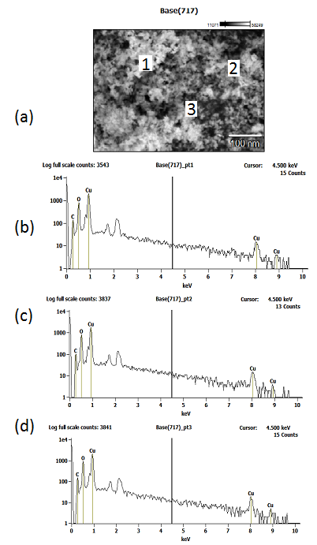

Figure 7: (a) EDX characterisation sample image of CuO NPs, (b) EDX graph showing amount of elements present in CuO NPs sample at point 1, (c) EDX graph showing amount of elements present in GO sample at point 2, (d) EDX graph showing amount of elements present in GO sample at point 3.

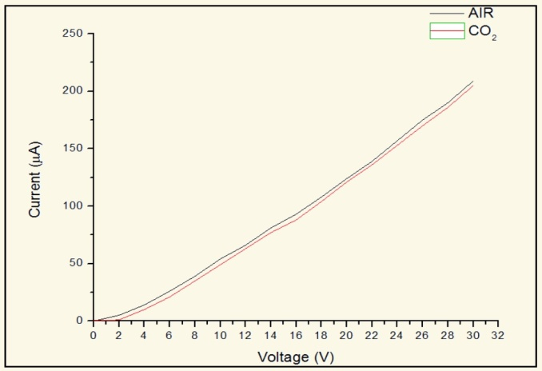

Figure 8: I-V characteristics of Sensor in Air and CO2 environment.

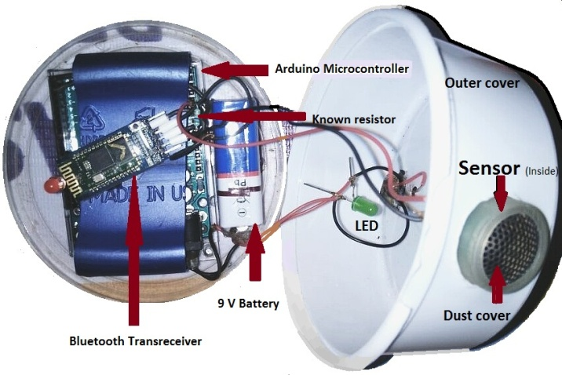

Figure 9: Sensor Device Components.

**3.9 Conclusion**

Graphene oxide (GO) was prepared by modified Hummer’s method and CuO nanoparticles using CuCl2 as precursor. UV-Vis spectroscopy, SEM and EDX analysis were used to characterize the prepared GO and CuO nanoparticles. GO-CuO nanohybrid was prepared using PVA-PVP mixture, and was used for sensor fabrication. The sensor was fabricated using Copper clad substrate which is etched and coated with the nanohybrid by Doctor Blade method. The sensor is then tested for change in resistance using SMU meter. The fabricated sensor is coupled with Arduino for sensing the CO2 gas. The sensing response of this sensor towards CO2 is found to be 60%.

**Acknowledgement:** The corresponding author acknowledges the research facility provided by VGST, Govt. of Karnataka (GRD No. 538).

# References

|  |  |
| --- | --- |
| [1] | S. Bennett, A History of Control Engineering, 1930-1955, Hitchin, Hertfordshire: Peter Peregrinus, 1993. |
| [2] | J. Yan, Machinery Prognostics and Prognosis Oriented Maintenance Management, Singapore: John Wiley & Sons Singapore Pte. Ltd, 2014. |
| [3] | J. Watson, "The tin oxide gas sensor and its applications.," *Sensors and Actuators,* vol. 5, no. 1, pp. 29-42, 1984. |
| [4] | N. Zabba, "Synthesis of Graphene Oxide using Modified Hummers Method: Solvent Influence," *Procedia Engineering,* vol. 184, pp. 469-477, 2017. |
| [5] | J. T. Robinson, "Reduced Graphene Oxide Molecular Sensors," *Nano Letters,* vol. 8, no. 10, pp. 3137-3140, 2008. |
| [6] | G. Naik, "Room-Temperature Humidity Sensing Using Graphene Oxide Thin Films," *Graphene,* vol. 5, no. 1, pp. 1-13, 2016. |
| [7] | S. Papamatthaiou, "The Effect of Thermal Reduction and Film Thickness on fast Response Transparent Graphene Oxide Humidity Sensors," *Procedia Engineering,* vol. 168, pp. 301-304, 2016. |
| [8] | F.-L. Meng, "Graphene-based hybrids for chemiresistive gas sensors," *TrAC Trends in Analytical Chemistry,* vol. 68, pp. 37-47, 2015. |
| [9] | N. Li, "Ultrahigh humidity sensitivity of graphene oxide combined with Ag nanoparticles," *RSC Advances,* vol. 7, no. 73, pp. 45988-45996, 2017. |
| [10] | A. Taylor, "Electrospray-Printed Nanostructured Graphene Oxide Gas Sensors," *Nanotechnology,* vol. 26, no. 50, pp. 505301 (1-8), 2015. |
| [11] | J. Park, "Characteristics tuning of graphene-oxide-based-graphene to various end-uses," *Energy Storage Materials,* vol. 14, pp. 8-21, 2018. |
| [12] | S. Balashov, "Influence of the deposition parameters of graphene oxide nanofilms on the kinetic characteristics of the SAW humidity sensor," *Sensors and Actuators B: Chemical,* vol. 217, pp. 88-91, 2015. |
| [13] | A. G. Bannov, "Investigation of Ammonia Gas Sensing Properties of Graphite Oxide," *Procedia Engineering,* vol. 168, pp. 231-234, 2016. |
| [14] | N. Tanvir, "Investigation of low temperature effects on work function based CO2 gas sensing of nanoparticulate CuO films," *Sensors and Actuators B: Chemical,* vol. 247, pp. 968-974, 2017. |
| [15] | J. Kshirsagar, "Preparation and characterization of copper oxide nanoparticles and determination of enhancement in critical heat flux," *Thermal Science,* vol. 21, no. 1A, pp. 233-242, 2015. |
| [16] | P. Chand, "Study of CuO Nanoparticles Synthesized by Sol‐gel Method," *AIP Conference Proceedings,* vol. 1393, pp. 211-212, 2011. |
| [17] | K. Phiwdang, "Synthesis of CuO Nanoparticles by Precipitation Method Using Different Precursors," *Energy Procedia,* vol. 34, pp. 740-745, 2013. |
| [18] | M. Mirmotallebi, "Characterization of three-dimensional reduced graphene oxide/copper oxide heterostructures for hydrogen sulfide gas sensing application," *Journal of Alloys and Compounds,* vol. 740, pp. 1024-1031, 2018. |
| [19] | S. Basu, "Recent developments on graphene and graphene oxide based solid state gas sensors," *Sensors and Actuators B: Chemical,* vol. 173, pp. 1-21, 2012. |
| [20] | J. Wu, "Boosted sensitivity of graphene gas sensor via nanoporous thin film structures," *Sensors and Actuators B: Chemical,* vol. 255, no. Part 2, pp. 1805-1813, 2018. |
| [21] | H. J. Yoon, "Carbon dioxide gas sensor using a graphene sheet," *Sensors and Actuators B: Chemical,* vol. 157, no. 1, pp. 310-313, 2011. |
| [22] | N. B. Tanvir, "Work Function Based CO2 Gas Sensing Using Metal Oxide Nanoparticles at Room Temperature," *Materials Today Proceedings,* vol. 2, no. 8, pp. 4190-4195, 2015. |