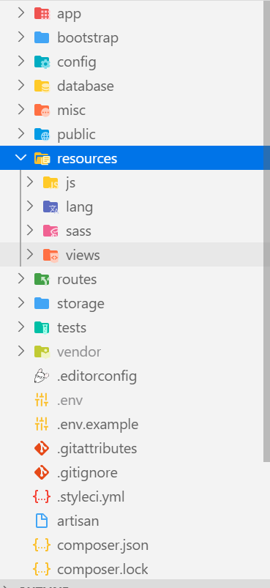

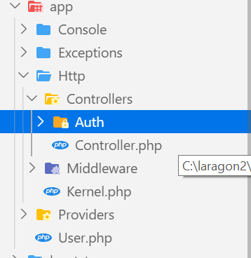

Controller – App\Http\Controllers

Views - Resources\Views

Model – App

Router – routes/web.php

Seeting - .env

* DB
* Email

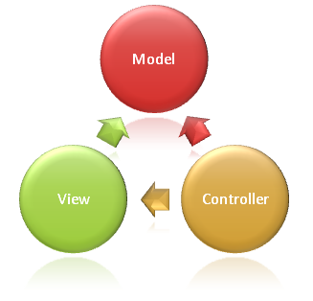

Router

## Laporan Bil Hari Proses Permohonan

* Utk spesifik application contoh 103411-2
* Ada carian permohonan

Tajuk : ……………….

Hasil carian … (table)

Tkh terima

On click carian, show statistik ini

**Agensi Dalaman**

|  |  |  |  |  |  |  |
| --- | --- | --- | --- | --- | --- | --- |
| Agensi | Bil Hari Proses | Bil hari SOP | Lewat | Bil Hari Balance | Tarikh Edar | Tkh Ulas |
| Perancang | 7 | 14 | 7 | 0 | 1.10.2019 | 17.10.2019 |
| Bangunan | 5 | 14 | 9 | 0 | 1.10.2019 | 15.10.2019 |
| Kejuruteraan |  | 14 | -12 | 0 | 1.10.2019 |  |
| Landskap |  | 14 | -12 | 0 | 1.10.2019 |  |

**Agens Luaran**

|  |  |  |  |
| --- | --- | --- | --- |
| Agensi | Bil | Tarikh Terima |  |
| JKR |  |  |  |
| JPS |  |  |  |
| JMG |  |  |  |
|  |  |  |  |